# 仿天猫

#### 项目预热配置

**需安装node后自动下载生成npm开发依赖集成包**

强大而强壮的Stylus预编译安装，进入项目目录，所有静态的资源都放在public目录下，index.js引入public目录下的文件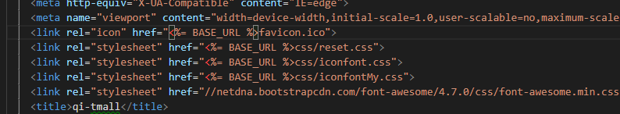public目录不会被webpack打包编译。

1. npm install stylus stylus-loader --save
2. 引入css样式重置
3. 准备相关icon图标文件
4. 安装swiper轮播vue-awesome版：npm install vue-awesome-swiper –save，安装完全局main.js引入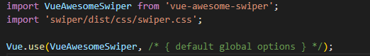
5. Axios的安装：npm install axios –save -dev,

6)准备全项目所需要的单文件数据接口：{

"msg":"ok",

"bannerImg":{

"id":"999",

"url":"//gw.alicdn.com/tfs/TB1wQw8qamWBuNjy1XaXXXCbXXa-237-41.png_240x10000.jpg_.webp"

},

"navIconData":[

{

"id":"1",

"url":"//gw.alicdn.com/tfs/TB1ISdWSFXXXXbFXXXXXXXXXXXX-146-147.png_110x10000.jpg_.webp",

"title":"苏宁易购"

},

{

"id":"2",

"url":"//gw.alicdn.com/tfs/TB1wSoFa5qAXuNjy1XdXXaYcVXa-196-196.png?avatar=1_110x10000.jpg_.webp",

"title":"天猫国际"

},

{

"id":"3",

"url":"//gw.alicdn.com/tfs/TB1Jc0fSFXXXXXTapXXXXXXXXXX-146-147.png_110x10000.jpg_.webp",

"title":"天猫国际"

},

{

"id":"4",

"url":"//gw.alicdn.com/tfs/TB15lhOSFXXXXaKXpXXXXXXXXXX-147-147.png_110x10000.jpg_.webp",

"title":"聚划算"

},

{

"id":"5",

"url":"//gw.alicdn.com/tfs/TB12CFXSFXXXXcpapXXXXXXXXXX-146-147.png_110x10000.jpg_.webp",

"title":"分类"

}

],

"swiperData":[

{

"id":"01",

"targetUrl":"//gw.alicdn.com/tfs/TB1HHWbNrPpK1RjSZFFXXa5PpXa-1035-390.png_790x10000.jpg_.webp"

},

{

"id":"02",

"targetUrl":"//gw.alicdn.com/imgextra/i1/62/O1CN01MWkfpz1CKR6GZ8iId_!!62-0-lubanu.jpg_790x10000Q75.jpg_.webp"

},

{

"id":"03",

"targetUrl":"//gw.alicdn.com/imgextra/i4/171/O1CN01eJJUrM1D8MGqCdgxR_!!171-0-lubanu.jpg_790x10000Q75.jpg_.webp"

},

{

"id":"04",

"targetUrl":"//gw.alicdn.com/imgextra/i4/148/O1CN01wYLn621CxpAANXV81_!!148-0-lubanu.jpg_790x10000Q75.jpg_.webp"

},

{

"id":"05",

"targetUrl":"//gw.alicdn.com/imgextra/i4/150/O1CN01cryV4i1Cyjx3mZ3N2_!!150-0-lubanu.jpg_790x10000Q75.jpg_.webp"

},

{

"id":"06",

"targetUrl":"//gw.alicdn.com/imgextra/i4/37/O1CN01GLHmpE1C8zCQI46cI_!!37-0-lubanu.jpg_790x10000Q75.jpg_.webp"

},

{

"id":"07",

"targetUrl":"//gw.alicdn.com/imgextra/i4/22/O1CN012Y5e6L1C27FyONWhB_!!22-0-lubanu.jpg_790x10000Q75.jpg_.webp"

},

{

"id":"08",

"targetUrl":"//gw.alicdn.com/imgextra/i1/160/O1CN0193bXW41D3JucYiIUb_!!160-0-lubanu.jpg_790x10000Q75.jpg_.webp"

},

{

"id":"09",

"targetUrl":"//gw.alicdn.com/imgextra/i4/124/O1CN014VbsHi1CmpenB4aPB_!!124-0-lubanu.jpg_790x10000Q75.jpg_.webp"

},

{

"id":"010",

"targetUrl":"//gw.alicdn.com/imgextra/i4/41/O1CN01SvHoio1CAomZFncvc_!!41-0-lubanu.jpg_790x10000Q75.jpg_.webp"

}

],

"AdvertisementData":{

"id":"888",

"url":"//gw.alicdn.com/tfs/TB1TwtpNxTpK1RjSZR0XXbEwXXa-750-386.png_790x10000.jpg_.webp"

},

"recommendData": [

{

"id":"001",

"targetUrlOne":"//gw.alicdn.com/i1/1956044649/TB2iN5QpFooBKNjSZFPXXXa2XXa_!!1956044649.png_170x10000.jpg_.webp",

"targetUrlOneInfo":"限时特价",

"targetUrlTwo":"//gw.alicdn.com/i2/665616839/O1CN01PNebwk20OJBVzR0Vf_!!2-item_pic.png_170x10000.jpg_.webp",

"targetUrlTwoInfo":"为你精选",

"title":"限时抢购"

},

{

"id":"002",

"targetUrlOne":"//gw.alicdn.com/tps/bao/upload/TB1ofF7U4TpK1RjSZR0XXbEwXXa.png_170x10000.jpg_.webp",

"targetUrlOneInfo":"仙女裙",

"targetUrlTwo":"//gw.alicdn.com/tps/bao/upload/TB1XWsdXACy2eVjSZPfXXbdgpXa.png_170x10000.jpg_.webp",

"targetUrlTwoInfo":"黑科技",

"title":"天猫好物"

},

{

"id":"003",

"targetUrlOne":"//gw.alicdn.com/tps/O1CN01sWbfag1CPvqhN5xxH_!!74-2-lubanu.png_170x10000.jpg_.webp",

"targetUrlOneInfo":"抢5折劵",

"targetUrlTwo":"//gw.alicdn.com/tps/O1CN01SeAi7v1D1wiyQUxV8_!!157-2-lubanu.png_170x10000.jpg_.webp",

"targetUrlTwoInfo":"满999元...",

"title":"聚划算"

},

{

"id":"004",

"targetUrlOne":"//gw.alicdn.com/tps/bao/upload/TB1VlpqS9zqK1RjSZFjXXblCFXa.png_170x10000.jpg_.webp",

"targetUrlOneInfo":"已降60元",

"targetUrlTwo":"//gw.alicdn.com/tps/i4/3683190185/O1CN018J9DRs1DElnbzCdGm_!!2-item_pic.png_170x10000.jpg_.webp",

"targetUrlTwoInfo":"已降5元",

"title":"天猫闪降"

}

],

"likeData":[

{

"id":"0001",

"url":"//gw.alicdn.com/bao/uploaded/i3/3075140505/O1CN01N9ozYo1FbKWDgnzeW_!!2-item_pic.png_290x10000.jpg_.webp",

"title":"临期-【2倍购买】ALDI奥乐齐 德国进口多谷物麦片500g坚果/水果",

"coupon":"10元劵",

"retreat":"破损包退",

"money":"19.9￥",

"beSimilar":"看相似"

},

{

"id":"0002",

"url":"//gw.alicdn.com/bao/uploaded/i3/2200695875205/O1CN01tNVwV31oJw2fkYD45_!!2-item_pic.png_290x10000.jpg_.webp",

"title":"嗨吃家酸辣粉旗舰正品 乐嗨家官网金汤爆粉 重庆红薯粉丝速食批发",

"coupon":"5元劵",

"retreat":"破损包退",

"money":"19.8￥",

"beSimilar":"看相似"

},

{

"id":"0003",

"url":"//gw.alicdn.com/bao/uploaded/i1/2975943106/O1CN01vGLFG31YoagZx6mWB_!!0-item_pic.jpg_290x10000Q75.jpg_.webp",

"title":"男士春秋季休闲工装夹克春装上衣服",

"coupon":"15元劵",

"retreat":"破损包退",

"money":"55￥",

"beSimilar":"看相似"

},

{

"id":"0004",

"url":"//gw.alicdn.com/bao/uploaded/i2/3358261187/O1CN01ELQO1Z1Kdgdjv3cJ3_!!0-item_pic.jpg_290x10000Q75.jpg_.webp",

"title":"妈妈装夏宽松夏装两件套中老年女装",

"coupon":"20元劵",

"retreat":"破损包退",

"money":"158￥",

"beSimilar":"看相似"

},

{

"id":"0005",

"url":"//gw.alicdn.com/bao/uploaded/i3/1744668024/O1CN01R7afV72992XWC6InV_!!2-item_pic.png_290x10000.jpg_.webp",

"title":"工程车玩具拆装模型挖土翻斗4螺丝",

"coupon":"3元劵",

"retreat":"破损包退",

"money":"45￥",

"beSimilar":"看相似"

},

{

"id":"0006",

"url":"//gw.alicdn.com/bao/uploaded/i4/3853367329/O1CN01NAnO5Y240jGzxDIZw_!!3853367329.jpg_290x10000Q75.jpg_.webp",

"title":"分类收纳家用厨房食物杂物标签贴纸",

"coupon":"10元劵",

"retreat":"破损包退",

"money":"6.9￥",

"beSimilar":"看相似"

},

{

"id":"0007",

"url":"//gw.alicdn.com/bao/uploaded/i4/2200737140086/O1CN01Byfi2B1CVQZFbbNlz_!!0-item_pic.jpg_290x10000Q75.jpg_.webp",

"title":"pnso成长玩具48 025号-048号模型",

"coupon":"2元劵",

"retreat":"破损包退",

"money":"12￥",

"beSimilar":"看相似"

},

{

"id":"0008",

"url":"//gw.alicdn.com/bao/uploaded/i1/TB1pE7cRkPoK1RjSZKbSut1IXXa.jpg_290x10000Q75.jpg_.webp",

"title":"2.5g-20g-10枚装石缝/草区倒钓铅",

"coupon":"2元劵",

"retreat":"破损包退",

"money":"9.9￥",

"beSimilar":"看相似"

},

{

"id":"0009",

"url":"//gw.alicdn.com/bao/uploaded/i2/2990350232/O1CN01srSmHG1DaIORNZ7up_!!0-item_pic.jpg_290x10000Q75.jpg_.webp",

"title":"夏网红无袖中长款很仙的v领连衣裙",

"coupon":"10元劵",

"retreat":"破损包退",

"money":"59￥",

"beSimilar":"看相似"

},

{

"id":"0010",

"url":"//gw.alicdn.com/bao/uploaded/i2/2074834859/O1CN01UbM9n71llSzNGXWs7_!!2074834859.jpg_290x10000Q75.jpg_.webp",

"title":"高档手帕巾礼服配饰领结配套口袋巾",

"coupon":"3元劵",

"retreat":"破损包退",

"money":"18.4￥",

"beSimilar":"看相似"

},

{

"id":"0011",

"url":"//gw.alicdn.com/bao/uploaded/i1/3525853293/O1CN015o7ioV1aCEkT7H7dS_!!0-item_pic.jpg_290x10000Q75.jpg_.webp",

"title":"敬酒服新娘2019新款红色吊带晚礼服女王气场高贵答谢宴连衣裙夏季",

"coupon":"158减10",

"retreat":"破损包退",

"money":"268￥",

"beSimilar":"看相似"

},

{

"id":"0012",

"url":"//gw.alicdn.com/bao/uploaded/i4/3334174968/O1CN01NEOomk1mZO9xHjEdd_!!2-item_pic.png_290x10000.jpg_.webp",

"title":"车辆外用高泡刷车水蜡清洗剂腊水",

"coupon":"5元劵",

"retreat":"破损包退",

"money":"22.8￥",

"beSimilar":"看相似"

},

{

"id":"0013",

"url":"//gw.alicdn.com/bao/uploaded/bao/upload/TB1KNbcVmzqK1RjSZFHXXb3CpXa.png_290x10000.jpg_.webp",

"title":"puma女鞋夏季蕾哈娜松糕底休闲鞋",

"coupon":"满688减30",

"retreat":"破损包退",

"money":"789￥",

"beSimilar":"看相似"

},

{

"id":"0014",

"url":"//gw.alicdn.com/bao/uploaded/i4/1749980208/O1CN010gTSK31DPIt51Yn9n_!!0-item_pic.jpg_290x10000Q75.jpg_.webp",

"title":"圆形布艺地板打坐阳台榻榻米蒲团",

"coupon":"3元劵",

"retreat":"破损包退",

"money":"39￥",

"beSimilar":"看相似"

},

{

"id":"0015",

"url":"//gw.alicdn.com/bao/uploaded/i3/2200737140086/O1CN01izIWrj1CVQZ8yakcJ_!!2-item_pic.png_290x10000.jpg_.webp",

"title":"pnso成长陪伴巨齿鲨巴顿模型",

"coupon":"满110减20",

"retreat":"破损包退",

"money":"199￥",

"beSimilar":"看相似"

},

{

"id":"0016",

"url":"//gw.alicdn.com/bao/uploaded/i1/1731307542/O1CN015r5yPe25aHfL5Tn3u_!!0-item_pic.jpg_290x10000Q75.jpg_.webp",

"title":"韩国stylenanda官方正品 纯色中长款连帽拉链马甲",

"coupon":"30元劵",

"retreat":"破损包退",

"money":"374￥",

"beSimilar":"看相似"

},

{

"id":"0017",

"url":"//gw.alicdn.com/bao/uploaded/i3/1051355616/O1CN01bp9UP51rMAoSqfzxu_!!0-item_pic.jpg_290x10000Q75.jpg_.webp",

"title":"男破洞5分纯棉牛仔七分裤五分裤",

"coupon":"20元劵",

"retreat":"破损包退",

"money":"128￥",

"beSimilar":"看相似"

},

{

"id":"0018",

"url":"//gw.alicdn.com/bao/uploaded/i2/690794404/O1CN01jOjJkr1iP4mAdrZED_!!0-item_pic.jpg_290x10000Q75.jpg_.webp",

"title":"福禄吉祥欧式客厅包邮新壁画背景墙",

"coupon":"20元劵",

"retreat":"破损包退",

"money":"398￥",

"beSimilar":"看相似"

},

{

"id":"0019",

"url":"//gw.alicdn.com/bao/uploaded/i3/3522961030/O1CN01VlxbFT1JTmT5pdw7h_!!0-item_pic.jpg_290x10000Q75.jpg_.webp",

"title":"不一样的你衣我情侣夏装旗袍t恤",

"coupon":"10元劵",

"retreat":"破损包退",

"money":"99￥",

"beSimilar":"看相似"

},

{

"id":"0020",

"url":"//gw.alicdn.com/bao/uploaded/i3/1875311741/O1CN01keQqy11OjQ3RYmxVl_!!0-item_pic.jpg_290x10000Q75.jpg_.webp",

"title":"夏季新款气质宽松洋气两件套阔腿裤",

"coupon":"25元劵",

"retreat":"破损包退",

"money":"188￥",

"beSimilar":"看相似"

}

],

"linkTitle":{

"title":"猜你喜欢"

},

"loadingData":{

"url":"https://gw.alicdn.com/tfs/TB1OJh.OrrpK1RjSZTEXXcWAVXa-654-760.png"

},

"orderData":[

{

"id":"00001",

"icon":"iconfont icon-order",

"msg":"全部订单"

},

{

"id":"00002",

"icon":"iconfont icon-02",

"msg":"收藏夹"

},

{

"id":"00003",

"icon":"iconfont icon-27",

"msg":"购物车"

},

{

"id":"00004",

"icon":"iconfont icon-zuji1",

"msg":"足迹"

}

]

}

#### 项目目录结构

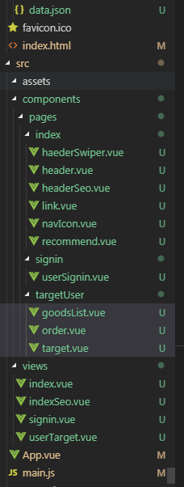

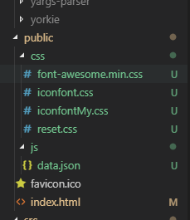

#### 首页效果图

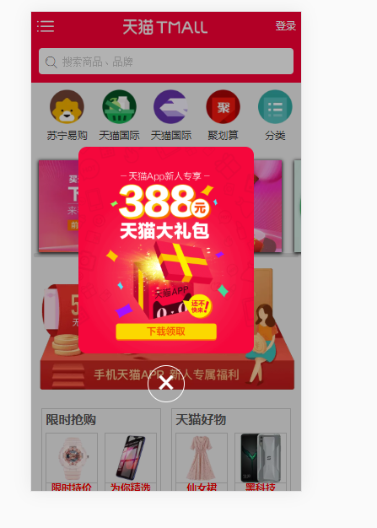

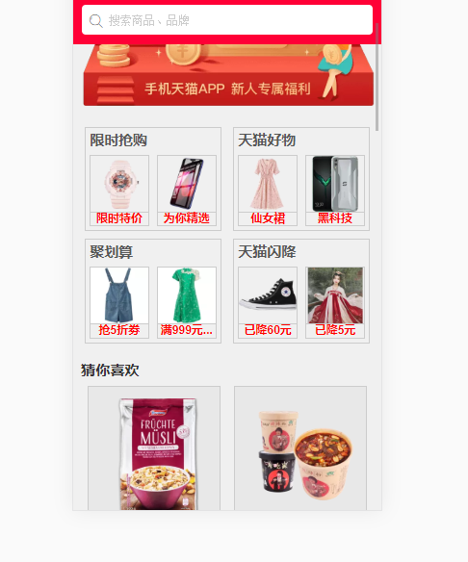

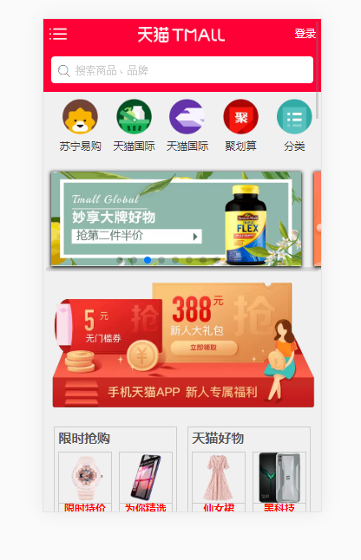

#### 首页index

1.1Header头部组件的实现

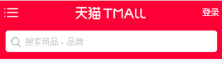

代码如下:

<template>

<div class="header">

<div class="header-list">

<div class="iconfont icon-icon-- icon-list"></div>

<div class="banner-img">

<img :src="bannerImg">

</div>

<router-link tag="div" to="/index/signin" class="signin">登录</router-link>

</div>

<router-link tag="div" to="/index/index-seo" class="header-seo">

<i class="iconfont icon-sousuo"></i>

<input class="seo" type="text" placeholder="搜索商品、品牌">

</router-link>

</div>

</template>

<script>

export default {

name: 'Header',

data () {

return {

bannerImg : []

}

},

mounted () {

this.getBanner()

},

methods: {

getBanner(){

this.axios.get('http://localhost:8080/js/data.json').then((res)=>{

var res = res.data;

if(res.msg === "ok"){

this.bannerImg = res.bannerImg.url

}

})

}

}

}

</script>

<style lang="stylus" scoped>

.header

position fixed

width 100%

z-index 9999

height 2.1rem

background-color #ff0036

.header-list

display flex

width 100%

height .85rem

.icon-list

float left

width .85rem

line-height .85rem

font-size .7rem

color white

text-align center

.banner-img

flex 1

line-height .85rem

text-align center

img

display inline

width 2.5rem

height .45rem

.signin

float right

width .9rem

line-height .85rem

font-size .3rem

color white

text-align center

.header-seo

box-sizing border-box

width 100%

height 0.975rem

position relative

padding .22rem

i

display block

position absolute

top 0.45rem

left .4rem

.seo

box-sizing border-box

width 100%

height 0.775rem

border-radius .1rem

padding-left .7rem

.seo::placeholder

color #ccc

</style>

1.2导航组件的实现

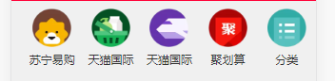

代码如下:

<template>

<div class="nav-icon">

<ul>

<li v-for="item in navIconList" :key="item.id">

<img :src="item.url">

<br>

<span class="title-icon">{{item.title}}</span>

</li>

</ul>

</div>

</template>

<script>

export default {

name: "navIcon",

data () {

return {

navIconList : []

}

},

mounted () {

this.getInfoNav()

},

methods: {

getInfoNav(){

this.axios.get('http://localhost:8080/js/data.json').then((res)=>{

var res = res.data;

if(res.msg === "ok"){

this.navIconList = res.navIconData

}

})

}

}

}

</script>

<style lang="stylus" scoped>

.nav-icon

width 100%

height 1.875rem

margin-top .2rem

ul

box-sizing border-box

padding-left .3rem

display flex

width 100%

li

flex 1

text-align center

img

display inline

width 1.025rem

height 1.025rem

margin-bottom .2rem

.title-icon

display block

width 100%

text-align center

</style>

1.3轮播组件的实现

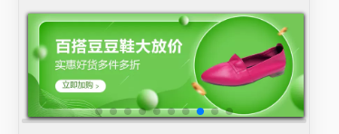

代码如下：<template>

<div class="header-swiper">

<swiper :options="swiperOption" ref="mySwiper" v-if="swiperList.length>1">

<!-- slides -->

<swiper-slide v-for="item of swiperList" :key="item.id">

<img class="swiper-img" :src="item.targetUrl">

</swiper-slide>

<!-- Optional controls -->

<div class="swiper-pagination" slot="pagination"></div>

<div class="swiper-scrollbar" slot="scrollbar"></div>

</swiper>

<div class="advertisement">

<img :src="Advertisement">

</div>

</div>

</template>

<script>

export default {

name: "HaederSwiper",

data () {

return {

swiperOption: {

autoplay: {//自动播放

delay: 3000,

disableOnInteraction: false

},

loop:true,

pagination : {

el : ".swiper-pagination"

}

},

swiperList:[],

Advertisement : []

}

},

mounted () {

this.getInfoSwiper()

},

methods: {

getInfoSwiper(){

this.axios.get('http://localhost:8080/js/data.json').then((res)=>{

var res = res.data;

if(res.msg === "ok"){

this.swiperList = res.swiperData

this.Advertisement = res.AdvertisementData.url

}

})

}

}

}

</script>

<style lang="stylus" scoped>

.header-swiper

position relative

overflow hidden

width 100%

height 38%

.swiper-img

width 95%

height 100%

box-shadow 0 1px .1rem #000

margin 3%

.advertisement

img

width 100%

height 100%

</style>

1.4商品推荐组件的实现

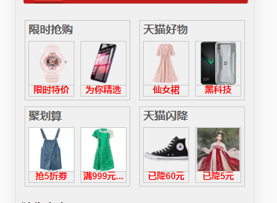

代码如下：<template>

<div class="recommend">

<ul class="recommend-wrap">

<li v-for="item of recommendList" :key="item.id">

<span class="title">{{item.title}}</span>

<br>

<div class="detail-wrap">

<ul class="detail">

<li>

<img :src="item.targetUrlOne">

<br>

<span>{{item.targetUrlOneInfo}}</span>

</li>

<li>

<img :src="item.targetUrlTwo">

<br>

<span>{{item.targetUrlTwoInfo}}</span>

</li>

</ul>

</div>

</li>

</ul>

</div>

</template>

<script>

export default {

name: "Recommend",

data () {

return {

recommendList : []

}

},

mounted () {

this.getRecommendInfo()

},

methods: {

getRecommendInfo(){

this.axios.get('http://localhost:8080/js/data.json').then((res)=>{

var res = res.data;

if(res.msg === "ok"){

this.recommendList = res.recommendData

}

})

}

}

}

</script>

<style lang="stylus" scoped>

.recommend

box-sizing border-box

height 50%

width 100%

padding .2rem

.recommend-wrap

display flex

flex-wrap wrap

justify-content space-between

box-sizing border-box

width 100%

li

width 46%

border 1px solid #ccc

margin .1rem

.title

display block

height 0

padding 4% 3%

width 100%

font-weight bolder

font-size 1.33444em

color #555

.detail-wrap

.detail

display flex

justify-content space-around

li

width 43%

img

width 100%

height 80%

border-bottom 1px solid #ccc

span

display block

width 100%

text-align center

color red

font-weight bold

</style>

1.5猜你喜欢组件实现

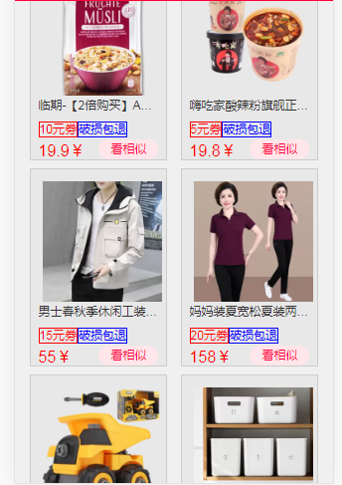

代码如下：<template>

<div class="link">

<div class="linkTitle">

<span>{{listTitle}}</span>

</div>

<ul class="link-list">

<li v-for="item of linkList" :key="item.id">

<ul>

<div class="info-wrap">

<img :src="item.url">

<br>

<span data-title="title">{{item.title}}</span>

<br>

<label for="#">{{item.coupon}}</label>

<label for="#">{{item.retreat}}</label>

<br>

<i>{{item.money}}</i>

<i>{{item.beSimilar}}</i>

</div>

</ul>

</li>

</ul>

</div>

</template>

<script>

export default {

name: "link",

data () {

return {

linkList:[],

listTitle:null

}

},

mounted () {

this.getLinkInfo()

},

methods: {

getLinkInfo () {

this.axios.get('http://localhost:8080/js/data.json').then((res)=>{

var res = res.data;

if(res.msg === "ok"){

this.linkList = res.likeData

this.listTitle = res.linkTitle.title

}

})

}

}

}

</script>

<style lang="stylus" scoped>

.link

width 100%

box-sizing border-box

padding .2rem

.linkTitle

span

display block

width 100%

height .6rem

font-weight bold

font-size .38rem

.link-list

display flex

flex-wrap wrap

justify-content space-around

width 100%

li

width 45%

background-color rgba(0, 0, 0, 0.03)

border 1px solid #ccc

margin-bottom .2rem

.info-wrap

box-sizing border-box

padding .2rem

[data-title=title]

display block

overflow hidden

text-overflow ellipsis

white-space nowrap

-webkit-line-clamp 2

label

border 1px solid blue

color blue

label:nth-of-type(odd)

border 1px solid red

color red

i

display block

i:nth-of-type(1)

margin-top .2rem

font-size .4rem

color red

float left

i:nth-of-type(2)

margin-top .1rem

width 1.5rem

height .5rem

line-height .5rem

text-align center

float right

border-radius 1rem

background-color rgb(255, 230, 235)

color rgb(255, 0, 54)

img

margin .1rem

width 100%

</style>

#### 登录signin

2.1用户登录

**Tips**：仿数据库验证跳转功能

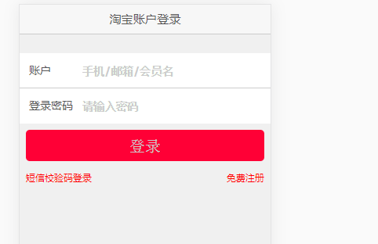

代码如下：<template>

<div class="user-signin">

<header>淘宝账户登录</header>

<section>

<form action="#" method="post">

<div class="user">

<label for="#">账户</label>

<input v-model="userVal" required style="border-bottom:.1px solid #ccc" :type="userType" name="user" placeholder="手机/邮箱/会员名">

</div>

<div class="pasw">

<label for="#">登录密码</label>

<input v-model="paswVal" title="请输入首3位字母和4位或7位数字" :pattern="patternPasw" required type="passwold" name="user-pswd" placeholder="请输入密码首3位字母和4位或7位数字">

</div>

<router-link tag="div" :to="to">

<input

type="submit"

value="登录"

class="submit"

@click="handleSuccess">

</router-link>

<br>

<a href="javascript:;">短信校验码登录</a>

<a href="javascript:;">免费注册</a>

</form>

</section>

</div>

</template>

<script>

export default {

name: "UserSignin",

data () {

return {

userType:"email",

patternPasw:"[A-z]{3}[0-9]{4,7}",

userVal:"",

paswVal:"",

userIf:false, //逆向思维设置双开关

paswIf:false,

to:"",

}

},

methods: {

handleSuccess(){

return this.to = (this.userIf && this.paswIf) ? "/index/signin/user-target" : ""

}

},

watch: {

userVal(val){

if(val.indexOf('@') == -1){ //模拟数据库检索字符

this.userIf = false

}else{

this.userIf = true

}

console.log(val)

},

paswVal(val){

console.log(val.length)

return this.paswIf = (val.length == 7 || val.length == 10) ? true : false

}

}

}

</script>

<style lang="stylus" scoped>

.user-signin

width 100%

height 100%

background-color #F0F0F0

color #555

header

width 100%

line-height .95rem

text-align center

font-size .38rem

background-color #f7f7f7

border-bottom .1px solid #ccc

section

margin-top .6rem

.user,.pasw

position relative

width 100%

height 1.125rem

label

position absolute

top 0

left 0

width 1.5rem

height 100%

line-height 1.125rem

margin-left .3rem

font-size .35rem

input

display inline-block

box-sizing border-box

padding-left 2rem

width 100%

height inherit

input::placeholder

font-size .35rem

color #ccc

font-weight bold

[type=submit]

width 95%

height 1rem

line-height 1rem

margin .2rem

color #ccc

background-color #ff0036

font-size .5rem

border-radius 5px

a:nth-of-type(1)

display inline-block

margin .2rem

a:nth-of-type(2)

float right

margin .2rem

a

color red

</style>

#### 个人用户targetUser

3.1跳转成功后界面组件的实现

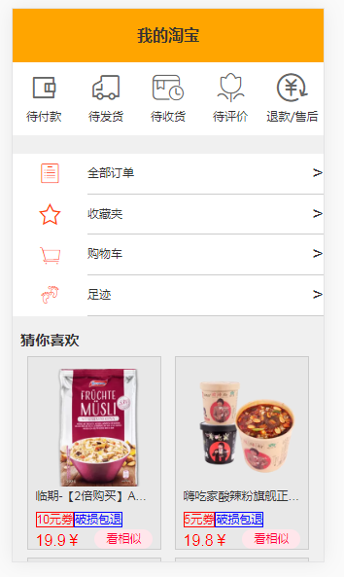

总组件代码：<template>

<div class="goodsList">

<ul class="goods-wrap">

<li class="iconfont">

<span class="icon-daifukuan my"></span>

<br>

<span class="title">待付款</span>

</li>

<li class="iconfont">

<span class="icon-daifahuo my"></span>

<br>

<span class="title">待发货</span>

</li>

<li class="iconfont">

<span class="icon-tubiaolunkuo- my"></span>

<br>

<span class="title">待收货</span>

</li>

<li class="iconfont">

<span class="icon-daipingjia my"></span>

<br>

<span class="title">待评价</span>

</li>

<li class="iconfont">

<span class="icon-icon5 my"></span>

<br>

<span class="title">退款/售后</span>

</li>

</ul>

</div>

</template>

<script>

export default {

name: "goodsList"

}

</script>

<style lang="stylus" scoped>

.goodsList

width 100%

height 1.875rem

margin-bottom 6%

.goods-wrap

display flex

justify-content space-around

box-sizing border-box

padding-top 3%

width 100%

height 1.875rem

background-color white

li

width 25%

height 100%

.my

display block

font-size .8rem

width 100%

text-align center

color #666

.title

display block

text-align center

margin-top -.2rem

font-size .2rem

</style>

3.2代码如下：

<template>

<div class="order">

<ul class="order">

<li v-for="item of orderList" :key="item.id" class="order-wrap">

<i :class="item.icon"></i>

<label for="#">{{item.msg}}</label>

<em>&gt;</em>

</li>

</ul>

</div>

</template>

<script>

export default {

name: "order",

data () {

return {

orderList:[]

}

},

mounted () {

this.getOrderInfo()

},

methods: {

getOrderInfo () {

this.axios.get('http://localhost:8080/js/data.json').then((res)=>{

var res = res.data;

if(res.msg === "ok"){

this.orderList = res.orderData

}

})

}

}

}

</script>

<style lang="stylus" scoped>

.order

width 100%

height 4rem

margin-bottom 5%

.order-wrap

display flex

width 100%

line-height 1rem

height 0

padding-bottom 13%

background-color white

i

flex 1

font-size .6rem

height 1rem

line-height 1rem

text-align center

display block

border-bottom 1px solid white

color orangered

label

flex 3

height 1.04rem

border-bottom .1px solid #ccc

em

height 1.04rem

border-bottom .1px solid #ccc

font-size .5rem

</style>

3.3代码如下：

<template>

<div class="target">

<header class="my-header">我的淘宝</header>

</div>

</template>

<script>

export default {

name: "Target"

}

</script>

<style lang="stylus" scoped>

.target

width 100%

height 1.375rem

.my-header

width 100%

line-height 1.375rem

font-size .4rem

text-align center

font-weight bold

background-color orange

</style>