MSBD6000B Project 3, Option 2:

Patch-based Convolutional Neural Network for Cancer Images Classification

**ABSTRACT**

In this report, we develop deep networking based on Convolutional Neural Network (CNN). Compared to traditional CNN directly for image-based label prediction, our method is to use a 2-level model, which utilizes CNN combined with Expectation-Maximization (EM) for patch-based label prediction, and then develop the second-level model to predict image-based labels using patch-based labels as input.

# INTRODUCTION

## Project Background

Breast cancer is the most common cancer in women worldwide. X-ray images are commonly used to help detect the cancer. Typically, the medical images are of much higher resolution than normal images. In this project, the image resolution is around 3328 x 4084. Applying CNN directly to the original high-resolution image is undesirable for 2 reasons. First, the downsampling required by CNN will lose discriminative information, while those cellular and sub-cellular level details are critical for detection in practice. Second, the CNN might only learn from one of the multiple discriminative patterns in a single image, which is not efficient in using data.

## Objective

The objective is to implement a model to detect if an X-ray image contains cancer tissue.

# DESIGN AND IMPLEMENTATION

## Overview of solution

The key idea [1] is to select representative parts of the image, and learn their patterns and train a classifier to predict image label based on sub-image level patterns.

Before training, we preprocess the images by dividing them into smaller patches and remove patches are all dark. Then we initialize the labels of all patches as the same as the image. We understand that for cancer x-ray, only a portion of the image contains abnormal symptom while the rest may show as usual. For those without cancer, all the patches should be label as 0. In other words, for x-ray photo that is label without cancer, it is fine for all its patch to label as 0. X = {X1,X2,X3…X90}, all label as 0. For those with cancer, X = {X1, X2,X3…X90}, and most likely some Xi is 1 while most of them could still be 0. Therefore, our first step after patching the image should try to find out which Xi in cancer image that should label as 1.

We try to use use Expectation-Maximization (EM) to the patches to identify which patch in cancer ray should label as 1. Initially, for expectation stage, all image label that label as 0 (non-cancer), all its patches would label as 0. All image label as 1 (cancer), all its patches would label as 1. This would feed into CNN model to train it and then use the model to evaluate the likelihood of Xi should belong to 1 or not. In maximization stage, we drop out those image with lowest likelihood Xi is 1 while its label is 1. Then repeat the Expectation stage. This process will be repeated for N times (30 for our training). The result of each non cancer patch is unchanged {X1,X2,…X90} while the result of each cancer patch would drop to {X1,X2,X3}

Then, all this patch of image feed into another CNN model and train it for N rounds. Note that as cancer patch is far less than non-cancer patches after the dropping in EM stage, we do up-sample a little bit (3 times) to balance the data before train up the level-2 CNN.

In the testing stage, an input image X will use same preprocessing method and divide into patch {X1,X2,X3…X90}. All the patches are then fit into our level-2 CNN and collect the predicted label for each patch on this image. Finally, if any patch from this image is positive, then the image will have label 1. In other words, if none of the patch have label 0, this image will label as 0

The overviews for training and testing are shown in figure 1 and 2.

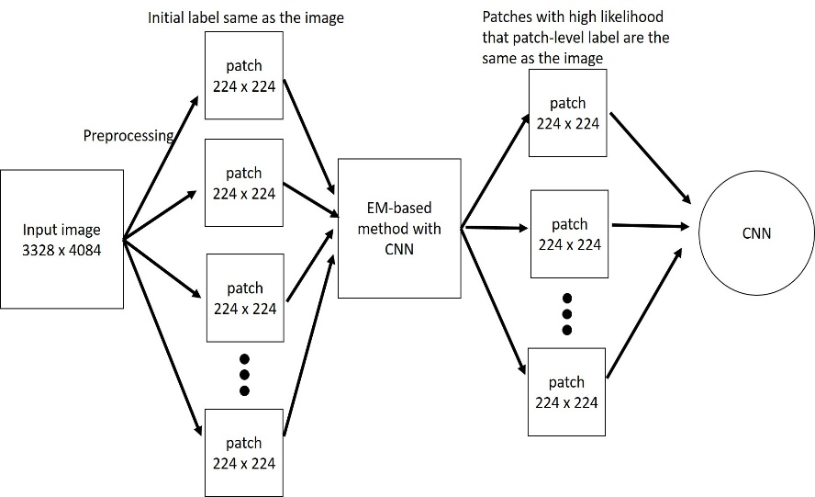

(Figure 1. Overview of the training flow)

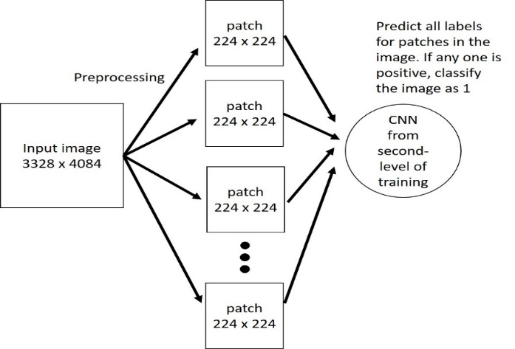

(Figure 2. Overview of the testing flow)

## Description of implementation

Maybe add some images in this session

Main Steps:

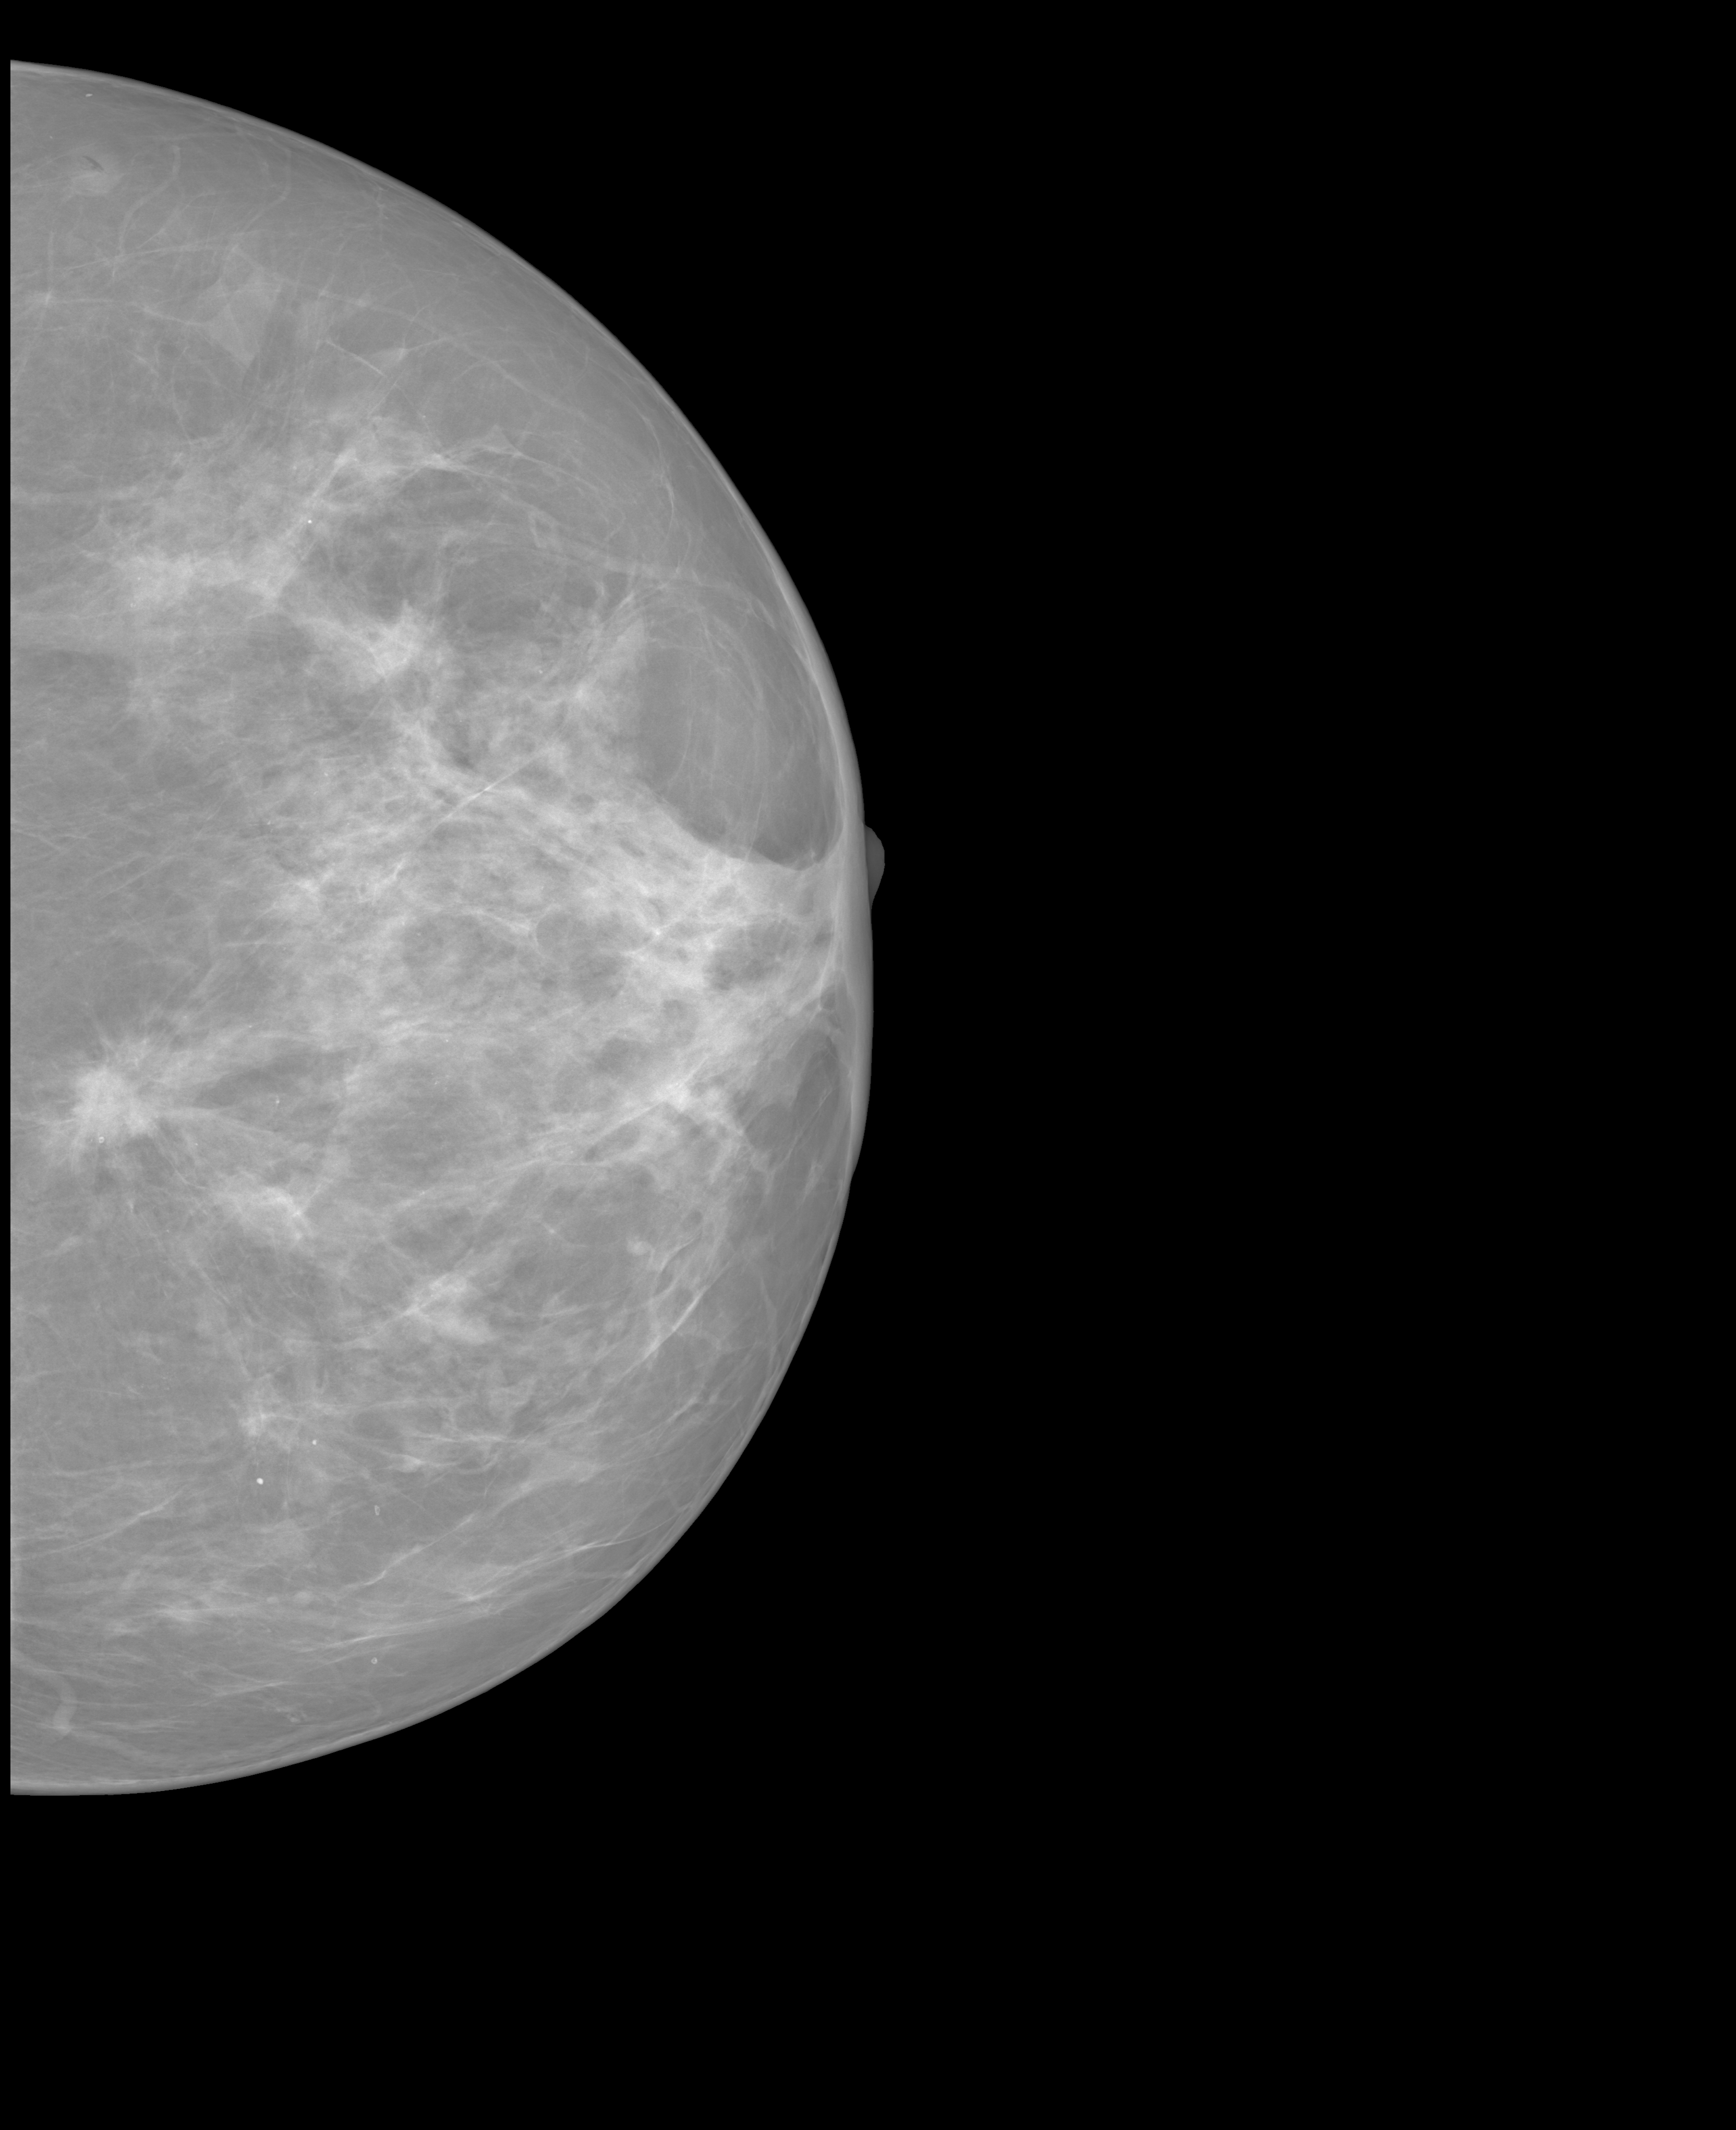 ->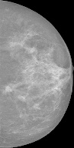 ->

->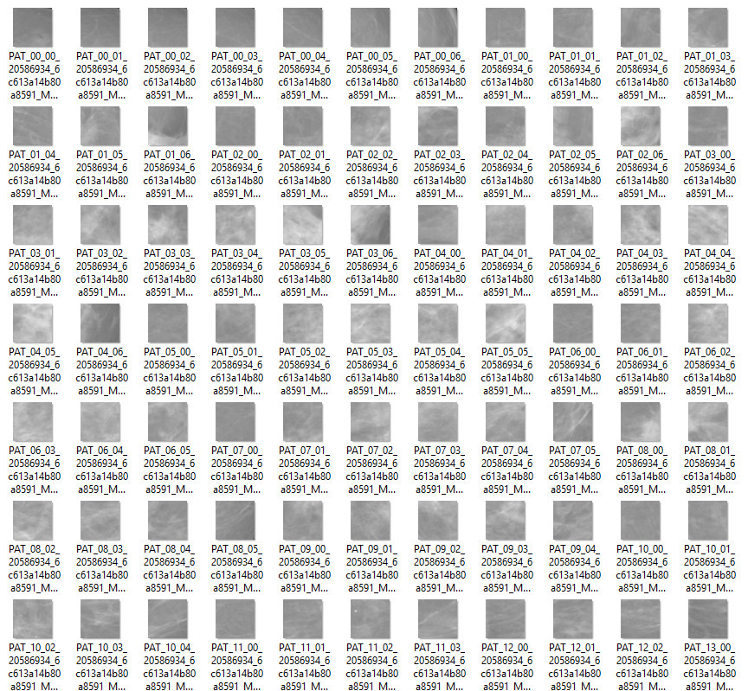

### Preprocessing:

Function: imagePreprocessing

cutDark: Cut the dark border for each imagesplitImage: Split the image into small image with size 224 x 224

initEMPercentage: Assign initial label to patches

suffleFile: don’t know what it does

### EM with CNN:

Function: EMLoop

E step: EMTrain: train a CNN (pretrained model: MobileNet) to estimate the likelihood on whether a patch is discriminative given the image as a distribution

M step: drop the patch with the least likelihood

### Level-2 CNN:

Function: TrainModel

Train a model based on pretrained MobileNet to learn patterns of the discriminative patches.

### Prediction:

Function: TestModel

Pass the image through preprocessing and level-2 CNN. Give output image label 1 if any patch-level label 1 is found, otherwise output image label 0.

# EVALUATION

## Performance metrics

Validation accuracy, confusion matix…

## Experimental result

Add something if necessary

# REFERENCES

1. L. Hou, D. Samaras, T. M. Kurc, Y. Gao, J. E. Davis and J. H. Saltz, "Patch-Based Convolutional Neural Network for Whole Slide Tissue Image Classification," *2016 IEEE* Conferenceon Computer Vision and PatternRecognition(CVPR), Las Vegas, NV, 2016, pp.2424-2433. doi:10.1109/CVPR.2016.266 URL: <http://ieeexplore.ieee.org/stamp/stamp.jsp?tp=&arnumber=7780635&isnumber=7780329>