Kusina

* Home
* [About](http://docs.google.com/html%20project/About.html)
* [Specialities](http://docs.google.com/html%20project/specialties.html)
* [Reservations](http://docs.google.com/html%20project/reservations.html)
* [Stories](http://docs.google.com/html%20project/stories.html)
* [Contact](http://docs.google.com/html%20project/contact.html)

MENU

We Love

Delicious Food

A small river named Duden flows by their place and supplies it with

the necessary regelialia. It is a paradisematic country.

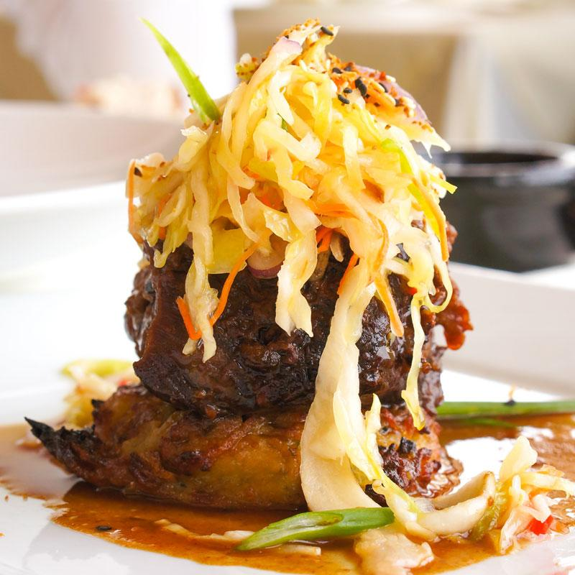 Australian Organic

Beef

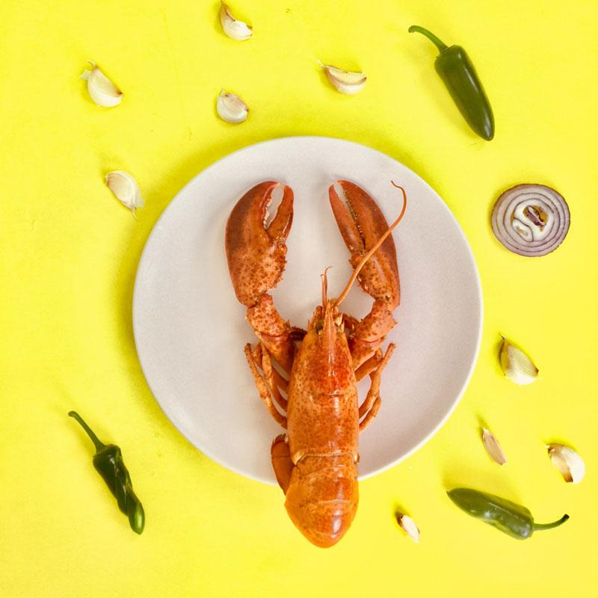 Australian Organic

Beef

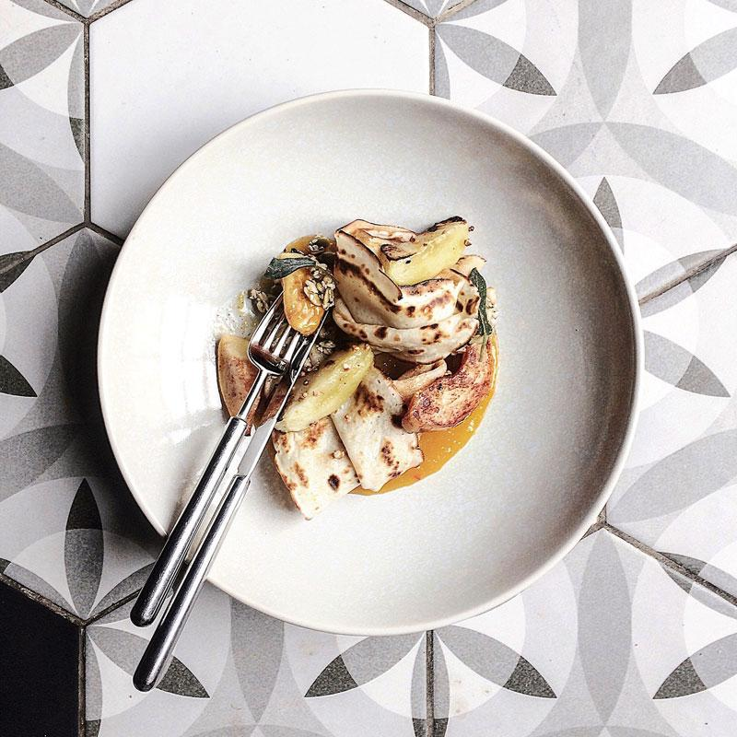 Australian Organic

Beef

Book A Table

## About

Welcome to Kusina Restaurant

On her way she met a copy. The copy warned the Little Blind Text, that where it came from it would have been rewritten a thousand times and everything that was left from its origin would be the word "and" and the Little Blind Text should turn around and return to its own, safe country. A small river named Duden flows by their place and supplies it with the necessary regelialia. It is a paradisematic country, in which roasted parts of sentences fly into your mouth.

### Special Recipe

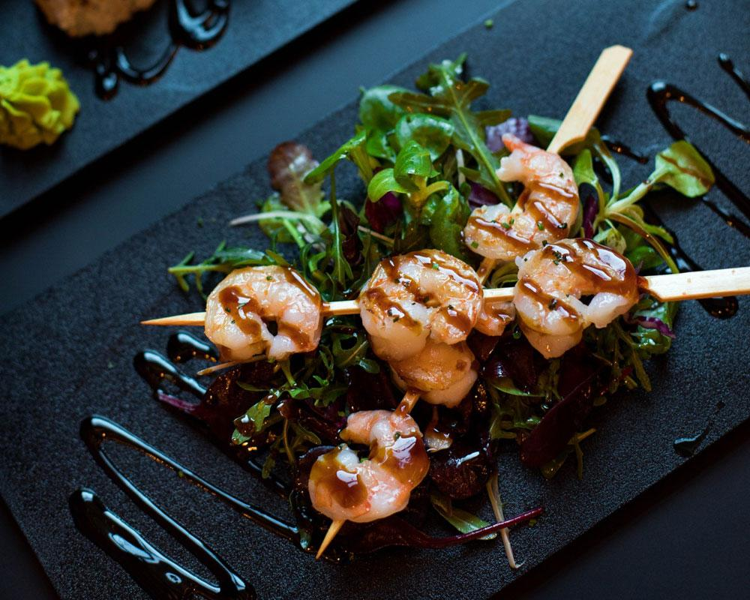 Australian Organic Beef

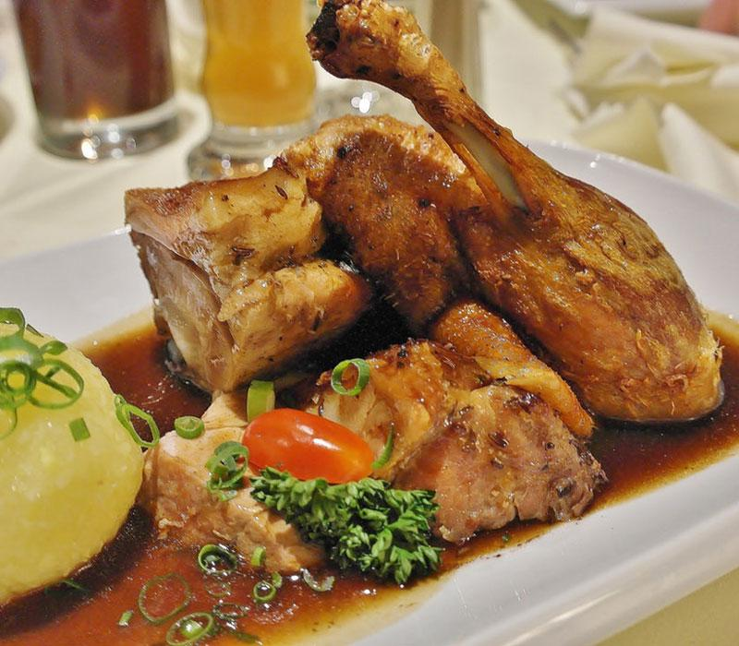 Australian Organic Beef

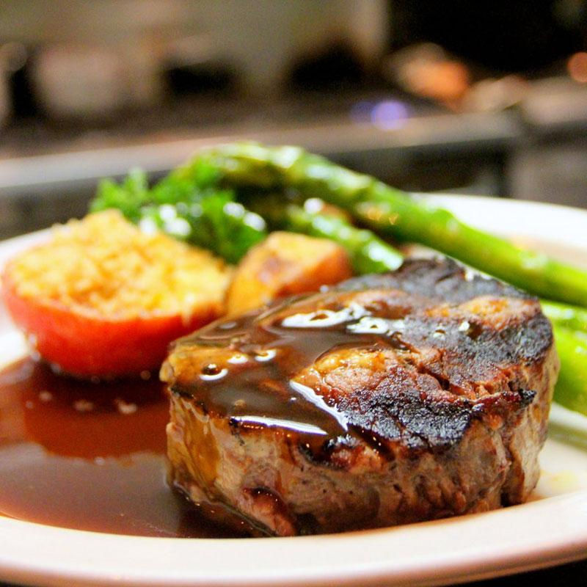 Australian Organic Beef

18

Years of Experienced

20,000

Happy Customers

564

Finished Projects

300

Working Days

Specialities

# Our Menu

Break fast

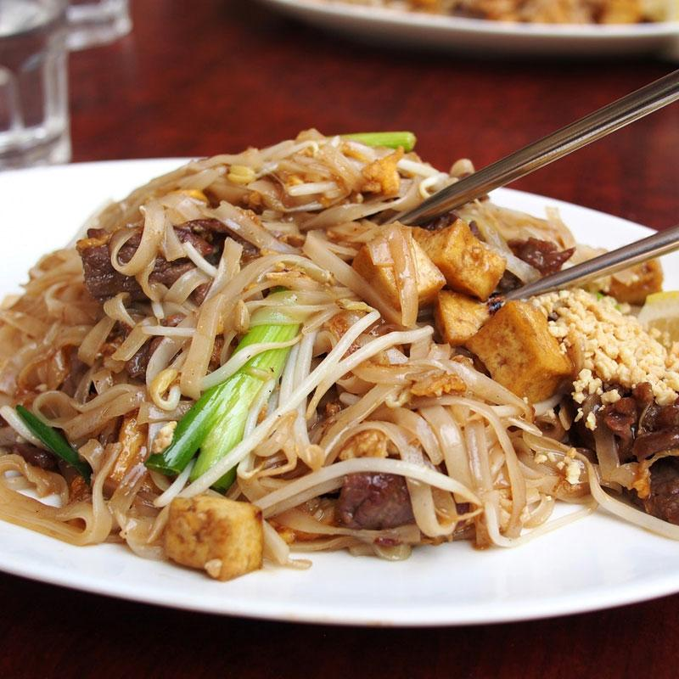

Grilled Beef with Potatoes

## 29$

Meat,Potatoes, Rice,Tomatoes

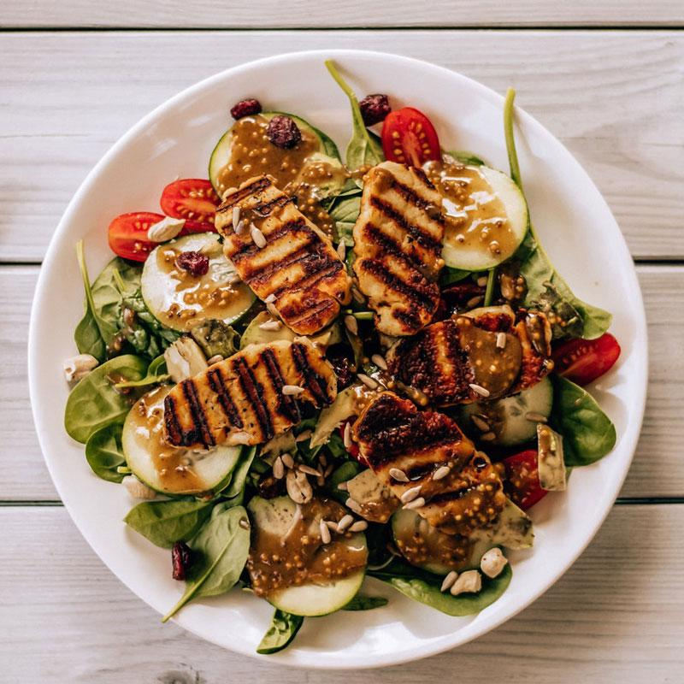

Grilled Crab with Onion

## 29$

Meat,Potatoes, Rice,Tomatoes



Grilled Crab with Onion

## 29$

Meat,Potatoes, Rice,Tomatoes

Luch

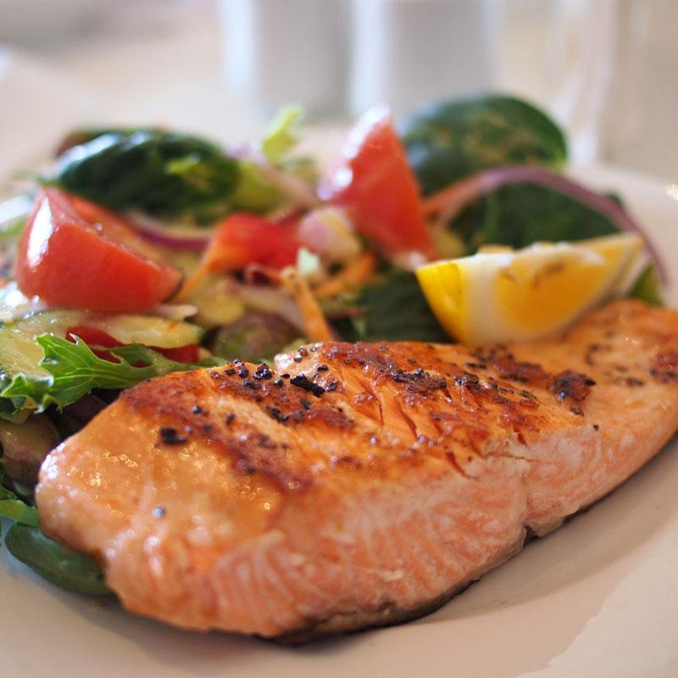

Grilled Beef with Potatoes

## 29$

Meat,Potatoes, Rice,Tomatoes

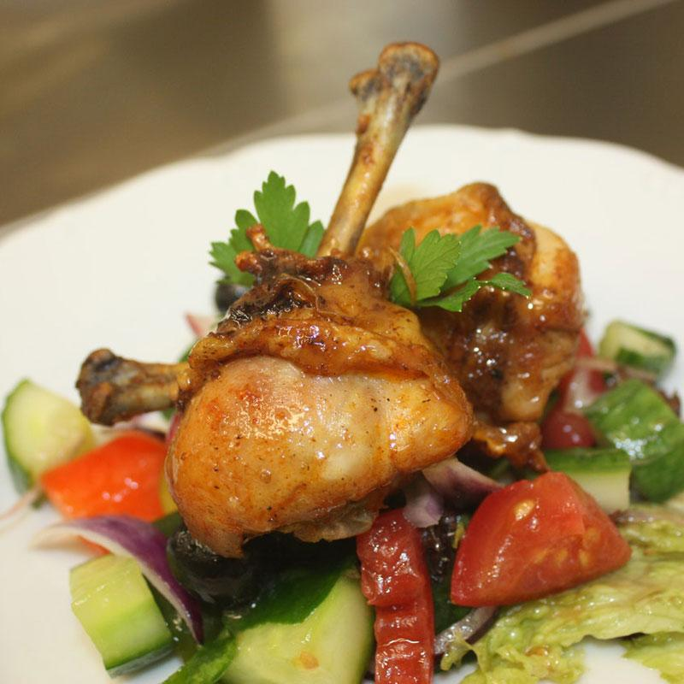

Grilled Crab with Onion

## 29$

Meat,Potatoes, Rice,Tomatoes

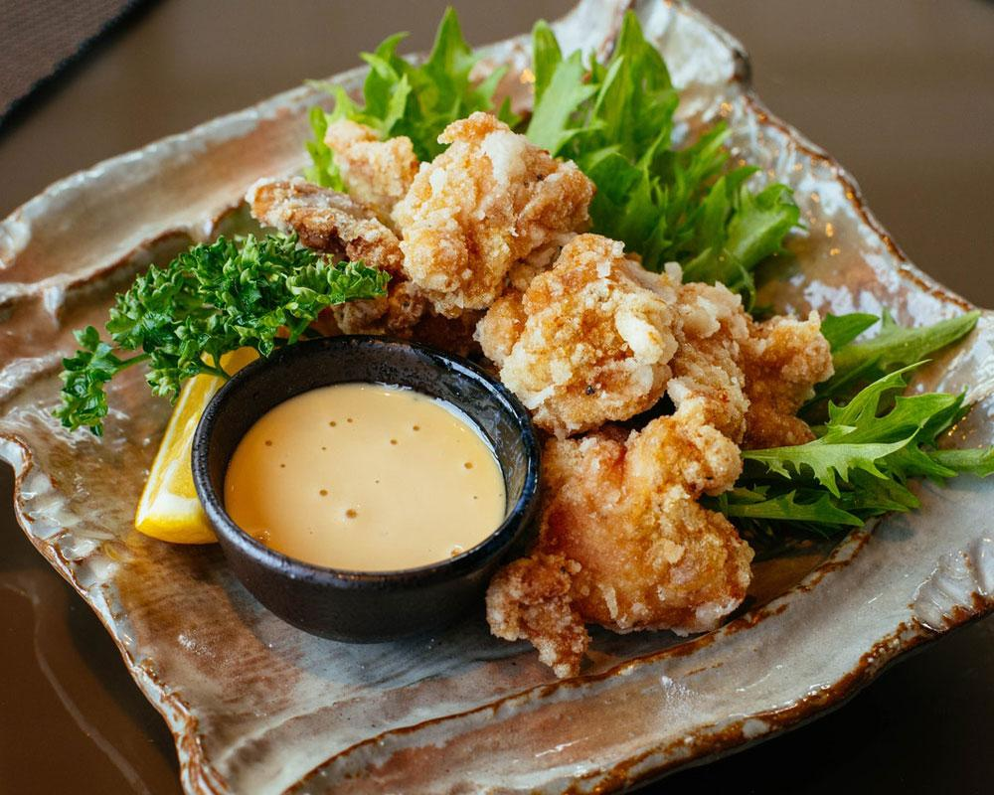

Grilled Crab with Onions

## 29$

Meat,Potatoes, Rice,Tomatoes

Dinner

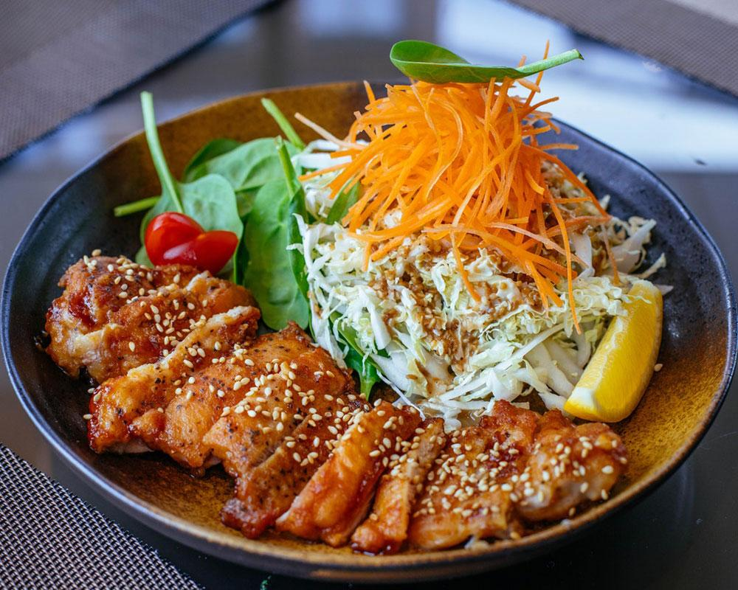

Grilled Beef with Potatoes

## 29$

Meat,Potatoes, Rice,Tomatoes

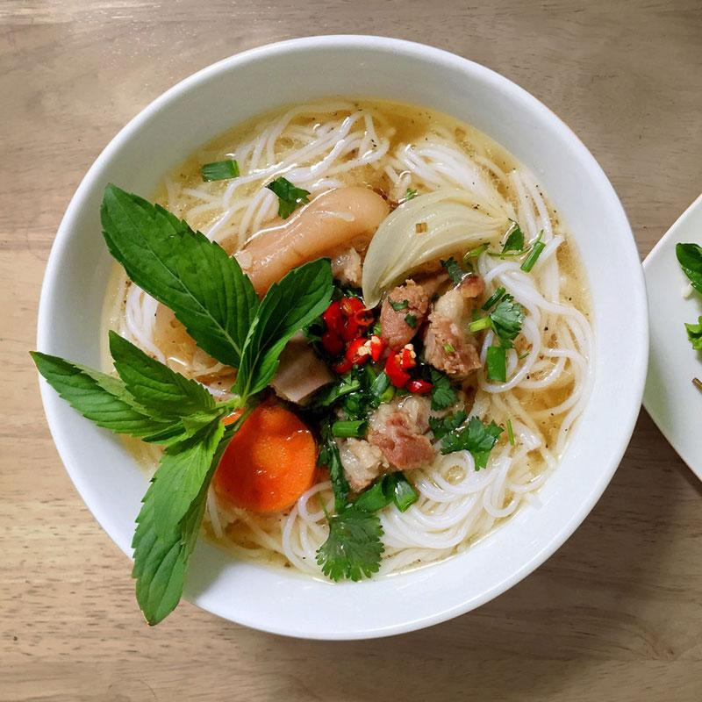

Grilled Crab with Onions

## 29$

Meat,Potatoes, Rice,Tomatoes

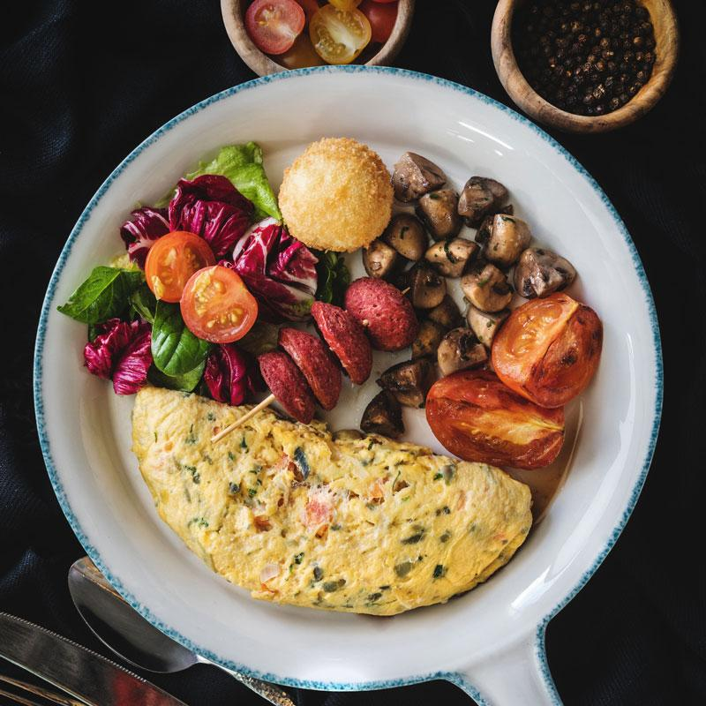

Grilled Crab with Onions

## 29$

Meat,Potatoes, Rice,Tomatoes

Desert

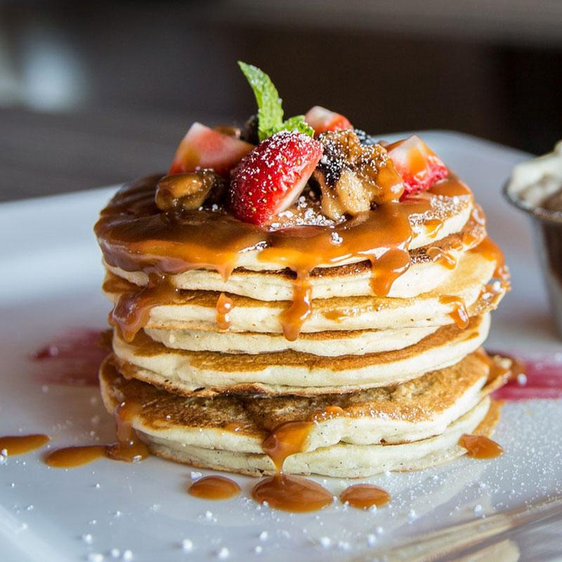

Grilled Beef with Potatoes

## 29$

Meat,Potatoes, Rice,Tomatoes

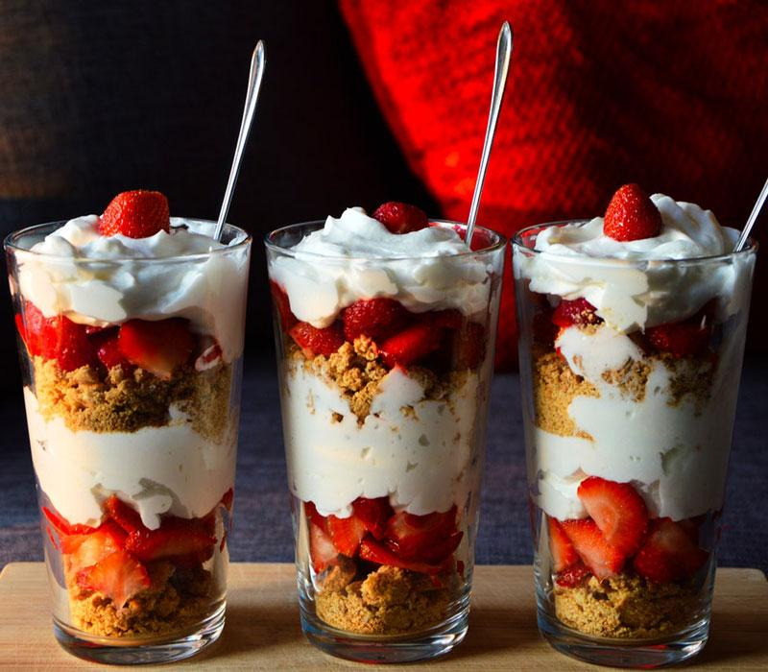

Grilled Crab with Onions

## 29$

Meat,Potatoes, Rice,Tomatoes

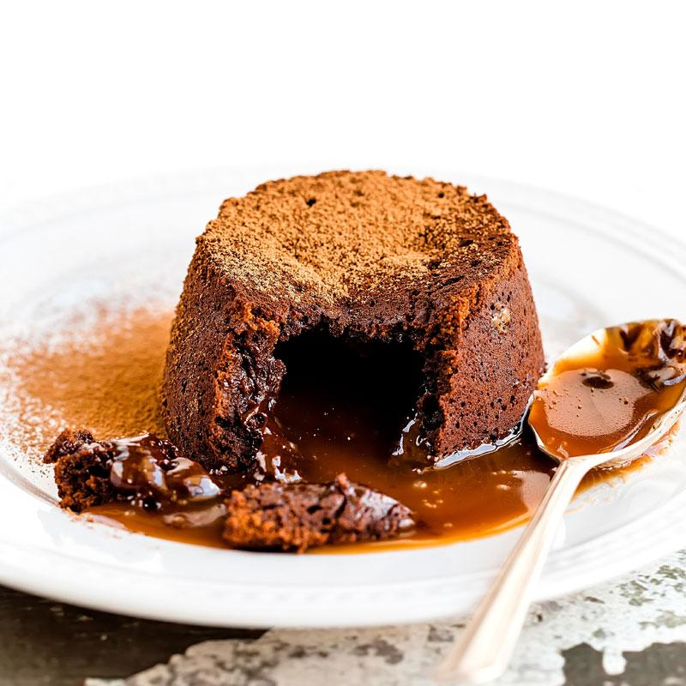

Grilled Crab with Onions

## 29$

Meat,Potatoes, Rice,Tomatoes

Wine Card

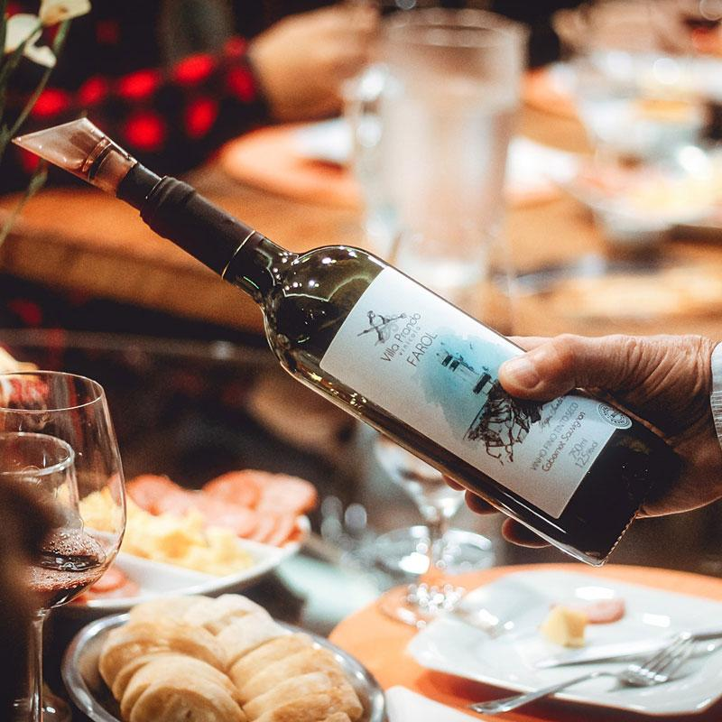

Grilled Beef with Potatoes

## 29$

Meat,Potatoes, Rice,Tomatoes

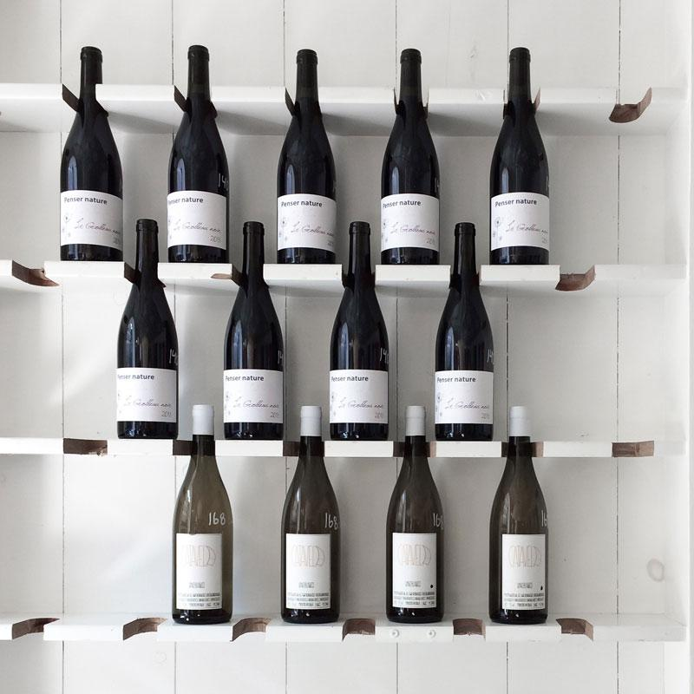

Grilled Crab with Onions

## 29$

Meat,Potatoes, Rice,Tomatoes

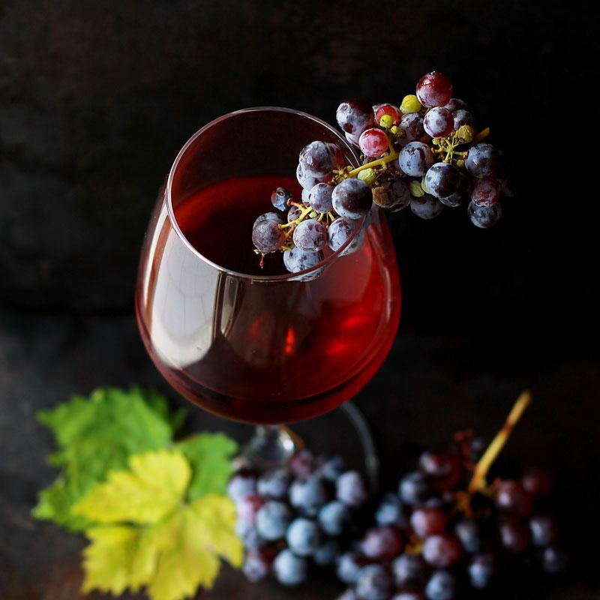

Grilled Crab with Onions

## 29$

Meat,Potatoes, Rice,Tomatoes

Drinks



Grilled Beef with Potatoes

## 29$

Meat,Potatoes, Rice,Tomatoes



Grilled Crab with Onions

## 29$

Meat,Potatoes, Rice,Tomatoes



Grilled Crab with Onions

## 29$

Meat,Potatoes, Rice,Tomatoes

VIew All Menu

Testimony

# Happy Customers



Far far away, behind the word mountains, far from the countries Vokalia and Consonantia, there live the blind texts.

### Arthur Browner

Customer

Chef

# Our Master chef



John Smooth

CEO, Co Founder



Rebeca Welson

Head Chef



Kharl Branyt

Chief



Luke Simon

Chief



Book a Table

# Make Reservations

Name

Email

Phone

Date

Phone

Person

Person 1 2 3 4+

Make a Reservation

Kusina

Far far away, behind the word mountains, far from the countries Vokalia and Consonantia, there live the blind texts.

Our Timing

* Monday
* Tuesday
* Wednesday
* Thursday
* Friday
* Saturday
* Saturday
* 9:00 - 24:00
* 9:00 - 24:00
* 9:00 - 24:00
* 9:00 - 24:00
* 9:00 - 02:00
* 9:00 - 02:00
* Closed

News Letters

Far far away, behind the word mountains, far from the countries.

Subscribe

Instagram

 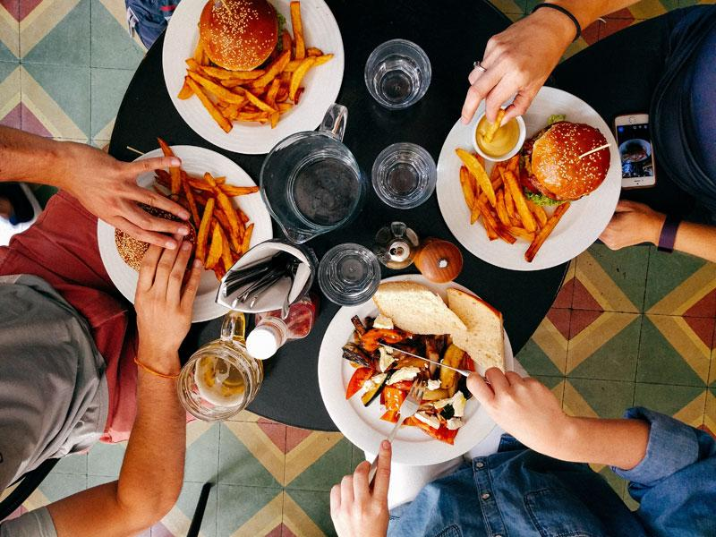 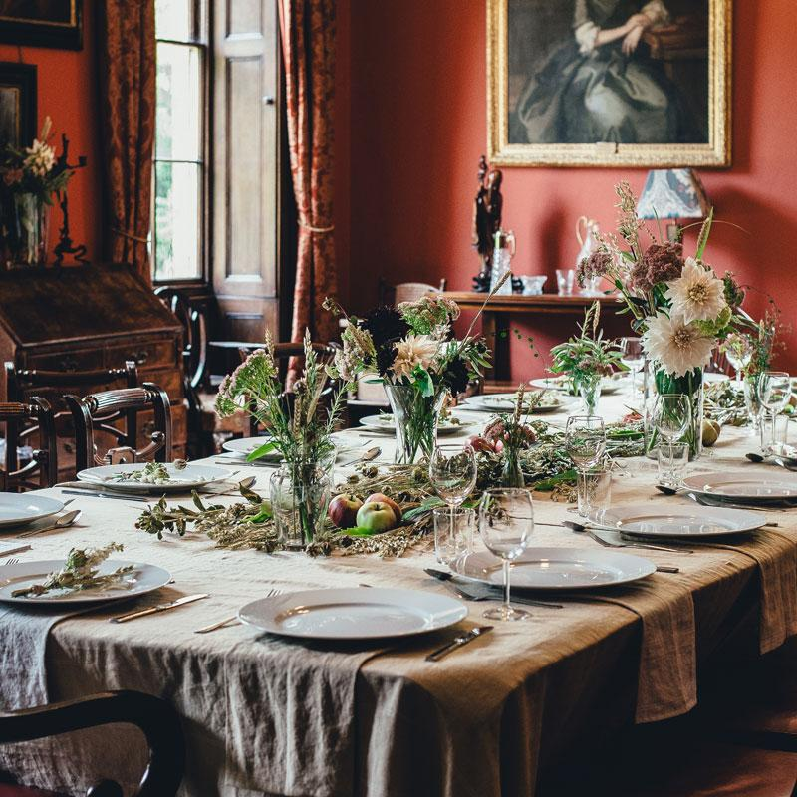  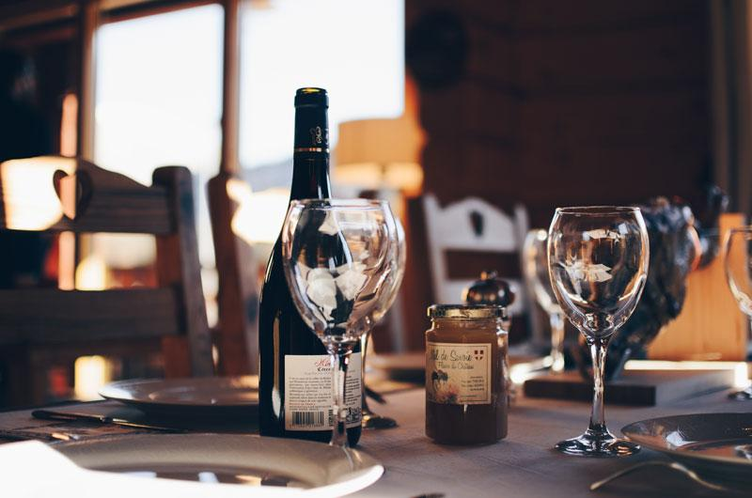 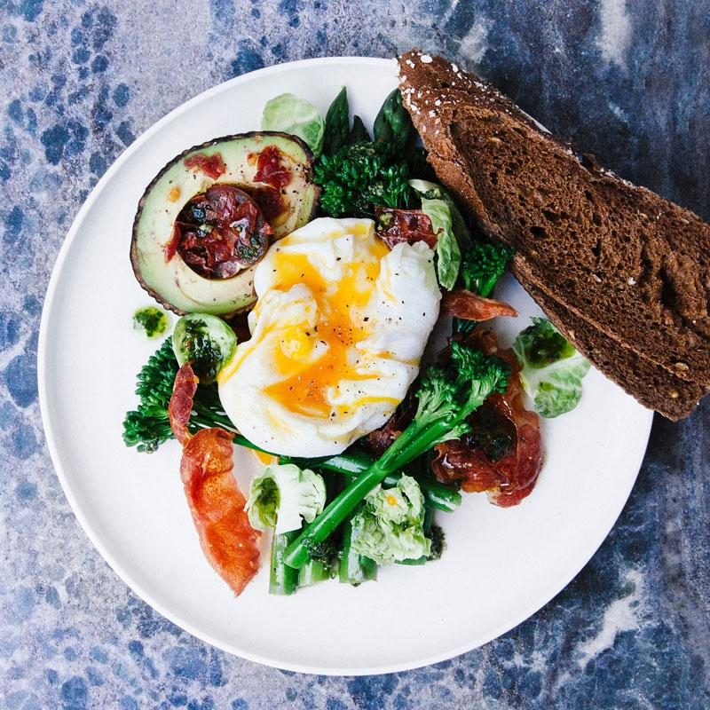

Copyright ©2022 All rights reserved | This template is made with by Colorlib