Draft as of 9 October 2026
SIDEX-ACDR 2026
Disaster Resilient Futures: Leadership, Solidarity, Preparedness

Asian Conference on Disaster Reduction 2026 (ACDR2026)
Future-Proofing Transboundary Climate and Disaster Risk Reduction through Advanced Technologies for a Resilient Society

27-30 October 2026
Singapore

Day 0: Tuesday, 27 October 2026
19:00-21:00 | SJ60 Commemorative Reception with SIDEX-ACDR2026  Venue: Residence of the Ambassador of Japan to Singapore

Day 1: Wednesday, 28 October 2026
10:00-10:30 | Joint Opening Ceremony  - GOH: Ms Sim Ann, Second Minister for Foreign Affairs and Second Minister for Home Affairs, Singapore (tbc)  - Mr HAYASHI Masamichi, Deputy Minister for Disaster Management, Cabinet Office of Japan (COJ)  - Mr Markham Shaw, Chairman of National Fire and Emergency Preparedness Council (NFEC), Singapore (tbc)  Venue: Hall 3, Singapore EXPO
10:30-11:45 | VIP Tour for Observing Singapore EXPO (including the Japan Pavilion) | Visit to the Japan Pavilion and the SIDEX Exhibition (guided by ADRC; Japanese exhibitors will welcome ACDR participants)  Venue: Hall 3, Singapore EXPO
11:45-12:45 | Lunch Break  Venue: Hall 3
12:45-13:00 | ACDR2026 Opening  - Mr Eric Yap Wee Teck, Commissioner, Singapore Civil Defence Force (SCDF)  - Mr HAYASHI Masamichi, Deputy Minister for Disaster Management, Cabinet Office of Japan (COJ)  - Prof. MIURA Fusanori, Chairman of Asian Disaster Reduction Center (ADRC)  Group Photo on stage (13:00-13:05) / Venue: Peridot 204-206
13:05-15:00 | Roundtable Session (Part 1): Progress and Remaining Challenges in Implementing SFDRR 2015-2030  Venue: Peridot 204-206  Moderator: Singapore SCDF
15:00-15:15 | Coffee Break  Venue: in front of Peridot 204-206
15:15-16:15 | Steering Committee Meeting (ADRC member countries only)
18:30-21:00 | SIDEX Gala Dinner *Depart from Dorsett Changi City Hotel at 17:30  Venue: Grand Ballroom, Orchard Hotel  *For ADRC member/advisor country participants and resource persons only

Day 2: Thursday 29 October 2026
09:00-09:30 | Roundtable Session (Part 2): Progress and Remaining Challenges in Implementing SFDRR 2015-2030  Venue: Peridot 204-206  Moderator: Singapore SCDF
09:30-11:30 | Technical Session: DRR DX for Isolated and Inaccessible Regions: Redefining Community Resilience through Advanced Technologies  Venue: Peridot 204-206  Moderator: Singapore SCDF  Co-Chair: ADRC
11:30-11:45 | Coffee Break  Venue: In front of Peridot 204-206
11:45-12:00 | ACDR 2026 Summary and Closing Remarks  Venue: Peridot 204-206
12:00-13:00 | Lunch Break  Venue: Hall 3
13:00-16:15 | Field Trip: Civil Defence Academy (CDA) *Depart from SG EXPO after Lunch  (For ADRC member country participants, resource persons and other invited participants only) *prior registration required
18:00-20:05  20:05-21:30 | SCDF Parade  Venue: Hall 4  SCDF Parade Dinner Reception  Venue: Garnet Room  (For ADRC member country participants, resource persons and other invited participants only)

Day 3: Friday, 30 October 2026
09:00-12:00 | SIDEX-ACDR 2026 Keynote Address: Forging Collective Readiness; Commanding Solidarity, and Leadership in Disaster and Emergency Management  SIDEX-ACDR 2026 Panel 1: Unity in Disaster Management - Cultivating Shared Responsibility  Venue: Hall 3
12:00-13:45 | Lunch Break  Venue: Hall 3
13:50-14:50 | Exhibition Tour
15:00-16:30 | SIDEX-ACDR 2026 Panel 2: Future-Ready Emergency Management - Strengthening Effective Crisis Planning, Risk Reduction, Response and Recovery  Venue: Hall 3
16:30-16:50 | Closing Ceremony

Reference: Preliminary overview of the SIDEX-ACDR 2026 and FiSAC 2026 programmes
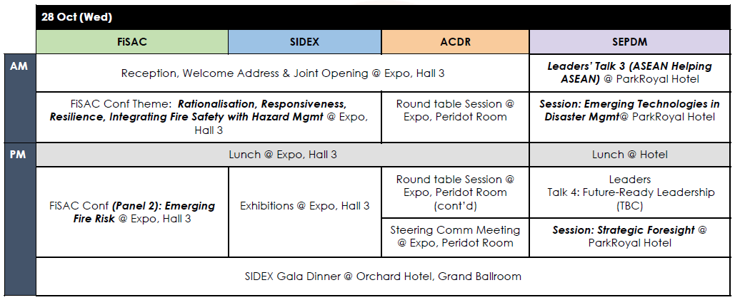


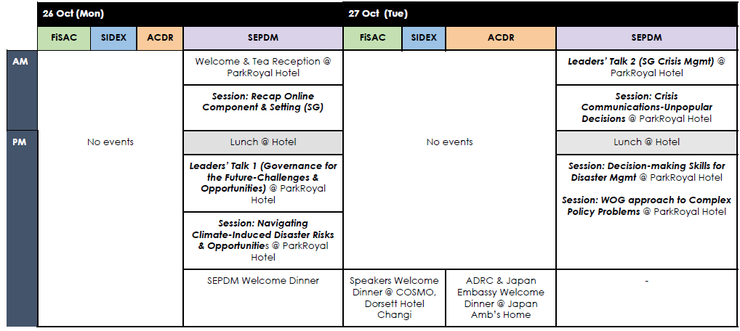
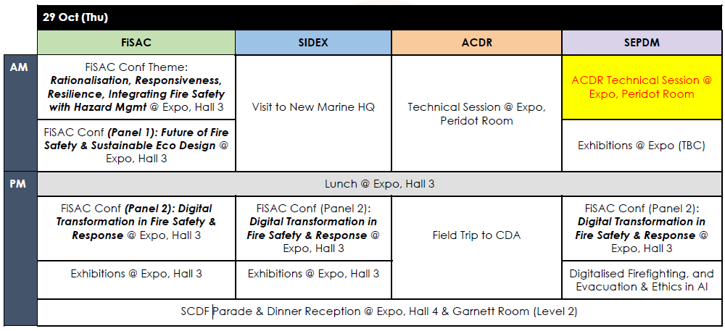
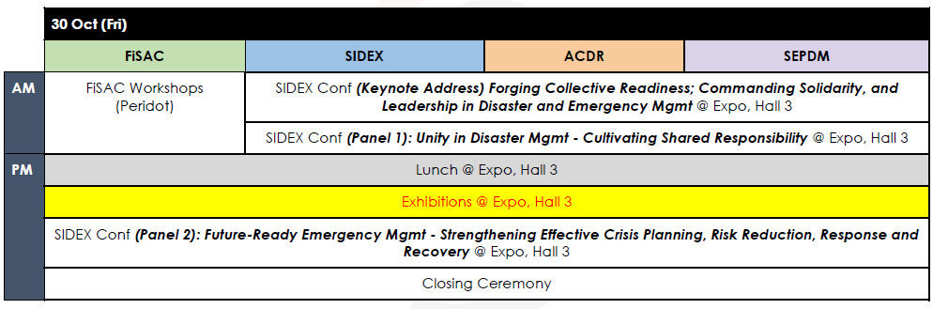

Date: 28 Oct 2026 (Day 1), Wednesday
Venue: Grand Ballroom, Orchard Hotel Singapore
