GENERAL INFORMATION
Logistic Information for Participants from ADRC Member Countries

Conference Schedule and Events

Asian Conference on Disaster Reduction 2026 (ACDR2026) will be held in Singapore together with the Singapore-International Disaster & Emergency Management Expo (SIDEX) as SIDEX-ACDR2026, and in conjunction with the Fire Safety Asia Conference (FiSAC) 2026.
- Asian Conference on Disaster Reduction 2026 (ACDR2026) sessions
Date: 28–29 October 2026
Venue: Peridot Room, Singapore EXPO
1 Expo Dr, Singapore 486150
https://www.singaporeexpo.com.sg/

- ADRC Steering Committee Meeting
Date: 28 October 2026
Time: 15:15–16:15
Venue: Same venue as the conference
* An AI-based translation tool will be introduced on a trial basis during the ACDR sessions and ADRC Steering Committee to support communication and accessibility for participants.

- SJ60 Commemorative Dinner
Date: 27 October 2026
Time: 19:00–21:00
Venue: The residence of the Japanese Ambassador to Singapore
- Joint Opening Ceremony
Date: 28 October 2026
Time: 10:00–10:30
Venue: Hall 3, Singapore EXPO

- SIDEX Gala Dinner
Date: 28 October 2026
Time: 18:30–21:00
Venue: Grand Ballroom, Orchard Hotel

- Field Trip
Date: 29 October 2026
Time: 13:00–16:15
Places to visit: Civil Defence Academy (CDA)

- SCDF Parade and Dinner Reception
Date: 29 October 2026
Time: 18:00–20:05, Dinner 20:05–21:30
Venue: Hall 4, Singapore EXPO/ Garnet Room

- SIDEX2026 Conference
Date: 30 October 2026
Venue: Hall 3, Singapore EXPO

- Closing Ceremony?

Accommodation
Dorsett Changi City Singapore
3 Changi Business Park Central 1, Singapore 486037
Website:
NOTE: Personal expenses such as phone calls, laundry service, minibar, and/or extension of stay are NOT covered by the Secretariat.

3. Transportation
- Transportation from airport to Dorsett Changi City Singapore
Staff members will be waiting for participants at the airport arrival area, holding a sign like the one shown below:

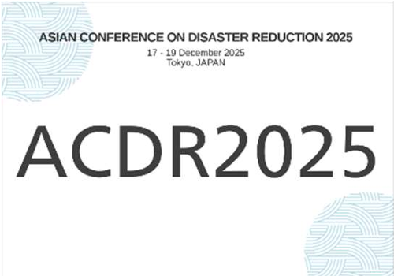
COSEM will arrange bus transportation from the airport to Dorsett Changi City Singapore.

- Transportation between Dorsett Changi City Singapore and Expo
Singapore EXPO is within walking distance of the hotel, approximately 10 minutes on foot. Staff members will assist participants in getting to and from the venue.
*If you have difficulty walking this distance and require transportation assistance, please inform the ACDR2026 Secretariat by ** October.

- Transportation between Dorsett Changi City Singapore and dinner venues
For the SJ60 Commemorative Dinner on 27 October, a bus will depart from Dorsett Changi City Singapore at 5:45 p.m. and take participants to the dinner venue.
Transportation for other dinners will also be arranged as necessary. Further details will be provided during the conference.

- Transportation from Dorsett Changi City Singapore to airport
COSEM will arrange bus transportation from Dorsett Changi City Singapore to Changi International Airport according to the participant’s departure flight schedule.

4. Meals
Breakfasts during your stay for the conference will be provided at your hotel. Please ask the hotel about the details.
Lunches will be provided for all three days to member country participants who attend the conference.

5. Daily allowance
Daily allowance (USD30) will be provided for the days of the conference (28–30 October), according to your attendance.

6. Medical and Overseas Travel Insurance

ADRC will not take responsibility for medical or travel insurance for the participants. We strongly ask all participants to have their own travel insurance.

7. Conference Documents
In line with our Go Green policy, paper copies of the documents will not be distributing. All conference documents and important updates will be shared via the WhatsApp during ACDR2026.

The documents and other information will also be available on the ACDR2026 website. However, please note that the information via WhatsApp will generally be provided more promptly.

To receive SIDEX-ACDR2026 updates via WhatsApp, please scan the QR code below and save the Secretariat's number to your contacts.

QR code

If you have not registered your mobile phone number please update your ACDR2026 website profile page with the mobile phone number linked to your WhatsApp or contact the ACDR2026 Secretariat via WhatsApp by scanning the QR code above.

8. ACDR2026 Secretariat

Asian Disaster Reduction Center (ADRC)
1-5-2-5F Wakinohamakaigan-dori, Chuo-ku, Kobe 651-0073 JAPAN
TEL: +81-78-262-5540 FAX: +81-78-262-5546
E-mail: acdr2026sgp@adrc.asia
ADRC Website: https://www.adrc.asia
ACDR2026 Website: https://acdr.adrc.asia/home/ACDR2026
SIDEX-ACDR2026 Website https://sidex.sg/

ACDR2026 Secretariat WhatsApp
*Please save this number in your WhatsApp phone contacts to receive messages from the secretariat.

