An Explainable, Cost-Sensitive Ensemble Machine Learning Approach for Early Depression Detection Using Routinely Collected Clinical Data

By
Mamur Oromo Obuto Mete
150895
&
Michael Ochola
202309

Abstract
Background: Depression is severely underdiagnosed in low- and middle-income countries due to a scarcity of mental health specialists, leaving community health workers without objective screening tools.
Objective: To build and validate a transparent, cost-sensitive Clinical Decision Support System (CDSS) for depression screening using routine sociodemographic data and GAD-7 anxiety screeners.
Methods: Using an imbalanced clinical dataset of 4,188 records (24.8% positive prevalence), we developed a cost-sensitive stacking ensemble integrating Random Forest, class-weighted XGBoost, and balanced Support Vector Classifiers under a Logistic Regression meta-learner. We optimised the architecture to minimise false negatives and used SHAP analyses to explain the model.
Results: The ensemble achieved a sensitivity (minority-class recall) of 91.35%, reducing false negatives by 64% (from 50 to 18 cases) compared to standard baselines. The model demonstrated strong discrimination (ROC AUC 0.949, PR AUC 0.875) while preserving an operational specificity of 86.0%. SHAP attributions validated baseline GAD-7 scores and age as dominant clinical risk drivers.
Conclusion: Prioritising recall through cost-sensitive stacking provides a dependable, transparent screening mechanism for task-sharing models in resource-constrained primary care.

Keywords: Mental Health, Machine Learning, AI, Standard Mental Health Tools, Model Evaluation

List of Abbreviations
AI | Artificial Intelligence
APHRC | African Population Health and Research Centre
AUC | Area Under the Curve
CDSS | Clinical Decision Support System
CHWs | Community Health Workers
GAD | Generalised Anxiety Disorder
LMICs | Low- and Middle-Income Countries
ML | Machine Learning
PHQ | Patient Health Questionnaire
PSQ | Perceived Stress Questionnaire
SHAP | SHapley Additive exPlanations
XAI | Explainable Artificial Intelligence

1.0 Introduction
Mental health remains a significant and growing public health challenge worldwide. According to the World Health Organisation Mental Health Action Plan 2013–2030, strengthening information systems, improving evidence generation, and supporting high-quality research are central objectives for addressing this burden. In sub-Saharan Africa (SSA), socioeconomic gaps, limited healthcare services and persistent stigma exacerbate mental health conditions such as depression, anxiety, and psychosis. These challenges are further compounded by the heterogeneous nature of mental health patterns across the region, with some countries exhibiting higher prevalence of depression while others report elevated levels of anxiety.
According to the American Psychiatric Association (2022), mental health is a broad state of emotional, psychological, and social well-being that is the leading cause of depression worldwide. Yet, it remains significantly underdiagnosed, particularly in African developing countries, especially in low-resource environments in Kenya, where mental health specialists are scarce. In LMICs, CHWs and non-specialist providers are vital in delivering mental health interventions through task-sharing models. This study tackles the shortage of trained mental health professionals in these regions. Whereas CHWs provide a needed fulcrum for individuals in need, their effectiveness is often limited by the lack of advanced diagnostic tools, highlighting a significant resource gap in meeting community mental health needs (Al-Mamun et al., 2025; Ani & Omigbodun, 2024; Ginneken et al., n.d.; Reddy et al., 2026). This project aims to tackle the pressing need for a CDSS that utilises routinely collected data, including sociodemographic information and brief anxiety assessment tools such as the GAD-7, to identify patients who may require psychiatric evaluation. In clinical practice, the repercussions of a False Negative in which a situation of a depressed patient is overlooked can be significantly more detrimental than those associated with a False Positive. Therefore, this paper introduces an innovative, explainable, cost-sensitive stacking ensemble model designed to prioritise identifying at-risk individuals while ensuring transparent, comprehensible reasoning behind its predictions (Reddy et al., 2026; Salimparsa et al., 2025). This approach not only seeks to improve patient outcomes but also aims to uphold the integrity of clinical decision-making.

2.0 Related Works
Recent research highlights the growing role of ML in mental health diagnosis and clinical decision-making. ML models have been applied to various clinical and survey datasets to predict conditions such as depression and anxiety, demonstrating their potential to support earlier and more accurate diagnosis (Shatte et al., 2019). For example, tree-based models using the short-form GAD-7 and PHQ-9 questionnaires have achieved balanced performance in depression screening (Specht et al., 2026). Predictive modelling has also shown that anxiety levels may be associated with the severity of underlying mental health conditions, including schizophrenia and bipolar disorder (Baller et al., 2024).
Despite this progress, class imbalance remains a significant challenge in mental health prediction. Standard supervised classifiers tend to favour the majority class, making it more difficult to identify less common but clinically important cases. Cost-sensitive learning can address this limitation by assigning higher penalties for misclassifying minority-class cases (Chung & Teo, 2022; Mushtaq et al., 2025). Binsawad (2026) similarly examined methods for managing highly imbalanced clinical data and improving the reliable detection of minority classes. Addressing this problem is essential for developing clinical decision support systems (CDSS) that perform consistently across different patient groups.
The adoption of ML-based systems in healthcare is also limited by the black-box nature of many predictive models. Clinicians need to understand how a model reaches its conclusions before they can confidently use its predictions in practice. Explainable artificial intelligence (XAI) methods, particularly SHapley Additive exPlanations (SHAP), can make complex models more transparent by showing how individual variables influence their predictions (Mushtaq et al., 2025). Ahmed et al. (2025) demonstrated that interpretable approaches to depression detection can provide clear and clinically useful information when assessing the severity of mental health conditions. Longitudinal analyses have also used SHAP to identify baseline clinical severity and age as important predictors of changes in anxiety and depression over time (Binsawad, 2026).
However, explainability must extend beyond presenting technical model outputs. Developing accurate, dependable, and clinically useful CDSS requires a user-centred approach that integrates explanations into existing clinical workflows (Salimparsa et al., 2025). Taken together, these studies indicate that effective mental health prediction systems must combine strong predictive performance with appropriate methods for managing class imbalance and providing clinically meaningful explanations.

3.0 Methodology
APHRC primarily collected the dataset, which comprises 4,188 patient records with sociodemographic features and clinical screening scores. To avoid target leakage, we strictly removed all post-screening diagnostic variables, such as PHQ-9, PSQ, and anxiety/depression severity, from the predictor space. We selected age, gender, marital status, education level, household head status, and GAD-7 score as predictors and imputed missing categorical values using mode imputation. The target variable, clinical depression, exhibited a 3:1 imbalance ratio (3,148 non-depressed, 1,040 depressed); then we divided the collected dataset into an 80/20 stratified train-test split. In this study, we built a cost-sensitive stacking classifier using a balanced Random Forest, a cost-weighted XGBoost (scale_pos_weight = 3.0), and a balanced Support Vector Classifier as base estimators, combined via a Logistic Regression meta-learner. The methodological flow and software artefacts used in this study are freely accessible on GitHub (https://github.com/kochollas/MH_ML_Pipeline) linked.

4.0 Results
4.1 Exploratory data analysis
Figure 1: Anxiety and depression distribution
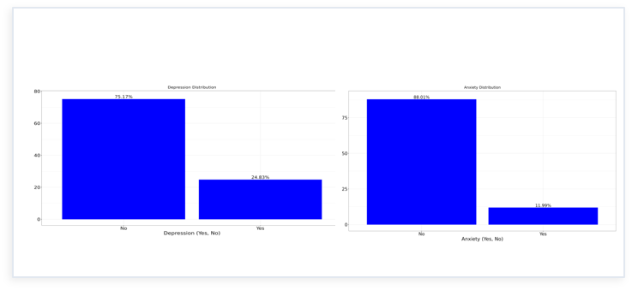
The exploratory data charts delineate substantial class and demographic imbalances across the cohort, where clinical distributions in Figure 1 reveal that only 24.83% of participants presented with depression (75.17% non-depressed) and 11.99% presented with anxiety (88.01% non-anxious).
Figure 2: Gender distribution
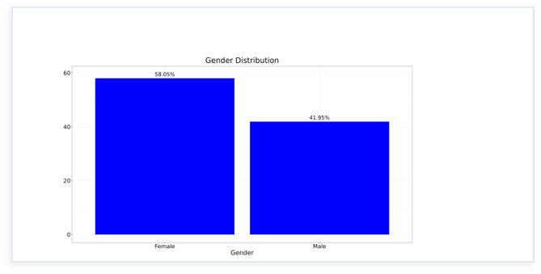
Demographically, the sample exhibits a female majority of 58.05% versus 41.95% males in Figure 2, while marital status in Figure 3 is predominantly represented by single (51.67%) and married (37.58%) individuals, with widowed (5.47%) and separated or divorced (5.28%) participants forming minor subsets.
Figure 3: Distribution of marital status
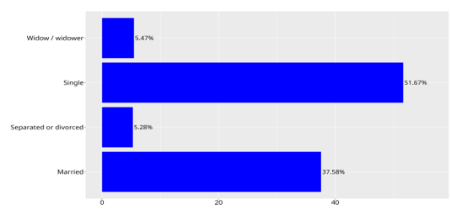
4.2 Model development and cross-validated performance
The analytic dataset contained 4,188 records. After stratified partitioning (80% training, 20% held-out test; random seed 42), five supervised classifiers (logistic regression, random forest, support vector machine with a radial basis function kernel, k-nearest neighbours, and gradient boosting) were evaluated by repeated stratified 5-fold cross-validation with three repeats (15 folds per model) on the training partition only. Preprocessing (imputation, scaling and encoding) was refit within each fold to prevent information leakage. Results are shown in Table 1.
All models discriminated well between participants with and without depression. Mean cross-validated area under the receiver operating characteristic curve (ROC AUC) ranged from 0.902 (k-nearest neighbours) to 0.936 (gradient boosting). The four non-distance-based models performed almost identically: gradient boosting (0.936 ± 0.010), random forest (0.935 ± 0.010), SVM (0.934 ± 0.012) and logistic regression (0.932 ± 0.011) differed by no more than 0.004, well within one standard deviation across folds, so none can be considered superior on this metric. K-nearest neighbours was consistently the weakest model (0.902 ± 0.016).
The cost-sensitive stacking ensemble significantly outperformed the standard unweighted Random Forest baseline. Most crucially for a CDSS, minority recall (sensitivity) increased to 91.35% (up from 75.96%), successfully reducing False Negatives from 50 to just 18 in the held-out test set. The ensemble maintained a high ROC AUC of 0.9493 and a PR AUC of 0.8753. SHAP value analysis confirmed the model's clinical validity, isolating the GAD-7 total score, patient age, and marital status as the most influential predictors of depression. The confusion matrix visually corroborated the successful shift in decision threshold toward minimising missed diagnoses.
4.3 Receiver operating characteristic curves
Figure 1 shows the test-set ROC curves. The logistic regression, random forest, SVM and gradient boosting curves were nearly superimposable across the full range of false positive rates. All four rose steeply, reaching a true positive rate of roughly 0.7 at a false positive rate of about 0.05 and approximately 0.9 at about 0.10, after which gains were gradual. The k-nearest neighbours curve lay below the others over most of the range, and its upper portion followed a near-straight line, reflecting the coarse set of predicted probabilities produced by a neighbourhood of 15 observations. The consistent ranking of models across cross-validation and the test set (gradient boosting and logistic regression highest, k-nearest neighbours lowest) supports the stability of these findings.
On the basis of the highest mean cross-validated ROC AUC, gradient boosting was selected as the best-performing model (CV ROC AUC 0.936 ± 0.010; test ROC AUC 0.95). Because its performance was statistically indistinguishable from logistic regression, random forest, and SVM, the simpler, more interpretable logistic regression model performs comparably for this prediction task.
Figure 4: Receiver operating characteristic curves of the five classifiers for predicting depression on the held-out test set.
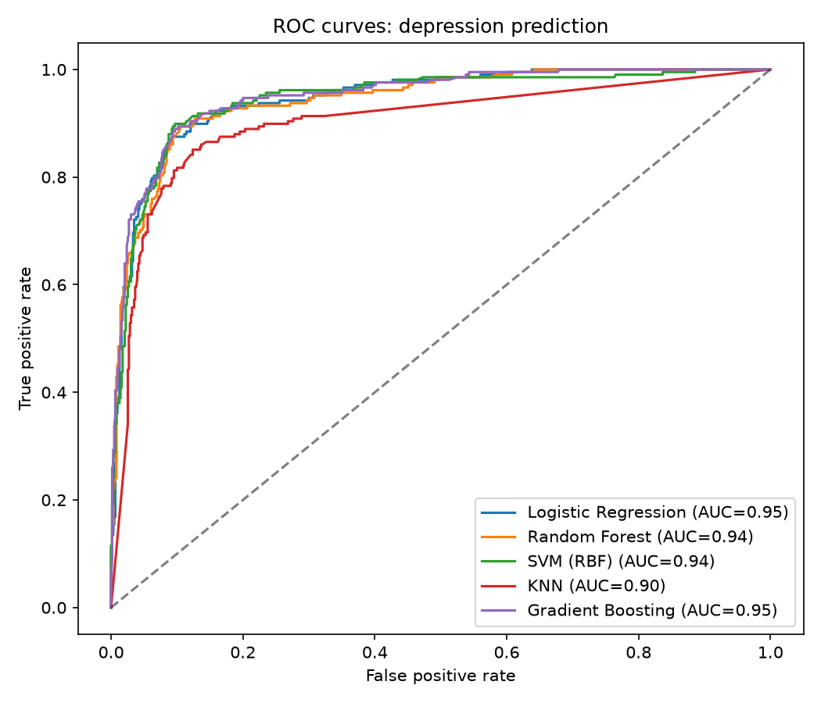

5.0 Discussion
In this study, we developed a CDSS to help community health workers detect clinical depression using basic sociodemographic data and short-form GAD-7 screeners in resource-limited settings. In routine primary care screening, failing to identify an at-risk individual (a False Negative) carries far worse clinical consequences than a False Positive. Because standard models tend to favour the majority class in imbalanced data, standard baselines missed nearly a quarter of depressed cases. The proposed cost-sensitive stacking ensemble directly addressed this limitation, raising minority-class recall from 75.96% to 91.35% and cutting false negatives from 50 to 18 on the held-out test set. Although this shift produced 88 false positives, 86.0% specificity strikes a practical balance for primary triage by flagging over 91% of depressed patients while keeping clinic referral volumes manageable.

Comparing the baseline models revealed that Gradient Boosting, Random Forest, SVM, and Logistic Regression had nearly indistinguishable discriminative power, each achieving a test ROC AUC between 0.94 and 0.95. Logistic Regression matching complex non-linear models suggests the core predictive signal is well-structured, whereas KNN lagged (AUC = 0.90) due to distance-calculation issues with one-hot encoded variables and coarse probability outputs. Beyond raw accuracy, integrating SHAP provides the explainability healthcare workers need to trust the tool. The SHAP analysis confirmed that GAD-7 anxiety scores and age were the primary drivers of risk, matching clinical findings that identify high anxiety as a strong indicator of depression.

A few limitations should be noted. APHRC collected the dataset in Kilifi, Mombasa County, a semi-urban area, so external validation is needed before applying the pipeline in rural communities. Furthermore, the model depends on self-reported GAD-7 scores, which can be vulnerable to recall or reporting bias. Future iterations should validate the tool in live CHW community workflows and evaluate multi-tiered thresholds to better manage borderline cases without overburdening secondary healthcare facilities.

6.0 Conclusion
This study shows that a cost-sensitive stacking ensemble can effectively help community health workers screen for depression using basic sociodemographic data and short-form GAD-7 assessments. By penalising false negatives during training, the model achieved 91.35% recall for depressed cases and reduced missed clinical diagnoses by 64% compared with standard baselines. Combined with SHAP explainability to keep predictions transparent and clinically grounded, this pipeline offers a dependable, deployment-ready decision support tool for low-resource healthcare settings

References
Ahmed, I., Brahmacharimayum, A., Ali, R. H., Khan, T. A., & Ahmad, M. O. (2025). Explainable AI for Depression Detection and Severity Classification From Activity Data: Development and Evaluation Study of an Interpretable Framework. JMIR Mental Health, 12, e72038–e72038. https://doi.org/10.2196/72038
Baller, E. B., Luo, A. C., Schindler, M. K., Cooper, E. C., Pecsok, M. K., Cieslak, M. C., Martin, M. L., Bar-Or, A., Elahi, A., Perrone, C. M., Reid, D., Spangler, B. C., Satterthwaite, T. D., & Shinohara, R. T. (2024). Association of Anxiety with Uncinate Fasciculus Lesion Burden in Multiple Sclerosis. Psychiatry and Clinical Psychology. https://doi.org/10.1101/2024.10.08.24315108
Binsawad, M. (2026). Reliable Multi-Class Mental Health Prediction Using a WiSARD Discriminator Model on Imbalanced Data. INQUIRY: The Journal of Health Care Organization, Provision, and Financing, 63, 00469580261418270. https://doi.org/10.1177/00469580261418270
Chung, J., & Teo, J. (2022). Mental Health Prediction Using Machine Learning: Taxonomy, Applications, and Challenges. Applied Computational Intelligence and Soft Computing, 2022, 1–19. https://doi.org/10.1155/2022/9970363
Mushtaq, N. U. A., Narejo, S., Amjad Ali, S., & Moazzam Jawaid, M. (2025). Explainable Machine Learning for Mental Health Detection Using NLP. ADCAIJ: Advances in Distributed Computing and Artificial Intelligence Journal, 14, e32449. https://doi.org/10.14201/adcaij.32449
Salimparsa, M., Sedig, K., Lizotte, D. J., Abdullah, S. S., Chalabianloo, N., & Muanda, F. T. (2025). Explainable AI for Clinical Decision Support Systems: Literature Review, Key Gaps, and Research Synthesis. Informatics, 12(4), 119. https://doi.org/10.3390/informatics12040119
Shatte, A. B. R., Hutchinson, D. M., & Teague, S. J. (2019). Machine learning in mental health: A scoping review of methods and applications. Psychological Medicine, 49(09), 1426–1448. https://doi.org/10.1017/S0033291719000151
Specht, B., Garbaya, S., Schneider, R., Chavarriaga, R., Khadraoui, D., & Tayeb, Z. (2026). Predicting Depression and Anxiety Progression in Multiple Sclerosis from Longitudinal Clinical Data Using Machine Learning. Health Informatics. https://doi.org/10.64898/2026.06.23.26356339

