# Public Website for new business - Wulaka.com

## Application audience and website purpose:

Tour (walking tour, climbing tour, kayaking trip), course (pottery, music, cooking), experience (white water rafting, hot air ballooning) operators. Small and medium sized businesses.

The public website will act as a brochure to sell subscriptions to the Wulaka.com software (this software is nearing completion and out of the scope of this project). The software is a booking system, electronic diary and business automation software running in the browser. The target market is any activity or tour operator.

## Scope:

The scope of this job is design a template and general look and feel for the website, following the visual guidelines listed below and then once approved go on to convert that design into high quality HTML and CSS that is well structured and adheres to modern best practices for HTML /CSS coding for all the requested pages. Sample content (starter only) is provided for the pages we want created. We will complete the content in the pages after the site is created - however the design should easily accommodate further content.

The homepage will require extra design focus. The further pages should all be somewhat similar to each other visually, however not necessarily that similar to the homepage.

We would expect a number of iterations of the design before approval and before you more onto the Html/Css development.

Deliverables at the end include all Html/Css files, all design artefacts, including the raw format (eg PSD) of the designs and any adjusted logos or images.

## Visual Guidelines/General Requirements:

Colour Scheme:

The following colours are part of the branding of the software and this should follow through in the public website:

primaryGrey : #404040

primaryGreen: rgb(39, 177, 34)

primaryOrange: #e54828

primaryBlue: #0072C0

secondaryBlue: #61a6d4

secondaryGrey: #737373

minorHeaderGrey: #4D4D4D

Examples of how these colours are used are shown below in a partial screenshot of the application:

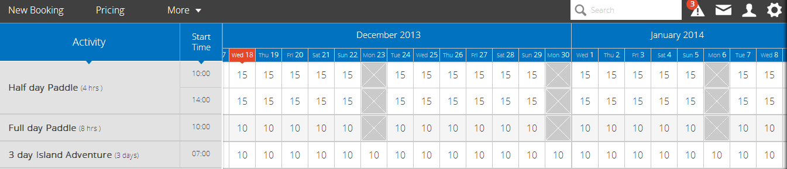

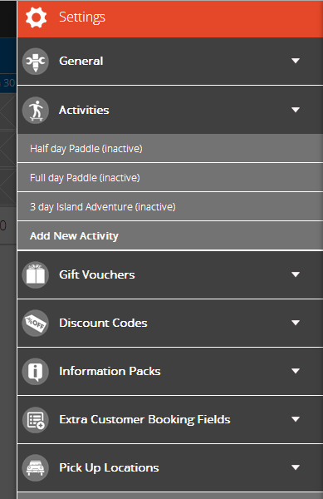

The website should be very flat with no or very little shadows or 3D affects. It should also be tablet and touch friendly (size of clickable areas are important).

The login page and other significant pages of the application make use of a full screen hero image of activities in progress as shown below (rotating on a schedule). We would like to try and incorporate this into the homepage of the public site as well - though if this doesn't work we would consider a more traditional hero image of a smaller size on the homepage.

Example:

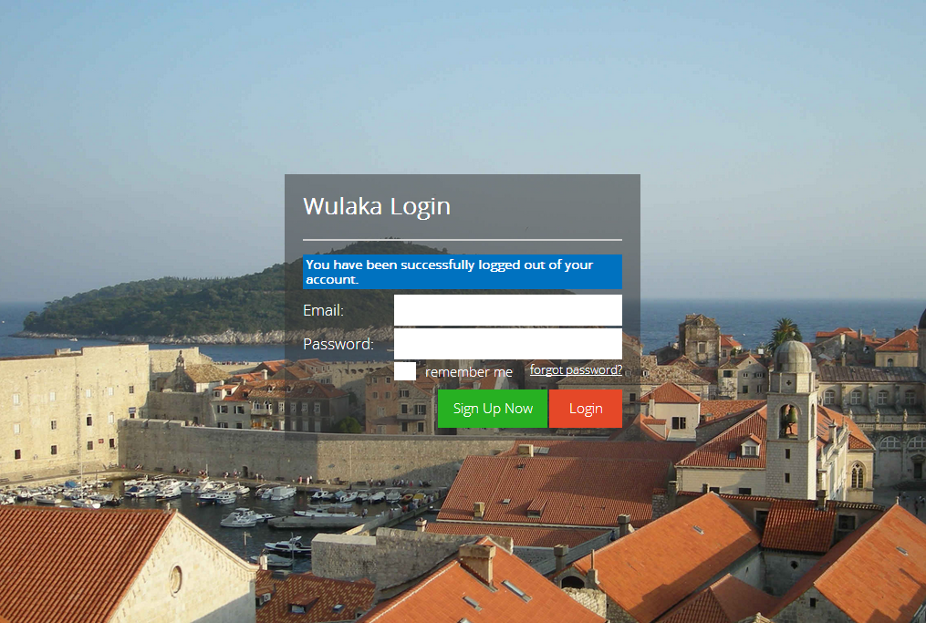

This website also needs to cater for EU cookie laws and be able to show the relevant info and acceptance box.

We have a rough logo which represents the W in Wulaka and is based on an aboriginal traditional design representing mountains and rivers. This logo is shown in situ below and provided as jpg - we realise this image might need some cleaning up before it is used and that is in scope of the project.

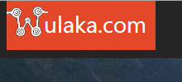

**Reference Sites:**

The following sites have good elements and are relevant to the industry/product:

Good competitor site: rezdy.com

Similar market (accommodation): eviivo.com

Style reference sites: bing.com, outlook.com, squarespace.com

**Sitemap:**

Welcome/Home

- Features

- Pricing

- Our Story

- News & Blog => Blog site

- Sign Up Now => Button/Link goes directly to a page in the application

- Operator Login => Button/Link goes directly to a page in the application

Footer:

- Normal social media links

- How we use cookies

- Legal Stuff

- Copyright statement

- About Wulaka.com

**Pages & Sample Content**

The strap line for the business is "discover.freedom".

The simple statement of what we are selling is:

ecommerce Booking System + Electronic Diary + Business Automation = More Bookings + More Free Time

The slightly expanded version of this would add More Money and Less Admin into the end part of the formula but that is probably too long.

We would like this theme to carry though the website where possible.

**HomePage**

- Simple Visual Representation of the selling statement above

The following selling statements with appropriate links/buttons for the customer to gain more information:

"Operating Software for Activity and Tour operators - [Browse features]"

"Want More Bookings, Less Admin, More Money & More Free Time? - [Find out how]"

Sales call to action, for example:

"Limited time only - [sign up now] - and get 1st month free and the next 3 months half price!"

Ideally use of hero images (two supplied as examples) either full screen or more traditional hero image.

**Features**

Prominent "Sign up Now", and "Pricing Options" buttons top and bottom

List of features organised into groups - "More Bookings/More Money", "Less Admin, More Free Time", "More Control"

We envisage each feature to be in fairly large font, but with a more info link and the whole feature clickable to expand into a larger section of text on the feature.

Example features:

Real TimeBooking and Payment direct to your bank account

Access anywhere, anytime

PC, Mac and Tablet friendly

Commission Free!

(You can expect there will be about 20 features listed at the top level).

**More bookings, less admin, more money and more free time**

Two subsections:

*"Want more bookings (and make more money)?"*

Some explanatory text on how we will make that happen.

*"Want less admin (and more free time)?"*

Some explanatory text on how we will make that happen.

Prominent "Browse Features", and "Sign Up Now" buttons.

**Pricing options**

Two options, side by side - Silver and Gold. Both priced on a per month basis, with a series of inclusions/exclusions side by side.

**Our Story**

Probably a fairly standard page with some text paragraphs and possibly a photo or two.

**Legal Stuff and other minor pages**

Just mock up one of these and they will be fairly text intensive simple pages but branded with standard header and footer.