1. Install GCC:
GNU Toolchain | GNU Arm Embedded Toolchain Downloads – Arm Developer
gcc-arm-none-eabi-10.3-2021.07-win32.exe
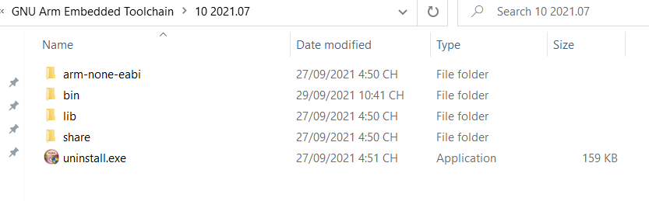
2. Install cmake
Download | CMake
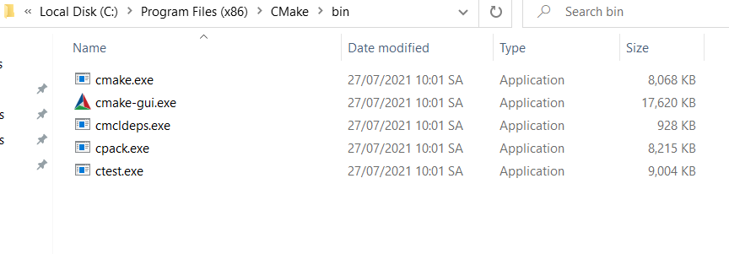
3. Download ninja
Releases · ninja-build/ninja (github.com)
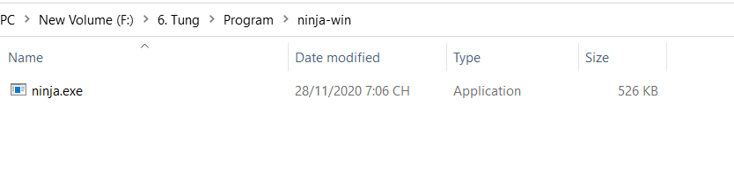
4. Download openocd
xpack-openocd-0.10.0-13-win32-x64.zip
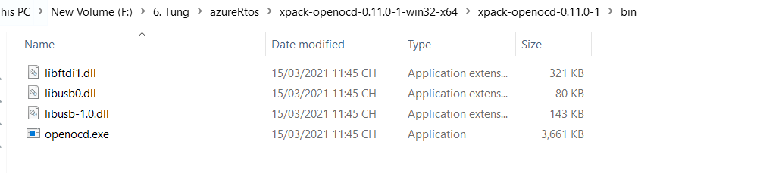
5. Add all of them to environment variable
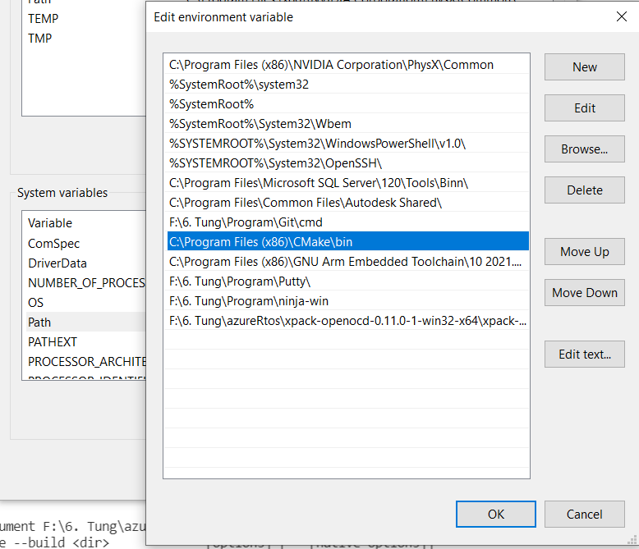

6. Install addon Cortex-Debug
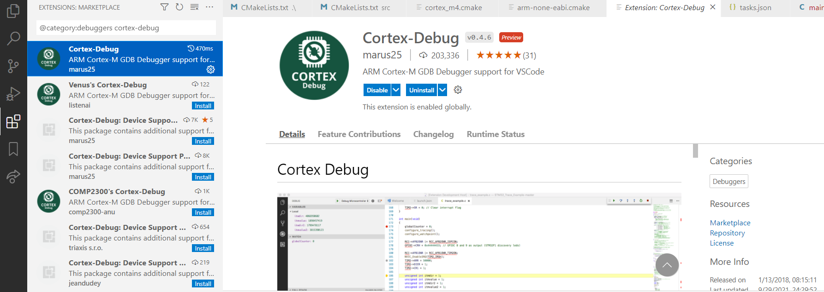
7. Create STM32 project
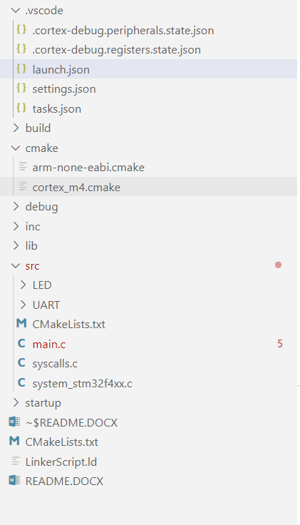
8. Add CMakeLists.txt files
9. Add Build configuration file: .vscode/task.json
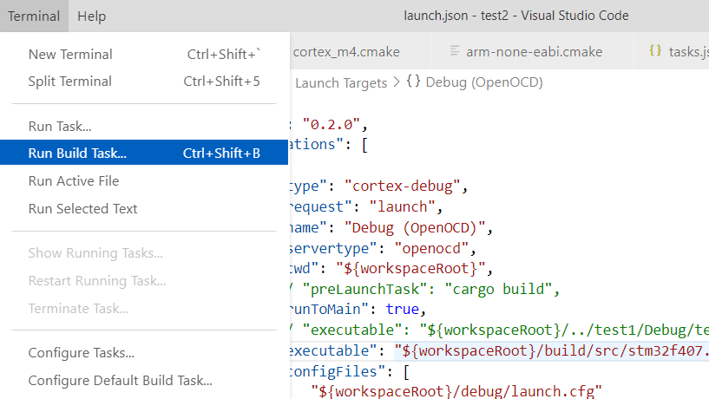
9.1. First, run cmake-debug
9.2. Second, run build
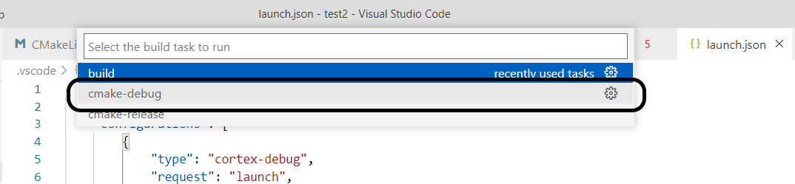
9.3. Build folder: ./build
10. Add debug configuration file: .vscode/launch.json
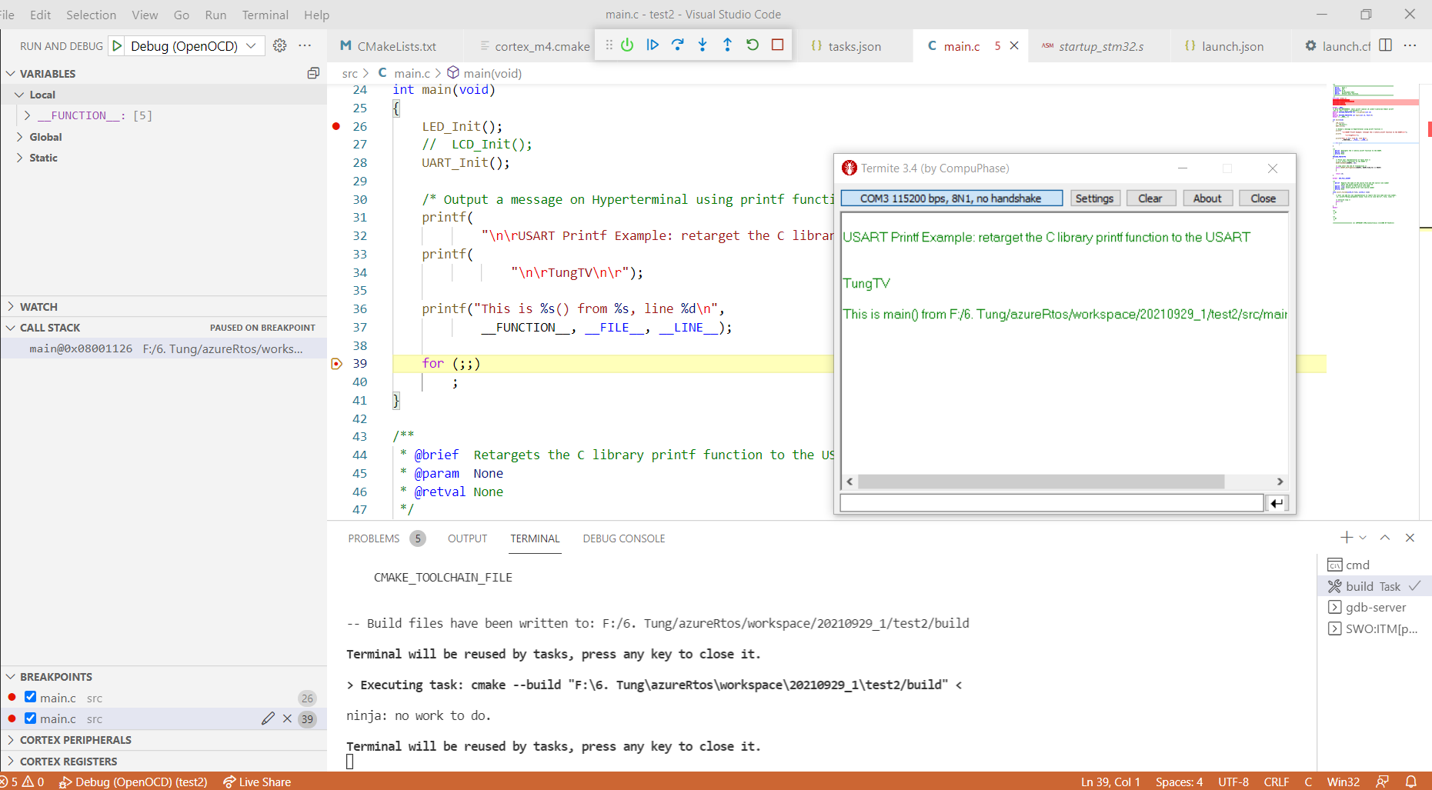
Note:
2 folders ./cmake and ./debug là em copy từ cái AC6 IDE.

