Team Name/Project Name | XXX
Document | Product Design Document

Note: this is a “living document”, meaning its content and format will grow with the implementation of the project. Use it to capture key project concepts and to document important design decisions.
You may use any drawing tool for your UML diagrams. Visio and Rose are available in the lab. If your diagrams are too big to cut and paste into this document, provide a reference to the external file where they can be found.

Architectural Model
This diagram represents the major subsystems of the product. Initially focus on the domain layer and its components before decomposing the user interface component. Note that a common interface allows both the GUI and Test Driver to access the domain model in the same manner without regard to the type of presentation technique.

Product Graphical User Interface (GUI)
Development Testing Interface (Test Driver)
Domain Model
Domain Layer
Presentation Layer
Data
Domain Model Interface

Components and Functions
Identify the components (logical groupings of software modules that perform a related set of functionality) and their product responsibilities by identifying the functionality they perform. Provide sufficient detail in each bulleted item that clearly describes the functionality supported in each component.

Date Range | - Can calculate the intersection of two date ranges  - Can tell if a date is in a range  - Can tell if two date ranges are the same  - Knows how to save/load itself
Calendar Controller | - Used to communicate between the GUI views and the states in the Model  - Does not know about to the states in the model but can access information from the model and send it back to the view
Observable Event Listener | - A Listener that allows Observable Events to perfoms actions that notify and update the views.
Appointment | - Set titles and description  - Knows when it’s been changed  - Knows how to save/load itself  - Knows if two appointments are the same
Calendar Model | - Knows the states of the utility classes that modify and store data from the users calendar application  - Cannot speak to the view directly must go through the controller to actually change the views.  - Can access most methods from the utility classes most of which are only visible in the project package
Day/Week/Month Ranges | - Subclasses of Date Range  - Use the Calendar classes along with the methods in DateRange to produce the next and previous Ranges of the specified class.  - Classes default to current dates
Observable Event | - Event objects that track the changes of the states of the utility classes
Persistent | - Allows the Calendar to store its filename and appointmentset so the application can save and load itself.
Month / Week / Day View | - Can display appointments on a given month / day / week  - Allows user to interact with model, make, save, and load appointments and allows user to change views
Appointment View | - Allows the user to create or edit appointments of the currently selected day  - Send to the controller so that the model can know to update the appointment set
Utility Panel | - A Panel of buttons that allows the user to save the user’s appointments, load the user’s appointments, and quit the application
Main Panel (DCal) | - The main GUI the instantiates each view in a card layout with the utility panel and the left side and the appointment view under the utility panel.  - Can update each view on next and previous events, and when appointments are added and removed
Appointment Template | - An AppointmentTemplate is a free-floating template for an appointment. It contains all of the data to create multiple entries of a type of appointment, but cannot serve directly as an appointment because it lacks a start date.  - To make a full appointment, one can instantiate the template by making a RefAppointment (reference appointment) that references a template and contains a start date for binding it to the calendar.
Ref Appointment | - A RefAppointment is an instantiated form of an Appointment. It stores the start date, and the parent AppointmentTemplate from which it will  - draw data such as the appointment's description, title, etc.  - This was done so that recurring appointments could be implemented.  - To make a full appointment, one can create a template, and instantiate  - it by making a RefAppointment that references the template and contains a start date for binding it to the calendar.
Day Of Week Pattern | - This class is the representation of a pattern that would exist on certain days of the week.  - If the user would like an appointment to exist several times a week then this is the class that would deal with it
N Days Pattern | - This class is the representation of a pattern that would exist  - every N number of days. If the user would like an appointment to  - exist over a periodic number of days, then this is the class that  - would deal with it
Recurrence | - This is the abstract class Recurrence Pattern  - It is a template for the patterns that recurring appointments should take.  - For example if a user would want to have an appointment happen every Tuesday and Thursday, one could extend this class into a class that returns the dates in which that appointment should exist

Product Design
Insert a UML class diagram to represent the product’s design. Note that this diagram will evolve and convey more detail as the product is developed. Also include a sequence diagram for one significant user story from your requirements document.

Please refer to UML.MDL in the repository under documents->technical
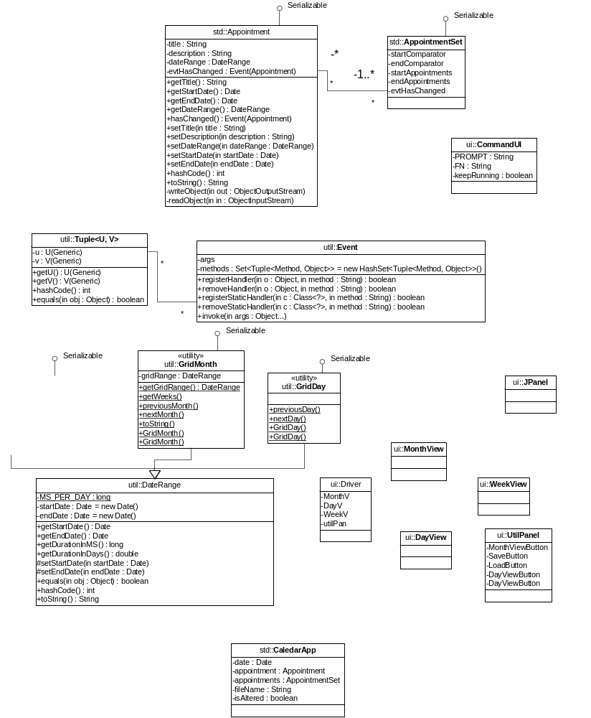

Design Notes
  - Capture the history of key design decisions and rejected alternatives.

