Design Document – Team A
GUI Model Design

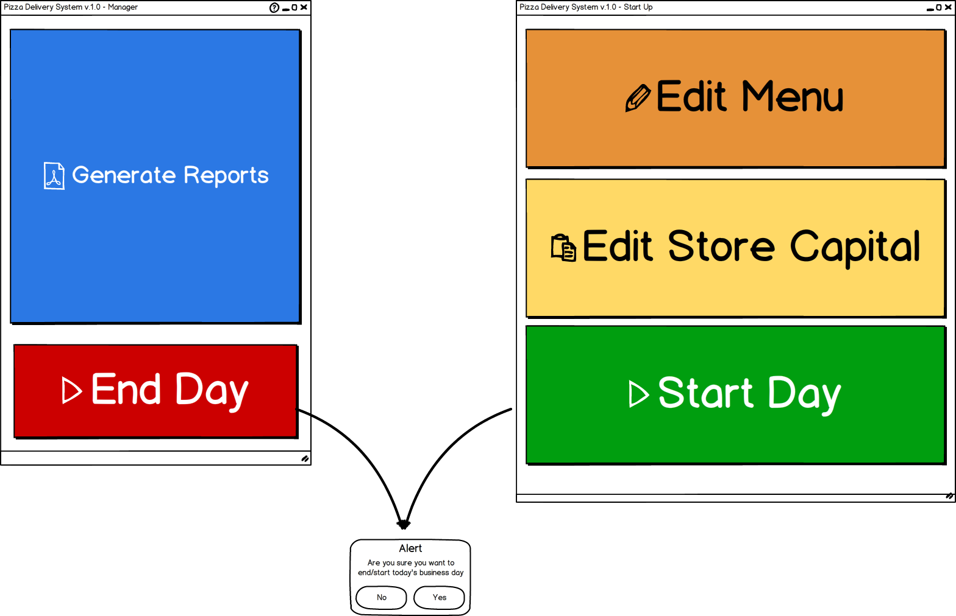

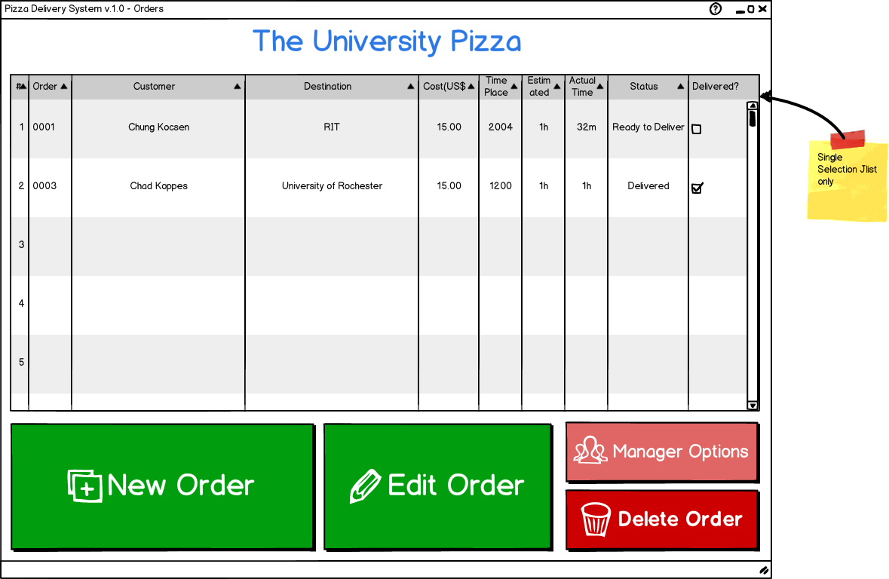
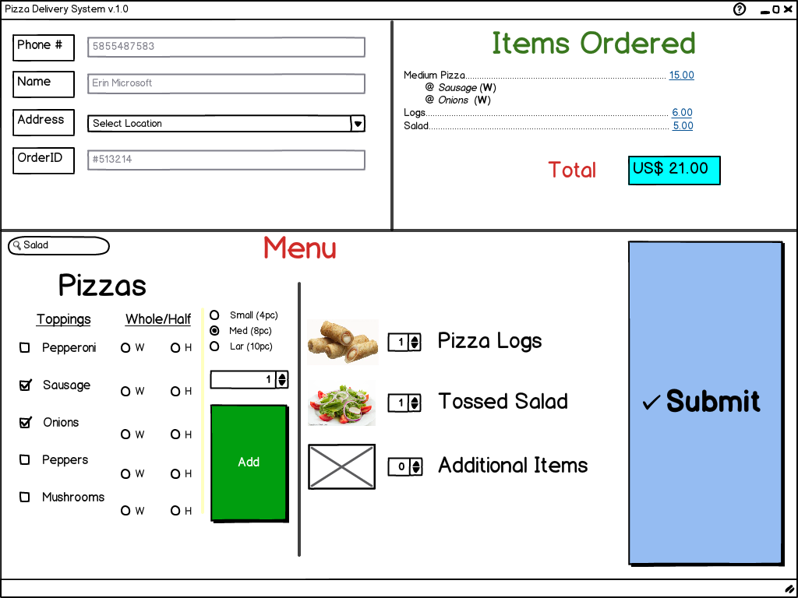

Architecture Model
New:
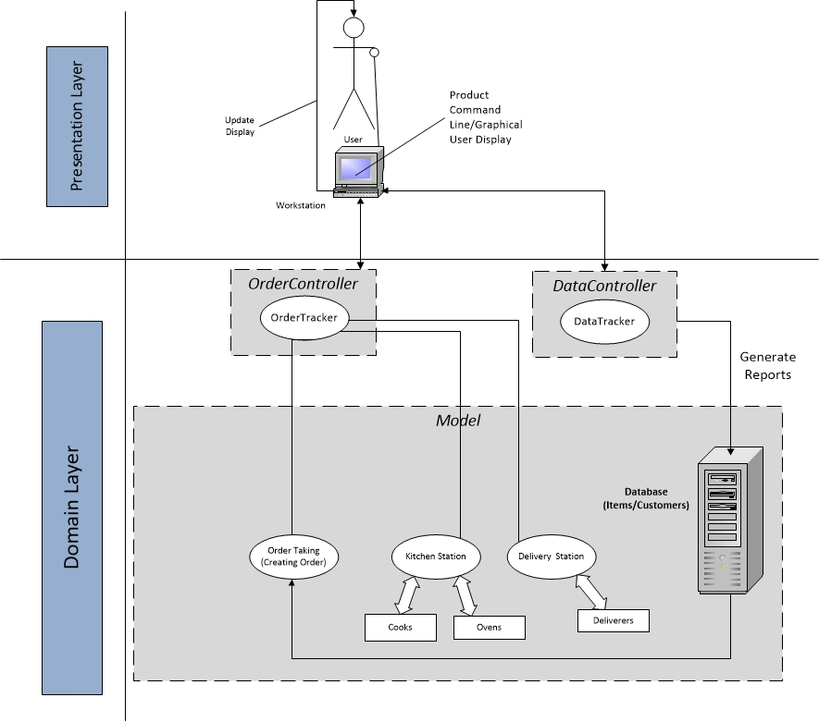

In the New architecture diagram we made some changes. We integrated the model view controller Interface. As seen on the diagram above, the User interacts with a workstation that alters the controller which then, in a protected manner, produces any change on the back end (model) of the system. Later on, the information is then updated on the command line or graphical display for the user to see.
As for the back end, the Order Tracker component is still the one that checks and moves around the orders created. Its task is to send orders to the kitchen and to the delivery station. The kitchen is in charged of passing the items through the cooks and ovens as necessary. Similarly, the Delivery Station is in charge of sending out the completed orders to the be delivered.
Class Descriptions
Order Taking | Component State  * Maintains the customer information database.* Has a list of possible order elements and their prices (pizza, drinks, etc).  Component Behavior  - The order taking component will combine the customer information with their specified food order. This order object will persist through the rest of the order’s progress in the delivery process.  - On order finalization, submit the order to the order tracking system as well as the cooking system.
Order Tracking | Component State  * A list of all orders for that day, either still being processed or delivered.  Component Behavior  - Different modules will inform the order tracking system of an order’s progress.  - Different modules may query the order tracking system to see a specific order’s progress.  - Management may query the order tracking system to see statistics or other metrics of pizza delivery operation.
Cooking Station | Component State  * List of available cooks.* List of available ovens.* Unfulfilled order queue.  Component Behavior  - As cooks ( or ovens if needed ) become available, check if there are any uncooked order elements. If so, begin cooking process.  - As elements are cooked, check if a whole order is cooked. If so, submit the order to the delivery system and inform the order tracking system of the order’s status.
Delivery Station | Component State  * List of available drivers.* Undelivered order queue.  Component Behavior  - As drivers become available, check if there are any undelivered orders. If so, begin delivery process.  - Upon completed delivery, inform the order tracking system of the order’s status.

UML Class Diagram
UML class diagram capturing the relationships between classes. It is only necessary to show methods that are publicly accessible by other classes. Only show an instance variable of a class if it is publicly accessible.
Newest Versions:
Command Line Interface: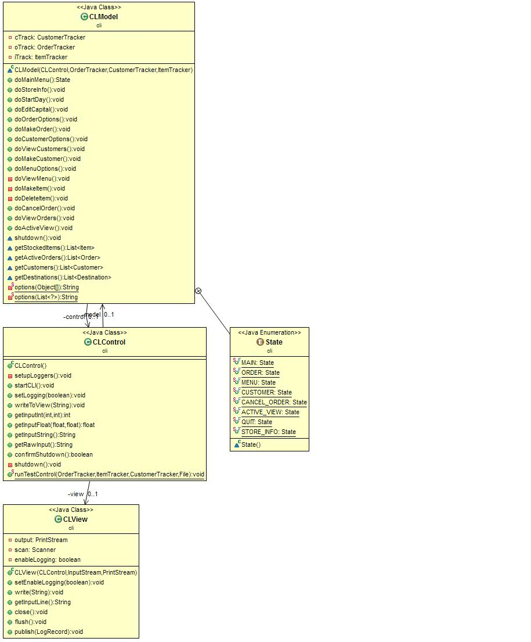
Data Tracking:
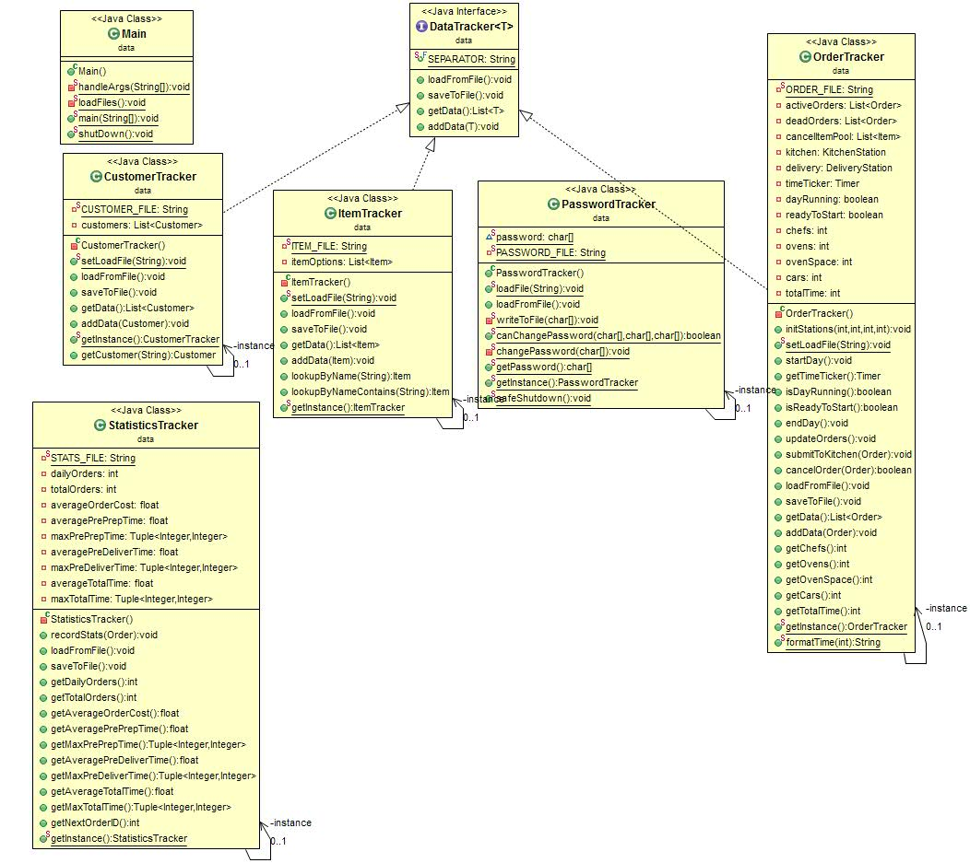

Domain (back-end):

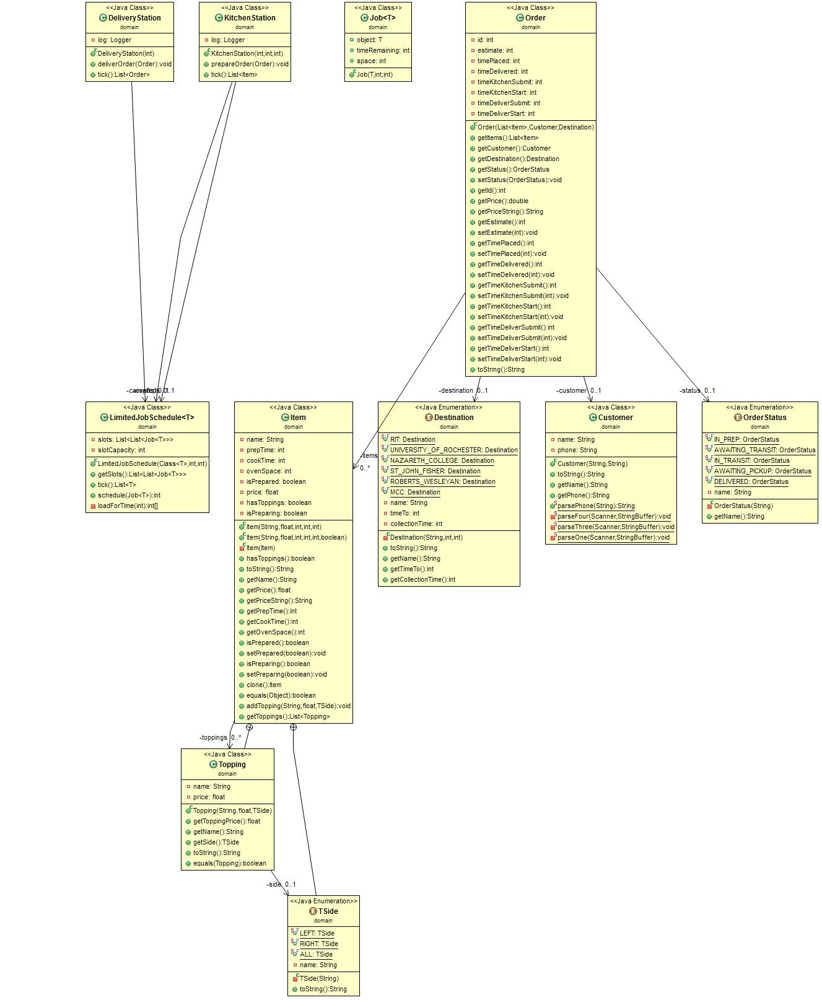

GUI Modeling:
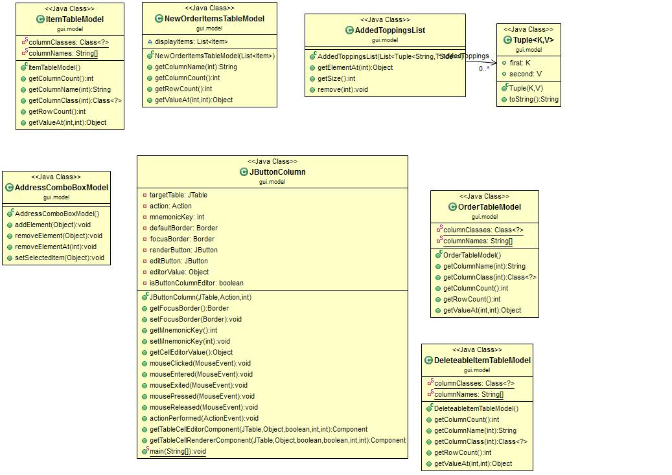

Sequence Diagram
Latest version:
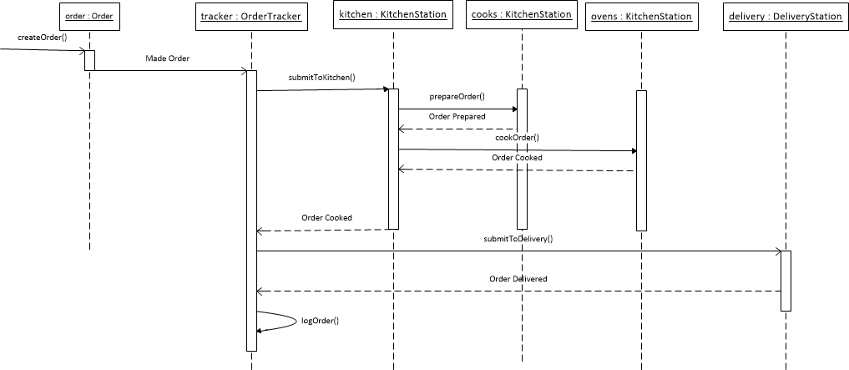

Design Rationale
Note: The way the design rationale works will be described by providing list of major components and functionality.
Draft 13 - Final Draft
Main Components:
- Order Taking (implicit - means instantiating an Order object)
- LimitedJobSchedule class (see above UML Class diagram)
- Limited Job Schedule queues Jobs;
  - cooks, ovens deliverers, and does work on them (JOB) every second.
  - Cooks and ovens belong to -> KitchenStation
  - Deliverers belong to ------------> DeliveryStation
CLI Components:
- CLControl - Controlling
  - Different kind of trackers: (use singleton pattern - Are used by CLI and GUI)
    - Customer Tracker -> Generates .dat (data) file
    - Data Tracker
    - Item Tracker --------> Generates .dat file
    - Order Tracker ------> Generates .dat file
    - Password Tracker > Generates .dat file
    - Statistics Tracker --> Generates .dat file
- CLModel - Modeling
- CLView - Viewer
- Order Tracking
- Main (Main is now in the CLI component side. Is the only .java file with a main method.)
  - Handles all arguments which give advanced system functionality like opening specific data documents, and running in cli or GUI mode AND ability to run simulation time.
- PasswordTracker (added file manager for maintaining the manager passwords)
I/O Handling: (See CLI components in generating .dat file) above.
GUI: -Note: Not implementing Singleton pattern for GUI
- Start day frame (here edit menu, store capital and start day)
  - Edit Store/Capital as a Dialog
  - Start day as a Dialog
  - View Order Frame (NEW!)
  - Load all the files here.
- Order tracker frame
  - New order frame as a Dialog
    - Confirm submission of order frame as a Dialog
  - Edit order frame as a Dialog
  - Manger option frame
    - Has password clearances a Dialog
    - End day frame
    - Are you sure you want to close the system? As a dialog
    - Generate reports
    - Close store
    - View Manager Reports
      - Pulls data from the Statistics Tracker.

Draft 12
Main Components:
- Order Taking (implicit - means instantiating an Order object)
- LimitedJobSchedule class (see above UML Class diagram)
- Limited Job Schedule queues Jobs;
  - cooks, ovens deliverers, and does work on them (JOB) every second.
  - Cooks and ovens belong to -> KitchenStation
  - Deliverers belong to ------------> DeliveryStation
CLI Components:
- CLControl - Controlling
  - Different kind of trackers: (use singleton pattern - Are used by CLI and GUI)
    - Customer Tracker -> Generates .dat (data) file
    - Data Tracker
    - Item Tracker --------> Generates .dat file
    - Order Tracker ------> Generates .dat file
    - Password Tracker > Generates .dat file
- CLModel - Modeling
- CLView - Viewer
- Order Tracking
- Main (Main is now in the CLI component side. Is the only .java file with a main method.)
- PasswordTracker (added file manager for maintaining the manager passwords)
I/O Handling: (See CLI components in generating .dat file) above.
GUI: -Note: Not implementing Singleton pattern for GUI
- Start day frame (here edit menu, store capital and start day)
  - Edit Store/Capital as a Dialog
  - Start day as a Dialog
- Order tracker frame
  - New order frame as a Dialog
    - Confirm submission of order frame as a Dialog
  - Edit order frame as a Dialog
  - Manger option frame
    - Has password clearances a Dialog
    - End day frame
      - Are you sure you want to close the system? As a dialog
    - Generate reports
    - Close store
Draft 11
Main Components:
- Order Taking (implicit - means instantiating an Order object)
- LimitedJobSchedule class (see above UML Class diagram)
- Limited Job Schedule queues Jobs;
  - cooks, ovens deliverers, and does work on them (JOB) every second.
  - Cooks and ovens belong to -> KitchenStation
  - Deliverers belong to ------------> DeliveryStation
CLI Components:
- CLControl - Controlling
  - Different kind of trackers: (use singleton pattern - Are used by CLI and GUI)
    - Customer Tracker -> Generates .dat (data) file
    - Data Tracker
    - Item Tracker --------> Generates .dat file
    - Order Tracker ------> Generates .dat file
- CLModel - Modeling
- CLView - Viewer
- Order Tracking
I/O Handling: (See CLI components in generating .dat file) above.
GUI: -Note: Not implementing Singleton pattern for GUI
- Start day frame (here edit menu, store capital and start day)
  - Edit Store/Capital as a Dialog
  - Start day as a Dialog
- Order tracker frame
  - New order frame as a Dialog
    - Confirm submission of order frame as a Dialog
  - Edit order frame as a Dialog
  - Manger option frame
    - Has password clearances a Dialog
    - End day frame
      - Are you sure you want to close the system? As a dialog
    - Generate reports
    - Close store

Draft 10
Main Components:
- Order Taking (implicit - means instantiating an Order object)
- LimitedJobSchedule class (see above UML Class diagram)
- Limited Job Schedule queues Jobs;
  - cooks, ovens deliverers, and does work on them (JOB) every second.
  - Cooks and ovens belong to -> KitchenStation
  - Deliverers belong to ------------> DeliveryStation
CLI Components: (NEW - Implement Singleton Pattern for CLI Classes)
- CLControl - Controlling
  - Different kind of trackers:
    - Customer Tracker -> Generates .dat (data) file
    - Data Tracker
    - Item Tracker --------> Generates .dat file
    - Order Tracker ------> Generates .dat file
- CLModel - Modeling
- CLView - Viewer
- Order Tracking
I/O Handling: (See CLI components in generating .dat file) above.
GUI:
- Start day frame (here edit menu, store capital and start day)
  - Edit Store/Capital
  - Start day
- Order tracker frame
  - New order frame
    - Confirm submission of order frame
  - Edit order frame
  - Manger option frame
    - Has password clearance.
  - End day frame
    - Generate reports
    - Close store

Draft 9
Main Components:
- Order Taking (implicit - means instantiating an Order object)
- LimitedJobSchedule class (see above UML Class diagram)
- Limited Job Schedule queues Jobs;
  - cooks, ovens deliverers, and does work on them (JOB) every second.
  - Cooks and ovens belong to -> KitchenStation
  - Deliverers belong to ------------> DeliveryStation
CLI Components: (NEW - Implement Singleton Pattern for CLI Classes)
- CLControl - Controlling
  - Different kind of trackers:
    - Customer Tracker
    - Data Tracker
    - Item Tracker
    - Order Tracker (moved from domain)
- CLModel - Modeling
- CLView - Viewer
- Order Tracking ----> Moved from domain (main) Components
I/O Handling:
GUI:
- Start day frame (here edit menu, store capital and start day)
  - Edit Store/Capital
  - Start day
- Order tracker frame
  - New order frame
    - Confirm submission of order frame
  - Edit order frame
  - Manger option frame
  - End day frame
    - Generate reports
    - Close store

Draft 8
Main Components:
- Order Taking (implicit - means instantiating an Order object)
- Cooking Station AND Delivery Station will be a composed of LimitedJobSchedule class (see above UML Class diagram)
- Limited Job Schedule queues Jobs;
  - cooks, ovens deliverers, and does work on them (JOB) every second.
- Generate Report
CLI Components: (NEW - Implement Singleton Pattern for CLI Classes)
- CLControl - Controlling
- CLModel - Modeling
- CLView - Viewer
- Order Tracking ----> Moved from domain (main) Components
  - Is now in charged of managing item, customer and order.

Draft 7
Main Components:
- Order Taking
- Order Tracking ----> Moved to CLI Component
- Cooking Station AND Delivery Station will be a composed of LimitedJobSchedule class (see above UML Class diagram)
- Limited Job Schedule class queues Jobs as cooks, ovens or deliverers, and does work on them every second.
- Generate Report
CLI Components:
- CLControl - Controlling
- CLModel - Modeling
- CLView - Viewer
- Order Tracking ----> Moved from domain (main) Components
  - Is now in charged of managing item, customer and order.

Draft 6
Components:
- Order Taking
- Order Tracking (single threaded)
- Cooking Station AND Delivery Station will be a composed of LimitedJobSchedule class (see above UML Class diagram)
- Limited Job Schedule class queues Jobs as cooks, ovens or deliverers, and does work on them every second.
- Generate Report (renamed)
CLI Components:
- CLControl - Controlling
- CLModel - Modeling
- CLView - Viewer

Draft 5
Components:
- Order Taking
- Order Tracking (Complete Change) -
  - Single thread would ping every second to check when items status (cooked, prepared, delivered)

- Cooking Station
- Delivery Station
- Write Report (renamed)

Draft 4
Components:
- Order Taking
- Order Tracking -
  - Order Tracking would use thread pools to launch each cook, oven and deliverer.
  - Each cook/oven/deliverer would notify of completion to begin with next task.
  - Order Tracking would distribute the order times around and launch when order is completed.
- Cooking Station
- Delivery Station
- Write Report (renamed)

Draft 3
Components:
- ?Order Taking
- Order Tracking - We decided this to be the heart of the architecture == controller.
- Cooking Station
- Delivery Station
This looks like a solid base design to start building on top of. Some concerns with making the Order Tracking component a controller have been taken into consideration, but have not been consequential as to change it or remove it. Some of the concerns include handling various requests at the same time, (i.e. moving order to kitchen as GUI requests database object and as order status requests status on an order.
Draft 2
Components:
- ?Order Taking
- Order Tracking - We decided this to be the heart of the architecture. In other words a controller.
- Prepping - MERGED into Cooking Station
- Cooking - MERGED into Cooking Station
- Cooking Station
- Delivery Station
- Logging - Integrated into Order Tracking
Prepping and Cooking seemed like they could be reduced to one component, so we decided to merge it into a single cooking station. Delivery transformed into Delivery Station for more accurate naming conventions. Logging was integrated into the Order Tracking component.
Draft 1
At first, our components were:
- ?Order Taking
- Order Tracking
- Prepping
- Cooking
- Delivering
- Logging
These components were more of a transposition from the use case diagram bubbles. In essence, the system actions.

