Class name : SY CSE(IOT)

Rollno : 2007

Urn no : 1022101007

Batch : S1

EXPERIMENT 2

2. Implement python programs to demonstrate decision control and looping

Statements

a) Write a python Program to read a number and display corresponding day using

if_elif_else?

CODE:-

#Write a python Program to read a number and display corresponding day using if_elif_else?

a = int(input("Enter number of the day : "))

if a == 1:

print("Monday")

elif a==2:

print("Tuesday")

elif a==3:

print("Wednesday")

elif a==4:

print("Thursday")

elif a==5:

print("Friday")

elif a==6:

print("Saturday")

elif a==7:

print("Sunday")

else:

print("Invalid Input")

OUTPUT:-

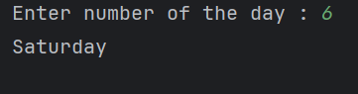

b) Write a program to create a menu with the following options

1. TO PERFORM ADDITITON

2. TO PERFORM SUBTRACTION

3. TO PERFORM MULTIPICATION

4. TO PERFORM DIVISION

Accepts users input and perform the operation accordingly

CODE:-

while(True):

print("1. TO PERFORM ADDITITON")

print("2. TO PERFORM SUBTRACTION")

print("3. TO PERFORM MULTIPICATION")

print("4. TO PERFORM DIVISION")

print("5. Exit")

a = int(input("Choice any one of the above option : "))

if a == 1:

b = int(input("Enter first number : "))

c = int(input("Enter second number : "))

print("The addition of 2 number is ",b+c)

elif a == 2:

b = int(input("Enter first number : "))

c = int(input("Enter second number : "))

print("The Subtraction of 2 number is ",b+c)

elif a == 3:

b = int(input("Enter first number : "))

c = int(input("Enter second number : "))

print("The Multiplication of 2 number is ",b+c)

elif a == 4:

b = int(input("Enter first number : "))

c = int(input("Enter second number : "))

print("The Division of 2 number is ",a/b)

elif a == 5:

print("!!!!!!!Exiting the program!!!!!!!")

break

else:

print("Invalid input ")

OUTPUT:-

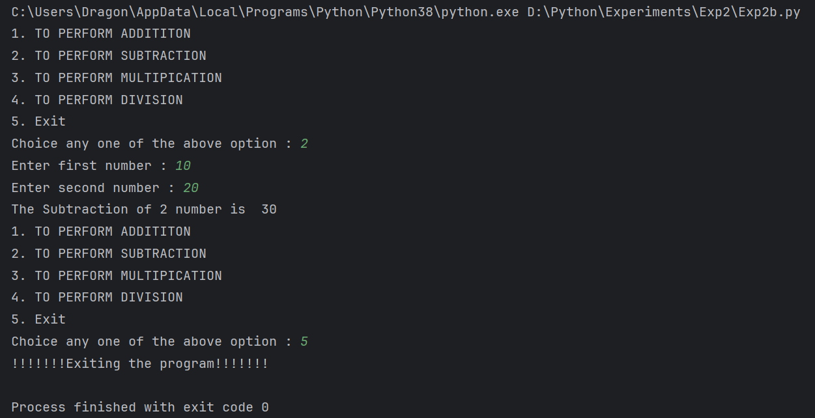

c) To generate prime numbers within an interval using for and while statements.

CODE:-

def is_prime(num):

"""Check if a number is prime."""

if num <= 1:

return False

if num <= 3:

return True

if num % 2 == 0 or num % 3 == 0:

return False

i = 5

while i * i <= num:

if num % i == 0 or num % (i + 2) == 0:

return False

i += 6

return True

def generate_primes(lower, upper):

"""Generate prime numbers in the given interval [lower, upper]."""

prime_numbers = []

for num in range(lower, upper + 1):

if is_prime(num):

prime_numbers.append(num)

return prime_numbers

# Get user input for the interval

lower_bound = int(input("Enter the lower bound of the interval: "))

upper_bound = int(input("Enter the upper bound of the interval: "))

# Generate and print prime numbers in the interval

primes = generate_primes(lower_bound, upper_bound)

print(f"Prime numbers between {lower_bound} and {upper_bound} are: {primes}")

OUTPUT:-

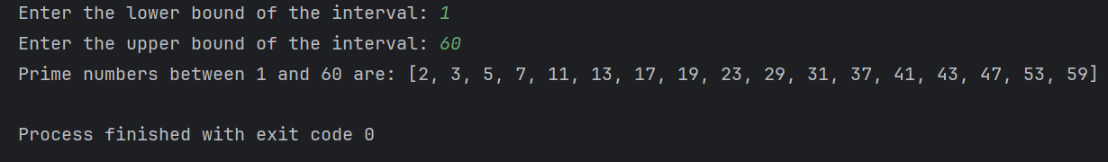

d) Write a python program to construct the following pattern, using a nested for loop

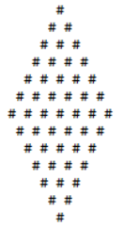

CODE:-

def Diamond(rows):

n = 1

for i in range(1, rows + 1):

# loop to print spaces

for j in range(1, (rows - i) + 1):

print(end=" ")

# loop to print star

while n != (i + 1):

print("*", end=" ")

n = n + 1

n = 1

# line break

print()

k = 0

n = 0

for i in range(1, rows + 1):

# loop to print spaces

for j in range(1, k + 1):

print(end=" ")

k = k + 1

# loop to print star

while n <= (rows - i):

print("*", end=" ")

n = n + 1

n = 0

print()

# Driver Code

# number of rows input

rows = 5

Diamond(rows)

OUTPUT:-

