Class name : SY CSE(IOT)

Rollno : 2007

Urn no : 1022101007

Batch : S1

EXPERIMENT 10

Import any CSV file to Pandas Data Frame and perform the following:

(a) Visualize the first and last 10 records

Code:

import pandas as pd

df = pd.read_csv("data.csv")

print("First 10 elements: ")

print(df.head(10))

print("Last 10 elements: ")

print(df.tail(10))

OUTPUT:-

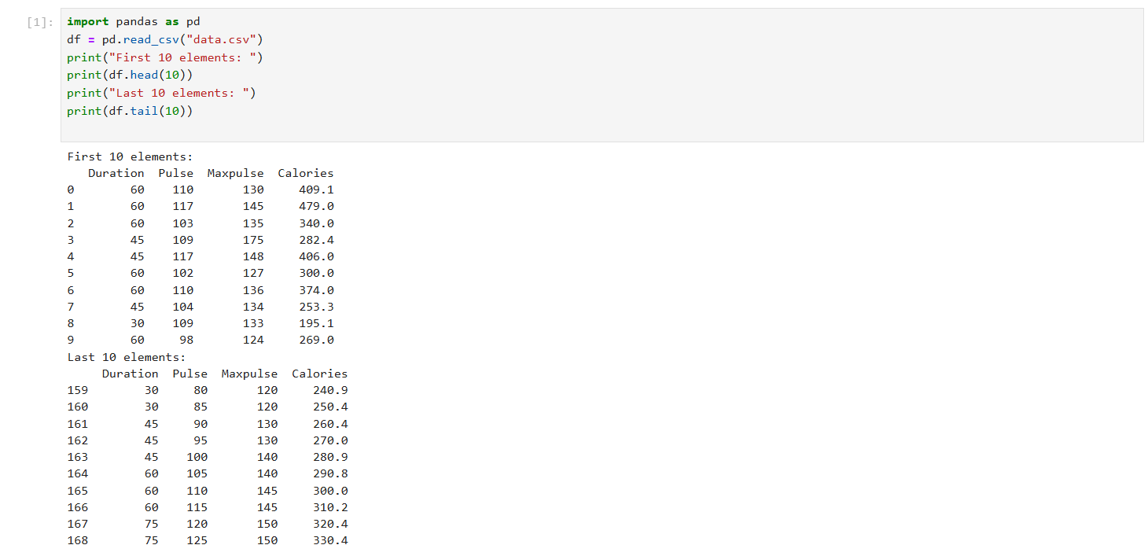

(b) Get the shape, index and column details

Code:-

print(df.info())

OUTPUT:-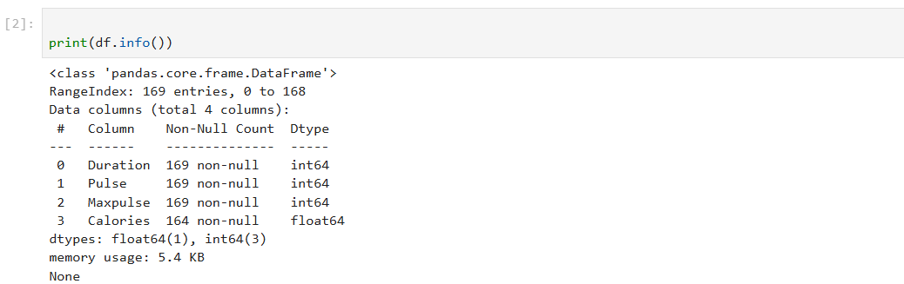

(c) Select/Delete the records (rows)/columns based on conditions.

Code:-

df2=df.query('Duration <45')

print(df2)

Output:-

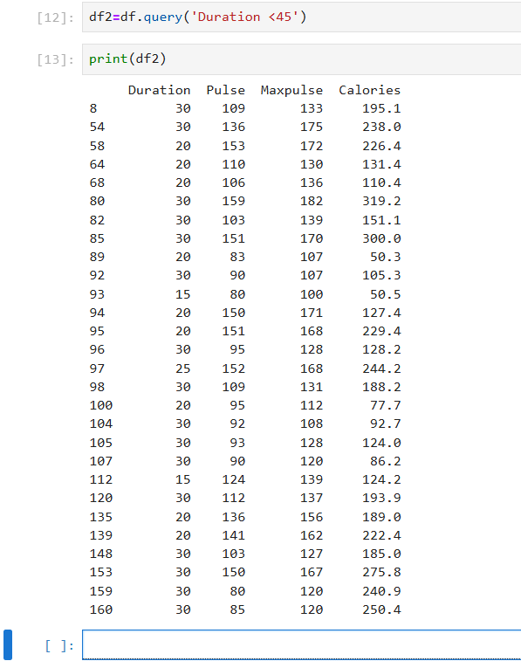

(d) Handle missing data by detecting and dropping/ filling missing values.

Code:-

print(df.dropna())

print(df.fillna(300,inplace=True))

Output:-

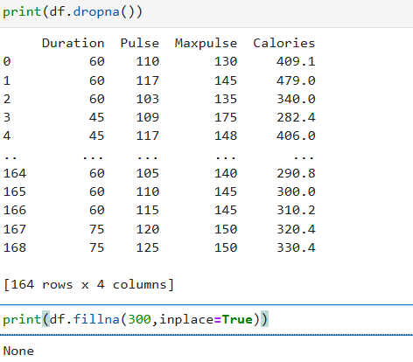

(e) Visualize data using Line Plots, Bar Plots, Histograms,  and Scatter Plots.

Code:- # scatter plot

import matplotlib.pyplot as p

df.plot(kind = 'scatter',x='Duration',y='Pulse')

Output:-

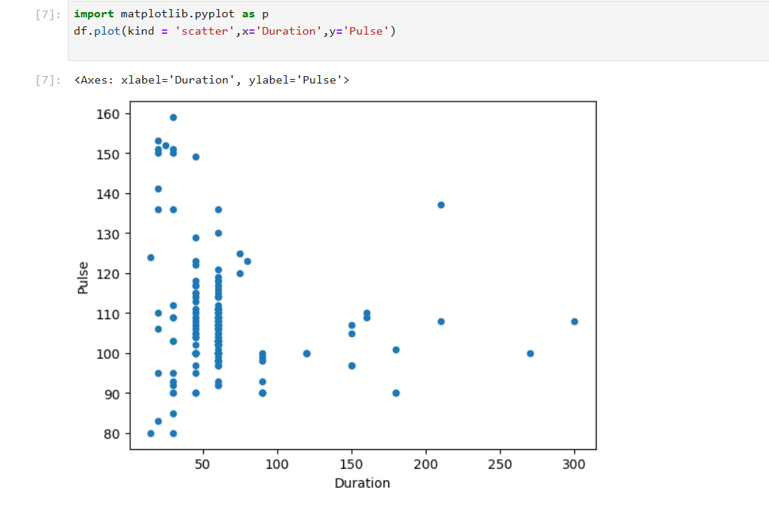

Code:- #Histogram

df["Duration"].plot(kind = 'hist')

Output:-

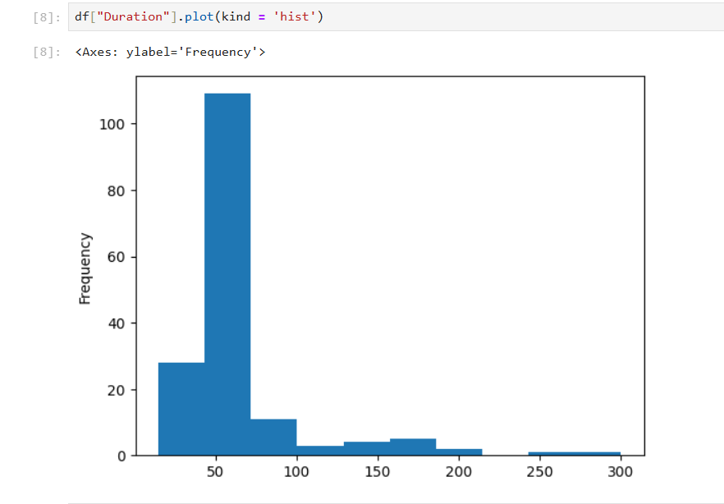

Code:- #Bar

df["Pulse"].plot(kind = 'bar')

Output:-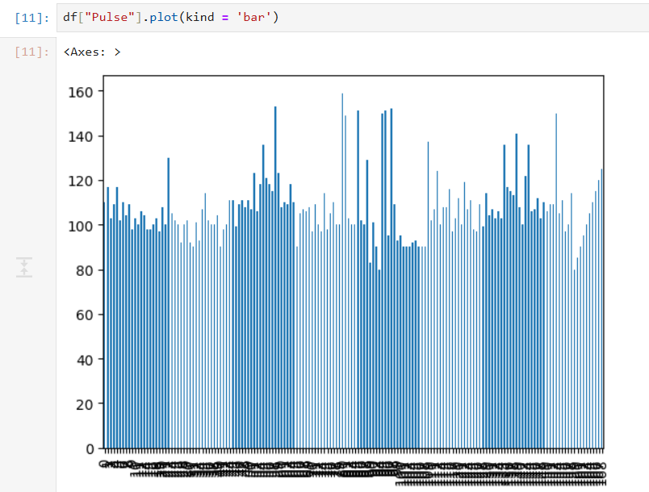

Code:- #line

df["Duration"].plot(kind = 'line')

Output:-

