Class name : SY CSE(IOT)

Rollno : 2007

Urn no : 1022101007

Batch : S1

EXPERIMENT 4

1. Implement OOP concepts.
2. Write a program to find sum of two numbers using class and methods

CODE:-

class sum:

def __init__(self):

self.a = int(input("Enter first number : "))

self.b = int(input("Enter second number : "))

def sum1(self):

return self.a+self.b

A = sum()

print(A.sum1())

OUTPUT:-

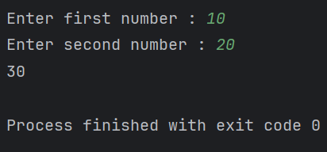

1. Write a program to read 3 subject marks and display pass or failed using class and object

CODE:-

class marks:

def __init__(self):

self.sub1 = int(input("Enter marks of subject 1 out of 100: "))

self.sub2 = int(input("Enter marks of subject 2 out of 100: "))

self.sub3 = int(input("Enter marks of subject 3 out of 100: "))

def result(self):

sum = (self.sub1+self.sub2+self.sub3)/3

if sum<36:

print("Fail")

else:

print("Pass")

def main():

A = marks()

A.result()

main()

CODE:-

