Class name : SY CSE(IOT)

Rollno : 2007

Urn no : 1022101007

Batch : S1

EXPERIMENT 5

5. Create user defined functions with different types of function arguments also demonstrate use predefined functions

a) Write a python program to print date, time using date and time functions.

CODE:-

from datetime import datetime

current_datetime = datetime.now()

print("Current date:", current_datetime.strftime("%Y-%m-%d"))

print("Current time:", current_datetime.strftime("%H:%M:%S"))

print("Current date and time:", current_datetime.strftime("%Y-%m-%d %H:%M:%S"))

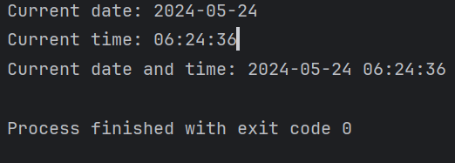

b) Write a python program which accepts the radius of a circle from user and computes the area (use math module).

CODE:-

import math

def area():

radius = int(input("Enter the radius of Circle: "))

print("Area of Circle = ",(radius**2)*math.pi)

area()

OUTPUT:-

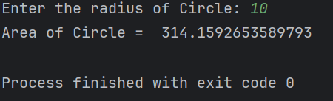

c) Write a python program to find the factorial of a number using recursion

CODE:-

def rec(x):

if x==0:

return 1

else:

return x*rec(x-1)

X = int(input("Enter number to find factorial : "))

print("The factrial = ",rec(X))

OUTPUT:-

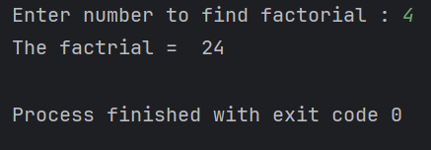

d) Demonstrate the following kinds of Parameters used while writing functions in

Python.

i) Positional Parameters ii) Default Parameters

iii)Keyword Parameters iv) Variable length Parameters

CODE:-

def greet(name, message="Good day!"):

print(f"Hello, {name}! {message}")

def sum_values(*args):

total = 0

for num in args:

total += num

return total

def print_info(**kwargs):

for key, value in kwargs.items():

print(f"{key}: {value}")

# Positional Parameters

print("Positional Parameters:")

greet("Alice")

# Default Parameters

print("\nDefault Parameters:")

greet("Bob", "How are you?")

# Keyword Parameters

print("\nKeyword Parameters:")

print_info(name="Charlie", age=25, city="London")

# Variable Length Parameters (positional)

print("\nVariable Length Parameters (positional):")

result = sum_values(1, 2, 3, 4, 5)

print("Sum of values:", result)

# Variable Length Parameters (keyword)

print("\nVariable Length Parameters (keyword):")

print_info(name="David", age=30, city="New York")

OUTPUT:-

