Class name : SY CSE(IOT)

Rollno : 2007

Urn no : 1022101007

Batch : S1

EXPERIMENT 6

1. Write a python program to open and write “hello world” into a file?

CODE:-

with open("output.txt", "w") as file:

file.write("hello world\n")

print("Successfully wrote 'hello world' to output.txt")

OUTPUT:-

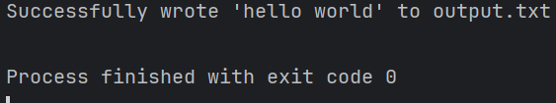

b) Write a python program to write the content “hi python programming” for the existing file.

CODE:-

with open("output.txt", "a") as file:

file.write("hi python programming\n")

print("Successfully appended 'hi python programming' to output.txt")

OUTPUT:-

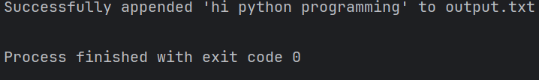

c) Write a program named copyfile. This program should prompt the user for the names of two text files. the contents of the first file should be input and written to the second file

CODE:-

def copy_file():

input_file_name = input("Enter the name of the input file: ")

output_file_name = input("Enter the name of the output file: ")

try:

with open(input_file_name, "r") as input_file, open(output_file_name, "w") as output_file:

content = input_file.read()

output_file.write(content)

print(f"Contents of '{input_file_name}' copied to '{output_file_name}' successfully.")

except FileNotFoundError:

print("One of the files does not exist. Please make sure both files exist and try again.")

if __name__ == "__main__":

copy_file()

OUTPUT:-

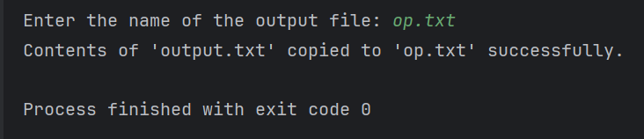

d) Python program to count frequency of characters in a given file.

CODE:-

def count_character_frequency(file_name):

try:

# Open the file in read mode

with open(file_name, "r") as file:

# Read the contents of the file

content = file.read()

# Create a dictionary to store character frequencies

frequency = {}

# Iterate through each character in the content

for char in content:

# Increment the frequency count for the character

frequency[char] = frequency.get(char, 0) + 1

return frequency

except FileNotFoundError:

print(f"Error: File '{file_name}' not found.")

if __name__ == "__main__":

file_name = input("Enter the name of the file: ")

character_frequency = count_character_frequency(file_name)

if character_frequency:

print("Character frequency in the file:")

for char, freq in character_frequency.items():

print(f"{char}: {freq}")

OUTPUT:-

