Class name : SY CSE(IOT)

Rollno : 2007

Urn no : 1022101007

Batch : S1

EXPERIMENT 8

**Implement  
various in built functions of Numpy library**

1. Using a numpy module create an array and check the following:  
   1. Type of array

2. Axes of array

3. Shape of array

4Type of elements in array

CODE:-

import numpy as np

a = np.array([1,2,3,4,5,6,7,8,90,100])

print("Type of array : ",type(a))

print("Shape of array : ",a.shape)

print("Type of element in array : ",type(a[2]))

OUTPUT:-

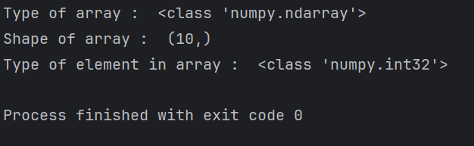

1. Using a numpy module create array and check the following:  
   1.List with type float
2. 3\*4 array with all zeros
3. From tuple
4. Random values

CODE:-

import numpy as np

l1 = [1.0,2.0,3.3,4.5]

a = np.array(l1)

print("Type of array : ",type(a))

b = np.zeros((3,4))

print("Array with all zeros : ")

print(b)

c = (1,2,3,4,5,6,7,8,9,0)

d = np.array(c)

print("Array using typle : ",d)

e = np.random.random((5,5))

print("Array with random values : ", e)

OUTPUT:-

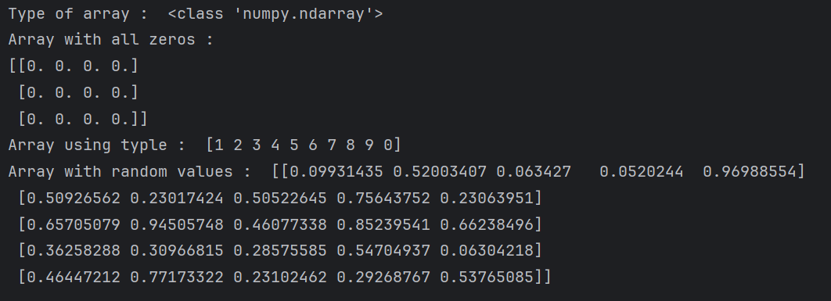

1. Using a numpy module create array and check the following:  
   1. Reshape 3X4 array to 2X2X3 array  
   2. Sequence of integers from 0 to 30 with steps of 5
2. Flatten array
3. Constant value array of complex type

CODE:-

import numpy as np

a = np.random.random((3,4))

print("Array with 3\*4 Shape : ")

print(a)

a.reshape(2,2,3)

print("Array converted to 2\*2\*3 : ")

print(a)

b = np.linspace(0,30,5)

print("Array using linspace : ")

print(b)

a.flatten()

print("Array after flatern : ")

print(a)

OUTPUT:-

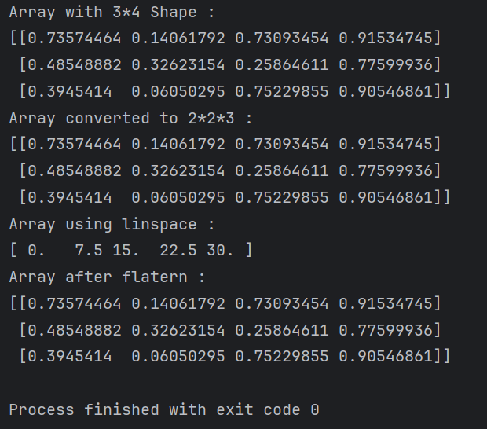

1. Using a numpy module create array and perform different statistical operation on array.

CODE:-

import numpy as np

a = np.random.random(10)

print(a)

print("Min = ",np.amin(a))

print("Max = ",np.amax(a))

print("Standard deviation = ",np.std(a))

print("Average = ",np.average(a))

print("PTP = ",np.ptp(a))

OUTPUT:-

