**P H Y S I C S**

T h e

M e c h a n I c a l

T o r c h

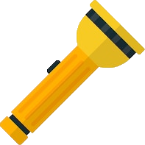

**A C K N O W L E D G E M E N T**

I feel proud to present my investigatory  
project. I would like to thank the principal  
of my school, **MR. ALOK SHARMA** for  
permittiong the use of resources of school  
for completing the project and his  
constructive advice.. I would like to express  
my sincere gratitude to my physics mentor  
**MR. SUDHIR DATIR**. This project wouldn’t  
have been feasible without the proper and  
rigorous guidance of him.  
Rigorous hardwork has been put into this  
project to ensure that it proves to be the  
best.I hope that this project will prove to be  
a breeding ground for next generation of  
students and help them in every possible  
way.

**1**

**C e r t I f I c a t e**

THIS IS TO CERTIFY THAT THE PROJECT TITLED **THE MECHANICAL TORCH** HAS BEEN SUCCESSFULLY COMPLETED  
BY  
**ABHISHEK S. CHAUDHARY** STUDYING IN CLASS XII A. IN PARTIAL  
FULLFILLMENT OF THE PHYSICS PRACTICAL EXAMINATION,  
AISSCE 2018-2019.  
I CERTIFY THAT THIS PROJECT IS DONE BY HIM WITH HIS  
OWN EFFORTS, WITH THE GUIDANCE OF THE TEACHER.

INTERNAL EXAMINER EXTERNAL EXAMINER

PRINCIPAL.

**2**

**P R I N C I P l e**

**The Mechanical torch** OR SIMPLY **Emergency torch** WORKS ON THE PRINCIPLE OF **ELECTROMAGNETIC INDUCTION.**

It states that:

WHEN THE **MAGNETIC FLUX** THROUGH A COIL CHANGES CURRENT IS **INDUCED** IN THE COIL.

.

**3**

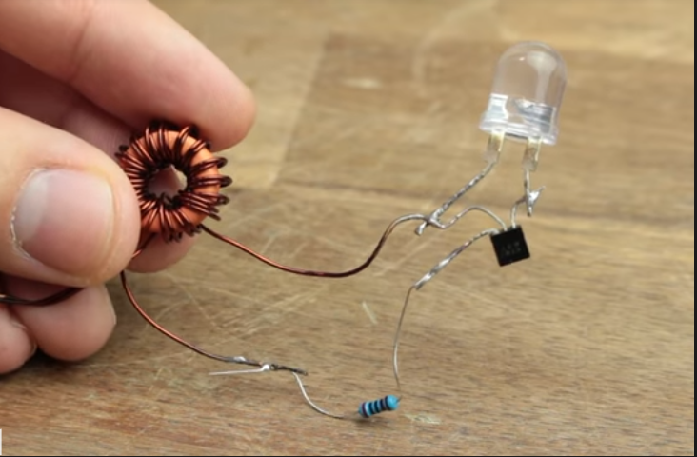

The MaGNETIC FIELD IS PRODUCED BY STRON **NEODYMIUM MAGNETS** WHICH MOVE GIVING RISE TO CHANGING MAGNETIC FIELD HENCE **INDUCING EMF** IN THE COIL.

**4**