**Store Management System**

**(Payment Module)**

Table of Contents

Introduction

* 1. Project Summary

1.2 Purpose of the Document

1.3 Scope

1.4 System Purpose

1.5 Users

1.6 Technologies to be used

1.7 Functional Requirements

1.8 Non-functional Requirements

1.9 Class Diagram

1.10 Flow Diagram

1.11 Use-case Diagram

1.12 Database Tables

**1. Introduction**

**1.1 Project Summary**

The Store Management System is a Web Application is intended to provide complete solutions for customers. It will enable a customer to browse the products and purchase them online without having to visit store physically. We have five modules those are

* User Module
* Inventory Module
* Payment Module
* Invoice Module
* Reports

**1.2 Purpose of the Document**

The purpose of this document is to make easy to understand more about this web application and features of this web application. In this document everything is in-detail about this application and it acts like a guide to the customer and also developer.

**1.3Scope**

We have searching mechanisms for easy and quick access to particular product and services. This Application makes payment process easy and securely. When user proceeds to check out the products, after that payment process initiated. Then it shows options for payment mode (user can choose the mode of payment) and this application made this payment process in a secured way.

**1.4 System Purpose**

This Web Application is a virtual store where visitors come to this website and pick the product by their choice and if they want purchase them. In this application, user can purchase products by making online payment for this user just need to enter their card details and save the card details if they want. By saving the card details, when purchasing something they don’t need to give card number every time, simply they can choose card in the saved card list and proceed to the payment and for refund process they need to enter bank account details. This application is promising and trustworthy towards the customer and also online sellers can get wide range of customers. It saves time for the customers, no waiting in traffic to buy small things, no need to go to market. In this application everything in one place, user can purchase products online.

**1.5 Users**

In this application we have 3 types of users

**Admin**: Admin team can manage everything related to the application like adding/deleting/modifying the products and their prices and also manage user queries and the solving user issues related to the application.

**User**: A registered user can browse the products and purchase products. Registered user get availability on offers and user can change their details.

**Seller**: It means seller of the product. This application is also useful to the online retailers who are going to sell their products online to the customers.

**1.6Technologies to be used:**

* Windows XP
* Java
* Apache Tomcat Web Server
* Oracle
* JSP

**1.7 Functional Requirement of Payment Module:**

* Adequate payment mechanism and gateway for all popular credit cards, debit cards, and other relevant options are also available
* User can choose their payment mode.
* If any product returned within the provided time then refund initiated.
* User can also view the Payment History.

**1.8 Non Functional Requirements of Payment module:**

* Payment Process is secured.
* User Bank Account details maintained securely.
* Better Interface provided that payment process makes easy to user.

**1.9 Class Diagram:**

**Seller**

**Name: string**

**Id : Int**

**card no: int**

**WebAddress: string**

**Receives payment**

**Cash on Delivery**

**Amount: Float**

**UPI Payment**

**Add UPI Id: Int**

**Validates upi id**

**Debit/Credit card**

**Name on card: string**

**Card no: string**

**Card Expiry: int**

**Card cvv: int**

**1) Authenticates Payment**

**2) Validates Account**

**Payment modes**

**Credit card: string**

**Debit card: string**

**UPI: String**

**Cash on delivery: Float**

**Payments initiated by one of these modes**

**Payment**

**Amount: Float**

**1.10 Flow Diagram:**

**Cash On Delivery**

**Online Mode**

**Payment-modes**

**start**

**Credit/debit**

**CashCollector collects the Cash**

**Enter UPI ID**

**Enter card no, pin no and verify**

**Payment Processed**

**Seller(Name:_____ Account no:____ )**

**1.11 Use-case Diagram:**

**Cash**

**Credit/Debit**

**UPI ID**

**Payment**

**View Product Details**

**Customer**

**1.12 Database Tables:** 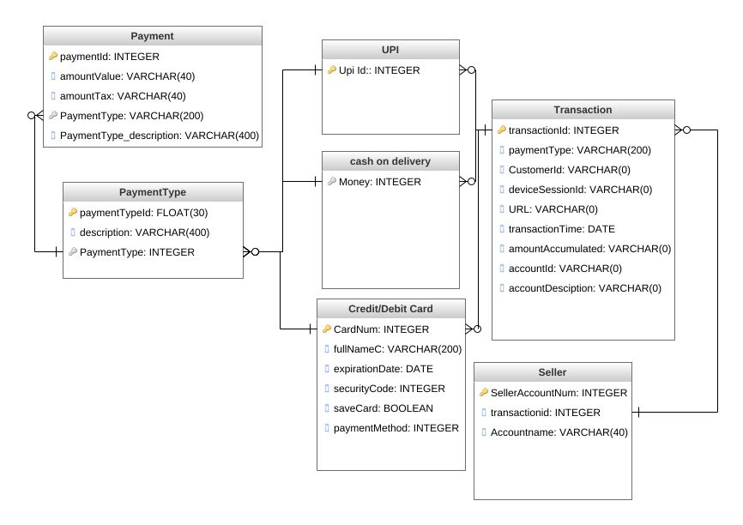

**Screen 1:**

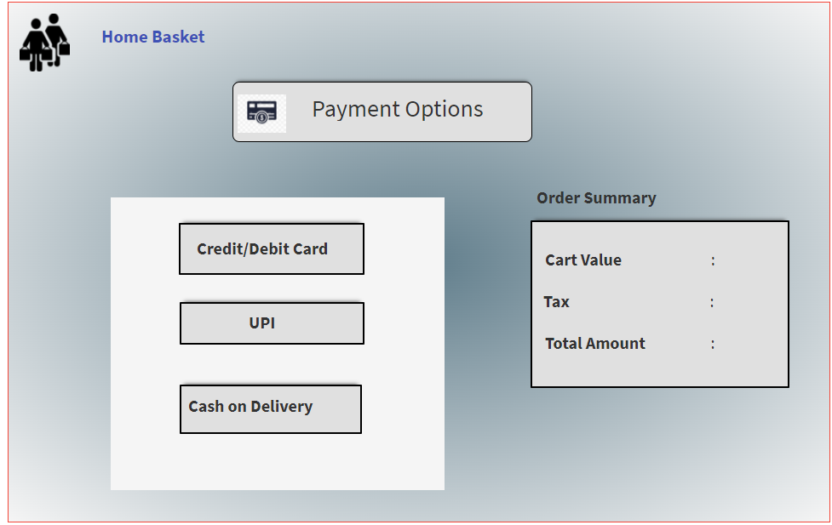

**Screen2:** 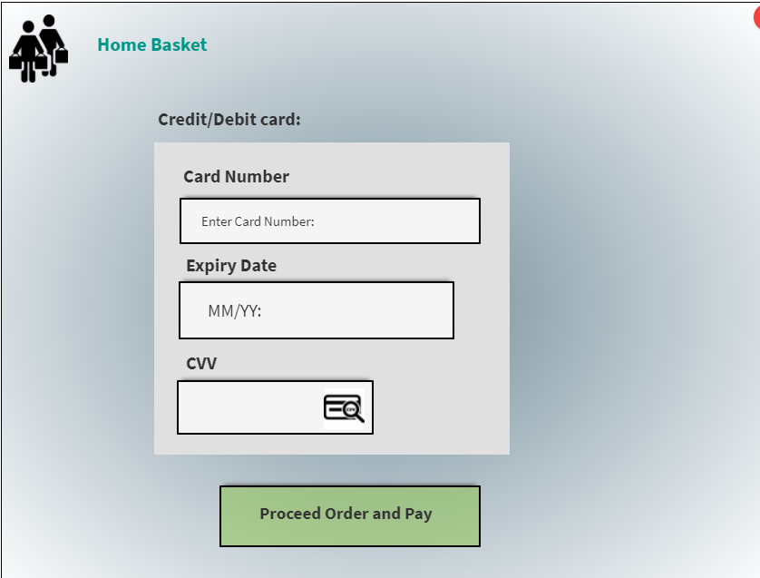

**Screen3:**

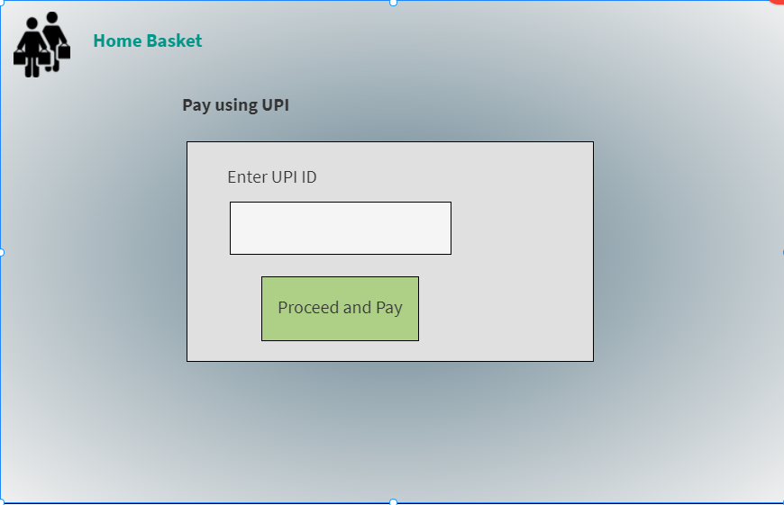

**Screen4:**

