First Day on GitHub

1. video

2. introduction to GitHub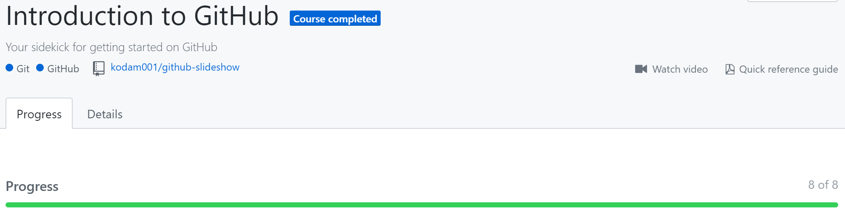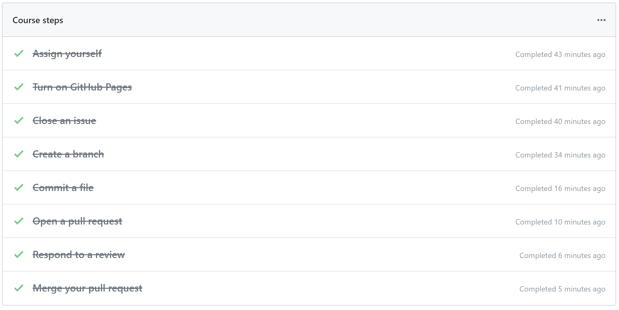

I understood how to use GitHub through this course.

3. Reading

4. Communicating using Markdown 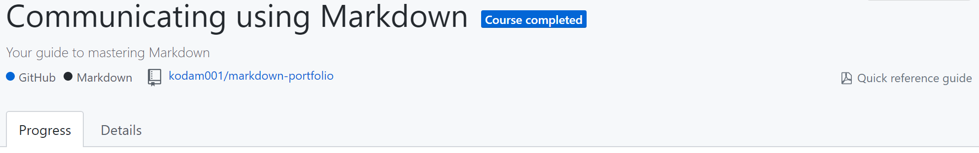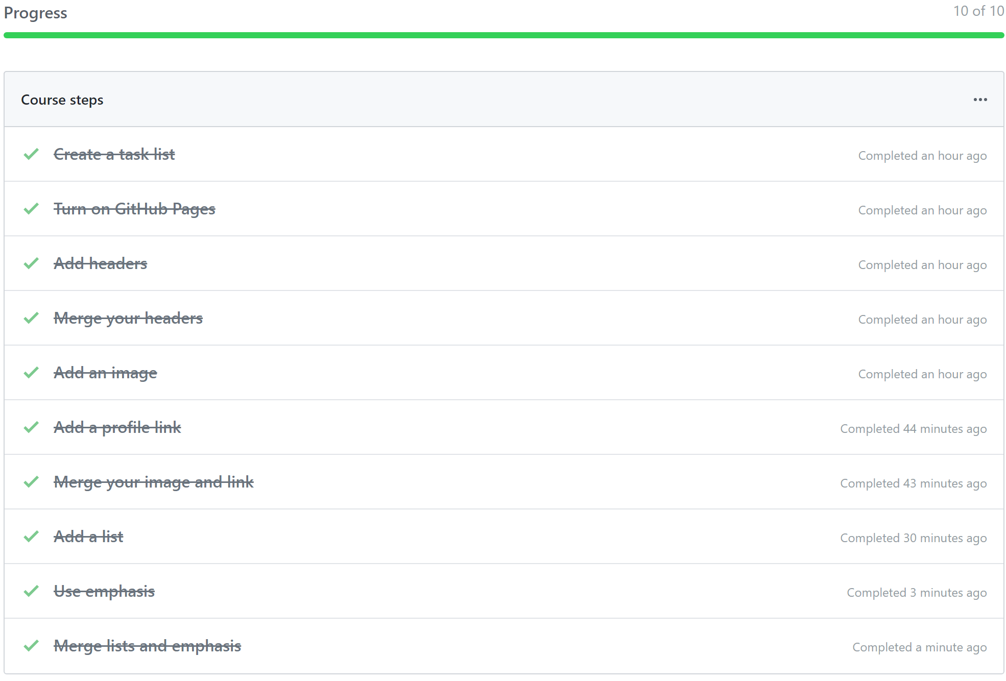

I learned how to create header with font size, add image, link, and emoji, and use bold and italic for emphases with GitHub.