

### 

### **NAME: GAGAN CHINNA**

**EMAIL:** [**KODAMGAGAN123@GMAIL.COM**](mailto:KODAMGAGAN123@GMAIL.COM)

1)Create three instances

2)Attach one EFS to two instance

3)Attach one EBS to two instance

1)

* Open aws console
* Go to ec2
* Create3 instances

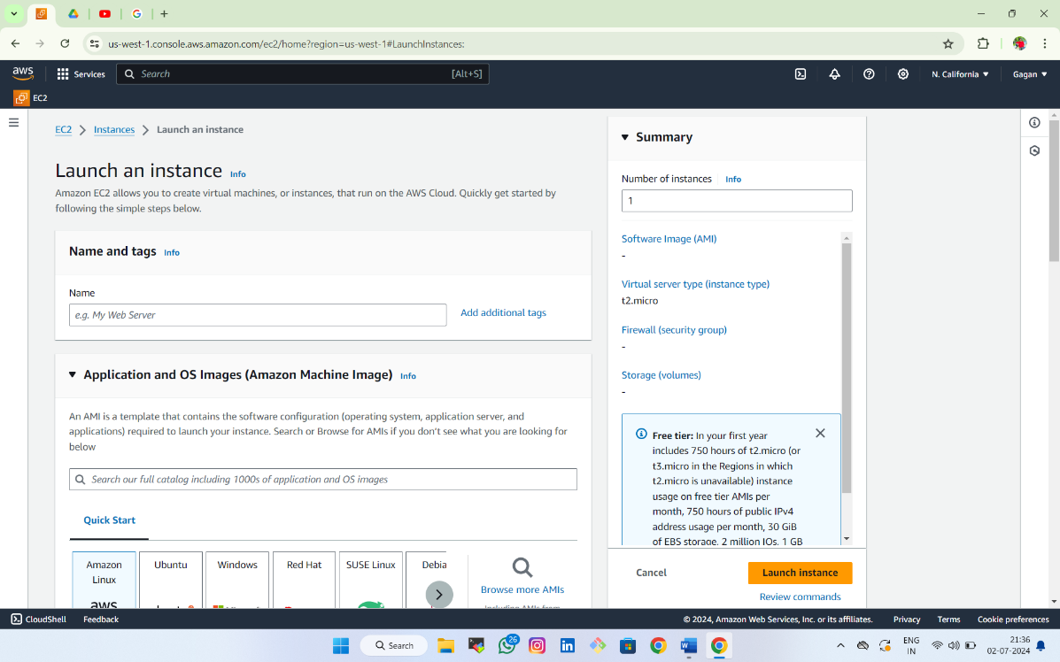

* Click on launch instance

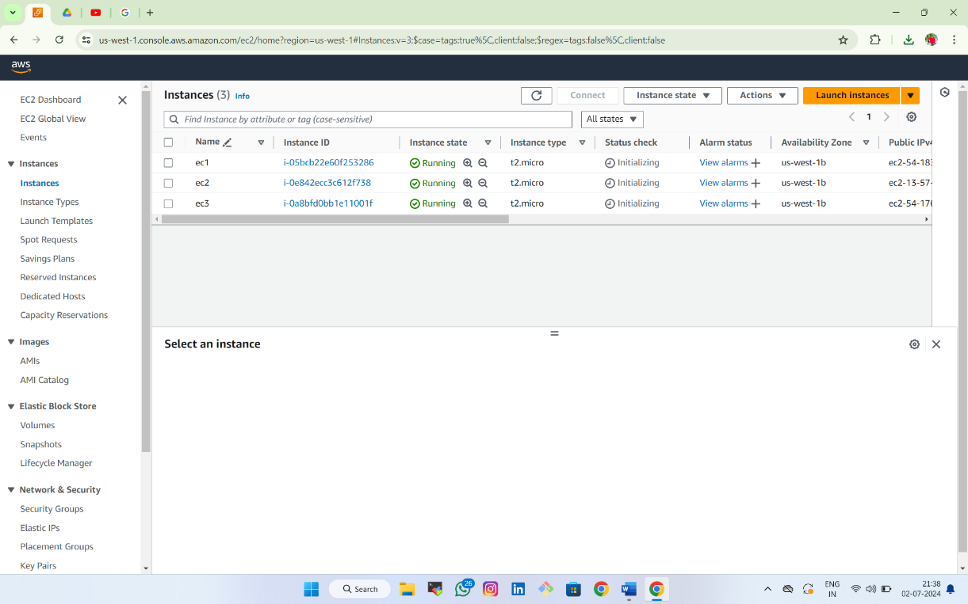

2)

* Create security group 1st
* Name/allow/default vpc/inbond rules
* Ssh/anywhere ipv4/range(0.0.0.0/0)
* Add rule all traffic(create)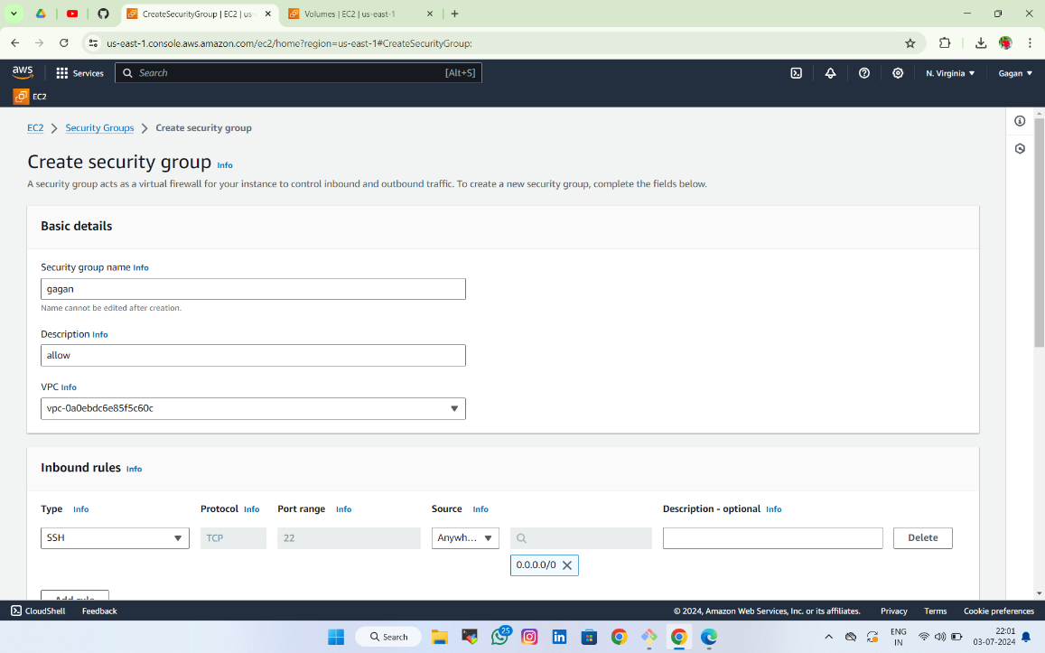

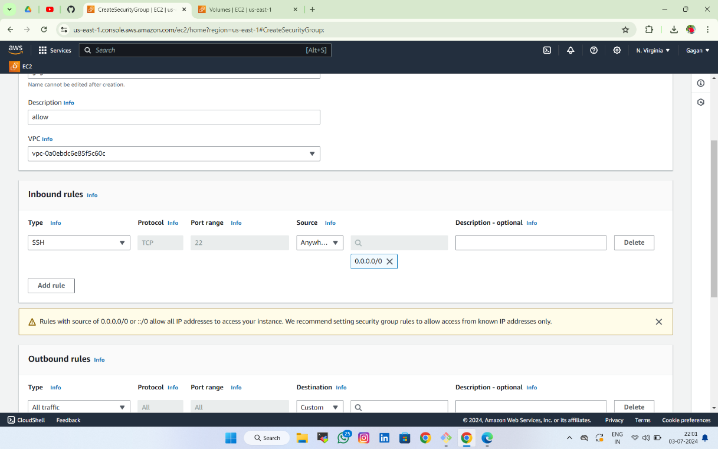

* Create file system
* Name/customised/network access/mount targets/my sg-i
* Create

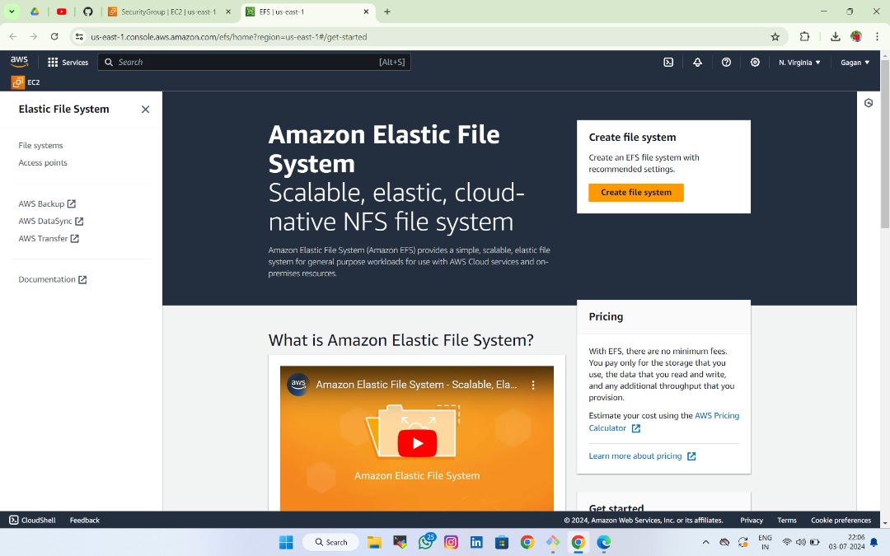

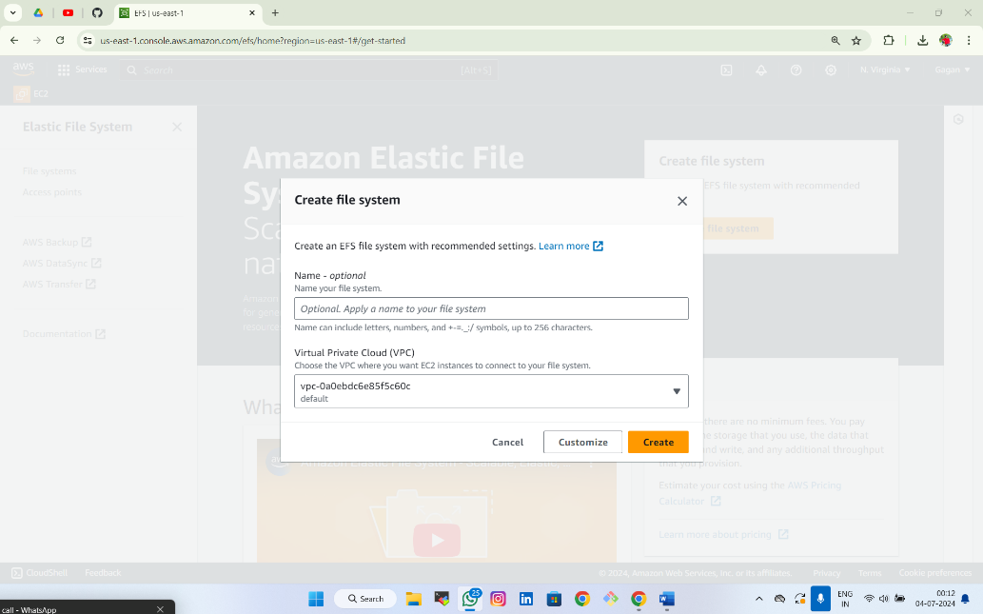

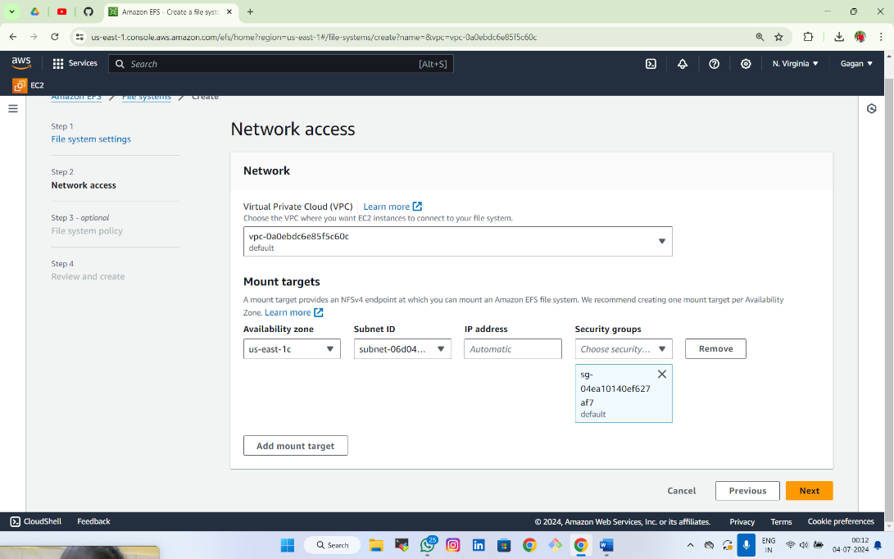

* Create two ec2 instances(ec1,ec2)
* Name/existing security group/add file system

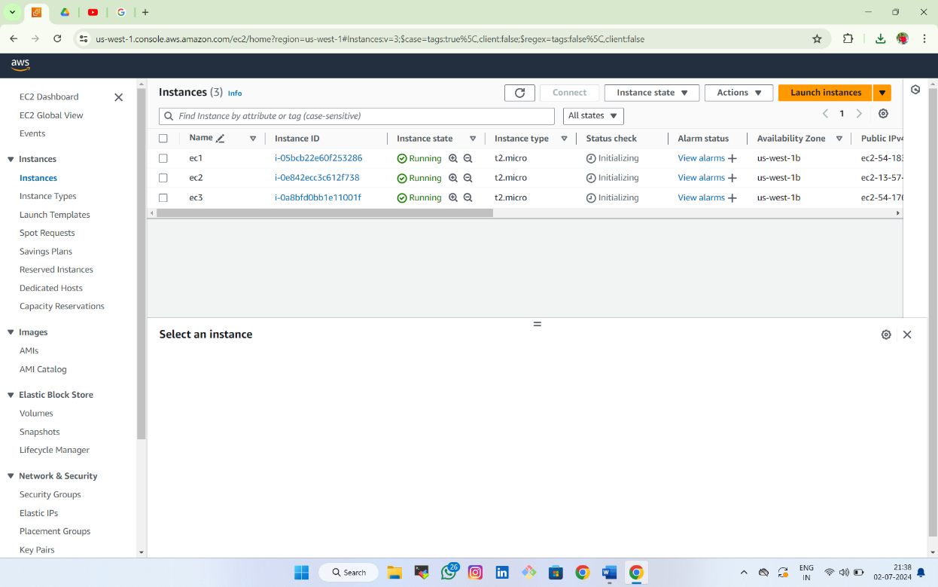

* Connect 2 ec2 instance in 2gitbashs
* Create file name and insert some matter in 1 instance
* 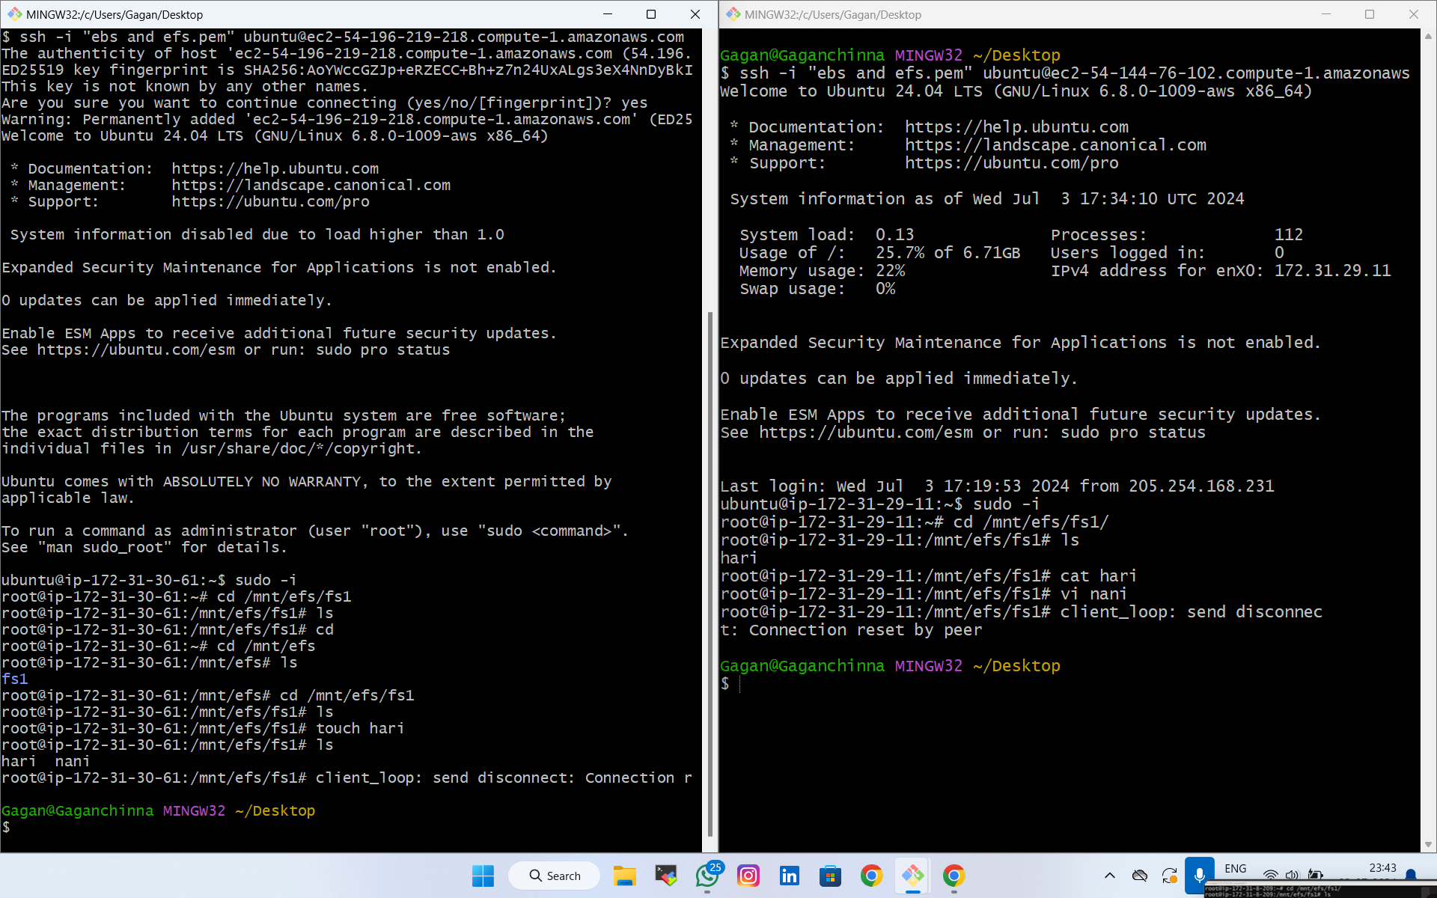It will be react in 2 instance also

3)

* Create volume and attach to 2 instances

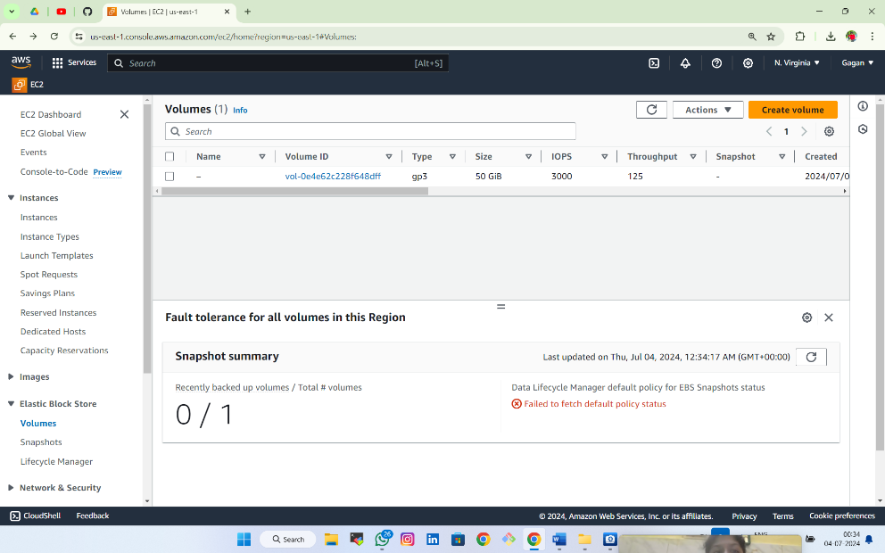

* 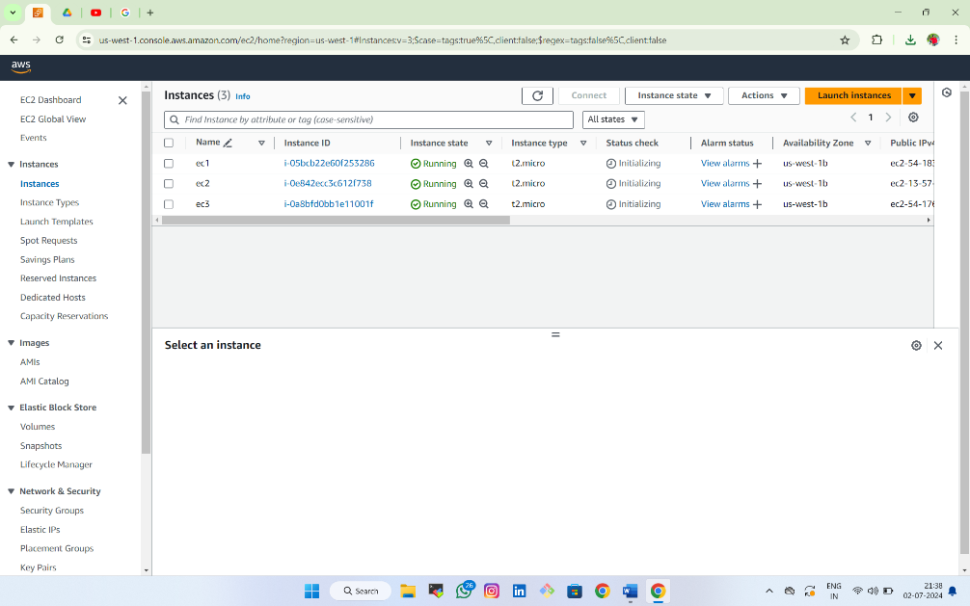Create two ec2 instance and connect in gitbash
* Lsblk to list all blocked devices
* Df -h to see disk space

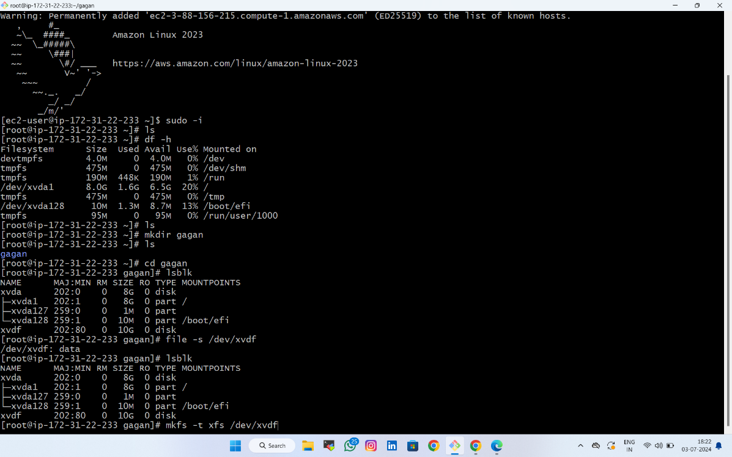

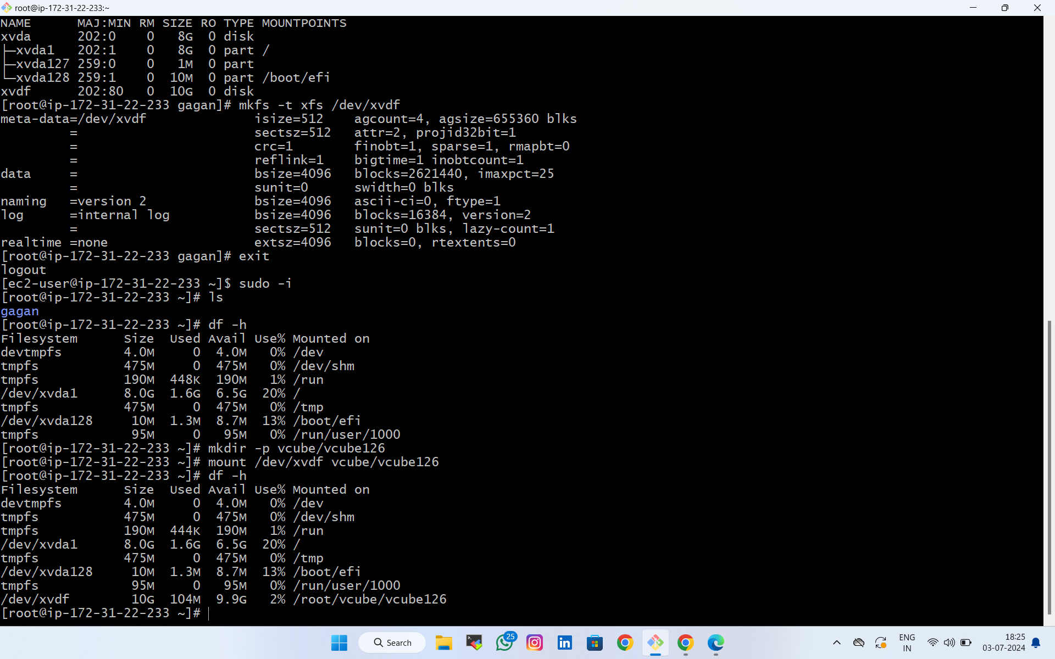

(Note): we cant attach one ebs to two instances at once

1st attach one volume to ebs and after completion deatch and attach to another instance