

**1.create three instance install ngnix and apply ALB?**

* **Before creating instance 1st create security group**

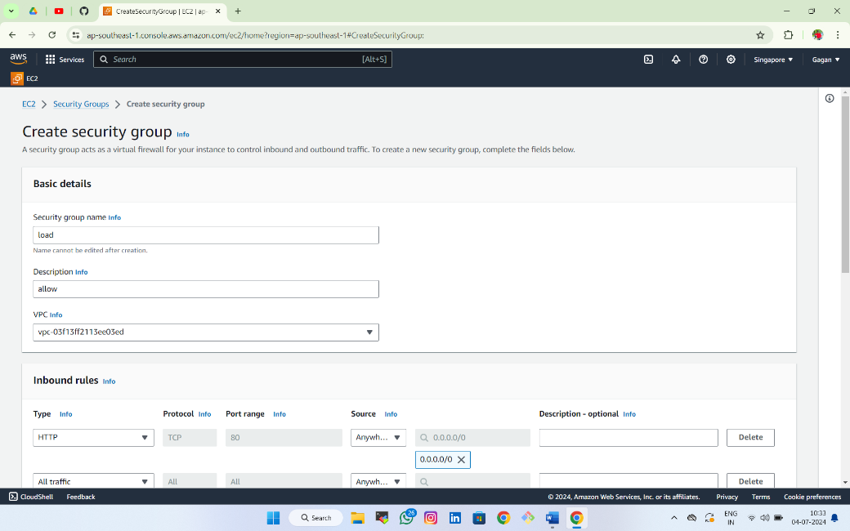**1.Create security group**

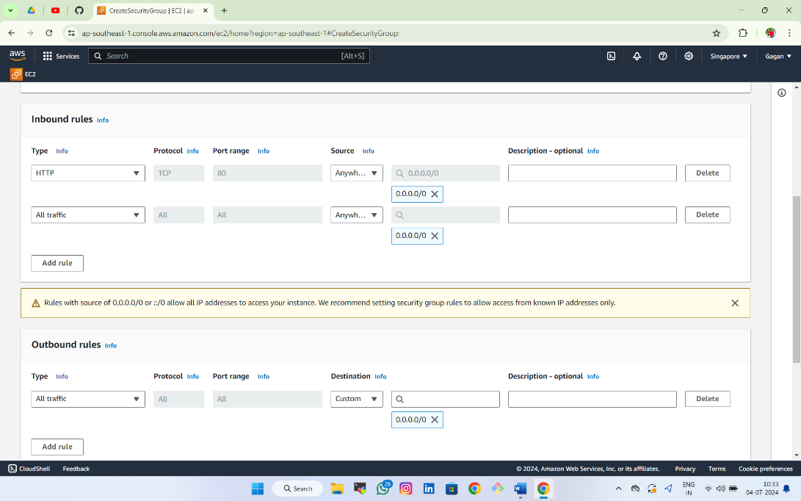

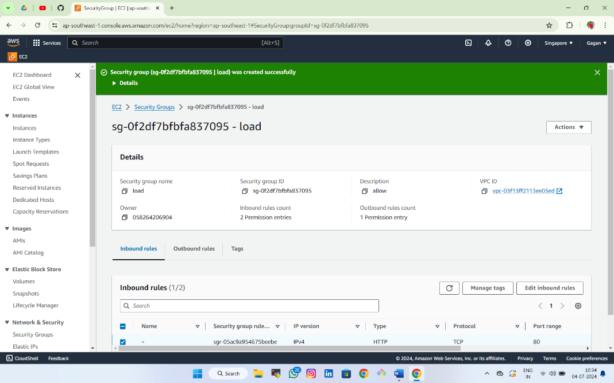

* **Create 3 instances with different availblity zones**

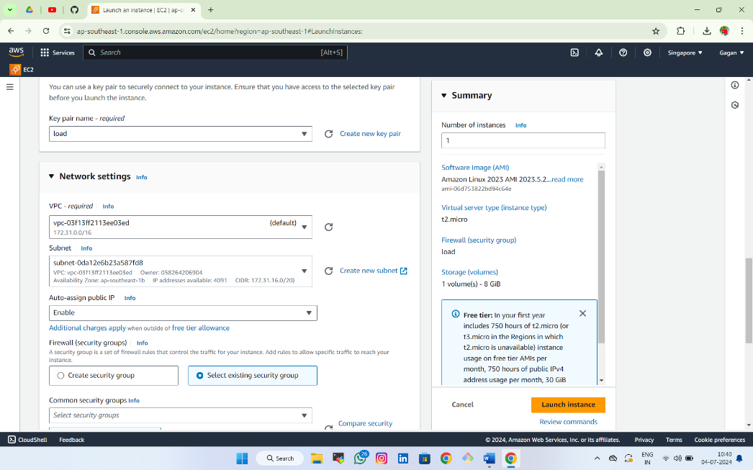

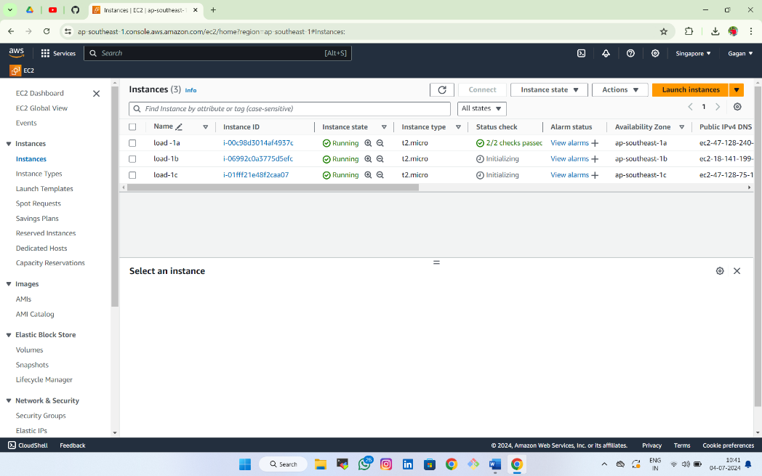

**Follow above steps for 3 instances and create**

* 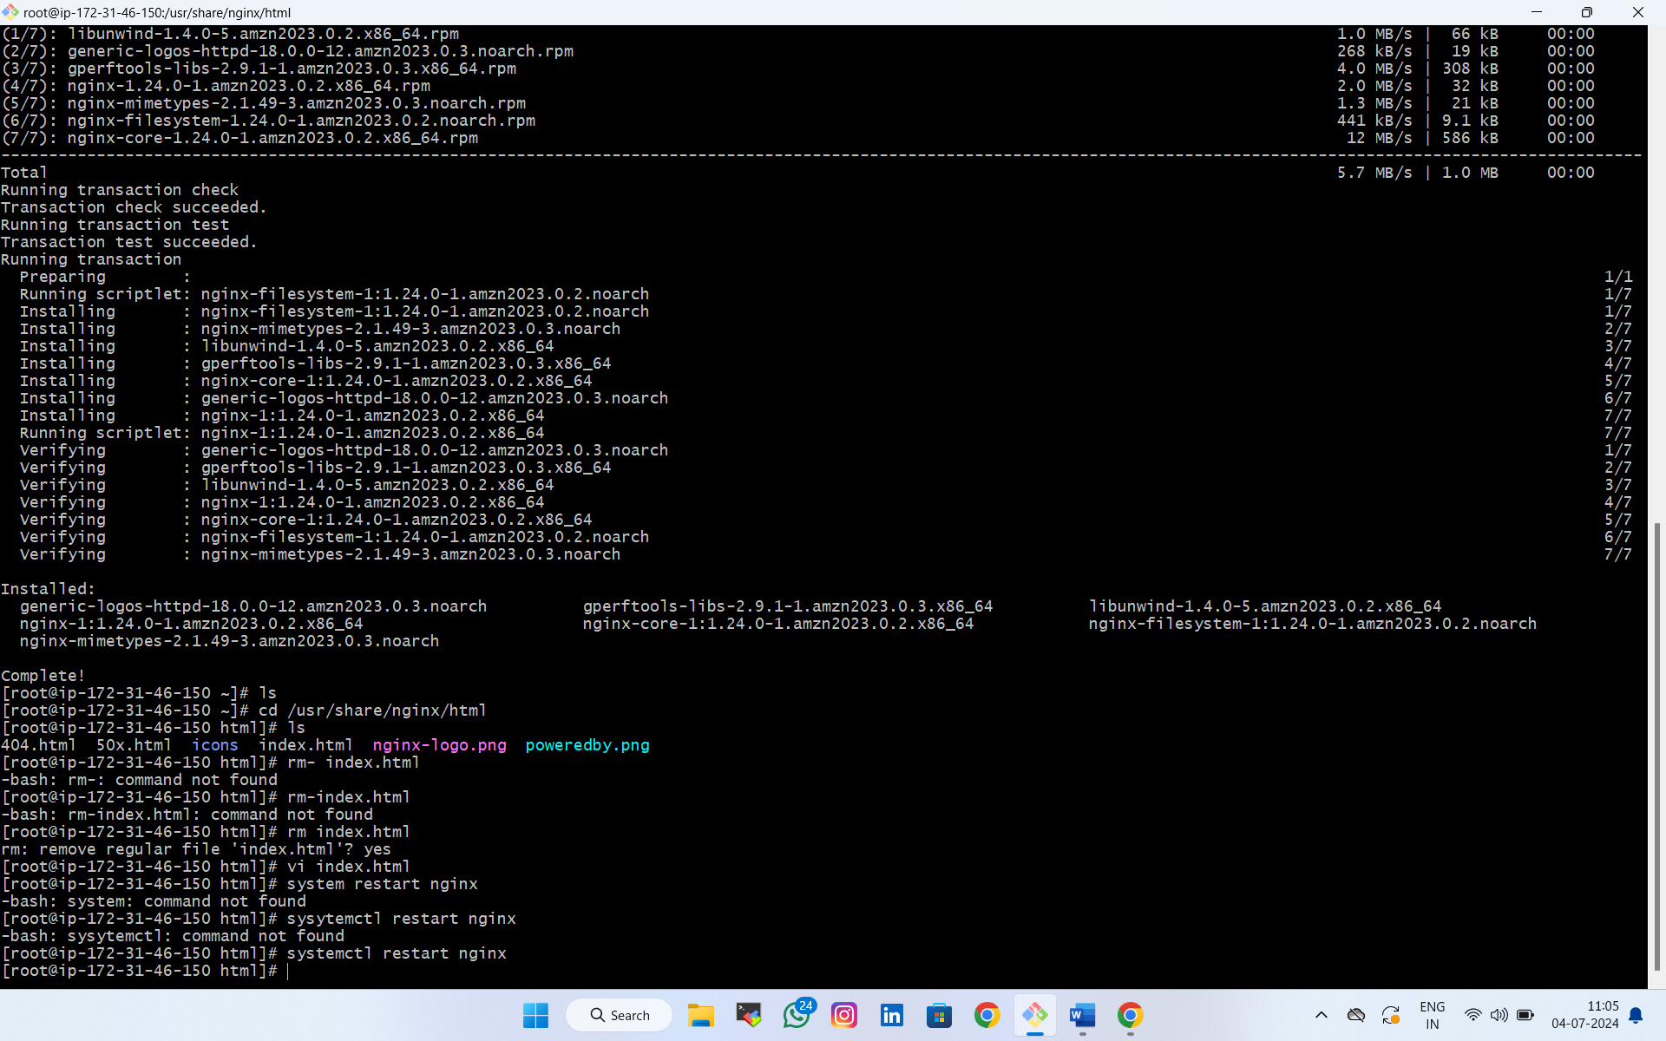**To connect instance install ngnix**
* **After copy public ip and open in new tab**
* **Do same process for three instances**









* **Create target group**
* 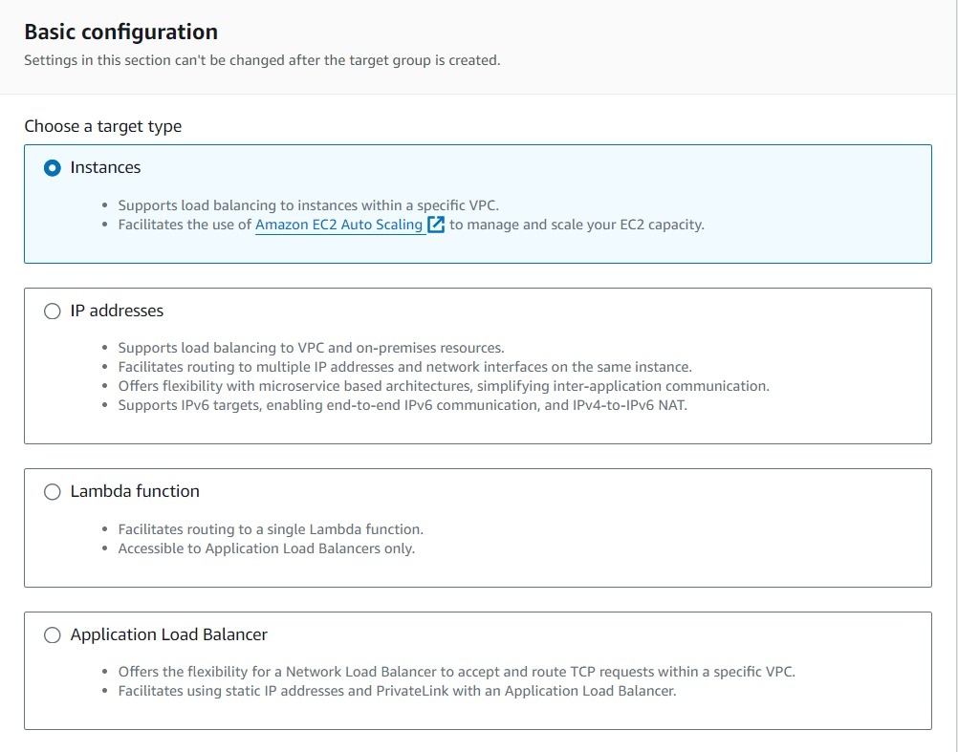**Choose target type**
* **Select all available instances & click on include as pending below**

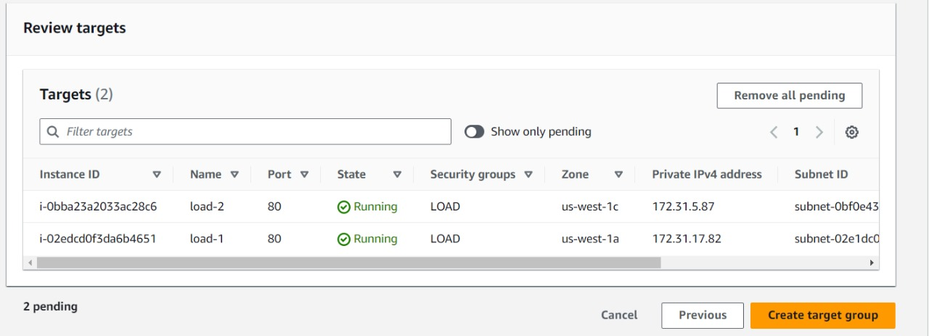

* **After create target group go to load balancer and create**

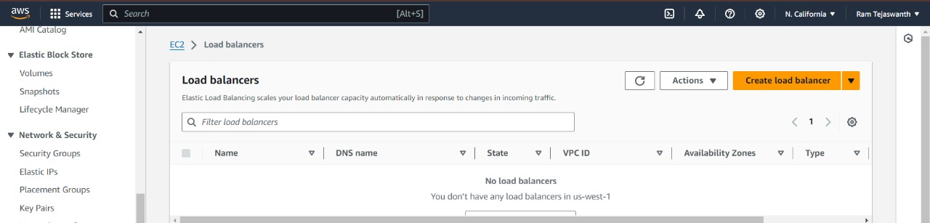

* **Select load balancer**
* **Name/availblity zone/**
* **Security group**

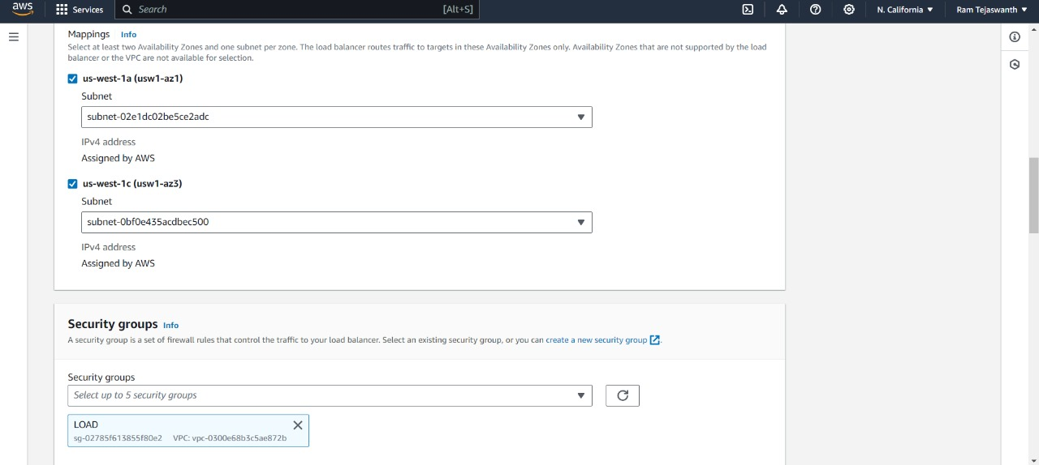

* **Select target group**

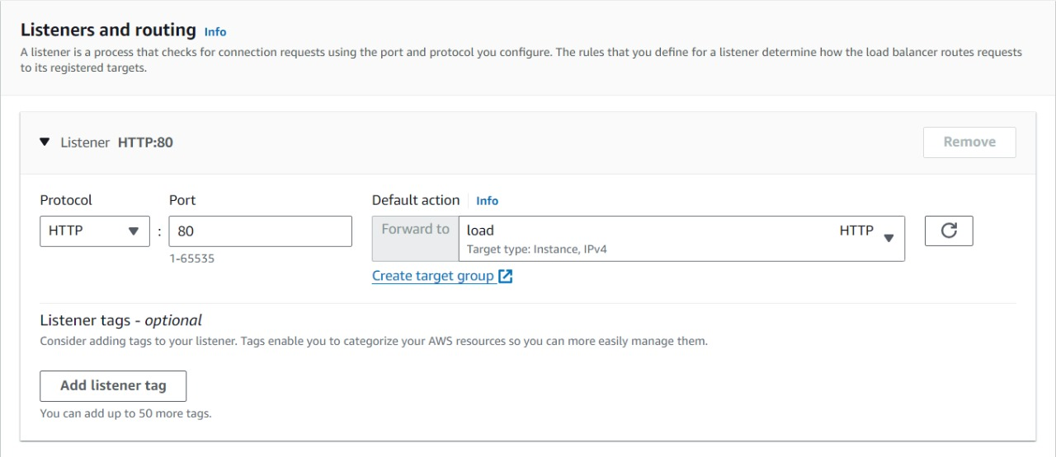

* 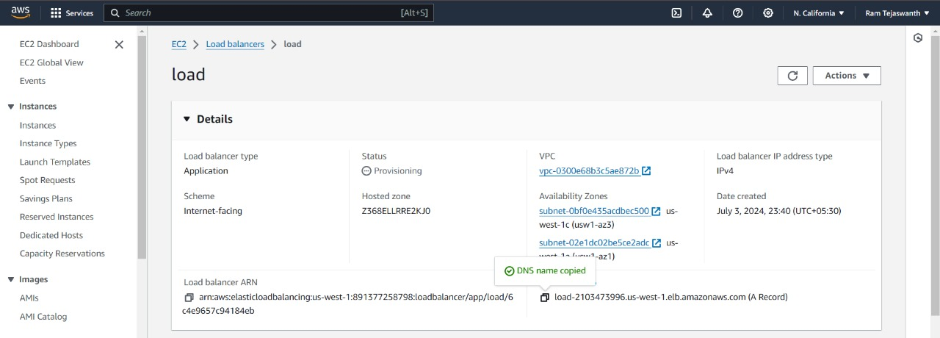**Click on create load balancer**
* **After creating load copy dns name and paste it in browser**

