Understanding Your Project:
Docker · Kafka · Flink
A concept-by-concept study guide, taught through real examples from the
Real-Time Crypto Market Anomaly Detection pipeline

Real-Time Big Data Processing · Free University of Bozen-Bolzano
Student study companion — Kodanda Challa

🔑 How to use this guide Read Parts 0–5 top to bottom. Each technology is explained with a picture and a real snippet from your code. Then close the file and try the Part 6 exam questions from memory — if you can answer them and narrate the Part 5 trace out loud, you understand the project.

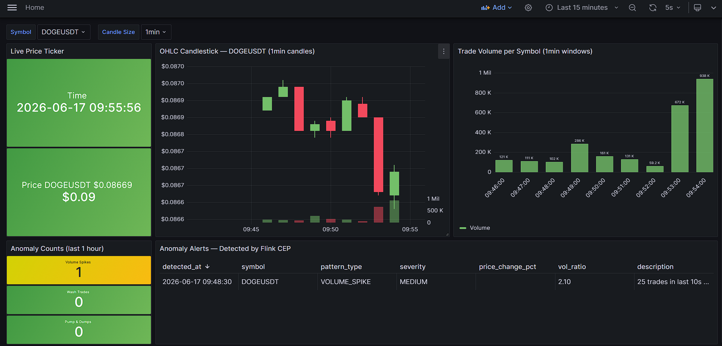

Part 0 — The big picture first
Classic batch processing collects data into a pile, then runs a job over the whole pile (“compute yesterday’s sales at midnight”). Stream processing flips this: data arrives continuously and never ends, and you process each event as it arrives, producing results within seconds.
Three properties define our problem — the “3 Vs”:
- Volume: hundreds of trades per second; too much to “just store and query later”.
- Velocity: the data is a never-ending stream; the job runs forever.
- Variety / Veracity: events can arrive late or out of order, so “correctness” needs care.
🔑 The whole pipeline in one sentence A producer reads live trades and writes them to Kafka; Flink reads from Kafka, aggregates and detects anomalies, and writes results to PostgreSQL; Grafana reads PostgreSQL and draws a live dashboard. Docker packages and runs all of it.

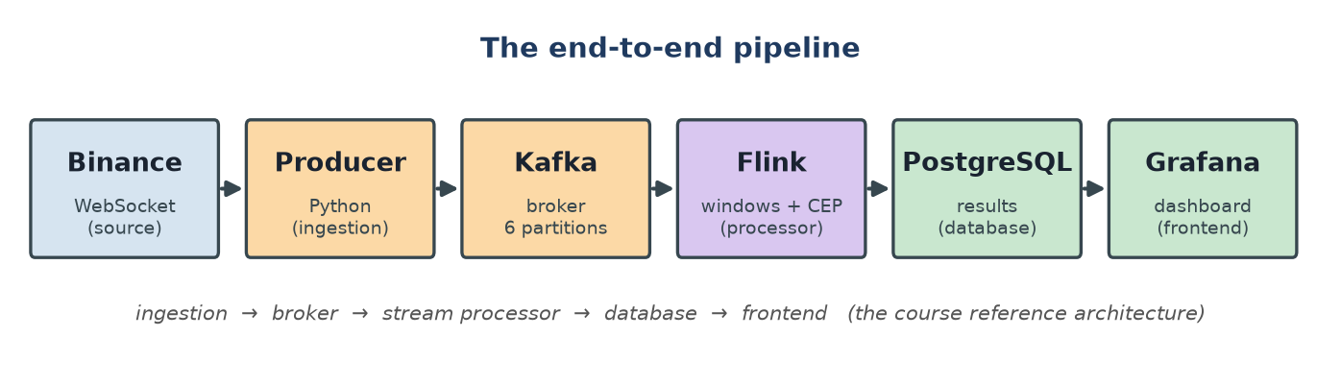
Figure 1 — The end-to-end pipeline. Keep this picture in your head: every concept in this guide lives at one of these arrows.
Why can’t we skip any piece? The “what breaks without it” test:
Piece | What breaks without it
Kafka | Producer and Flink become tightly coupled; if Flink is slow or down, trades are lost. Kafka is the buffer, decoupler and replay log.
Flink | You have raw trades but no candles, no anomaly detection, no event-time correctness. Flink is the brain.
PostgreSQL | Grafana can’t easily query a Kafka topic for “last hour of alerts”. The DB gives queryable, indexed, persisted results.
Grafana | No human-facing output. It is the frontend.
Docker | “Works on my machine” chaos: 5 services, specific Java/Python versions, networking. Docker makes it one reproducible command.

Part 1 — Docker & Docker Compose
Your Flink job needs Java 17 + Python 3.11 + PyFlink + a specific Kafka connector JAR; your producer needs Python 3.11 + two libraries. Installing all of that natively is fragile. Docker packages an app plus its entire environment into an image; a running instance of an image is a container that behaves identically on any machine.

1.1 Image vs container vs Dockerfile
- Dockerfile: the recipe — a text file of build steps.
- Image: the compiled, immutable result of building a Dockerfile (a stack of read-only layers).
- Container: a running image, with a thin writable layer on top.
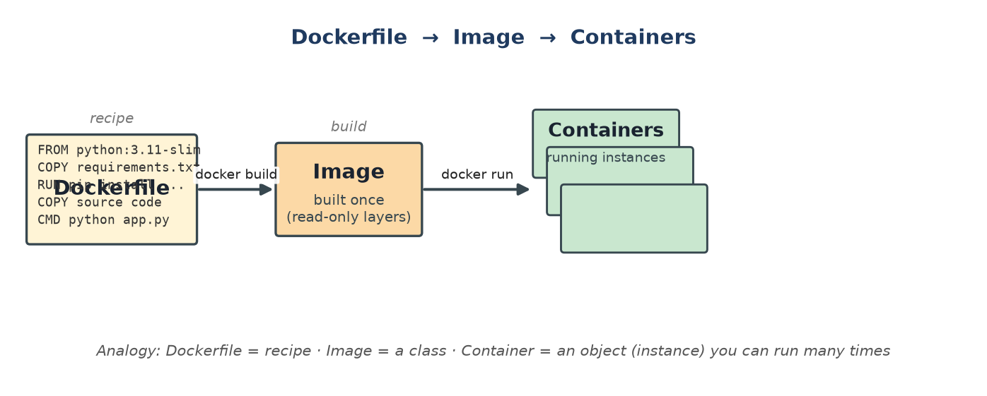
Figure 2 — Dockerfile → Image → Containers.
🔑 Analogy A Dockerfile is a recipe, an image is a class, and a container is an object (instance). You build an image once, then run many containers from it.

Your producer’s Dockerfile, line by line:
FROM python:3.11-slim # base image: minimal OS + Python 3.11
WORKDIR /app # working directory inside the container
COPY producer/requirements.txt . # copy deps list FIRST (caching trick)
RUN pip install -r requirements.txt
COPY producer/binance_producer.py .
CMD ["python", "binance_producer.py"] # run on container start

1.2 Worked example: why copy requirements.txt first?
Docker caches each layer and re-runs a layer only if it (or a layer above) changed. If you copied the source code before installing dependencies, every one-line code edit would re-run the slow pip install. By copying requirements.txt first, the expensive install layer is reused until your dependencies actually change — only the cheap “COPY source” layer re-runs. This is a real, common exam question.

1.3 Docker Compose — orchestrating six services
One container is easy; you have six that must start in order and talk to each other. Compose describes them all in one declarative file, started with one command:
docker compose up -d --build # build images, then start all services
docker compose ps # list services + health
docker compose logs -f flink-processor
docker compose down # stop (keep data); -v also deletes volumes

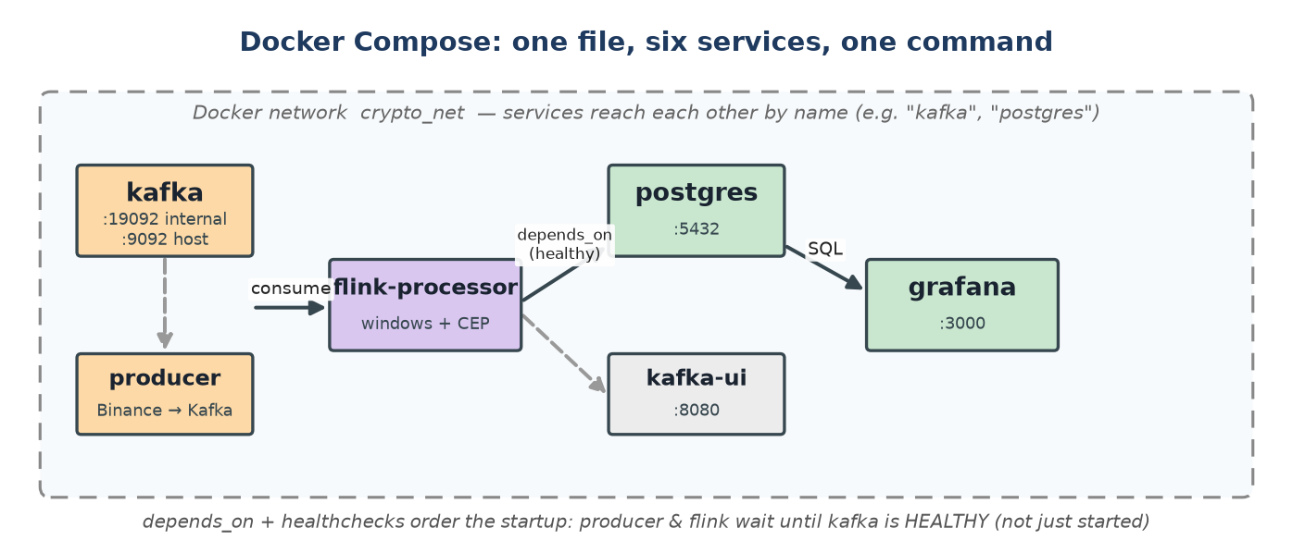
Figure 3 — Six services on one Docker network, with health-gated startup ordering.

1.4 The three Compose concepts you must know
(a) Networking — services find each other by name.
Every service on the crypto_net network reaches another using its service name as a hostname:
flink-processor:
environment:
KAFKA_BOOTSTRAP: "kafka:19092" # "kafka" = service name
PG_HOST: "postgres" # "postgres" = service name

🔑 The #1 beginner bug Inside a container use kafka:19092, NOT localhost:9092. “localhost” inside the producer means the producer container itself, not the host. The host port mapping 9092:9092 is only for tools running on your laptop.

(b) Volumes — data that survives restarts.
Containers are ephemeral; to persist Kafka logs and Postgres rows you mount named volumes. docker compose down keeps them; docker compose down -v wipes them.
kafka:
volumes:
- kafka_data:/var/lib/kafka/data # messages survive restarts

(c) Startup ordering — depends_on + healthchecks.
Containers start almost simultaneously, but Kafka needs ~30 s to be ready. You gate dependents on Kafka’s health:
kafka:
healthcheck:
test: ["CMD-SHELL", ".../kafka-topics.sh --bootstrap-server localhost:9092 --list"]
start_period: 30s
flink-processor:
depends_on:
kafka: { condition: service_healthy }
postgres: { condition: service_healthy }

🔑 Subtle but important depends_on only controls container start order — it does not know your app is ready. A healthcheck does. And your Python code still polls (wait_for_kafka) as a third safety net. Distributed systems never assume a dependency is up.

🔑 Check yourself

- Why does KAFKA_BOOTSTRAP differ between the producer (kafka:19092) and a laptop tool (localhost:9092)?
- What is the difference between docker compose down and docker compose down -v?
- Why install dependencies before copying source code in a Dockerfile?

Part 2 — Apache Kafka
Kafka is a distributed, append-only commit log used as a message broker. Producers append messages; consumers read them at their own pace. Think of it as a durable, replayable tape that many readers scan independently. Why not have the producer call Flink directly? Decoupling, buffering against bursts, replay after failure, and fan-out to multiple consumers.

2.1 The vocabulary (all visible in your project)
Term | Meaning | In your project
Broker | a Kafka server storing data and serving clients | the single kafka container
Topic | a named stream of messages | raw-trades
Partition | a topic split into ordered shards for parallelism | 6 partitions (one per symbol)
Offset | position (0,1,2…) of a message in a partition | committed by the consumer group
Consumer group | consumers sharing work + tracking offsets together | flink-crypto-processor
Retention | how long messages are kept | 2 hours

2.2 Partitions — the heart of scalability and ordering
Two facts to internalize: (1) ordering is guaranteed only within a partition, never across; (2) each partition is consumed by at most one consumer in a group — so partitions are the unit of parallelism.
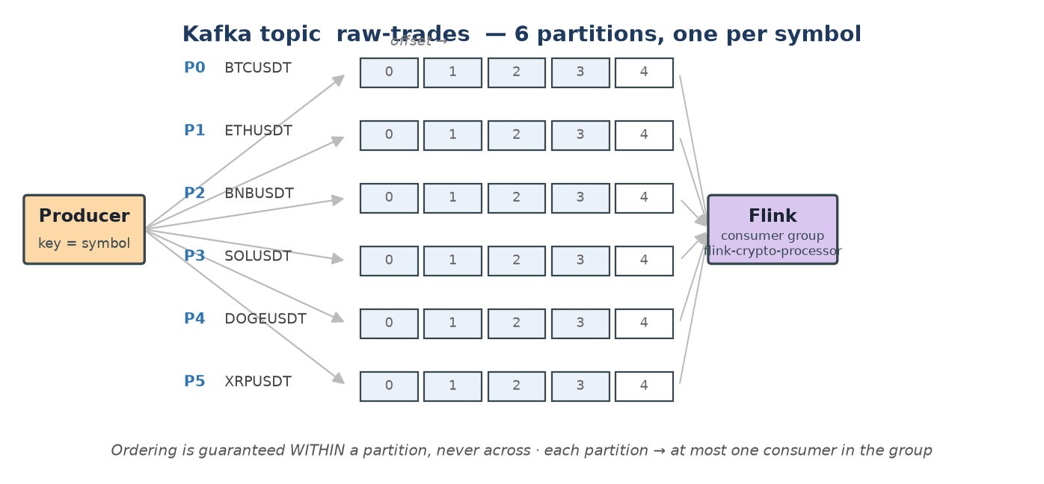
Figure 4 — raw-trades split into 6 partitions, one symbol each, read by Flink’s consumer group.
You pinned each symbol to a fixed partition rather than relying on hashing:
SYMBOL_PARTITION = {"BTCUSDT":0,"ETHUSDT":1,"BNBUSDT":2,
"SOLUSDT":3,"DOGEUSDT":4,"XRPUSDT":5}
producer.produce(topic="raw-trades", key=symbol.encode(),
value=json.dumps(trade).encode(),
partition=SYMBOL_PARTITION[symbol])

🔑 Why pin explicitly? With only 6 keys, hash collisions could dump two symbols into one partition and leave another empty. Explicit assignment guarantees one symbol per partition — so all BTC trades stay strictly ordered and the job can scale up to 6 consumers. This is the reasoning the examiner wants.

2.3 Worked example: the Producer config dials
PRODUCER_CONFIG = {
"acks": "1", # durability vs speed
"linger.ms": 20, # wait 20ms to batch...
"batch.size": 65536, # ...up to 64KB per request
"compression.type": "lz4",
}
producer.produce(...); producer.poll(0) # poll triggers delivery callbacks

- Durability — acks=0 (fire-and-forget, may lose data), acks=1 (leader confirms — your balanced choice), acks=all (all replicas confirm — safest, slowest). With one broker, acks=1 is the max.
- Throughput — linger.ms + batch.size send fewer, bigger requests; lz4 shrinks them on the wire and disk.
- The poll() rule — produce() is asynchronous — it only enqueues. poll() actually sends and fires callbacks (the course hint: “call poll() or writing may hang”).

2.4 Offsets & consumer groups — clean restarts
A consumer group tracks, per partition, the offset of the last processed message. Your Flink source uses a fixed group id so a restart resumes exactly where it left off:
KafkaSource.builder()
.set_group_id("flink-crypto-processor") # fixed -> resume from last offset
.set_starting_offsets(KafkaOffsetsInitializer.latest()) # first run: only NEW data

latest() ignores the backlog on first start; earliest() would replay all retained history (useful after a logic change). Also note: modern Kafka runs in KRaft mode — no ZooKeeper; your single node is both broker and controller.
🔑 Check yourself

- Kafka guarantees ordering within a ____ but not across ____.
- Why pin symbols to partitions instead of relying on key hashing?
- What does a fixed consumer-group id give you when the Flink job restarts?
- What does acks=1 trade off, and why is it the maximum for your setup?

Part 3 — Apache Flink (the core)
Flink is the stream processor — it reads the unbounded trade stream from Kafka and turns it into OHLC candles and anomaly alerts. This is where the hard concepts live.

3.1 The mental model: a dataflow graph
You don’t write a loop. You declare a graph of operators; nothing runs until env.execute(), which ships the graph to the engine, which then streams data through it forever. Note the fan-out: one keyed stream feeds five operators.
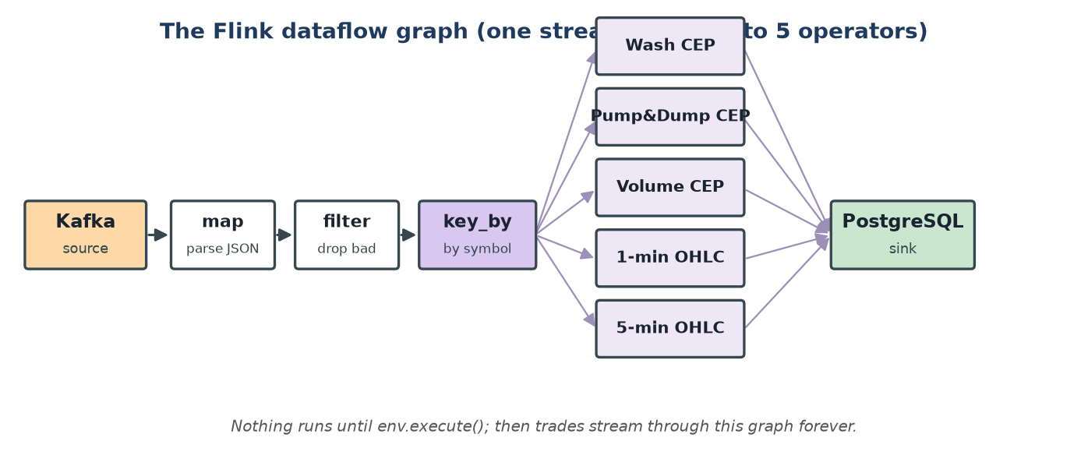
Figure 5 — Your Flink dataflow graph: source → map → filter → key_by → five operators → sink.
raw = env.from_source(kafka_source, watermark_strategy, "Binance Kafka Source")
trades = raw.map(ParseTradeMap(), output_type=...).filter(lambda t: t is not None)
keyed = trades.key_by(lambda t: t[0]) # key by symbol
keyed.process(WashTradeDetector())
keyed.process(PumpDumpDetector())
keyed.process(VolumeSpikeDetector())
keyed.window(TumblingEventTimeWindows.of(Time.minutes(1))).process(OHLCWindowFunction("1min"))
env.execute("Crypto Market Anomaly Detection Pipeline") # data starts flowing HERE

3.2 Event time vs processing time (THE key concept)
Processing time = when Flink happens to handle an event (depends on network delay, GC, restarts). Event time = when the event actually happened, carried inside it. For correct candles you must use event time — the exchange’s trade timestamp — so a trade executed at 10:00:59 lands in the 10:00 candle even if it arrives at 10:01:02.
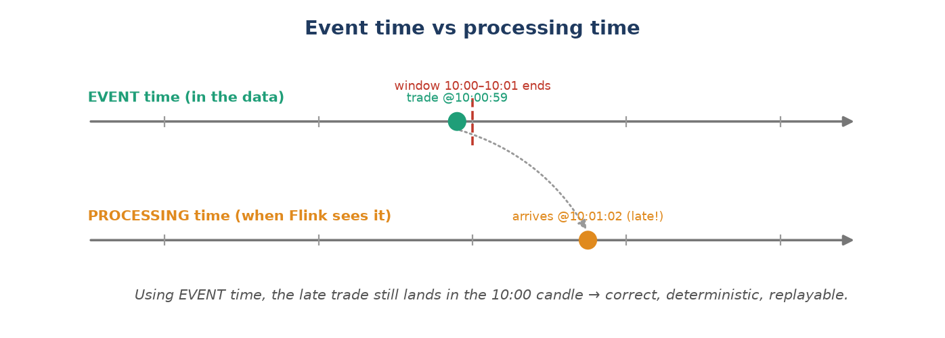
Figure 6 — With event time, a late-arriving trade still lands in the correct window.
.with_timestamp_assigner(lambda trade, _: trade[3]) # trade[3] = exchange ms = EVENT TIME

🔑 Why it matters Processing time would make candles wrong whenever the network hiccuped, and two runs over the same data could differ. Event time makes results deterministic and replayable — a core course theme.

3.3 Watermarks — when is a window finished?
If events can arrive late, when is it safe to close a window and emit the candle? A watermark of time T is a promise: “I don’t expect any more events with timestamp ≤ T.” When the watermark passes a window’s end, the window fires.
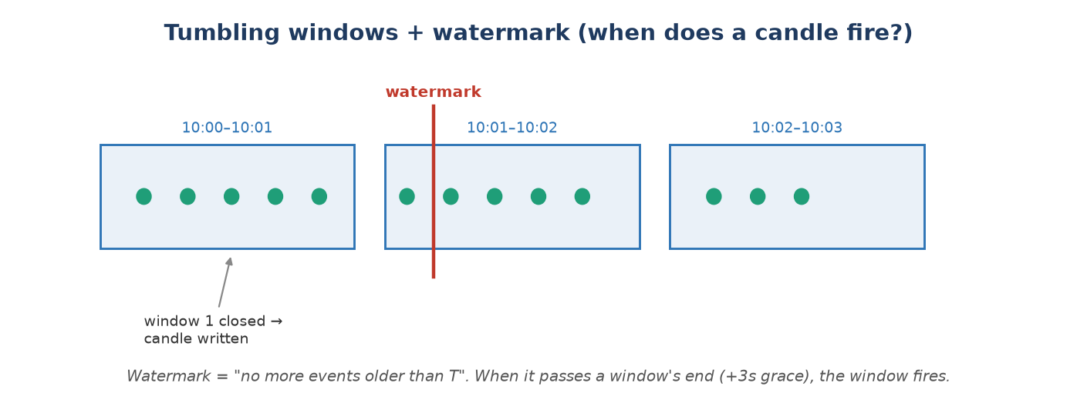
Figure 7 — Tumbling windows on a timeline; the window fires when the watermark passes its end.
WatermarkStrategy
.for_bounded_out_of_orderness(Duration.of_seconds(3)) # tolerate 3s lateness
.with_timestamp_assigner(lambda t,_: t[3])
.with_idleness(Duration.of_seconds(10)) # ignore idle partitions

🔑 The idleness bug you hit The global watermark is the MINIMUM across all partitions. If BNB goes quiet, its watermark stops advancing and freezes every symbol’s windows. with_idleness(10s) tells Flink to ignore a partition silent for 10 s. This is in your Lessons Learned for a reason — examiners love it.

3.4 key_by and windows — turning an infinite stream into candles
key_by(symbol) reroutes the stream so all events with the same key reach the same operator instance, keeping independent state per symbol. A tumbling window then groups each symbol’s trades into fixed, non-overlapping time chunks. When the watermark passes the window end, Flink hands you all trades in that window:
def process(self, key, context, elements):
prices = [t[1] for t in elements]
open_price, close_price = prices[0], prices[-1] # first / last
high_price, low_price = max(prices), min(prices)
volume = sum(t[2] for t in elements)
self.pg.write_ohlc(key, ..., open_price, high_price, low_price, close_price, volume, len(prices))

Window type | Shape | Example
Tumbling | fixed size, no overlap | your 1-min / 5-min candles
Sliding | fixed size, overlapping | “5-min average updated every 1 min”
Session | gap-based, dynamic size | “group activity until 30 s of silence”

3.5 State — Flink’s superpower
To detect a pump-and-dump you must remember the baseline and peak across many events. Flink gives each keyed operator managed state it persists and restores automatically. ValueState holds one value per key; ListState holds a list.
# rolling history per symbol (capped so memory stays constant):
self.price_history = ctx.get_list_state(ListStateDescriptor("wash_prices", Types.FLOAT()))
...
prices = prices[-60:] # keep only the last ~30s of trades

🔑 Bounded state is mandatory An unbounded list grows until the job runs out of memory. Capping to the last 60 entries keeps memory constant no matter how long the job runs — the efficiency/scalability point in the rubric.

Why open the DB connection and state in open(), not __init__()?
Flink operators are serialized and shipped to worker tasks. __init__ runs on the client during graph construction; open() runs on the task, after the runtime and network exist. So state handles and the Postgres connection are created in open(). Each operator also gets its own connection because operators run as independent parallel tasks.

3.6 The three detectors (Complex Event Processing)
CEP = detecting patterns over sequences of events, not single events. Each detector is a KeyedProcessFunction: it sees one event at a time, updates per-symbol state, and emits an alert when a pattern completes.
- Wash trade — keep the last ~60 prices/volumes; fire when price oscillation is high AND current volume is well above the rolling average at the same time (ListState).
- Pump & dump — a sequence (rise then drop) within a time bound — a true CEP pattern, modelled as a state machine (ValueState).
- Volume spike — count trades in the last 10 s vs a 10-minute baseline; fire on ≥ 2×, with a 30 s cooldown so it doesn’t flood the alert table (ListState + ValueState).
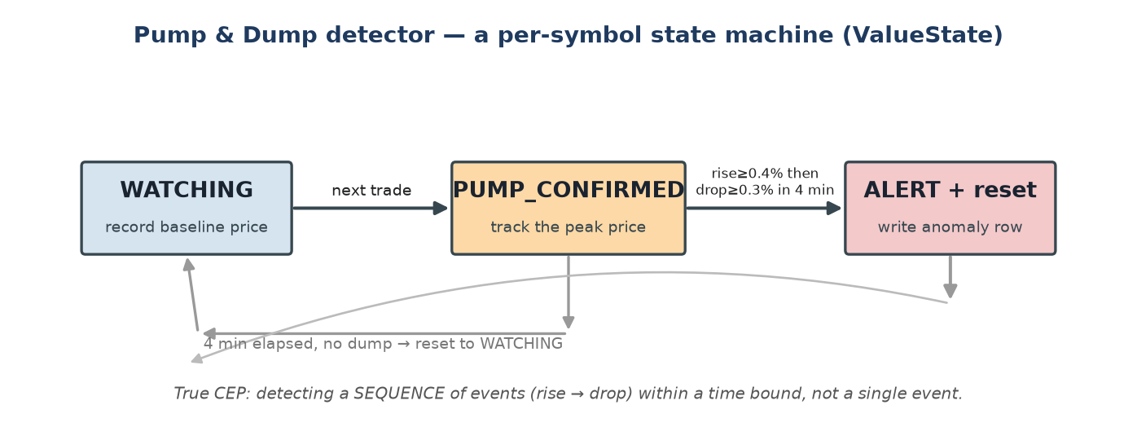
Figure 8 — The pump-and-dump detector as a per-symbol state machine.
if phase == "PUMP_CONFIRMED":
new_peak = max(peak_price, price)
rise_pct = (new_peak - start_price) / start_price * 100
drop_pct = (new_peak - price) / new_peak * 100
if rise_pct >= 0.4 and drop_pct >= 0.3 and elapsed_ms <= 240_000:
write PUMP_AND_DUMP alert; self._reset(price, ts_ms)

3.7 Checkpointing — fault tolerance
A checkpoint is a consistent snapshot of all operator state plus the Kafka offsets that produced it, written to disk every 30 s. If the job crashes, Flink restores state and rewinds Kafka to the matching offsets — giving exact resume instead of “replay everything” or “lose progress”.
env.get_checkpoint_config().set_checkpoint_interval(30_000) # snapshot every 30s

🔑 Check yourself

- Difference between event time and processing time — and why candles need event time?
- In one sentence, what is a watermark, and what does with_idleness prevent?
- Why is key_by(symbol) necessary for per-symbol rolling averages to be correct?
- Which state type for “the peak price so far” vs “the last 60 prices”?
- Why open the DB connection in open() rather than __init__()?
- What exactly does a checkpoint snapshot, and how does restart use it?

Part 4 — PostgreSQL & Grafana (sink + frontend)
PostgreSQL is the queryable results store. init.sql runs once on first boot and creates three tables, each shaped for how Grafana queries it: ohlc_candles (one row per symbol+window, indexed on symbol+time), anomaly_events (one row per detection), and price_ticker (exactly one row per symbol, kept current with an upsert).
INSERT INTO price_ticker (...) VALUES (...)
ON CONFLICT (symbol) DO UPDATE SET price = EXCLUDED.price, ... -- keep ONE row/symbol

🔑 Store aggregates, not the raw stream Only compact candles, alerts and the latest price go to the DB — never the whole input stream (a course hint). Indexes make Grafana’s 5-second queries fast instead of full scans.

Grafana is the frontend: it connects to Postgres (auto-provisioned, no manual setup), and each panel is a SQL query with dashboard variables ($symbol, $candle_size) from dropdowns. It polls every 5 s and re-renders — your “live” dashboard is really just SQL over well-indexed results tables.

Part 5 — Trace one trade end-to-end
Follow a single BTC trade executed at 12:00:30.250. If you can narrate this from memory, you understand the project.
- Binance emits {s:"BTCUSDT", p:"64210.5", q:"0.01", T:...250} on the WebSocket.
- Producer parses it and produces JSON to raw-trades partition 0 (BTC), keyed BTCUSDT; poll(0) flushes the callback.
- Kafka appends it to partition 0 at the next offset; retained for 2 hours.
- Flink source consumes it (group flink-crypto-processor), assigns event time = 12:00:30.250, advances the watermark.
- map → filter make a typed tuple; key_by routes it to the BTC instance of every downstream operator.
- It updates the 1-min and 5-min windows and is fed to all three CEP detectors, each updating BTC state.
- When the watermark passes 12:01:00 + 3 s, the 1-min window fires → OHLC candle INSERTed; ticker upserted; any completed pattern → anomaly_events INSERT.
- Within 5 s, Grafana polls Postgres and the new candle / alert appears on the dashboard.
- Every 30 s Flink checkpoints state + offsets, so a crash here resumes cleanly.

Part 6 — Exam prep: questions & crisp answers
Q: Why Kafka at all — why not produce straight into Flink?
A: Decoupling, buffering against bursts, replay after failure, and fan-out to multiple consumers. Kafka is the durable shock-absorber between ingestion and processing.
Q: Why Flink over Spark here?
A: Flink suits complex aggregations, pattern matching (CEP) and chained aggregations, and behaves better on Windows (no Hadoop winutils). Spark is stronger for ML/simple aggregations. For event-time CEP, Flink is the natural pick.
Q: Event time vs processing time?
A: Event time = when the trade happened (timestamp in the data); processing time = when Flink saw it. Event time gives correct, deterministic, replayable windows despite delay/out-of-order data.
Q: What is a watermark; what does idleness solve?
A: A watermark is Flink’s estimate that no events older than T remain, used to decide when to close windows. The global watermark is the min across partitions; with_idleness stops a quiet partition from freezing all windows.
Q: How do you guarantee per-symbol ordering and parallelism?
A: 6 partitions, one symbol each, explicitly pinned by the producer; Kafka guarantees order within a partition; Flink key_by(symbol) keeps independent state; parallelism can scale to 6.
Q: How is the system fault tolerant / late-data safe?
A: Late/out-of-order: event time + 3 s bounded-out-of-orderness watermark. Faults: 30 s Flink checkpoints of state + Kafka offsets, fixed consumer-group id, healthchecks + reconnect logic. Cooldowns prevent duplicate alerts.
Q: How does it scale? Is it efficient?
A: Raise Flink parallelism to the partition count (6) — no code change. Efficiency: producer batching + lz4; only compact aggregates stored; indexed tables; bounded operator state.
Q: What would you improve?
A: Express OHLC in Flink Table/SQL and use the CEP library; run on a real cluster with parallelism = partitions; adaptive per-symbol thresholds; a schema registry; replay-based tests.
Q: Why Docker Compose; what does depends_on guarantee?
A: One-command reproducible multi-service startup with shared networking and persistent volumes. depends_on only orders container starts; readiness needs healthchecks (and the code still polls).
🔑 One-line summary for the exam Live trades → Kafka (decouple, partition per symbol) → Flink (event-time windows + stateful CEP, checkpointed) → PostgreSQL (compact, indexed results) → Grafana (SQL panels, 5 s refresh), all wired together and made reproducible by Docker Compose.

