- Application Domain
Cryptocurrency markets generate millions of trade events per second across global exchanges. Detecting anomalous trading behaviour — coordinated volume spikes, wash trading, and pump-and-dump patterns in real time is a critical requirement for exchanges, regulators, and algorithmic trading systems. This project builds a real-time crypto market monitoring and anomaly detection pipeline that ingests live trade data from Binance's public WebSocket feed (no API key required), processes it using Apache Flink's Complex Event Processing (CEP) and window aggregations, stores results in PostgreSQL, and exposes a live Grafana dashboard mirroring the architecture used in production at fintech companies such as Coinbase, Kraken, and Revolut.
2. Data Sources
- Binance Public WebSocket API: Provides a real-time stream of every individual trade for BTCUSDT, ETHUSDT, and BNBUSDT. Each event contains: symbol, trade price, quantity, buyer/seller aggressor flag, and millisecond-precision timestamp.
- Access method: persistent WebSocket connection to wss://stream.binance.com:9443/ws/<symbol>@trade, read in Python via websocket-client.
- Data volume: approximately 50–200 trade events per second per symbol, providing meaningful real-time throughput for stream processing demonstrations.
- Technologies & Architecture
Component | Technology | Role in System
Data Source | Binance WebSocket | Live crypto trade stream — BTCUSDT, ETHUSDT, BNBUSDT, etc
Data Ingestion | Custom Kafka Producer (Python) | websocket-client connects to Binance; confluent-kafka publishes JSON trade events to raw-trades topic.
Message Broker | Apache Kafka (Docker) | Decouples ingestion from processing; persists raw trade stream with configurable retention.
Stream Processor | Apache Flink — Table/SQL + CEP | OHLC tumbling window aggregations; CEP for wash trading and volume-spike anomaly detection.
Database | PostgreSQL (Docker) | Stores aggregated OHLC candles and flagged anomaly events written directly by Flink.
Frontend | Grafana (Docker) | Live candlestick charts, anomaly alert table, rolling volume panel — driven by PostgreSQL.
System Architecture Diagram
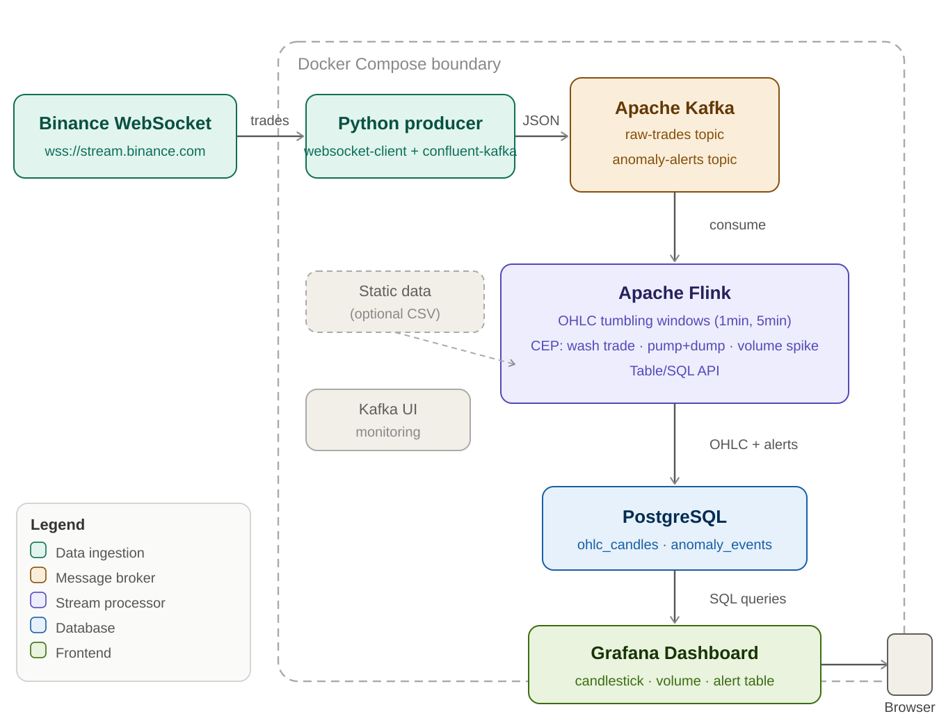
Figure 1 — Full system architecture showing data flow from Binance WebSocket through Kafka, Flink, PostgreSQL to Grafana.
Flink CEP Anomaly Patterns (core original contribution):
CEP Pattern | Detection Logic | Real-World Meaning
Wash Trading | price oscillates ±2% within 30-second window, volume >5× average | Coordinated buy/sell to inflate volume artificially
Pump & Dump | Price rises >5% in 2 min, then drops >4% in the following 2 min | Classic crypto market manipulation pattern
Volume Spike | Trade count in 10-second window exceeds 10× the 10-minute rolling average | Signals coordinated activity or flash crash

Runtime Sequence Diagram
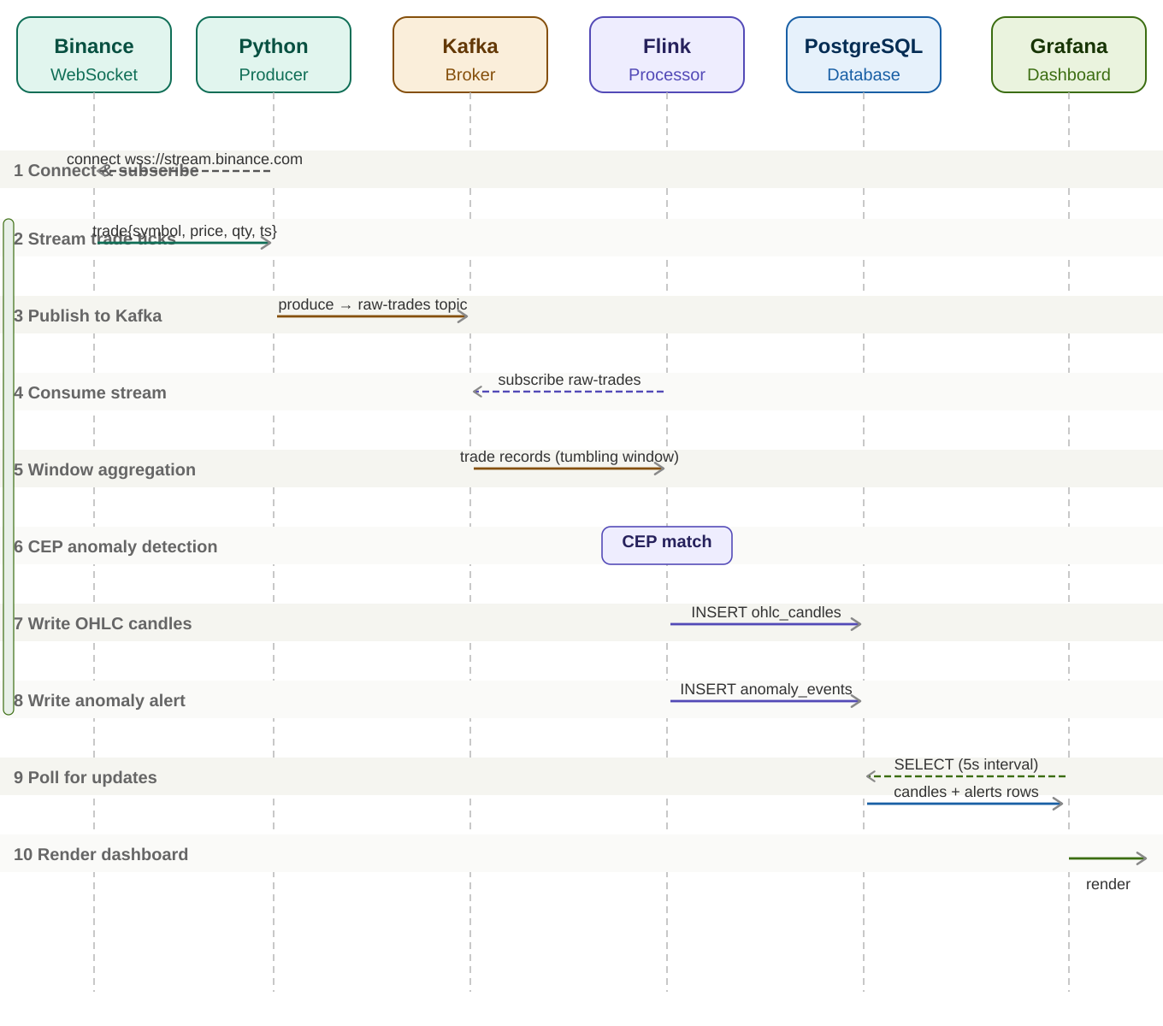

Figure 2 — Runtime message sequence across all pipeline components. Solid arrows = data messages; dashed arrows = subscriptions/polls. The continuous streaming loop (steps 2–5).
- Functionalities
End users interact with a Grafana dashboard providing the following live views:
- Live OHLC candlestick chart: 1-minute and 5-minute candles per symbol, computed by Flink tumbling windows and stored in PostgreSQL.
- Real-time volume panel: rolling 10-second trade count and cumulative volume per symbol, refreshed every 5 seconds.
- Anomaly alert table: events flagged by Flink CEP patterns (Wash Trading, Pump & Dump, Volume Spike) with timestamp, symbol, pattern type, and severity.
- Per-symbol price ticker: latest trade price with colour-coded percentage change indicator, updated every 5 seconds.
- Historical drill-down: Grafana dashboard variables allow filtering by symbol and time range to query past anomaly events from PostgreSQL.

GitLab Repository: https://gitlab.inf.unibz.it/kodanda.challa/rtbdp-crypto-anomaly
GitHub Repository: https://github.com/kodandachalla/RTBDP_Project

