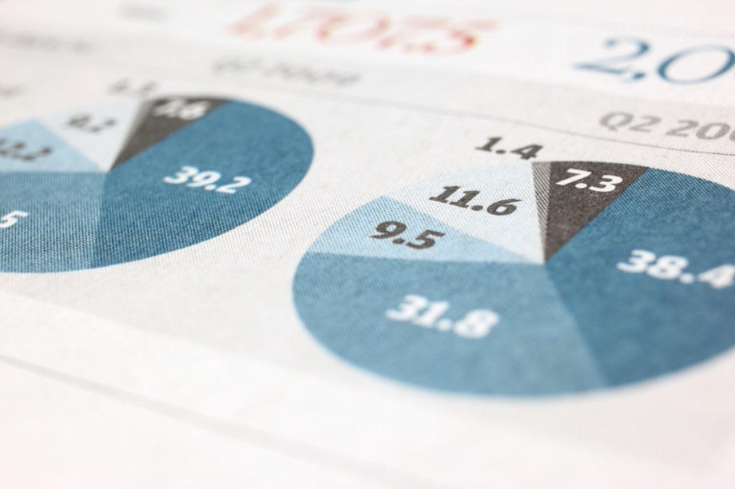
Real-Time Crypto Market Anomaly Detection & Dashboard
Spotting cheating in live crypto trading and showing it on a dashboard
Challa Kodanda | 6/24/26 | Real-Time Big Data Processing

Abstract
This project watches live cryptocurrency trades and looks for signs of market cheating as it happens. Trades for six popular coins are read straight from Binance, the world’s largest crypto exchange. The trades flow through a small pipeline of well-known tools: a Python program sends them into Apache Kafka (a fast message queue), Apache Flink (a stream-processing engine) does the maths and spots three kinds of cheating, the results are saved in a PostgreSQL database, and a Grafana dashboard shows everything live and refreshes every five seconds. The most important practical point is simplicity: the whole system — all six parts — starts with a single command, “docker compose up -d –build”. Nothing else needs to be installed. The project shows the main ideas of real-time big-data processing in a clear, working example: reading a live data stream, grouping it into time windows, detecting patterns, handling late or out-of-order data, recovering after a crash, and displaying the results live.

Source code:
- GitLab Repository: https://gitlab.inf.unibz.it/kodanda.challa/rtbdp-crypto-anomaly
- GitHub Repository: https://github.com/kodandachalla/RTBDP_Project

Table of Contents
1. Application Domain 1
2. The Data Source 1
3. Technologies and Architecture 2
3.1. The tools used (and what each one is for) 2
3.2. How the parts fit together 3
3.3. How a trade travels through the system 4
3.4. Two ideas that make it work well 4
3.5. How the pipeline splits into streams and operators 6
4. What the User Sees (Functionalities) 7
4.1. The three cheating patterns 7
4.2. How to run it 9
5. Putting it together: trace one trade end-to-end 9
6. Lessons Learned 9
7. Detailed architecture diagram 11

Application Domain
Cryptocurrency markets never close. They run 24 hours a day, every day, and they produce a huge number of trades — often thousands every second. Because these markets are only lightly regulated, some people try to cheat. Three common tricks are:
- Wash trading — a person quietly buys and sells to themselves to make a coin look busier than it really is.
- Pump and dump — a group pushes a price up fast, then sells everything at the top, leaving other buyers with losses.
- Volume spikes — a sudden flood of trades, which can come before a price crash.
Finding these tricks a day later is not very useful. To be helpful for an exchange or a regulator, the warning has to appear within a few seconds. That is exactly what this project does. It reads every trade for six popular coins, works out simple price and volume numbers in real time, checks for the three cheating patterns, and shows the result on a live dashboard. Figure 1 shows the whole idea in six steps.
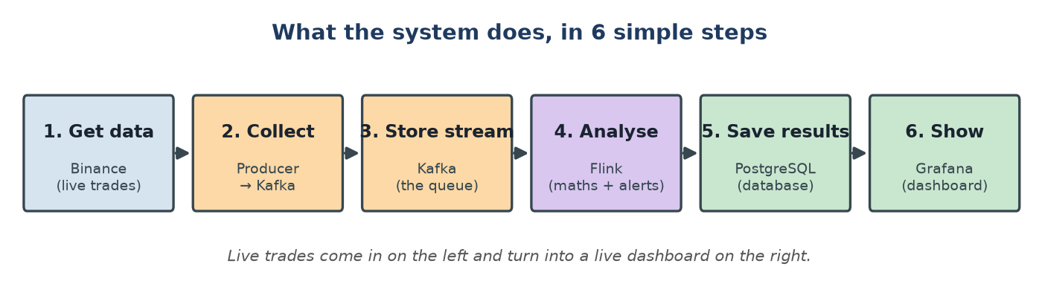
Figure 1 — What the system does, in six simple steps. Live trades come in on the left and become a live dashboard on the right.
The six coins are BTC, ETH, BNB, SOL, DOGE and XRP. The two “meme coins” (DOGE and XRP) were chosen on purpose because their prices jump around a lot, so the cheating patterns show up quickly during a demo.

The Data Source
All the data comes from one place: the public Binance trade feed. It is free and needs no password or API key. The program opens a single WebSocket connection (a connection that stays open and pushes new data to us instantly) and receives a small message for every trade that happens on the exchange.
Each message is tiny and contains just what we need: which coin, the price, the amount traded, and the exact time of the trade (down to the millisecond):
- It is fast — the data never stops — it is a live stream, so the program must keep running forever.
- There is enough of it — about 50 to 200 trades per second for each coin.
- It is slightly messy — trades can sometimes arrive a little out of order, so the system has to handle that correctly.

We use the trade’s own timestamp (the time the trade really happened) for all the time-based maths. This is important and is explained in Section 3.

Technologies and Architecture

The tools used (and what each one is for)
Every tool below runs inside Docker. You do not need to install Java, Python, Kafka or anything else by hand — Docker brings them all.
Part | Tool | What it does (in plain words)
Data source | Binance WebSocket | Gives us a live stream of every trade, for free.
Collector | Python producer | A small program that reads the trades and sends them into Kafka.
Message queue | Apache Kafka | Holds the stream of trades safely, like a conveyor belt between programs.
Brain (processor) | Apache Flink | Does the maths (price candles) and spots the three cheating patterns.
Database | PostgreSQL | Stores the results so the dashboard can read them quickly.
Dashboard | Grafana | Shows live charts and a table of alerts; refreshes every 5 seconds.
Helper | Kafka UI | A web page to peek inside Kafka and check trades are flowing.

Both the data collector and stream processor are written in Python 3.11. The collector (binance_producer.py) uses two libraries: websocket-client 1.7.0 which manages the Binance WebSocket connection, and confluent-kafka 2.3.0 which wraps the C library librdkafka — making it faster than pure-Python alternatives at high throughput. It also provides an AdminClient used at startup to wait for Kafka readiness and create the raw-trades topic.
The stream processor (crypto_processor.py) uses PyFlink 2.2.0 — the official Python API for Apache Flink. Python acts purely as a description language defining WHAT the pipeline should do, while the actual computation is executed by a Java Virtual Machine running Flink's Java runtime in the background — which is why Java 17 is required in the Docker image. The Kafka connector JAR (flink-sql-connector-kafka-4.0.1-2.0.jar) acts as the Java bridge between Flink and Kafka, downloaded automatically from Maven Central during the Docker build. Writing to PostgreSQL is handled separately using psycopg2 2.9.9 — a pure Python library that connects directly to postgres:5432 with autocommit=True, making every INSERT immediately visible to Grafana without any Java connector needed. setuptools>=69.0.0 is also explicitly listed as a dependency because PyFlink's internal packages use pkg_resources at import time — a module provided by setuptools — and without a sufficiently recent version present, PyFlink fails to import entirely before the pipeline even starts.

How the parts fit together
Figure 2 (Simple) and 10 (Detailed) is the architecture diagram: collect the data into Kafka, let Flink process it and save results to a database, and let the dashboard read the database. Each box is one Docker container, and they all talk to each other on a private Docker network by name (for example, Flink finds the database simply by using the name “postgres”).
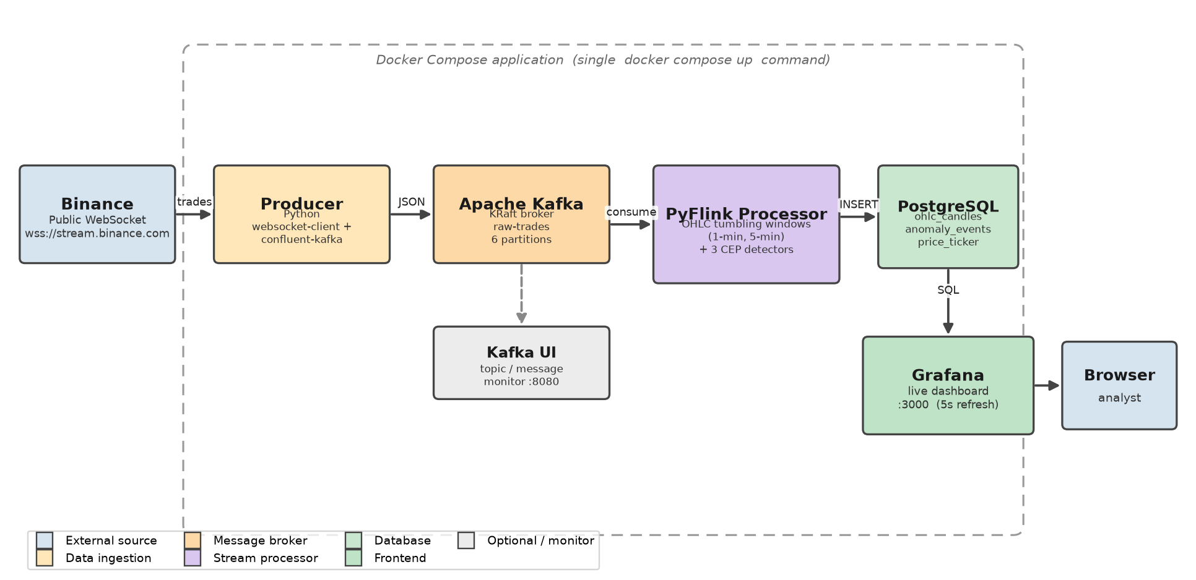
Figure 2 — The architecture, Every box inside the dashed line is a Docker container started together.
✅ One command starts everything All six parts are described in one file (docker-compose.yml). You start the entire system with a single command — docker compose up -d --build — and Docker downloads, builds and launches every part in the right order. There is no manual setup. To stop it, you run docker compose down.
Starting order: Kafka + PostgreSQL → Kafka-UI + Grafana + Producer → Flink-processor

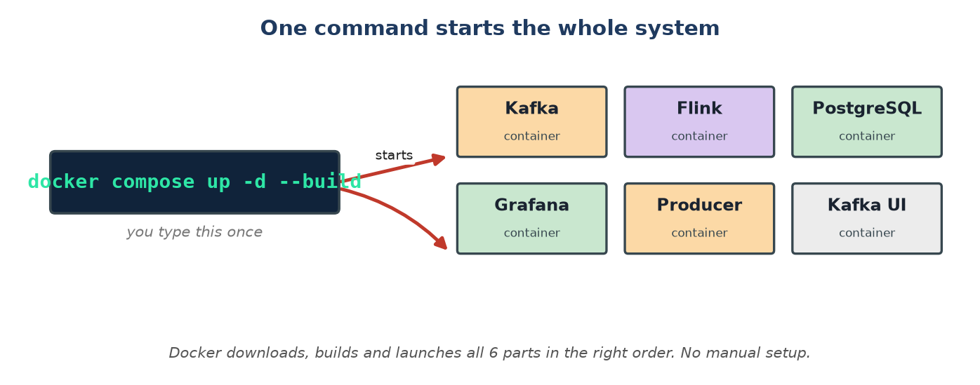
Figure 3 — One command builds and launches all six parts. Docker also starts them in the correct order, waiting until Kafka and the database are ready.

How a trade travels through the system
Figure 4 follows a single trade from start to finish. Reading it top to bottom shows the live loop that repeats for every trade, forever.
- Step 1–2: Binance sends a trade; the Python collector reads it and cleans it up.
- Step 3: The collector puts the trade into Kafka, on the lane for that coin.
- Step 4–5: Flink takes the trade out of Kafka using the trade’s own timestamp.
- Step 6: Flink updates the price candles and checks the three cheating patterns.
- Step 7–8: Flink saves the candle (and any alert) into the PostgreSQL database.
- Step 9–10: Grafana asks the database for fresh data every 5 seconds and redraws the dashboard.
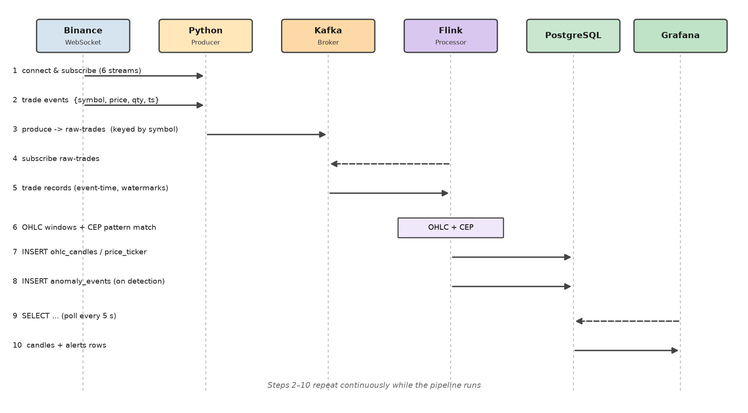
Figure 4 — The journey of one trade. Solid arrows are data; dashed arrows are requests. Steps 2–10 repeat all the time while the system runs.

Two ideas that make it work well
One lane per coin.
Inside Kafka, the trade stream is split into six “lanes” (called partitions), one per coin (Figure 5). This keeps each coin’s trades in the correct order and lets the work run in parallel. It also means the system can be made faster later simply by adding more workers — up to one per lane — without changing the code.
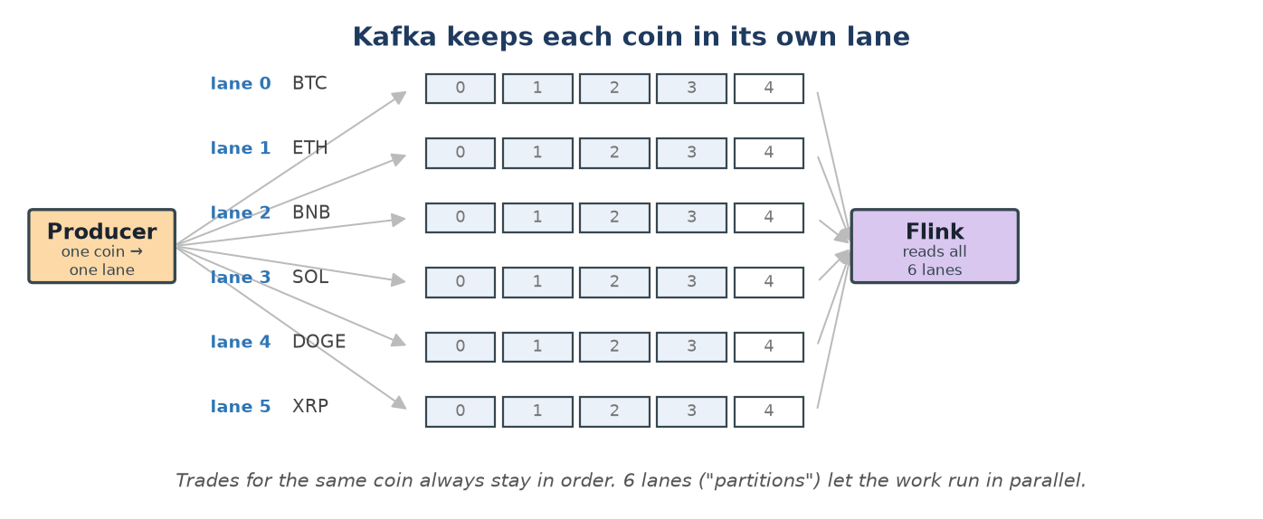
Figure 5 — Kafka keeps each coin in its own lane, so trades stay in order and can be processed in parallel.
Turning trades into candles.
Traders read price “candles”. A candle is a simple summary of a short period of time: the first price (open), the highest, the lowest, and the last price (close). Flink groups all trades in each 1-minute and 5-minute period and turns them into one candle each (Figure 6). Because Flink uses the trade’s real timestamp, a trade that arrives a little late still goes into the correct candle.
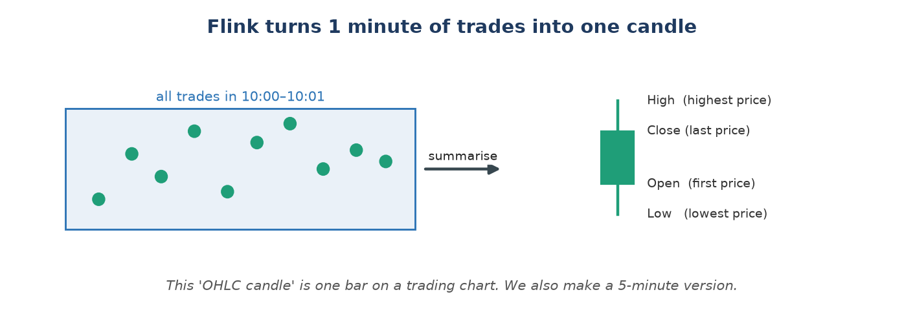
Figure 6 — Flink summarises one minute of trades into a single OHLC candle (Open, High, Low, Close). It also builds 5-minute candles.
Getting the right answer, even with problems.
The system is built to stay correct when things go wrong:
- Late trades — it waits a few seconds for slightly-late trades before finishing a candle, so nothing is missed.
- No freezing — if one quiet coin stops trading for a moment, it does not freeze the others.
- Crash recovery — Flink saves its progress to disk every 30 seconds, so after a crash it continues from where it stopped instead of starting over.
- Stays light — only small summaries (candles and alerts) are saved to the database, never the full raw stream, so storage stays small and the dashboard stays fast.

How the pipeline splits into streams and operators
The figure 7 below shows how the PyFlink pipeline transforms a single Kafka stream into thirty isolated operator instances across six trading symbols. The pipeline has four stages. First, KafkaSource reads raw JSON trade messages from all six Kafka partitions simultaneously. ParseTradeMap converts each message into a typed tuple, and a filter operator discards any malformed messages. Second, key_by(symbol) partitions the stream by symbol, routing all BTCUSDT events to one operator instance and all ETHUSDT events to another. This is the most important step: every downstream operator automatically gets its own completely isolated state per symbol. Third, five operators run in parallel per symbol, giving thirty instances in total. WashTradeDetector and VolumeSpikeDetector use ListState capped at 60 entries to maintain a rolling history. PumpDumpDetector uses ValueState to implement a three-phase state machine. Two TumblingEventTimeWindows operators compute OHLC candles at one-minute and five-minute granularities. Finally, all operators write results to PostgreSQL via psycopg2, and all state is checkpointed every 30 seconds for crash recovery.
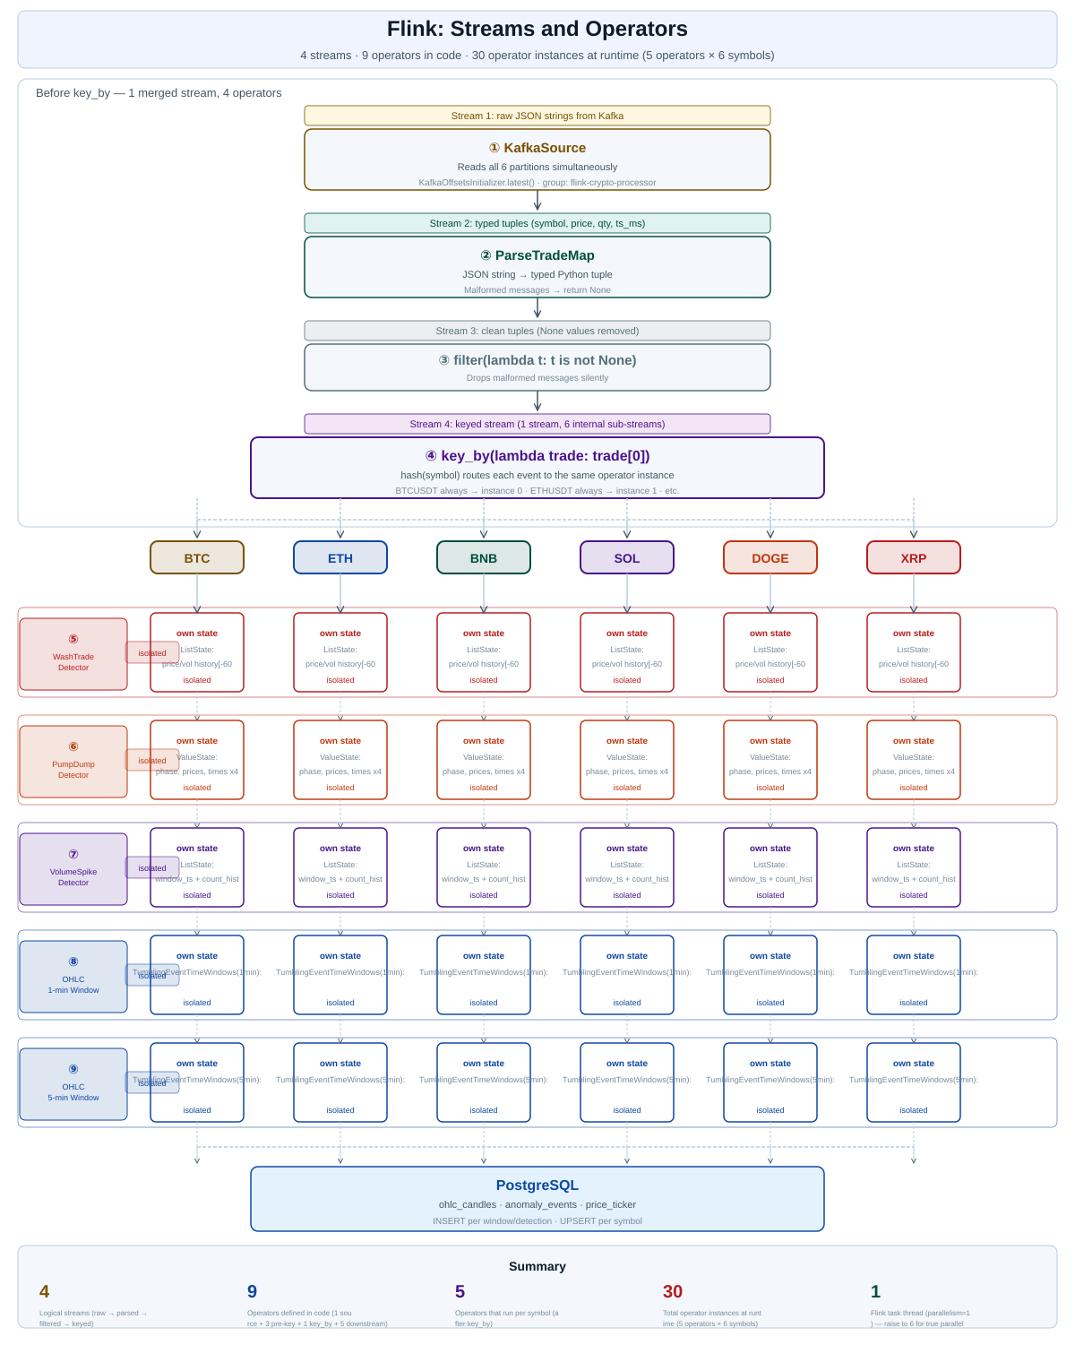
Figure 7 — Flink stream pipeline: 4 streams, 9 operators in code, 30 isolated operator instances at runtime (5 operators × 6 symbols)

What the User Sees (Functionalities)
Everything the user needs is on one Grafana dashboard (Figure 8). It updates by itself every five seconds. Two simple drop-downs at the top let the user pick a coin and choose 1-minute or 5-minute candles.
The dashboard has five live panels:
- Price ticker — the current price of each coin.
- Price candles — the candle chart for the chosen coin, with green for closing price greater than opening price, Red for closing price lesser than opening price.
- Volume bars — how much was traded for each coin.
- Alert count — how many alerts happened in the last hour.
- Alerts table — a live table of detected cheating, with the time, pattern and how serious it is.
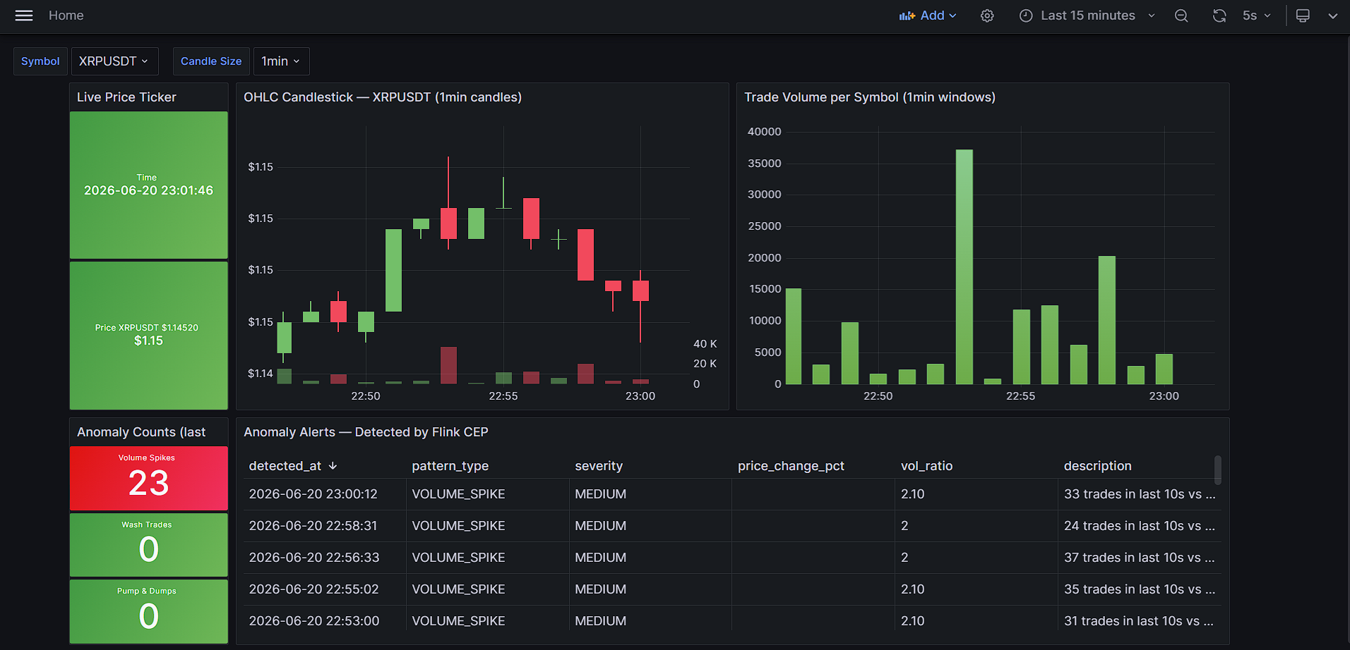
Figure 8 — The live Grafana dashboard

The three cheating patterns
The heart of the project is detecting three patterns. Figure 9 shows what each one looks like, and the table explains the simple rule behind each.
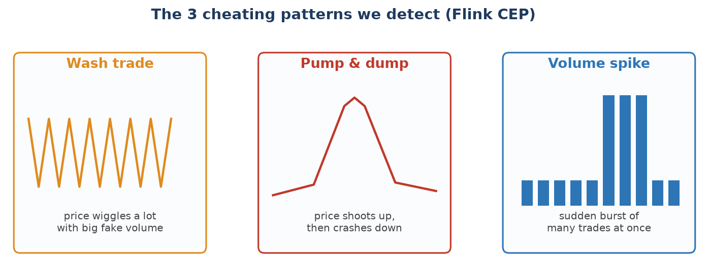
Figure 9 — The three patterns the system looks for.
Values are different from Proposal for demonstration
 | WASH TRADE | PUMP AND DUMP | VOLUME SPIKE
Class | WashTradeDetector | PumpDumpDetector | VolumeSpikeDetector
Flink State | ListState — price history[-60] + vol history[-60] | ValueState × 4 — phase, start_price, start_time, peak_price | ListState × 2 — count_history[-60] + current_window_ts · ValueState — last_alert_ts
Condition 1 | swing_pct >= 0.3% where swing = (max - min) / min × 100 across last 60 trades | rise_pct >= 0.4% where rise = (peak - start_price) / start_price × 100 | volume_ratio >= 2.0× where ratio = current_10s_count / rolling_avg
Condition 2 | volume_ratio >= 1.5× where ratio = current_qty / avg_qty | drop_pct >= 0.3% where drop = (peak - price) / peak × 100 | cooldown_ok — more than 30 seconds since last alert
Condition 3 | Both must be true simultaneously | Must complete within 240,000 ms (4 minutes) | 6 snapshots = 1 minute
State machine | None — fires on every trade that meets both conditions | WATCHING → PUMP_CONFIRMED → ALERT → reset to WATCHING | None — fires whenever conditions met after cooldown
Time window | Rolling last 60 trades (~30 seconds of data) | Max 4 minutes from baseline to dump confirmation | Sliding 10-second trade count vs 10-minute rolling average (60 snapshots)
Severity: MEDIUM | swing_pct <= 1.5% | (rise_pct + drop_pct) <= 3.0% | volume_ratio <= 5.0×
Severity: HIGH | swing_pct > 1.5% | (rise_pct + drop_pct) > 3.0% | volume_ratio > 5.0×
What fires alert | write_anomaly(..., "WASH_TRADE", severity, low, high, swing_pct, volume_ratio) | write_anomaly(..., "PUMP_AND_DUMP", severity, start_price, price, rise_pct, volume_ratio) | write_anomaly(..., "VOLUME_SPIKE", severity, None, price, None, volume_ratio)
price_change_pct | Filled — swing_pct | Filled — rise_pct | NULL — not applicable
Resets when | Never resets — evaluates every trade | After alert fires OR 4-minute window expires | After each alert — cooldown enforced by last_alert_ts
Min data needed | 20 trades before first evaluation | No minimum — fires immediately | 1 history snapshot minimum

How to run it
Running the whole system takes one command. Health checks make sure each part only starts once the parts it needs are ready.
- docker compose up -d --build — build and start all six parts (the only command you need)
- http://localhost:3000 — open the Grafana dashboard (login admin / admin)
- http://localhost:8080 — open Kafka UI to watch trades flowing
- docker compose down — stop everything

Putting it together: trace one trade end-to-end
Follow a single BTC trade executed at 12:00:30.250:
- Binance emits {s:"BTCUSDT", p:"64210.5", q:"0.01", T:1718...250} on the WebSocket.
- Producer parses it, and produce()s JSON to raw-trades partition 0 (BTC's partition), keyed BTCUSDT; poll(0) flushes the delivery callback.
- Kafka appends it to partition 0 at the next offset; it'll be retained for 2 hours.
- Flink source consumes it (group flink-crypto-processor), assigns event time = 12:00:30.250, and contributes to the watermark.
- map → filter turns it into ("BTCUSDT", 64210.5, 0.01, ...); key_by routes it to the BTC instance of every downstream operator.
- It updates the 1-min window [12:00,12:01) and the 5-min window, and is fed to all three CEP detectors, each updating BTC's state.
- When the watermark passes 12:01:00 + 3s, the 1-min window fires → an OHLC candle is computed and Inserted into Postgres OHLC candles table; the ticker is upserted. If a detector's pattern completed, an alert is inserted into anomaly events table.
- Within 5 s, Grafana polls Postgres and the new candle / alert appears on your dashboard.
- Every 30 s, Flink checkpoints state + offsets, so a crash here resumes cleanly.

Lessons Learned
What went well:
- A simple, well-known design — the standard “Kafka → Flink → database → dashboard” shape made the design clear and easy to follow.
- One-command setup — putting everything in Docker meant the whole project starts with one command, which is great for anyone trying it out.
- One lane per coin — giving each coin its own lane kept the data tidy and made the system easy to speed up later.
What was tricky:
- Start-up timing — Docker starts all parts at almost the same time, but Kafka needs a moment to be ready. The programs had to wait and check before connecting.
- A quiet coin froze things — at first, one quiet coin could freeze the candles for all coins. A small setting fixed this.
What could be improved:
- Less custom code — use Flink’s SQL features to write the candle maths with less code.
- Bigger scale — run Flink on a bigger cluster to handle even more coins at once.
- Smarter limits — let the system learn each coin’s “normal” behaviour automatically instead of using fixed limits.

Detailed architecture diagram
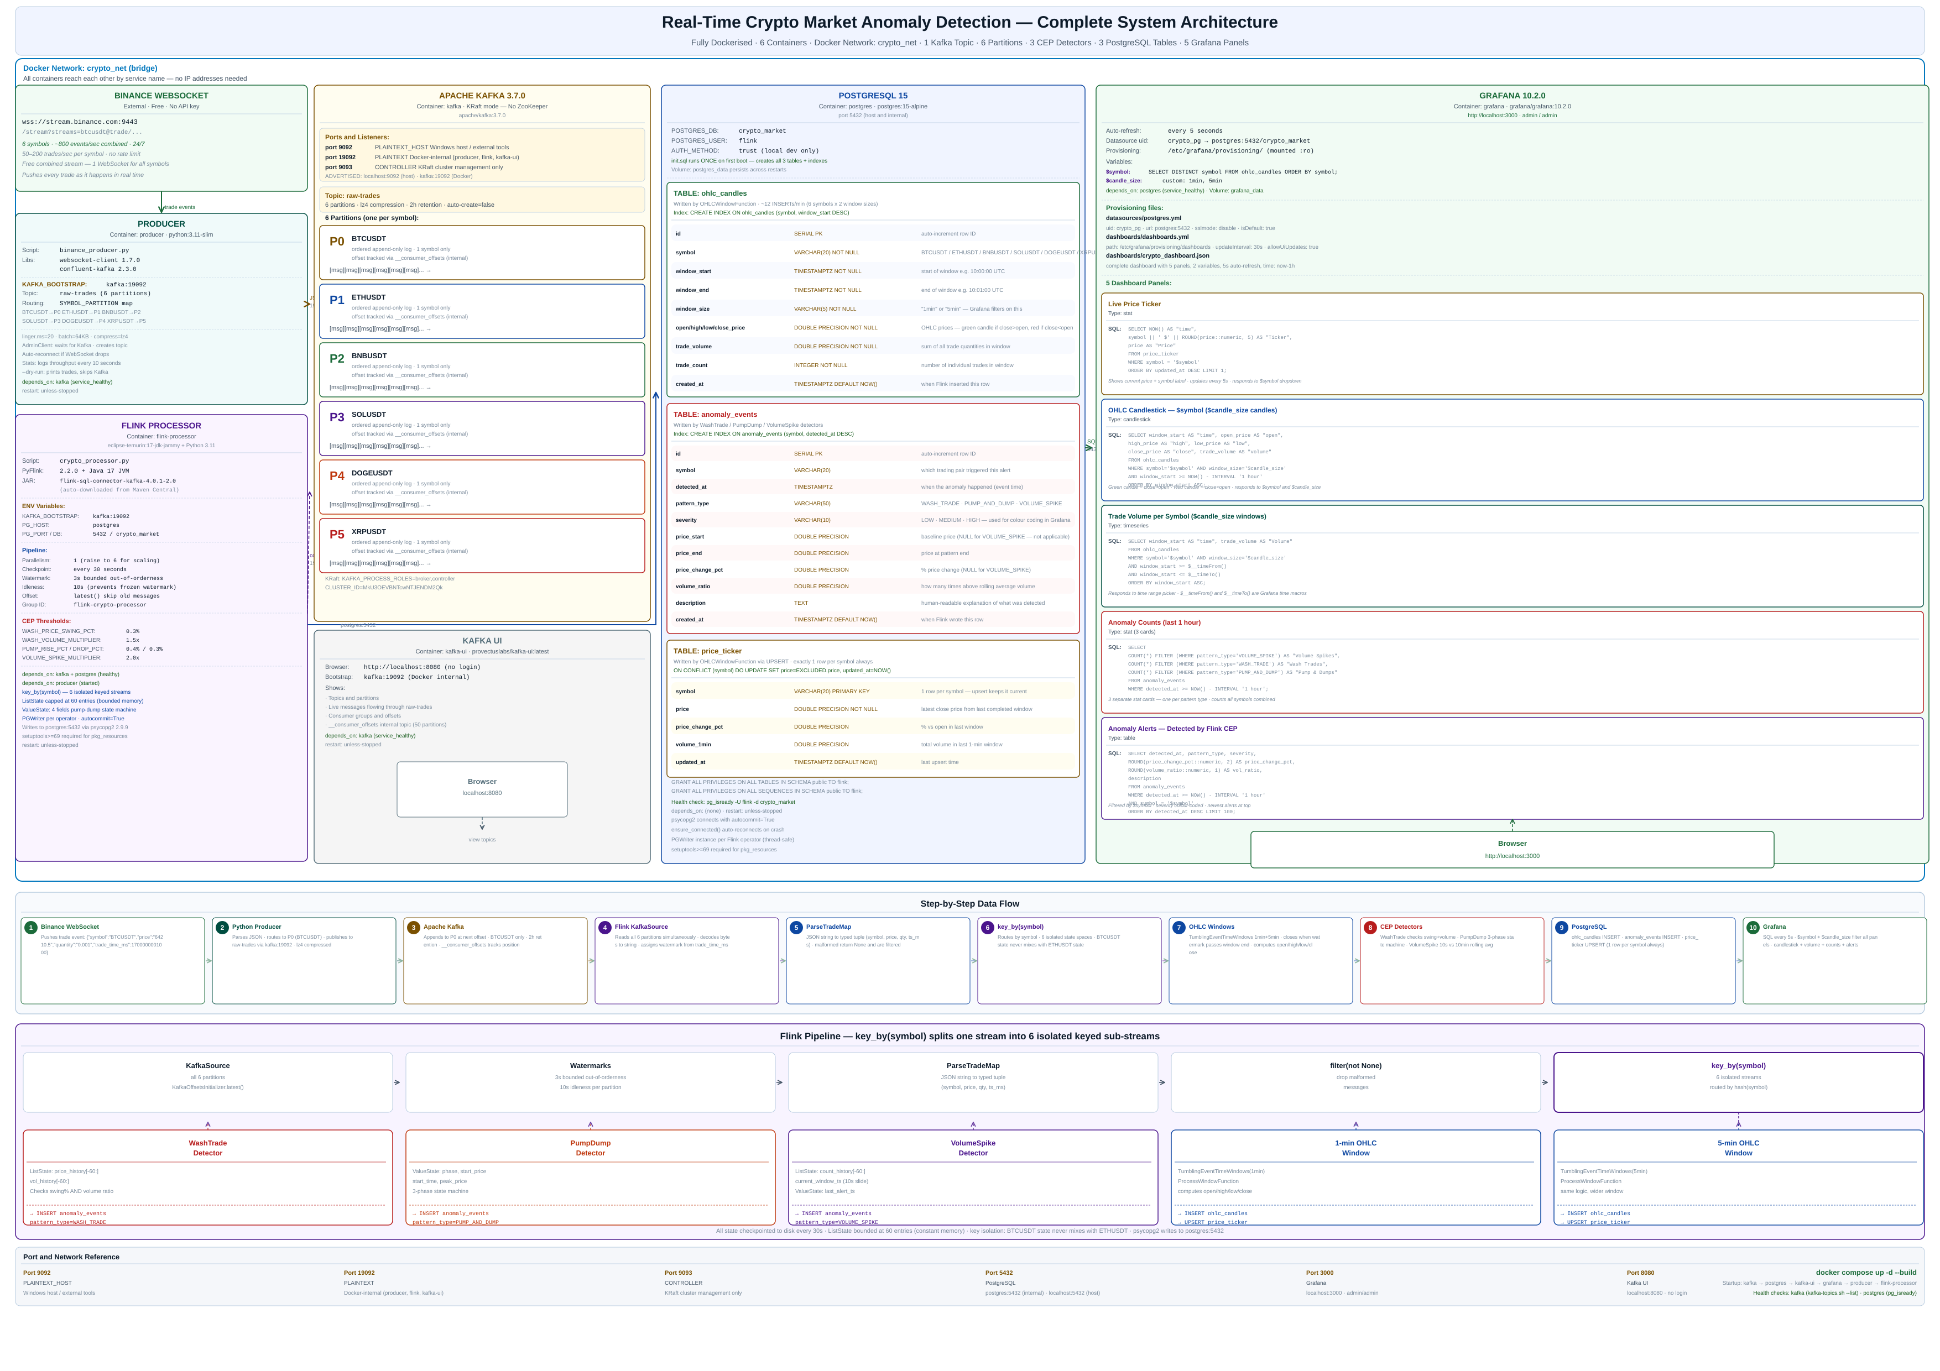
Figure 10 — complete architecture diagram

Thanks
Kodanda Challa

