Linear Regression (Python Implementation)
This article discusses the basics of linear regression and its implementation in Python programming language.
Linear Regression is a statistical approach for modeling relationship between a dependent variable (Y) with a given set of independent variables (X).
Regression Methods:
- Linear
  - Simple
  - Multiple
- non-Linear
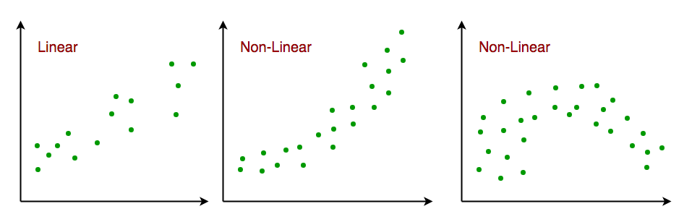
Simple Linear Regression: Simple Linear Regression is an approach for predicting a response (Y) using a single feature (X).
تحلیل گر داده، هیچ گاه مطمین نیست که کدام الگوریتم، مدل (فرمول) دقیق‌تری می دهد.
برای مثال ما، به نظر می‌رسد که داده‌ها با هم ارتباط خطی دارند. به صورت خطی کاهش می یابند. بنابراین، روش رگراسیون خطی ساده را برای پیدا کردن مدل، اجرا می کنیم.
It is assumed that the two variables are linearly related. Hence, we try to find a linear function that predicts the response value (Y) as accurately as possible as a function of the feature variable (X).
Example: Let us consider a dataset where we have a value of response y for every feature x:
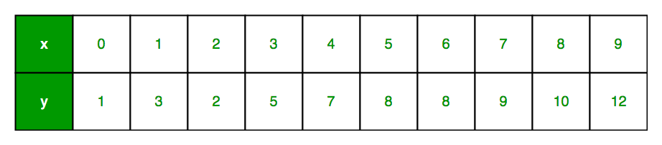
For generality, we define:
X = [x₁ , x₂ , … , x_{n}]
Y = [y₁ , y₂ , … , y_{n}]
for n observations (in above example, n=10).
A scatter plot of above dataset looks like:
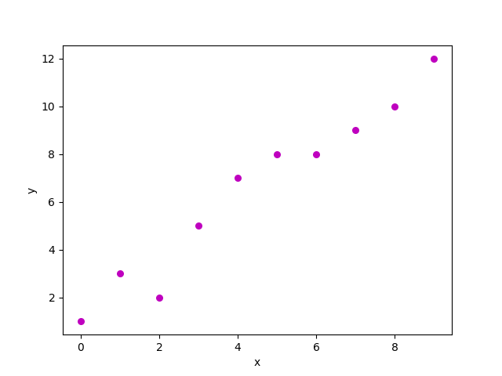
Now, the task is to find a line which fits best in above scatter plot so that we can predict the response for any new feature values. (i.e. a value of x not present in dataset)
This line is called regression line.
The equation of regression line is represented as:

Here,
- represents the predicted response value for th observation.
- and are regression coefficients and represent y-intercept and slope of regression line respectively.
To create our model, we must “learn” or estimate the values of regression coefficients and . And once we’ve estimated these coefficients, we can use the model to predict responses!
In this article, we are going to use the Least Squares technique.
Now consider:

Here, is residual error in th observation. So, our aim is to minimize the total residual error. We define the squared error (cost function), as:

and our task is to find the value of and for which is minimum!
Without going into the mathematical details, we present the result here:

where is the sum of cross-deviations of and :

and is the sum of squared deviations of :

Given below is the python implementation of above technique on our small data-set:
import numpy as np
import matplotlib.pyplot as plt

def estimate_coef (x, y):
# ...
# omitted
# ...
plot_regression_line (x, y, b)

if __name__ == "__main__":
main ()
Output of above piece of code is:
Estimated coefficients:
b_0 = -0.0586206896552
b_1 = 1.45747126437
And graph obtained looks like this:
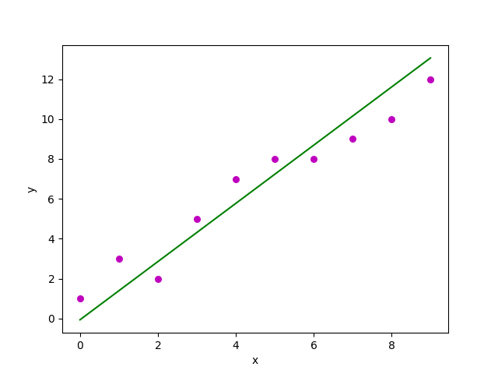

https://www.amherst.edu/system/files/media/1287/SLR_Leastsquares.pdf
Complete Code: q3.py

