Multiple Linear Regression
Multiple Linear Regression attempts to model the relationship between two or more features and a response by fitting a linear equation to observed data.
Clearly, it is nothing but an extension of Simple Linear Regression.
Consider a dataset withfeatures (or independent variables: ) and one response (or dependent variable: ). Also, the dataset contains rows/observations.
We define:
(feature matrix) = a matrix of shapewhere denotes the values of th feature for th observation.
So,
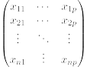
and
(response vector) = a vector of size where denotes the value of response forth observation.

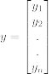
The regression line for p features is represented as:
whereis predicted response value forth observation and are the regression coefficients.
Also, we can write:
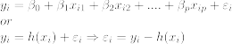
where represents residual error inth observation.
We can generalize our linear model a little bit more by representing feature matrix as:
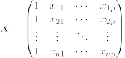
So now, the linear model can be expressed in terms of matrices as:
where,
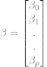
and
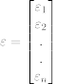
Now, we determine estimate of b, i.e. using Least Squares method.
As already explained, Least Squares method tends to determine for which total residual error is minimized.
We present the result directly here:
whererepresents the transpose of the matrix while represents the matrix inverse.
Knowing the least square estimates, , the multiple linear regression model can now be estimated as:
where is estimated response vector.
Note: The complete derivation for obtaining least square estimates in multiple linear regression can be found here.
Given below is the implementation of multiple linear regression technique on the Boston house pricing dataset using Scikit-learn.
در مثال زیر، روش‌های مزکور را روی یکی از دیتاست های آماده ماژول اجرا می کنیم.
#https://www.geeksforgeeks.org/linear-regression-python-implementation/

import numpy as np
from sklearn import datasets, linear_model, metrics

# load the boston dataset
boston = datasets.load_boston(return_X_y=False)

# defining feature matrix(X) and response vector(y)
X = boston.data
y = boston.target

# splitting X and y into training and testing sets
from sklearn.model_selection import train_test_split
X_train, X_test, y_train, y_test = \
train_test_split(X, y, test_size=0.4, random_state=1)

# create linear regression object
reg = linear_model.LinearRegression()

# train the model using the training sets
reg.fit(X_train, y_train)

# regression coefficients
print('Coefficients: \n', reg.coef_)

# variance score: 1 means perfect prediction
print('Variance score: {}'.format(reg.score(X_test, y_test)))

خروجی آن به قرار زیر است:
Coefficients:
[ -8.80740828e-02 6.72507352e-02 5.10280463e-02 2.18879172e+00
-1.72283734e+01 3.62985243e+00 2.13933641e-03 -1.36531300e+00
2.88788067e-01 -1.22618657e-02 -8.36014969e-01 9.53058061e-03
-5.05036163e-01]
Variance score: 0.720898784611
ملاحظه می‌ شود که تا پیدا کرد. چون دیتاست تا ستون داشت. یعنی برای هر ستون معادله خطی به صورت
پیذا کرد. آن را روی اجرا می کنیم. و مقادیر حاصل را با واقعی مقایسه می کند. دقت مدل () را محاسبه می کند. در اینجا درصد شده. یعنی این مدل دقت مطلوبی دارد و قابل اطمینان است.
فرمول محاسبه به صورت زیر است:

In above example, we determine accuracy score using Explained Variance Score:
1 – Var{y – y’}/Var{y}
where is the estimated target output, the corresponding (correct) target output, and is Variance, the square of the standard deviation.
The best possible score is , lower values are worse.
Providing the original.csv data-set, with 5 columns and 9484 rows:
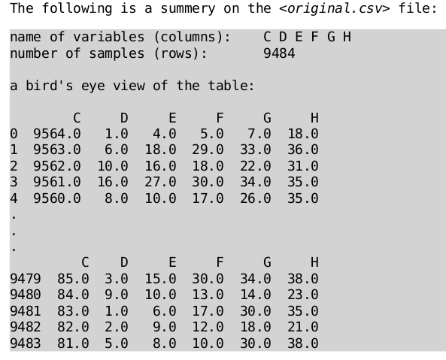
We ready to apply the Multiple Linear Regression on them variables:
import pandas as pd
import numpy as np
from sklearn.model_selection import train_test_split
from sklearn import datasets, linear_model, metrics
// omitted ...
# 'H'
X = v[['C', 'D', 'E', 'F', 'G']]
X = np.array(X)
y = v['H']
y = np.array(y)
The Scores for each of them variables are:
‘D’: Variance score: 0.425745578495
‘E’: Variance score: 0.64434924678
‘F’: Variance score: 0.671096989866
‘G’: Variance score: 0.621778826067
‘H’: Variance score: 0.413719006021

let’s consider one example enlisting for instances of the column:
score: 0.67 %
y^ int(y^) y HIT
-----------------------------------
24.16 (23, 24, 25) 26 no
14.45 (13, 14, 15) 13 yes
15.65 (14, 15, 16) 14 yes
28.75 (27, 28, 29) 28 yes
21.87 (20, 21, 22) 11 no
12.82 (11, 12, 13) 10 no
13.16 (12, 13, 14) 12 yes
18.17 (17, 18, 19) 18 yes
…
22.49 (21, 22, 23) 24 no
12.18 (11, 12, 13) 13 yes
Now, this is time to predict the unseen values for the column, using the achieved model. This is NOT feasible for X is a 1-dim array. However, we could separately apply the multi linear regression on each column. The For column:
The result is not promising as expected:
The score is very close to 0!

