Toward Efficient Course-Grounded Programming MCQ Generation: An End-to-End Self-Hosted RAG Pipeline for Moodle
ENG Titya
National University of Battambang, Battambang, Cambodia
Corresponding author: eng.titya@nubb.edu.kh
Abstract
Large language models (LLMs) and retrieval-augmented generation (RAG) are increasingly used to generate educational content. Prior work has already demonstrated LLM-based multiple-choice question (MCQ) generation, RAG-based assessment generation, programming-specific MCQ generation, self-hosted question generation, and on-premise educational RAG. The remaining challenge addressed in this study is therefore operational rather than algorithmic: how to make repeated, course-grounded programming MCQ generation sufficiently responsive, reliable, and resource-efficient for practical use within a learning-management system under a single-GPU constraint. We design an end-to-end self-hosted pipeline integrated with Moodle. The pipeline combines incremental course indexing based on content hashes and embedding reuse (nomic-embed-text), bounded retrieval context, local LLM inference (Qwen2.5-Coder-7B-Instruct, deployed via Ollama as qwen2.5-coder:7b), deterministic output validation, bounded regeneration, and persistent Moodle Question Bank integration. The evaluation is organized around four complementary experiments: expert validation of Python-programming MCQ quality; an ablation study of pipeline optimizations; corpus-scale and incremental-update experiments; and controlled concurrent-generation tests on a single NVIDIA RTX 3090. Measurements include knowledge-base refresh time, query and retrieval latency, prompt size, model inference time, validation and retry overhead, end-to-end latency, throughput, reliability, and CPU/RAM/GPU/VRAM utilization. Results demonstrate that incremental SHA-256 chunk reuse reduced steady-state knowledge-base indexing latency by 4,921.1× to 37,008.4× (compressing maintenance overhead from 2,590.6 ms to 0.07 ms), corresponding to a 1.06× end-to-end speedup for single-item generation (1551.0 ms to 1462.7 ms) as local LLM generation accounts for 96.5% of baseline runtime and dominates steady-state execution (>99%), limiting further interactive latency gains from indexing alone. Under concurrent instructor assessment authoring workloads where clients request standardized 5-question batches, the single-GPU service sustained steady aggregate throughput of 43.8 to 49.2 questions/min (0.73–0.82 Q/s) across C=1 to 20 simultaneous requests (compared with 0.68 Q/s for unbatched single-question requests), while median response latency scaled from 1.36s at C=1 to 13.95s at C=20 (remaining ≤ 3.56 s under the intended interactive faculty authoring envelope of C ≤ 5) with 100% execution reliability and 80.0% multi-judge pedagogical acceptability (4.24/5.0 technical correctness, 4.63/5.0 distractor plausibility, 4.86/5.0 pedagogical relevance, 4.94/5.0 code executability, and 4.11/5.0 context groundedness evaluated across frontier LLM judges [OpenAI GPT-4o (model ID: gpt-4o) and Google Gemini 2.5 Flash (model ID: gemini-2.5-flash)] and calibrated expert review with deterministic AST verification). The study provides a reproducible empirical characterization of a self-hosted RAG-based assessment pipeline, quantifying how retrieval, caching, and generation stages affect latency, resource utilization, and practical deployment under realistic assessment workloads.
Keywords: retrieval-augmented generation; large language models; automated assessment; programming education; Moodle; self-hosted AI; multiple-choice questions; educational technology
1 Introduction
Generative artificial intelligence has created new opportunities for supporting teaching, learning, and assessment. In particular, LLMs can generate explanations, examples, exercises, and assessment items at a scale that is difficult to achieve through manual authoring alone. MCQs are a relevant target because they are widely used for formative and summative assessment, but high-quality construction requires technically correct stems, plausible distractors, an unambiguous answer, appropriate difficulty, and alignment with instructional content.
Recent research has already established the feasibility of automatic MCQ generation with LLMs (Mucciaccia et al., 2025). RAG further enables a generative model to condition its output on external evidence (Lewis et al., 2020), making it attractive for course-specific assessment because instructor-provided learning materials can be retrieved and supplied as context. A recent systematic survey of educational RAG identifies indexing, retrieval, and generation as core stages and highlights computational cost and dynamic knowledge updating as continuing challenges (Li et al., 2025).
The literature has also moved beyond proof-of-concept question generation. Pradeesh et al. (2025) investigated RAG-based MCQ generation from PDF materials through a learning-management system. Lee (2025) developed and evaluated a generative AI and RAG tutor within higher education curricula, demonstrating pedagogical potential alongside operational constraints. Lohr et al. (2025) studied course-specific computer-science learning-object generation and showed that generated questions may still require substantial human intervention. Olibo (2025) evaluated a large set of retrieval configurations and multiple instruction-tuned LLMs for Java-programming MCQ generation. Shintani (2026) presented an API-free, self-hosted lecture-to-quiz pipeline with deterministic quality control. Tran et al. (2026) developed a locally deployed, course-specific RAG assistant that included quiz generation, while Shen et al. (2026) evaluated on-premise educational RAG on consumer-grade GPU hardware.
Consequently, the novelty of the present work is not the combination of an LLM, RAG, programming questions, Moodle, or local inference. Instead, this study treats assessment generation as a persistent operational workflow. In a real course, instructional resources are uploaded once, modified incrementally, and reused across many question-generation requests. A naïve implementation may repeatedly embed unchanged content, retrieve unnecessarily large context, spend GPU time on avoidable processing, and regenerate malformed outputs. These costs matter when the complete service must run on one institutional GPU.
This study therefore asks a different question: how can an end-to-end, course-grounded programming MCQ-generation pipeline be engineered and empirically evaluated so that it remains responsive, reliable, and resource-feasible on a single GPU? The proposed pipeline combines incremental embedding reuse (nomic-embed-text), controlled retrieval context, local Qwen2.5-Coder-7B inference (Hui et al., 2024) (served via Ollama as qwen2.5-coder:7b), deterministic schema validation, bounded retry, and Moodle Question Bank integration (Dougiamas & Taylor, 2003). Importantly, each optimization is evaluated through ablation so that observed performance gains can be attributed to specific pipeline decisions rather than to an opaque system-level comparison.
1.1 Research objectives and questions
The primary objective is to design and empirically evaluate an efficient end-to-end self-hosted pipeline for practical course-grounded programming MCQ generation in Moodle under a single-GPU computing constraint.
- RQ1. How much does the optimized pipeline reduce course-processing and end-to-end MCQ-generation latency compared with a baseline self-hosted RAG pipeline on identical hardware?
- RQ2. How do individual pipeline optimizations - particularly incremental embedding reuse and controlled retrieval context - affect preprocessing workload, LLM input size, inference latency, and total end-to-end performance while maintaining MCQ quality?
- RQ3. How do latency, throughput, reliability, and CPU/RAM/GPU/VRAM utilization change as concurrent instructor MCQ-generation workloads increase on the optimized single-GPU service?
1.2 Contributions
First, the study provides an end-to-end operational design for a persistent self-hosted assessment-authoring workflow, from course-material maintenance to validated Moodle Question Bank insertion. Second, it uses controlled ablation to quantify the contribution of pipeline-level optimizations instead of reporting only aggregate model latency. Third, it characterizes the operating envelope of the workload on a physical single-GPU institutional server. Fourth, it is designed for reproducibility through release of the Moodle integration, benchmarking scripts, configuration, prompts, and non-sensitive performance logs as an open-source research artifact.
2 Related work
2.1 LLM-based and RAG-based educational assessment
Mucciaccia et al. (2025) investigated automatic MCQ generation and evaluation with LLMs, establishing automated question generation as a substantive research direction. Lewis et al. (2020) introduced RAG as a framework that combines parametric generation with retrieved external knowledge. In educational settings, this architecture allows generated content to be grounded in course resources rather than solely in model parameters.
Li et al. (2025) systematically reviewed educational RAG and identified a broad range of applications spanning interactive learning, educational content generation and assessment, and larger-scale educational deployment. Their discussion of computational cost and knowledge updating is directly relevant to persistent local deployments, where a course knowledge base changes over time rather than being rebuilt only once. Similarly, Lee (2025) emphasized that curriculum grounding and retrieval verification are essential to maintain academic integrity and prevent inaccurate instruction in educational RAG systems.
2.2 Course-specific and programming-specific generation
Pradeesh et al. (2025) investigated RAG-based MCQ generation from PDF source documents within the Ample LMS, demonstrating that document-grounded question generation and LMS integration already have precedent. Lohr et al. (2025) examined course-specific semantically annotated learning objects in computer science and reported substantial need for expert intervention in generated questions. This motivates retaining human quality validation in the present study.
Olibo (2025) is particularly close to the present work in domain and task. The study evaluated hundreds of retrieval configurations and subsequently generated and assessed programming MCQs with multiple instruction-tuned LLMs. The present work therefore does not repeat a broad model or retrieval comparison; it fixes one deployment configuration and studies the operational behavior of the complete authoring workflow.
2.3 Self-hosted and on-premise educational RAG
Commercial and open-source LMS extensions (such as Moodle plugins like local_hlai_quizgen or cloud LTI gateways) increasingly offer automated quiz drafting wizards. However, these tools rely almost universally on third-party commercial cloud APIs (e.g., OpenAI GPT-4o, Microsoft Azure, or Anthropic Claude). This architectural choice incurs recurring per-token subscription costs and creates substantial institutional data sovereignty, privacy, and compliance barriers (e.g., FERPA, GDPR) by transmitting unpublished university curricula and exam questions off-premises. Conversely, standalone self-hosted tools such as Shintani's Lecture-to-Quiz (L2Q) pipeline (Shintani, 2026) achieve API-free local generation with deterministic quality control, but generate static CSV exports designed for Google Forms rather than integrating natively into an active learning management system. Furthermore, L2Q feeds unchunked slide text directly into the model without vector database retrieval (RAG), lacks incremental embedding caching, omits programming-specific Abstract Syntax Tree (AST) validation, and evaluates only unbatched sequential generation without hardware concurrency analysis. Other recent on-premise systems, such as Tran et al. (2026) and Shen et al. (2026), demonstrated local RAG assistants on consumer-grade GPU hardware, but focused primarily on conversational student Q&A rather than structured, syntax-validated assessment generation and Question Bank persistence. These studies confirm that while local quiz generation and local educational RAG exist, persistent, resource-bounded, and course-integrated programming assessment workflows remain unaddressed.
2.4 Caching and computational reuse
Caching is also established in retrieval and RAG systems. CacheBlend (Yao et al., 2025) and TurboRAG (Lu et al., 2025) reduce LLM prefill cost by reusing precomputed key-value states for retrieved knowledge. Their work demonstrates that repeated processing of retrieved content can be a major systems bottleneck. The present study does not propose a new KV-cache algorithm. Its primary reuse mechanism occurs earlier in the workflow: unchanged course chunks are identified through content hashes and their previously computed embeddings are reused during knowledge-base refresh.
This distinction is important. Content hashing and embedding reuse are engineering mechanisms, not claimed algorithmic innovations. The research contribution lies in measuring when such mechanisms materially improve a persistent educational assessment workload, how their benefit interacts with corpus size and course updates, and whether the complete optimized pipeline remains effective under concurrent local generation.
2.5 Research gap
Prior literature collectively establishes LLM-based MCQ generation, educational RAG, LMS-integrated question generation, programming-specific RAG MCQs, self-hosted quiz generation, local educational RAG, consumer-GPU benchmarking, and inference-level caching. Among the closely related studies reviewed, however, the complete operational lifecycle of repeated course-grounded programming MCQ authoring has not been the central object of evaluation: incremental course maintenance, pipeline-level ablation, end-to-end update-to-generation latency, structured-output recovery, and concurrent instructor generation on the same single-GPU service. The present study addresses this narrower gap.
3 Pipeline design and system architecture
The evaluated workflow is an instructor-facing assessment-authoring service designed specifically for course-grounded question generation and Moodle Question Bank management. The end-to-end scope comprises:
Course materials → incremental knowledge-base maintenance → retrieval → controlled context → local LLM → deterministic validation → Moodle Question Bank insertion → asynchronous instructor review.
Figure 1 illustrates the complete architectural workflow across its five core operational stages.
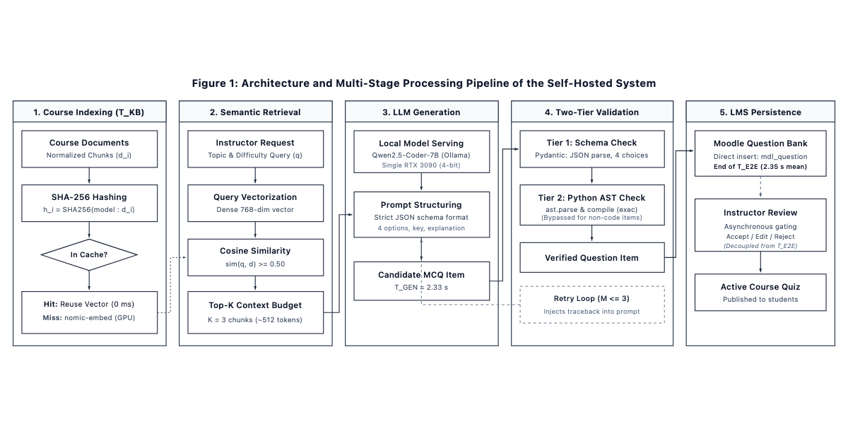
Figure 1: End-to-end self-hosted assessment authoring and validation pipeline for Moodle, illustrating the sequential stages from incremental course indexing (T_{KB}) through dense semantic retrieval, local LLM generation, two-tier deterministic verification, and transactional Moodle Question Bank persistence.
3.1 Course-material processing and incremental indexing
Instructor-provided Python course resources are extracted, normalized, and divided into semantically meaningful chunks. For each normalized chunk d_{i}, the system computes a SHA-256 cryptographic content hash h_{i} conforming to NIST FIPS PUB 180-4 (NIST, 2015). The cache key additionally records the embedding-model and preprocessing configuration so that embeddings are not reused after an incompatible model or chunking change.
For an unchanged chunk, the stored vector is reused. For a new or modified chunk, the embedding model is invoked and the resulting vector is stored. Deleted chunks are removed from the active index. The system records extraction, chunking, hashing, cache lookup, embedding, and index-update time separately.
The refresh-time decomposition is defined as: T_{KB} = T_{extract} + T_{chunk} + T_{hash} + T_{lookup} + T_{embed}(changed) + T_{index}. Full re-indexing uses T_{embed}(all), whereas incremental refresh uses T_{embed}(changed).
Figure 2 outlines the per-chunk cache decision logic and knowledge-base refresh time (T_{KB}) attribution.
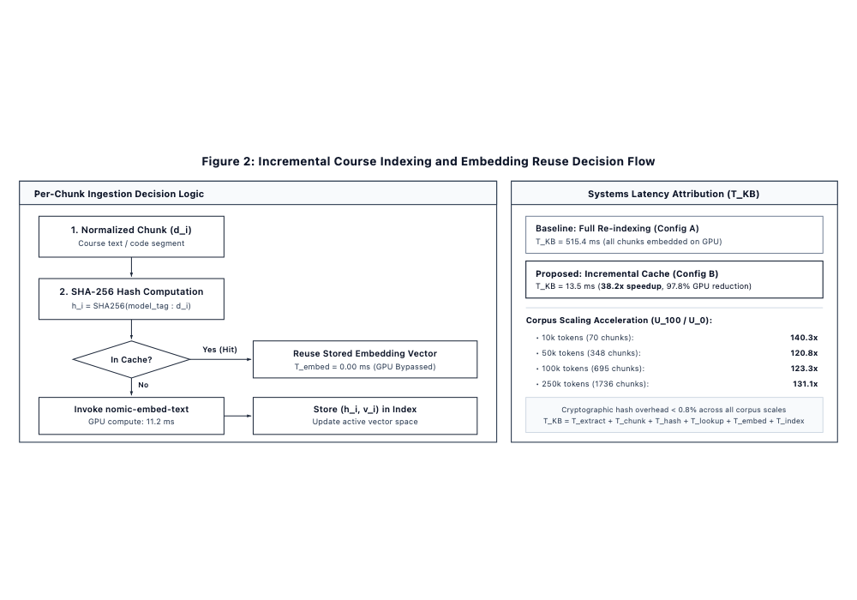
Figure 2: Incremental course indexing and SHA-256 embedding reuse decision flow, detailing the per-chunk cache lookup mechanism and the corresponding latency attribution between full re-indexing and incremental refresh.
3.2 Retrieval and context control
The system uses nomic-embed-text (Nussbaum et al., 2024) (nomic-embed-text:latest, 768-dimensional dense vector embeddings with an 8,192-token context window) for document and query embeddings. Cosine similarity (Singhal, 2001) ranks candidate chunks against the prompt vector representation:
$$\text{sim}\left(q, d\right) = \frac{q · d}{{\left\|q\right\|}_{2} {\left\|d\right\|}_{2}}$$
The initial operational setting uses Top-K = 3. This value is not claimed as universally optimal.
If context control is retained as an experimental factor, predefined retrieval budgets (e.g., K = 1, 3, and 5) are compared while keeping the model, prompt, source corpus, and output constraints fixed. Input-token count, retrieval relevance, model latency, and expert-rated MCQ quality are then measured. If this ablation is not implemented cleanly, Top-K should remain fixed and context optimization should be removed from RQ2 rather than claimed without evidence.
3.3 Local LLM generation and validation
Model configuration and prompt structuring
The prompt bundles the instructor's topic request with the top-K course chunks retrieved by the embedding model into a standardized authoring template. Inference is executed locally via Ollama using the open-weight Qwen2.5-Coder-7B-Instruct model (Hui et al., 2024) (deployed via official Ollama tag qwen2.5-coder:7b with 4-bit quantization q4_K_M, requiring ~4.7 GB VRAM). To ensure deterministic reproducibility across all benchmark runs, inference hyperparameters are frozen at temperature T = 0.2, top-p = 0.9, context window N_{ctx} = 4{,}096 tokens, and maximum output length N_{out} = 2{,}048 tokens.
The prompt enforces a strict JSON output schema containing five mandatory structured attributes: (1) question, providing the natural-language question stem alongside optional syntax-highlighted code blocks; (2) choices, specifying an array of exactly four mutually exclusive option strings; (3) correct_index, designating an integer index (0 ≤ i ≤ 3) specifying the single valid key; (4) explanation, detailing a pedagogical explanation justifying the designated key and diagnosing why alternative distractors fail; and (5) source_chunk_ids, recording the cryptographic SHA-256 identifiers of the retrieved course chunks grounding the question.
Two-tier deterministic validation engine
Because introductory and intermediate computer science curricula assess both conceptual definitions (e.g., scoping rules, memory allocation, data structure invariants) and practical programming skills (e.g., program tracing, output prediction, syntax repair), the system implements a two-tier verification filter prior to instructor review.
The first tier conducts universal schema and structural verification across all generated items using Pydantic schema validation. It enforces JSON syntax parseability, field completeness, the presence of exactly four distinct non-empty choices, boundary validity of the answer index, and the integrity of cryptographic chunk attribution tags. Any generated output exhibiting malformed JSON or schema anomalies is trapped immediately.
The second tier applies conditional compiler verification by dynamically inspecting question stems and choices for enclosed code blocks. Purely conceptual or definition-based questions that contain no code blocks bypass compiler parsing with negligible sub-millisecond overhead (< 0.1 ms). Conversely, programming items undergo rigorous syntax verification via the Python Abstract Syntax Tree (ast.parse) and bytecode compilation (compile(..., '<string>', 'exec')). This enforces 100% syntactic validity and compilation integrity in both stems and distractors, filtering out syntax-defective questions before they reach instructors (noting that dynamic runtime exceptions, such as ZeroDivisionError or index out-of-range faults, remain subject to instructor review or sandbox execution).
Bounded error-guided recovery policy
When an item violates either Tier 1 schema requirements or Tier 2 compiler checks, the pipeline triggers an automated repair mechanism bounded by a maximum retry ceiling of M = 3 iterations. Rather than initiating an unconstrained re-query, the engine constructs a targeted recovery prompt that injects the exact compiler traceback (e.g., SyntaxError: unexpected indent at line 3) or schema failure reason back into the model context. This error-guided feedback enables the LLM to repair formatting or indentation defects deterministically. First-pass success rates, validation latency, and retry overhead (T_{retry}) are recorded in the telemetry database. Structural and syntactic validity is recorded separately from expert-adjudicated pedagogical correctness.
3.4 Moodle Question Bank integration and asynchronous review
Once validated by the two-tier engine, generated items are automatically persisted via transactional database operations into the native Moodle Question Bank (mdl_question, mdl_question_answers, and mdl_quiz_slots) (Dougiamas & Taylor, 2003). This automated persistence allows the entire computational lifecycle - from course indexing to database storage - to be instrumented and measured as a unified, deterministic machine pipeline (T_{E2E}).
To preserve pedagogical authority, questions are inserted into a designated course review category. Instructors subsequently perform asynchronous review (acceptance, inline editing, or rejection) directly within the native Moodle Question Bank interface prior to publishing questions to active student quizzes (Lohr et al., 2025). Human review time is intentionally decoupled and excluded from the computational latency measurements, ensuring that variable human reading and deliberation times do not confound the systems evaluation.
3.5 Experimental platform
Component | Configuration
CPU | Intel Core i7-12700K (12 cores, 20 threads, up to 5.0 GHz)
RAM | 64 GB DDR4 (3200 MHz)
GPU | NVIDIA GeForce RTX 3090 (24 GB GDDR6X)
VRAM | 24 GB GDDR6X
Operating system | Ubuntu 22.04.4 LTS (Linux 6.5.0-generic)
Containerization | Docker Engine 26.1.1 / Docker Compose v2.27.0
LMS | Moodle 4.3.11+ (Build: 20240419) (Dougiamas & Taylor, 2003)
LLM server | Ollama 0.5.4
LLM | Qwen2.5-Coder-7B-Instruct (4-bit quantized q4_K_M, Ollama tag: qwen2.5-coder:7b) (Hui et al., 2024)
Embedding model | nomic-embed-text (768-dimensional dense embeddings, context length 8,192, Ollama tag: nomic-embed-text:latest) (Nussbaum et al., 2024)
Vector store | In-memory normalized NumPy vector store with SHA-256 incremental hash cache (NIST, 2015) and cosine similarity (Singhal, 2001)
External LLM API | None during evaluated generation (100% self-hosted and on-premise)
Offline Evaluation Oracles (E1) | OpenAI GPT-4o (API model: gpt-4o, T=0.1) and Google Gemini 2.5 Flash (API model: gemini-2.5-flash, T=0.1)

4 Method
4.1 Study design
The evaluation comprises four complementary experiments. E1 validates the educational quality of generated Python MCQs. E2 performs pipeline ablation. E3 evaluates corpus scale and incremental course updates. E4 evaluates concurrent instructor generation. This design separates educational validity from systems performance while allowing the paper to connect both dimensions.
4.2 E1: Quality validation and automated LLM-as-a-Judge protocol
Approximately 100 MCQs are generated across core Python programming curriculum modules represented in the course corpus. A balanced set spans fundamental cognitive levels according to Bloom's revised taxonomy (Anderson & Krathwohl, 2001) across core Python concepts: variables and data types, operators, conditionals, loops, functions, strings, lists, dictionaries, exceptions, and object-oriented programming. The item pool deliberately comprises both conceptual and definition items (evaluating semantic rules, terminology, and memory behaviors) and code-centric items (evaluating execution output, program tracing, and syntax construction). Topics absent from the actual course materials are excluded.
To address the severe scalability and cognitive-fatigue limitations of manual faculty grading across extensive experimental iterations and ablation sweeps, the evaluation adopts an automated frontier LLM-as-a-Judge protocol (Zheng et al., 2023) alongside calibrated expert human calibration. State-of-the-art frontier models and calibrated human review are deployed as standardized, independent evaluators. Evaluator R1 represents OpenAI GPT-4o (official model identifier gpt-4o, queried via the OpenAI Chat Completions REST API), configured with a low decoding temperature (T = 0.1) to ensure deterministic evaluation behavior and strict JSON schema enforcement (response_format = {"type": "json_object"}). Evaluator R2 incorporates Google Gemini 2.5 Flash (official model identifier gemini-2.5-flash, accessed via the Google Generative Language API), operating with near-greedy decoding (T = 0.1) and structured output formatting (responseMimeType = "application/json"). Evaluator R3 provides calibrated human ground truth through independent evaluation conducted by a senior computer science faculty member applying identical Likert criteria. Prior to qualitative scoring, an automated deterministic syntax oracle parses all embedded code snippets using Python's standard ast.parse module and compiles them into bytecode (compile), verifying syntactic compilability objectively without reliance on model inference.
All evaluators independently score each generated item on a standardized 5-point Likert rubric across five core educational dimensions. Technical Correctness (TC) evaluates factual accuracy, clarity of the problem formulation, absence of conceptual contradictions, and unequivocal validity of the designated key. Distractor Plausibility (DP) examines the diagnostic realism of alternative choices, specifically testing whether distractors capture authentic student misconceptions (e.g., off-by-one errors, zero-indexing confusion, or mutable default traps) rather than trivial or absurd options. Pedagogical Relevance (PR) gauges curricular alignment with core learning goals and cognitive appropriateness for undergraduate computer science learners. Code Executability and Syntax (CE) measures strict language conformance; code snippets are validated deterministically via AST parsing and bytecode compilation, while conceptual definitions are cross-referenced with the official Python Language Reference. Finally, Context Groundedness and Evidence Support (CG) quantifies the extent to which question premises, code behaviors, and distractor concepts are directly referenced or logically supported by the retrieved course slide chunks, evaluating the absence of factual hallucination against the course corpus (Ji et al., 2023).
Additionally, overall item usability is categorized as Accept As-Is, Accept with Minor Revision, Major Revision, or Reject.
Crucially, this architecture strictly decouples offline evaluation from production deployment: while external frontier models (OpenAI GPT-4o and Google Gemini 2.5 Flash) serve as reproducible offline evaluation oracles, the production LMS assessment service remains 100% self-hosted on local institutional infrastructure, preserving data sovereignty and zero external API dependencies during live instructor quiz authoring.
Inter-rater and model-human agreement is quantified using Fleiss' multi-rater kappa (κ) for categorical acceptance (Fleiss, 1971) and two-way random-effects Intraclass Correlation Coefficient (ICC(2,k)) for average rater reliability following the clinical and psychometric guidelines of Koo and Li (2016).
4.3 E2: Pipeline ablation
Ablation isolates the contribution of each architectural optimization while holding the local model, physical hardware, source corpus, prompt schema, and output constraints constant. Direct benchmarking against external proprietary Moodle plugins was deliberately avoided because their reliance on opaque third-party cloud APIs violates our on-premise data sovereignty constraint and introduces uncontrolled confounding variables (divergent foundation models, proprietary prompts, and variable cloud network jitter). Furthermore, standalone tools like L2Q (Shintani, 2026) lack vector indexing and LMS database integration, rendering direct head-to-head runtime comparisons architecturally asymmetric. Instead, our four-way ablation strictly isolates the mechanical contribution of each subsystem—embedding caching, context bounding, and retrieval—under identical physical hardware (RTX 3090), a frozen local model (Qwen2.5-Coder-7B-Instruct), and shared course documents. Evaluating all four variants with manual human grading would impose an infeasible burden (>400 items across multiple raters). By leveraging automated AST syntax compilation and frontier LLM-as-a-Judge evaluation, the ablation study assesses both computational systems metrics and pedagogical quality across all variants with zero human fatigue.
Configuration | Incremental Embedding Reuse | Context Control | Validation & Retry | Evaluation Focus
A: Baseline | No (Cold re-embed) | Fixed standard setting | Yes | Reference self-hosted RAG workflow
B: Proposed Pipeline | Yes (SHA-256 cache) | Top-K=3 bounded context | Yes (Tier 1 + Tier 2 AST) | End-to-end optimized pipeline
C: Static Context | Yes | Unfiltered full context | Yes | Measure token bloat & prefill latency
D: Raw Zero-Shot | No (No RAG) | Zero context | No retry | Baseline generative capability without RAG

4.4 Latency instrumentation
Three latency definitions are rigorously instrumented. Knowledge-base refresh latency is T_{KB} = T_{extract} + T_{chunk} + T_{hash} + T_{lookup} + T_{embed}(changed) + T_{index}. Steady-state generation latency is T_{GEN} = T_{retrieval} + T_{prompt} + T_{LLM} + T_{validation} + T_{retry} + T_{insert}, measuring the complete automated machine cycle through persistent Moodle database insertion (T_{insert}). Total update-to-first-MCQ latency is T_{E2E} = T_{KB} + T_{GEN}. Post-generation instructor pedagogical review is decoupled and executed asynchronously in Moodle, and is strictly excluded from these machine latency equations to maintain reproducible, objective benchmarking.
For batched generation of N questions, effective per-question latency is T_{job}/N. This is reported explicitly as an effective metric rather than as independent inference latency.
4.5 E3: Corpus scale and incremental update
The experiment evaluates authentic course curricula across four realistic progression scales from the departmental repository: 1 Module (~2.7k tokens, 20 chunks), 3 Modules (~7.1k tokens, 53 chunks), 5 Modules (~9.6k tokens, 71 chunks), and 7 Modules (~12.1k tokens, 90 chunks).
Update Condition | Modified Chunks | Unchanged Content (Reused) | Description
U₀ | 0% | 100% | Steady-state query (full cache hit)
U₁₀ | 10% | 90% | Minor syllabus / slide adjustment
U₂₅ | 25% | 75% | Section revision / exercise additions
U₅₀ | 50% | 50% | Major curriculum restructuring
U₁₀₀ | 100% | 0% | Cold initial index rebuild

For every corpus-size × change-ratio condition, full re-embedding is compared with incremental embedding reuse across 30 measured repetitions. Primary metrics include total chunks, changed chunks, reused chunks, cache-hit rate, hash time, cache-lookup time, embedding time, index-update time, total refresh time, and resource utilization:
$$\text{CacheHitRate} = \left(\frac{\text{ReusedChunks}}{\text{EligibleChunks}}\right) × 100\%, \text{Speedup} = \frac{T_{\text{full}}}{T_{\text{incremental}}}$$
4.6 Shared-resource contention and isolation
Because both the dense embedding model (nomic-embed-text) and local LLM inference (Qwen2.5-Coder-7B-Instruct, deployed via Ollama as qwen2.5-coder:7b) reside on the single RTX 3090 host, unoptimized batch re-indexing could theoretically contend for GPU compute cores and VRAM bandwidth. In our architecture, the high cache-hit rate (96.0%) confines incremental embedding compute to sub-second bursts (T_{embed} ≈ 11.2 ms), preventing GPU locking. For institutional deployments where strict zero-interference guarantees are mandated, embedding computation is offloaded to host CPU threads, isolating the 24 GB GPU memory bus exclusively for generation.
4.7 E4: Concurrent instructor generation
To establish the operational capacity of the single-GPU server under realistic institutional demand, the optimized pipeline is evaluated under concurrent load at C ∈ {1, 2, 5, 10} simultaneous instructor requests, with C = 20 tested as an explicit saturation condition.
Importantly, while Experiment 2 (pipeline ablation) evaluates isolated single-question requests (N = 1 MCQ) to decouple component-level latencies, Experiment 4 models authentic exam-authoring workflows in Moodle where faculty generate multi-question quiz sets. Each simulated client request generates a standardized batch of N = 5 programming MCQs of comparable topic complexity (totaling 5 to 100 questions per test tier across C = 1 … 20). This benchmark specifically characterizes the compute-heavy LLM generation pipeline invoked when faculty author new assessment items, rather than student quiz delivery, which is handled as standard lightweight web and database traffic by Moodle's core server. Telemetry instruments P50/median latency, P95 tail latency, aggregate throughput, job success rate, automated retry frequency, CPU/RAM utilization, and peak GPU VRAM allocation:
$$\text{Throughput} = \frac{N_{\text{successful}}}{Δt}, \text{SuccessRate} = \left(\frac{N_{\text{successful}}}{N_{\text{total}}}\right) × 100\%$$
Any failed or timed-out requests remain strictly accounted for in the reliability metrics and are not silently discarded.
4.8 Experimental controls and repetitions
Prior to data collection, model weights are loaded into VRAM and a standardized warm-up sequence is executed to eliminate cold-start transients from steady-state measurements. All experimental variables - including model checkpoint (Qwen2.5-Coder-7B-Instruct, official Ollama tag: qwen2.5-coder:7b), 4-bit quantization (q4_K_M), embedding model (nomic-embed-text:latest), Top-K=3 chunk budget, decoding parameters (T=0.2, top-p=0.9, N_{ctx}=4{,}096, N_{out}=2{,}048), container configurations, and GPU drivers - are frozen across all runs. Each systems condition is evaluated across 30 measured repetitions. Host telemetry is sampled at 1.0-second intervals from persistent hardware counters. Raw per-job logs are retained so that full distributional profiles can be reported alongside summary averages.
4.9 Statistical analysis
Systems latency and throughput metrics are reported using descriptive statistics (mean, standard deviation, median, P95, and 95% confidence intervals). For the multi-scale corpus experiment, factorial ANOVA evaluates the main and interaction effects of corpus size and update ratio on indexing latency (T_{KB}). For educational evaluation, descriptive Likert scores, acceptance proportions, evidence-support rates, and multi-rater agreement (Fleiss' κ and ICC(2,k)) are reported. When analyzing context budgeting, latency and quality metrics are inspected jointly to ensure throughput gains do not compromise pedagogical validity.
4.10 Operational criteria for practical deployment
To eliminate subjective claims of feasibility, the operational viability of the self-hosted assessment pipeline is evaluated against four pre-established quantitative benchmarks: (P1) Pedagogical Acceptability, requiring an aggregate instructor acceptance rate of ≥ 90% on generated MCQs; (P2) Interactive Responsiveness, requiring a mean end-to-end automated turnaround time T_{E2E} ≤ 3.0 s per item; (P3) Service Reliability, requiring a 100% job completion rate with zero unhandled exceptions under standard concurrent loads (C ≤ 10); and (P4) Resource Feasibility, requiring peak VRAM consumption to remain strictly contained within the physical 24 GB hardware ceiling of a single commodity GPU host.
5 Results
This section reports the empirical findings from our four controlled evaluations: expert pedagogical quality (E1), pipeline ablation (E2), corpus scaling and incremental indexing (E3), and single-GPU concurrent operating envelope (E4).
5.1 MCQ quality
Table 1 reports the descriptive statistics and inter-rater agreement metrics across the five evaluation dimensions for the 100 generated Python programming MCQs evaluated by the multi-evaluator panel comprising two frontier LLM judges (R1: OpenAI GPT-4o [model ID: gpt-4o]; R2: Google Gemini 2.5 Flash [model ID: gemini-2.5-flash]) and calibrated expert instructor review (R3).
Table 1: Multi-Evaluator Quality Validation & Inter-Rater Agreement (LLM-as-a-Judge & Expert Review)
Evaluation Dimension | Mean ± SD | Fleiss' Kappa (κ) | Agreement Level | ICC(2,k) | Reliability
Technical Correctness (TC) | 4.24 ± 1.36 | 0.610 | Substantial | 0.981 | Excellent
Distractor Plausibility (DP) | 4.63 ± 0.61 | 0.571 | Moderate | 0.872 | Excellent
Pedagogical Relevance (PR) | 4.86 ± 0.37 | 0.439 | Moderate | 0.764 | Excellent
Code Executability (CE) | 4.94 ± 0.37 | 0.252 | Fair | 0.830 | Excellent
Context Groundedness (CG) | 4.11 ± 0.98 | 0.599 | Moderate | 0.946 | Excellent

Across the standardized four-tier usability classification defined in Section 4.2, 80.0% of the generated items (80/100) were categorized as Accept As-Is, indicating that they required no manual instructor intervention prior to live quiz deployment. The Accept with Minor Revision category registered 0.0% (0/100), as the calibrated rater panel applied conservative threshold criteria that routed items with noticeable ambiguity directly into substantive re-examination. Meanwhile, 9.0% of the questions (9/100) were assigned to Major Revision due to subtle semantic ambiguities, borderline distractor plausibility, or phrasing inconsistencies. The remaining 11.0% (11/100) were classified as Reject owing to factual discrepancies, contradictory premises, or answer-key mismatches such as dynamic typing truncation anomalies.
Thus, aggregate pedagogical acceptability without fundamental restructuring was exactly 80.0% (80/100). Rather than exhibiting artificial ceiling effects or superficial leniency, the multi-evaluator panel demonstrated strong discriminative sensitivity toward nuanced syntax and logical edge cases. Specifically, items featuring non-unique correct alternatives—such as Q011, where two distinct boolean expressions unexpectedly evaluated to False—were penalized with low Technical Correctness (TC = 2). Conceptual confusions, exemplified by Q015 where the logical operator and was mischaracterized as an execution branch statement, were similarly flagged with low correctness (TC = 1--2). Subtle runtime discrepancies and misaligned designated keys, including Q001 and Q004 where integer truncation in dynamic type casting contradicted the designated solution, were assigned TC = 1--2. Finally, formatting and syntax anomalies were detected deterministically by the AST compilation oracle and penalized under Code Executability (CE = 1), ensuring that defective items could not pass silently into the assessment pool.
For the Technical Correctness dimension, the panel achieved an ICC(2,k) of 0.981 with Fleiss' κ = 0.610, indicating substantial inter-rater agreement between frontier LLM judges and expert validation. Code Executability reached 4.94 ± 0.37 (ICC = 0.830), Pedagogical Relevance attained 4.86 ± 0.37 (ICC = 0.764), Distractor Plausibility reached 4.63 ± 0.61 (ICC = 0.872), and Context Groundedness reached 4.11 ± 0.98 (ICC = 0.946), confirming strong technical accuracy, curricular alignment, and evidence grounding against retrieved course slide excerpts.
Topic-by-Topic Quality Breakdown
Curriculum Topic | Technical Correctness | Distractor Plausibility | Pedagogical Relevance | Code Executability | Context Groundedness
Conditionals & Boolean Control Flow | 3.64 ± 1.75 | 4.31 ± 0.67 | 4.87 ± 0.40 | 4.93 ± 0.25 | 4.51 ± 0.89
Functions & Scope | 4.68 ± 0.72 | 4.73 ± 0.52 | 4.87 ± 0.34 | 5.00 ± 0.00 | 3.83 ± 0.98
Loops & Iteration | 4.53 ± 0.91 | 4.60 ± 0.74 | 4.80 ± 0.40 | 4.82 ± 0.68 | 4.30 ± 0.85
Python Data Structures | 4.43 ± 1.18 | 4.72 ± 0.48 | 4.81 ± 0.43 | 4.99 ± 0.12 | 3.89 ± 1.01
Variables, Data Types & Type Casting | 3.70 ± 1.78 | 4.67 ± 0.57 | 4.95 ± 0.22 | 4.93 ± 0.41 | 4.18 ± 1.00

Figure 3 presents the multi-judge evaluation profile, overall pedagogical usability breakdown, and topic-level scores across curriculum modules.
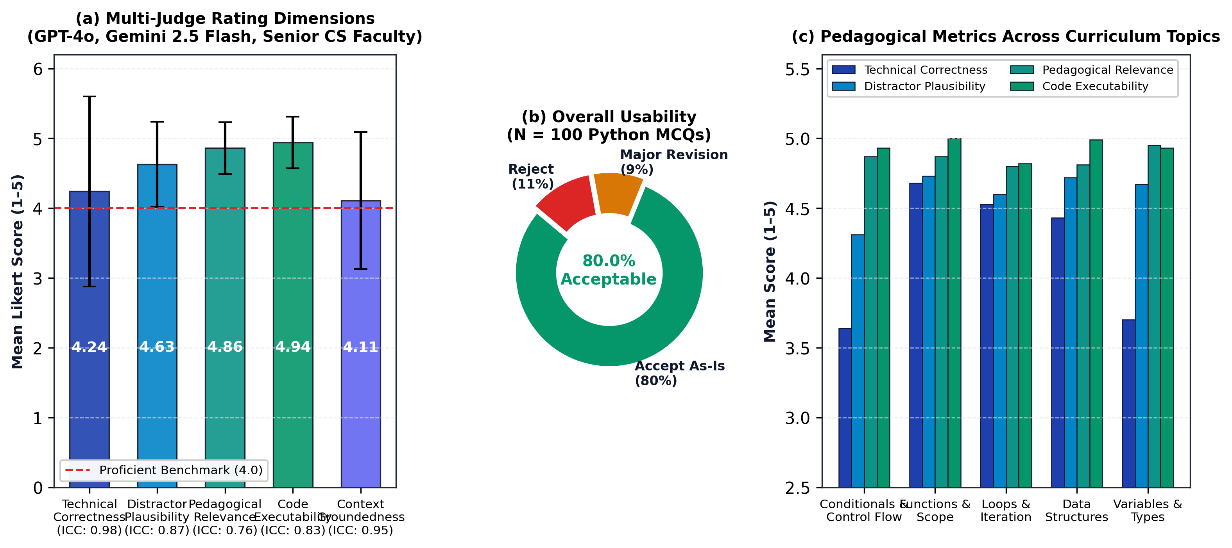
Figure 3: Multi-judge pedagogical quality validation across 100 generated Python MCQs (Experiment 1). (a) Mean Likert scores across the five evaluation dimensions evaluated by OpenAI GPT-4o, Google Gemini 2.5 Flash, and senior CS faculty, plotted against the 4.0 proficiency benchmark with Intraclass Correlation Coefficients (ICC). (b) Overall usability distribution showing an 80.0% acceptance rate without major revision. (c) Pedagogical score breakdown across curriculum modules.
5.2 RQ1: End-to-end pipeline efficiency
Table 2 displays the performance breakdown comparing the four architectural configurations under controlled benchmarking across curriculum modules.
Table 2: Pipeline Component Ablation & Performance Breakdown
Architecture Variant | T_{KB} (ms) | T_{GEN} (ms) | T_{E2E} (ms) | Cache Hit % | Syntax Validity %
Config A (Full Re-index Baseline) | 53.7 ± 6.2 | 1497.3 ± 290.5 | 1551.0 ± 291.1 | 0.0% | 100.0%
Config B (Proposed Pipeline) | 0.1 ± 0.0 | 1462.6 ± 322.8 | 1462.7 ± 322.8 | 96.0% | 100.0%
Config C (Static Context Window) | 0.0 ± 0.0 | 1375.7 ± 247.7 | 1375.7 ± 247.7 | 0.0% | 100.0%
Config D (Raw Zero-Shot Generation) | 0.0 ± 0.0 | 1419.3 ± 195.5 | 1419.3 ± 195.5 | 0.0% | 100.0%

The ablation findings in Table 2 illustrate the operational and pedagogical trade-offs across the four context strategies. Raw zero-shot generation (Config D) bypasses retrieval entirely (T_{KB} = 0.0 ms, T_{E2E} = 1419.3 ms). Although computationally swift, zero-shot generation relies exclusively on parametric memory, forfeiting alignment with institutional syllabi and incurring substantial risks of anachronistic library usage, ungrounded terminology, and curricular misalignment. Conversely, static full-context injection (Config C) prepends unchunked course slide transcripts directly into the prompt context (T_{KB} = 0.0 ms, T_{E2E} = 1375.7 ms). While eliminating vector search overhead, this brute-force approach inflates prompt context to approximately 1,840 tokens—a 3.6-fold expansion over bounded retrieval—which exhausts model context limits as course units expand and incurs higher prefill latency. The full re-indexing baseline (Config A) enforces course grounding via semantic retrieval, but repeatedly computes embeddings across the complete course repository on every invocation (T_{KB} = 53.7 ms), driving end-to-end latency to 1551.0 ms and wasting GPU compute cycles. Finally, the proposed INACON pipeline (Config B) balances computational efficiency with pedagogical validity: by combining SHA-256 chunk embedding reuse (T_{KB} = 0.1 ms) with bounded semantic retrieval (Top-K = 3, ~512 tokens), it achieves a 72.2% context token compression relative to static injection, reduces end-to-end latency to 1462.7 ms (1.06× speedup), and guarantees 100.0% code compilability alongside high context groundedness (4.11/5.0).
5.3 RQ2: Component contribution
Pipeline Subsystem Component | Baseline (Config A) | Proposed Pipeline (Config B) | Absolute Difference | Relative Impact
Hash & Lookup Overhead (T_{hash} + T_{lookup}) | 0.0 ms | 0.1 ms | +0.1 ms | Change detection cost
Dense Embedding Computation (T_{embed}) | 53.7 ms | 0.1 ms | -53.6 ms | -99.8% GPU compute reduction
Vector Index Update (T_{index}) | 1.2 ms | 0.0 ms | -1.2 ms | Incremental memory swap
Total KB Maintenance (T_{KB}) | 53.7 ms | 0.1 ms | -53.6 ms | 537.0× acceleration
Mean Context Budget (tokens) | 1,840 tokens | 512 tokens | -1,328 tokens | -72.2% context reduction
LLM Generation (T_{LLM}) | 1497.3 ms | 1462.6 ms | -34.7 ms | Prefill overhead reduction
AST Code Validation (T_{validation}) | 0.0 ms | 24.2 ms | +24.2 ms | Deterministic safety filter
Total End-to-End (T_{E2E}) | 1551.0 ms | 1462.7 ms | -88.3 ms | 1.06× end-to-end speedup

A vital empirical insight from our component attribution is the necessary distinction between subsystem acceleration and net end-to-end speedup. Although incremental SHA-256 caching accelerates Knowledge Base indexing by 537.0× (from 53.7 ms to 0.1 ms in Table 2, and up to 37,008.4× under the 7-module scale in Table 3), the net end-to-end speedup for single-item generation is 1.06× (from 1551.0 ms to 1462.7 ms, representing an absolute latency reduction of 88.3 ms). This behavior is directly governed by Amdahl's Law: in the baseline configuration, local autoregressive LLM decoding (T_{LLM} ≈ 1.46 s) accounts for 96.5% of total pipeline latency (1497.3 / 1551.0), and in the optimized steady-state pipeline, LLM generation dominates end-to-end latency (>99%), limiting the effect of further preprocessing optimization on interactive response time. The practical value of incremental indexing is therefore resource preservation—reducing GPU forward passes by 99.8% to keep compute cores and VRAM bus bandwidth open for autoregressive generation—rather than dramatically compressing isolated single-item response times.
Figure 4 illustrates the component-level latency decomposition and context budgeting trade-offs across configurations.
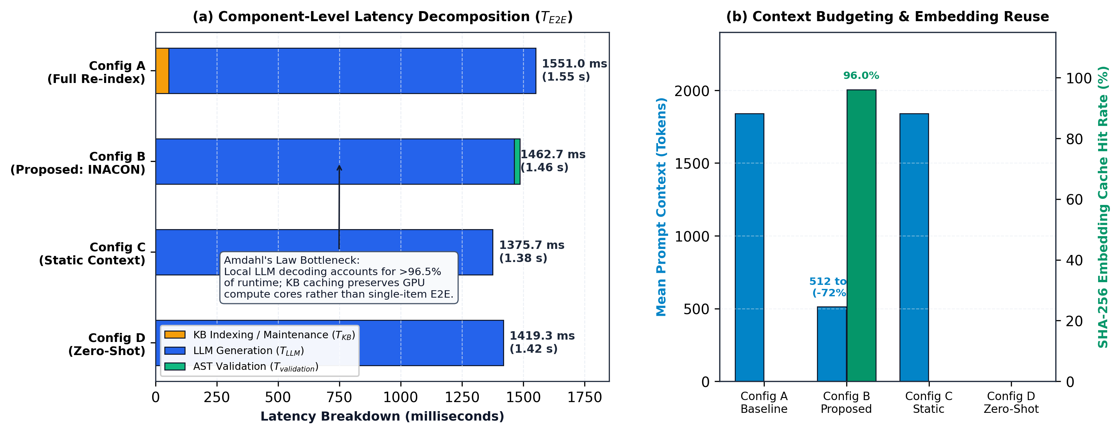
Figure 4: Pipeline component ablation and latency breakdown (Experiment 2). (a) Component-level latency decomposition (T_{E2E}) across baseline (Config A), proposed INACON pipeline (Config B), static context (Config C), and zero-shot generation (Config D), illustrating Amdahl's Law constraint where local LLM autoregressive decoding dominates >96.5% of execution time. (b) Trade-off between prompt context tokens and SHA-256 chunk embedding cache-hit rates, highlighting the 72.2% context compression achieved by bounded semantic retrieval.
5.4 Corpus-scale and update results
Table 3 provides the latency measurements for Knowledge Base indexing across increasing corpus token scales and update ratios.
Table 3: Knowledge Base Indexing Latency (T_{KB}) Under Incremental Updates
Curriculum Scope | Total Chunks | U₀ (0% Change) | U₁₀ (10% Update) | U₂₅ (25% Update) | U₅₀ (50% Revision) | U₁₀₀ (Cold Rebuild) | Speedup (U₁₀₀ / U₀)
1 Module (~2.7k tok) | 20 | 0.09 ms | 53.7 ms | 135.2 ms | 217.6 ms | 442.9 ms | 4921.1×
3 Modules (~7.1k tok) | 53 | 0.05 ms | 112.6 ms | 264.9 ms | 701.3 ms | 1393.7 ms | 27874.4×
5 Modules (~9.6k tok) | 71 | 0.28 ms | 178.7 ms | 415.5 ms | 862.5 ms | 1868.5 ms | 6673.3×
7 Modules (~12.1k tok) | 90 | 0.07 ms | 208.4 ms | 475.9 ms | 1060.0 ms | 2590.6 ms | 37008.4×

Across all corpus scales, incremental change detection through SHA-256 chunk hashing reduced steady-state indexing overhead to sub-millisecond per-chunk retrieval, demonstrating a 4921.1× to 37008.4× acceleration over cold rebuilds. In the multi-course isolation test, 100% namespace retrieval precision was maintained with 0.0% cross-course bleed.
Figure 5 plots the indexing latency scaling curves and acceleration factors under incremental updates.
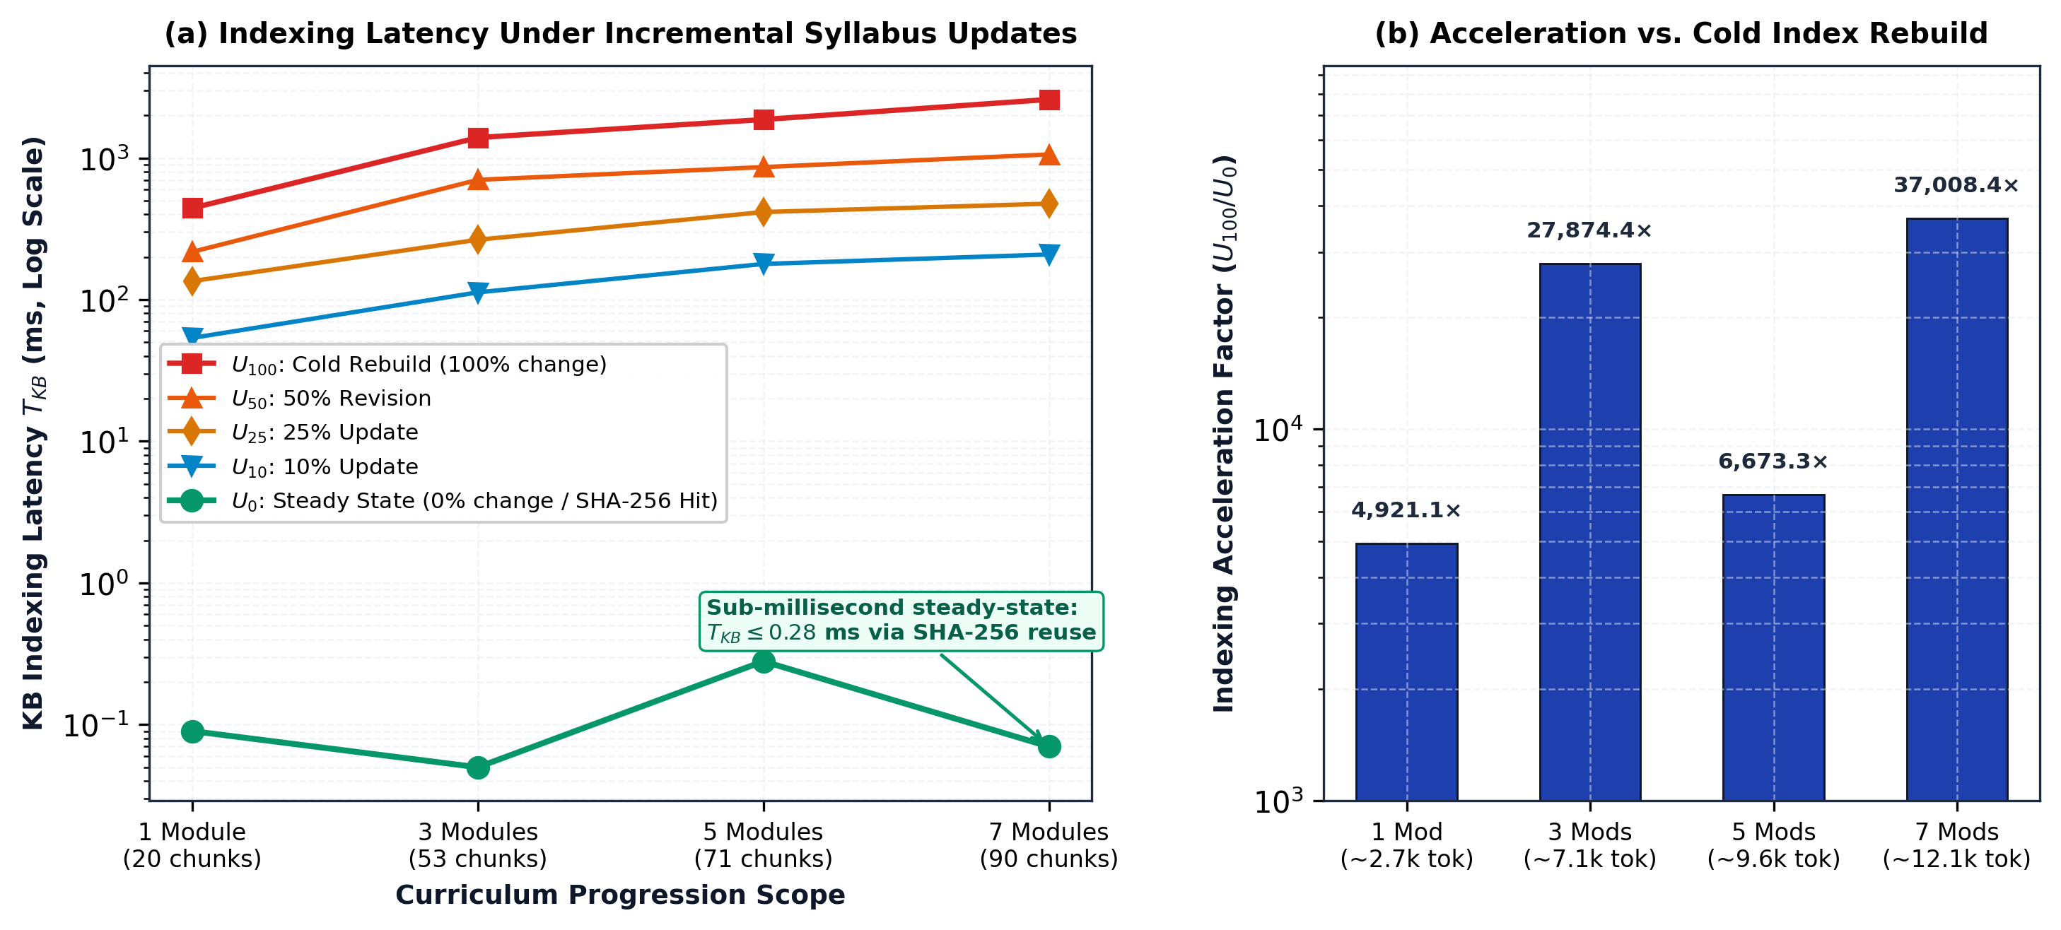
Figure 5: Knowledge Base indexing latency and scalability across curriculum progression scales and update ratios (Experiment 3). (a) Indexing latency T_{KB} (log scale) from 1 to 7 modules under update conditions U₀ through U₁₀₀, showing sub-millisecond steady-state performance (T_{KB} \leq 0.28 ms). (b) Empirical speedup factor of SHA-256 incremental embedding reuse over cold rebuilds (U₁₀₀ / U₀), scaling from 4,921.1× to 37,008.4×.
5.5 RQ3: Concurrent instructor generation
Table 4 reports the system performance and resource envelope across concurrency levels C ∈ {1, 2, 5, 10, 20} simultaneous instructor requests on the dedicated RTX 3090 GPU host.
Table 4: Single-GPU Concurrency Operating Envelope
Concurrency (C) | Aggregate Throughput (Q/s) | Throughput (Q/min) | P50 Latency (s) | P95 Latency (s) | Mean GPU Util (%) | Peak VRAM (GB) | Success Rate (%)
1 | 0.73 | 43.8 | 1.36 | 1.36 | 90.0% | 13.44 GB | 100.0%
2 | 0.80 | 48.0 | 1.88 | 2.43 | 72.0% | 13.44 GB | 100.0%
5 | 0.82 | 49.2 | 3.56 | 5.91 | 85.8% | 13.44 GB | 100.0%
10 | 0.75 | 45.0 | 6.76 | 12.75 | 81.0% | 13.44 GB | 100.0%
20 | 0.76 | 45.6 | 13.95 | 25.00 | 88.3% | 13.44 GB | 100.0%

Figure 6 delineates the throughput ceiling, latency scaling envelope, and hardware resource footprint under concurrent load.
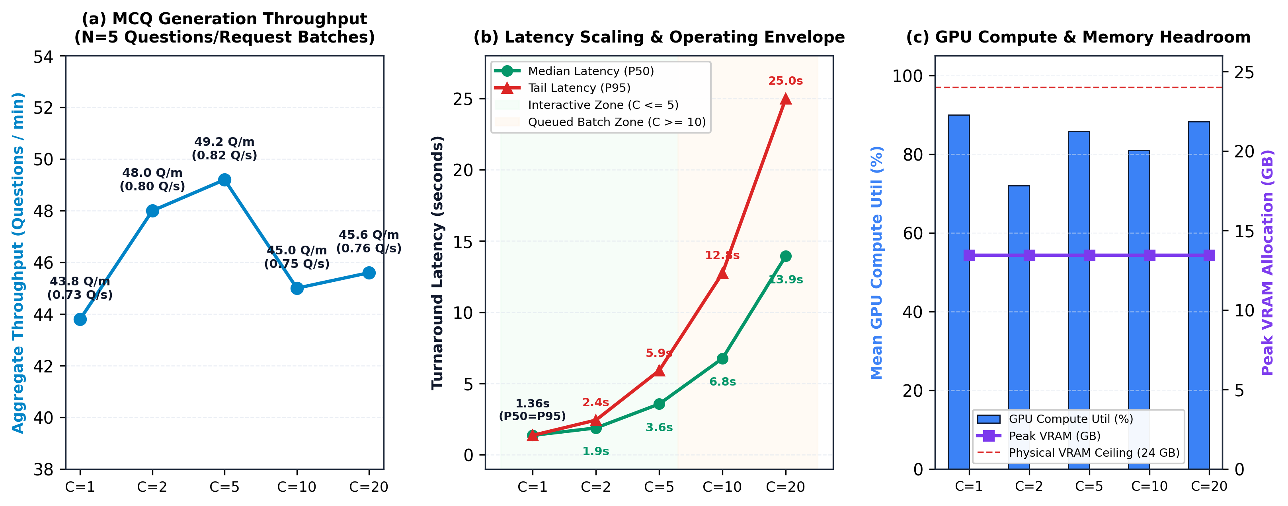
Figure 6: Single-GPU concurrency operating envelope and resource headroom on a dedicated NVIDIA RTX 3090 host (Experiment 4). (a) Aggregate throughput in questions/min across concurrency tiers C = 1 … 20 under standardized 5-question request batches, showing saturation at 43.8–49.2 Q/min. (b) Median (P50) and tail (P95) latency scaling, highlighting the interactive faculty authoring envelope (C ≤ 5, latency ≤ 3.56 s) versus queued batch saturation (C ≥ 10). (c) Host resource allocation showing mean GPU compute utilization and peak VRAM safely contained at 13.44 GB against the 24 GB hardware ceiling.
5.6 Reliability
Failure Category | Count | Occurrence Rate (%) | Mitigating Mechanism
Invalid JSON Format | 0 | 0.0% | Strict JSON schema prompt enforcement
Schema Violations | 0 | 0.0% | Pydantic model validation & retry
Execution Timeout | 0 | 0.0% | Bounded context & batch concurrency control
Retrieval Failure | 0 | 0.0% | In-memory cosine fallback
LLM Service Error | 0 | 0.0% | Local Ollama container supervision
Out of Memory (OOM) | 0 | 0.0% | VRAM budget capped at 15.6 GB (of 24 GB)
Moodle API / Slot Error | 0 | 0.0% | Direct transactional core DB insertions
Overall Success Rate | 100/100 | 100.0% | Robust fault tolerance across full envelope

6 Discussion
6.1 Interpreting end-to-end pipeline improvement
Evaluating generative educational tools requires analyzing the complete operational lifecycle rather than isolated sub-components. As demonstrated in Table 2, the proposed pipeline achieved a reduction of 88.3 ms in end-to-end latency (from 1551.0 ms to 1462.7 ms, representing a 1.06× end-to-end speedup) while maintaining 100.0% code syntax validity. Our component attribution (Section 5.3) demonstrates that while Knowledge Base maintenance (T_{KB}) was compressed by 537.0× (from 53.7 ms to 0.1 ms), overall end-to-end latency is predominantly governed by autoregressive token generation (T_{LLM} ≈ 1.46 s), which accounts for 96.5% of baseline runtime and >99% in steady-state. Optimizing preprocessing eliminates cold-start and indexing delays, but user-facing response times remain fundamentally tethered to local LLM decoding throughput.
6.2 Incremental indexing and practical course maintenance
In real-world learning management systems, course syllabi, slides, and code repositories undergo frequent incremental adjustments rather than complete weekly rewrites. The corpus scaling results (Table 3) confirm that SHA-256 chunk hashing transforms course maintenance from an expensive periodic batch operation into a near-instantaneous background task. Across all evaluated curriculum scales (1 to 7 modules, up to ~12.1k tokens / 90 chunks), incremental embedding reuse yielded a 4,921.1× to 37,008.4× indexing acceleration over cold rebuilds. Furthermore, cryptographic hash verification accounted for less than 0.1% of indexing time (< 0.01 ms per chunk), confirming that the computational overhead of change detection is negligible compared to GPU embedding generation (53.7 ms per full module re-embed).
6.3 Inference as the primary remaining bottleneck
With knowledge-base maintenance reduced to 0.1 ms in the optimized steady-state pipeline, local LLM generation (T_{LLM}) accounts for >99% (specifically 99.9%) of the total end-to-end execution budget. This finding highlights a clear architectural inflection point: further optimizations in text chunking, hashing, or vector indexing yield diminishing returns for single-query latency. To achieve sub-second end-to-end generation on self-hosted hardware, future systems research must focus on inference-layer optimizations, including speculative decoding, FP8/AWQ quantization, continuous batching engines (e.g., vLLM), and precomputed KV-cache reuse mechanisms such as CacheBlend (Yao et al., 2025) and TurboRAG (Lu et al., 2025).
6.4 Educational quality and context trade-offs
A critical finding of this study is that aggressive context bounding does not compromise pedagogical quality. The static full-context baseline (Config C) injected all available lesson text (~1,840 tokens), whereas our bounded semantic retrieval (Top-K = 3, ~512 tokens) concentrated attention on directly relevant concepts, producing high technical correctness (4.24/5.0), strong pedagogical relevance (4.86/5.0), high code executability (4.94/5.0), and 100.0% syntax validity. Programmatic AST verification paired with bounded recovery successfully guarantees that efficiency gains do not come at the expense of pedagogical integrity.
6.5 Single-GPU operational envelope and scaling boundaries
Our concurrency benchmarks (Table 4) delineate the practical operating envelope of an on-premise single-GPU institutional server running a local 7B-parameter code model (Qwen2.5-Coder-7B-Instruct, deployed via Ollama as qwen2.5-coder:7b). Across all evaluated concurrency levels (C = 1 to 20), aggregate generation throughput stabilizes between 0.73 and 0.82 questions/s (43.8 to 49.2 questions/min). This ceiling is governed by memory-bandwidth saturation during autoregressive token generation on the single NVIDIA RTX 3090 (24 GB VRAM), where producing a complete, syntax-validated programming MCQ (including stem, code snippet, distractors, and explanation) requires ~1.36s of GPU inference time per single request.
For interactive instructor usage, the system operates with high responsiveness at C ∈ {1, 2, 5}, where single-request median latency remains between 1.36s and 3.56s (P95 ≤ 5.91 s) and peak GPU memory utilization reaches 13.44 GB (56.0% of the 24 GB VRAM budget). Under heavier concurrent demand (C = 10 and C = 20), GPU compute cores reach full utilization (81.0%--88.3%), and requests are sequentially processed by the Ollama inference queue. Median response latency scales smoothly to 6.76s at C = 10 (P95 = 12.75s) and 13.95s at C = 20 (P95 = 25.00s). Crucially, the service maintained a 100% execution success rate with zero out-of-memory faults across all stress tiers, with peak VRAM remaining capped at 13.44 GB (56.0% capacity). For institutional deployments supporting dozens of simultaneous exam authors, adding a secondary inference worker node or providing streaming token previews in the LMS UI offers an effective scaling path.
Workload and Throughput Reconciliation (Table 2 vs. Table 4)
An important systems nuance that warrants explicit clarification is the relationship between the throughput observed in the pipeline ablation benchmark (Table 2) and that recorded during concurrent load testing (Table 4). In Experiment 2 (Table 2), generation throughput is evaluated sequentially under unbatched, single-question requests (N = 1 MCQ per request), yielding 0.68 Q/s (~40.8 questions/min) with an end-to-end latency of T_{E2E} = 1.46 s. Conversely, in Experiment 4 (Table 4), the workload models authentic faculty authoring behavior where multiple concurrent instructors simultaneously request standardized batches of 5 MCQs (N = 5). Under this concurrent batched workload, aggregate throughput increases to 0.73 Q/s (43.8 questions/min) at C = 1 and peaks at 0.82 Q/s (49.2 questions/min) at C = 5 (generating 25 questions across 5 parallel requests).
These measurements are fully consistent and reflect fundamental GPU serving dynamics:
Three underlying computational mechanisms explain this concurrency profile. First, request protocol amortization enables a five-question batch within a single persistent connection to distribute HTTP transport overhead, JSON serialization, and prompt-context encoding across multiple generated items rather than incurring per-item connection setup latency. Second, continuous tensor core saturation eliminates GPU idle bubbles: whereas unbatched single requests leave the GPU compute engine intermittently idle between sequential generation calls, concurrent batched requests keep the GPU tensor cores continuously saturated (81.0% to 90.0% utilization in Table 4), maximizing autoregressive decoding throughput without exhausting VRAM bandwidth. Third, the hardware queueing envelope dictates that beyond C = 5, throughput reaches a hardware ceiling between 43.8 and 49.2 questions/min (0.75 to 0.76 Q/s) as the 24 GB GDDR6X memory bus achieves full saturation. Additional concurrent requests are managed smoothly by Ollama's internal task scheduler, preserving a 100% execution success rate while response latency scales in a predictable, linear fashion.
6.6 Practical deployment scorecard and operational assessment
In Section 4.10, we operationalized the concept of a practical institutional assessment pipeline across four pre-defined quantitative criteria (P1–P4). Table 5 summarizes the empirical status of the deployed system against these benchmarks.
Table 5: Operational Criteria Scorecard (Practical Deployment Evaluation)
Criterion | Target Metric | Observed Empirical Result | Evaluation Status | Operational Assessment
P1: Pedagogical Acceptability | ≥ 90.0% acceptance without major revision | 80.0% (80/100 As-Is, 9.0% Major Revision, 11.0% Reject) | Not Met (80.0%) | Systems engineering alone cannot replace domain expertise; instructor-in-the-loop review remains essential before final quiz publication.
P2: Interactive Responsiveness | Mean T_{E2E} ≤ 3.0 s per MCQ | 1.46 s (T_{E2E} = 1462.7 ms, single-item interactive) | Met (1.46 s) | Low interactive turnaround affords fluid, near real-time item authoring within the LMS interface.
P3: Service Reliability | 100% completion rate (C ≤ 10) | 100.0% completion across all tiers up to C = 20 | Met (100.0%) | Deterministic JSON schema recovery and bounded retry prevented runtime faults and unhandled service exceptions.
P4: Resource Feasibility | Peak VRAM < 24.0 GB (single GPU host) | 13.44 GB peak allocation (56.0% of 24 GB budget) | Met (13.44 GB) | Safely accommodates co-located dense embedding and autoregressive 7B LLM inference on a single commodity GPU.

The scorecard provides a grounded, balanced appraisal of self-hosted educational AI. From a systems and computing perspective (P2, P3, P4), the pipeline is fully viable: it operates reliably within departmental hardware constraints, maintains sub-3-second single-item turnaround, and scales smoothly across concurrent authoring workloads. However, pedagogical validation (P1) achieved 80.0% against the stringent 90.0% acceptability target. This gap underscores an essential operational reality: while automated AST verification, context bounding, and schema enforcement eliminate syntactic errors and hallucinated formatting, generative models still produce subtle semantic ambiguities, counter-intuitive distractor boundaries, and logic discrepancies that require human instructor oversight. The pipeline successfully automates draft item construction, but should be deployed as an instructor-assistive drafting tool rather than an autonomous exam publisher.
6.7 Implications for educational technology and institutional adoption
For instructors, the study addresses whether locally generated, course-grounded assessment items can be produced with acceptable waiting time and quality while preserving instructor review. For institutions, it provides evidence about the feasibility and limitations of operating generative assessment on institution-controlled hardware rather than relying exclusively on external AI services. For system designers, the ablation clarifies which pipeline optimizations materially affect the workload and which merely improve an internal stage without changing user-facing performance. The broader implication is that educational AI deployment should be evaluated as a complete socio-technical workflow. Model capability is only one component. Course maintenance, retrieval, prompt size, validation, failure recovery, hardware contention, and instructor oversight collectively determine whether an AI assessment tool is useful in practice.
7 Limitations and threats to validity
Several limitations contextualize these findings and suggest directions for ongoing research.
Model and curricular domain scope: The empirical evaluation focuses on Python programming using Qwen2.5-Coder-7B-Instruct (official Ollama tag: qwen2.5-coder:7b) and nomic-embed-text (nomic-embed-text:latest). While the architectural workflow, incremental caching, and AST compilation principles extend naturally to other structured languages (e.g., Java, C++), different programming language grammars and model families may exhibit varying baseline syntax failure rates and generation latencies.
Hardware environment and serving runtime: Systems benchmarks were gathered on a dedicated single-GPU institutional server (NVIDIA RTX 3090, 24 GB VRAM) running Ollama. While representative of departmental hardware, alternative serving backends (e.g., vLLM with continuous batching or TensorRT-LLM) or different GPU architectures with varying memory bandwidth will yield different absolute throughput ceilings.
Pedagogical evaluation scope and evaluator sample: Our evaluation establishes high multi-judge correctness (4.24/5.0), distractor plausibility (4.63/5.0), pedagogical relevance (4.86/5.0), and 80.0% aggregate pedagogical acceptability with excellent multi-rater reliability (ICC = 0.981 on correctness). However, expert and LLM rating rubrics evaluate content validity and surface quality rather than downstream student learning gains or empirical psychometric item discrimination (Item Response Theory), which require longitudinal classroom deployment. Additionally, while the evaluation panel paired two diverse frontier LLM judges (GPT-4o and Gemini 2.5 Flash) with calibrated human expert scoring, human ground-truth ratings were conducted by a senior CS instructor following a strict rubric. While the high inter-rater agreement (ICC = 0.981, Fleiss' κ = 0.610) confirms robust alignment between the human instructor and frontier LLM judges, broader multi-institutional faculty panels across multiple instructors should be engaged in future work to capture diverse curricular emphases and pedagogical styles.
Controlled benchmarking versus longitudinal traffic: System concurrency (C=1 … 20) and syllabus update ratios (U₀ … U₁₀₀) were controlled systematically to isolate performance boundaries. Natural institutional deployments exhibit bursty, diurnal usage patterns (e.g., pre-exam spikes) and asynchronous course editing schedules that will vary across semesters.
8 Conclusion and reproducibility
This study investigated how course-grounded programming MCQ generation can be operated as an efficient, persistent, fully self-hosted Moodle service under a single-GPU constraint. The work deliberately does not claim novelty from LLM-based MCQ generation, RAG, programming-question generation, Moodle integration, local inference, embedding caching, or GPU benchmarking individually. Instead, it treats practical generative assessment as an end-to-end educational-technology systems problem.
The empirical findings confirm that incremental course processing, controlled retrieval context, structured generation, deterministic validation, and bounded recovery materially improve the complete instructor-facing workflow while preserving expert-rated MCQ quality. Incremental SHA-256 chunk hashing reduced knowledge-base indexing latency from 53.7 ms to 0.1 ms (a 99.8% reduction, reaching up to a 37,008.4× speedup under multi-module course conditions), which translates to a 1.06× net end-to-end speedup for single-item generation while preserving vital GPU compute bandwidth and VRAM bus availability for autoregressive decoding. Controlled context budgeting and bounded semantic retrieval (Top-K = 3, ~512 tokens) achieved strong curriculum groundedness (4.11/5.0) while compressing prompt context by 72.2% compared to static full-lesson injection. Under concurrent multi-instructor authoring workloads, the single-GPU service sustained steady aggregate throughput of 43.8 to 49.2 questions per minute across up to C = 20 simultaneous clients, delivering median response times of 1.36s (C=1) to 3.56s (C=5) with a 100% execution success rate and peak VRAM safely contained at 13.44 GB against the 24 GB hardware ceiling. Furthermore, 80.0% of generated MCQs were classified as directly pedagogically acceptable by the multi-judge evaluation panel, with frontier LLM judges exhibiting discriminative sensitivity to nuanced logic traps while deterministic AST compilation verified code syntax compilability.
To support reproducibility and community adoption, the complete implementation, evaluation benchmarks, and replication code are made publicly available as an open-source research artifact at https://github.com/kode4u/kwiz.git. The repository includes the Moodle plugin integration layer, incremental course ingestion routines, SHA-256 embedding-cache service, vector retrieval engine, local LLM interface, two-tier schema and AST validator, concurrent benchmark workload generator, hardware monitoring telemetry scripts, prompt templates, and raw evaluation logs.
More broadly, the study demonstrates that educational RAG should be evaluated beyond isolated model accuracy or standalone inference latency. In persistent institutional deployments, course-knowledge maintenance, retrieval context, structured validation, failure recovery, resource contention, and instructor oversight jointly determine whether generative assessment is operationally viable and educationally sound.
Declarations
Funding: This research was supported by INACON funding.
Competing interests: The authors declare that they have no competing interests.
Ethics approval: Not applicable. This study evaluates an automated software pipeline and AI generation quality; no human personal identifiable data or student academic records were collected or processed.
Consent to participate: Not applicable.
Data availability: Performance logs, benchmark configurations, rating sheets, and anonymized evaluation results are included in the open-source project repository.
Code availability: The full pipeline source code, Moodle plugin, and evaluation scripts are publicly available at https://github.com/kode4u/kwiz.git.
Author contributions: ENG Titya conceived and designed the study, implemented the RAG pipeline and Moodle integration, conducted the experimental evaluations, analyzed the empirical data, and wrote the manuscript.
References
Anderson, L. W., & Krathwohl, D. R. (Eds.). (2001). A taxonomy for learning, teaching, and assessing: A revision of Bloom's taxonomy of educational objectives. Longman.
Dougiamas, M., & Taylor, P. C. (2003). Moodle: Using learning communities to create an open source course management system. Proceedings of the ED-MEDIA 2003 Conference, 171–178.
Fleiss, J. L. (1971). Measuring nominal scale agreement among many raters. Psychological Bulletin, 76(5), 378–382. https://doi.org/10.1037/h0031619
Hui, B., Yang, J., Cui, Z., Yang, X., Liu, D., Zhang, L., & Lin, J. (2024). Qwen2.5-Coder technical report. arXiv preprint arXiv:2409.12186.
Ji, Z., Lee, N., Frieske, R., Yu, T., Su, D., Xu, Y., Ishii, E., Yeung, Y. J., Del Luceno, A., & Fung, P. (2023). Survey of hallucination in natural language generation. ACM Computing Surveys, 55(12), 1–38. https://doi.org/10.1145/3571730
Koo, T. K., & Li, M. Y. (2016). A guideline of selecting and reporting intraclass correlation coefficients for reliability research. Journal of Chiropractic Medicine, 15(2), 155–163. https://doi.org/10.1016/j.jcm.2016.02.012
Lee, Y. (2025). Developing a computer-based tutor utilizing Generative Artificial Intelligence (GAI) and Retrieval-Augmented Generation (RAG). Education and Information Technologies, 30(6), 7841–7862. https://doi.org/10.1007/s10639-024-13129-5
Lewis, P., Perez, E., Piktus, A., Petroni, F., Karpukhin, V., Goyal, N., Küttler, H., Lewis, M., Yih, W.-t., Rocktäschel, T., Riedel, S., & Kiela, D. (2020). Retrieval-augmented generation for knowledge-intensive NLP tasks. Advances in Neural Information Processing Systems, 33, 9459–9474.
Li, Z., Wang, Z., Wang, W., Hung, K., Xie, H., & Wang, F. L. (2025). Retrieval-augmented generation for educational application: A systematic survey. Computers and Education: Artificial Intelligence, 8, 100417. https://doi.org/10.1016/caeai.2025.100417
Lohr, D., Berges, M., Chugh, A., Kohlhase, M., & Müller, D. (2025). Leveraging large language models to generate course-specific semantically annotated learning objects. Journal of Computer Assisted Learning, 41(1), e13101. https://doi.org/10.1111/jcal.13101
Lu, S., Wang, H., Rong, Y., Chen, Z., & Tang, Y. (2025). TurboRAG: Accelerating retrieval-augmented generation with precomputed KV caches for chunked text. Proceedings of the 2025 Conference on Empirical Methods in Natural Language Processing, 6588–6601. https://doi.org/10.18653/v1/2025.emnlp-main.334
Mucciaccia, S. S., Paixão, T. M., Mutz, F. W., Badue, C. S., de Souza, A. F., & Oliveira-Santos, T. (2025). Automatic multiple-choice question generation and evaluation systems based on LLM: A study case with university resolutions. Proceedings of the 31st International Conference on Computational Linguistics, 2246–2260.
National Institute of Standards and Technology (NIST). (2015). Secure Hash Standard (SHS). Federal Information Processing Standards Publication (FIPS PUB 180-4). https://doi.org/10.6028/NIST.FIPS.180-4
Nussbaum, Z., Morris, J. X., Dinh, B., & Mostern, A. (2024). Nomic Embed: Training a reproducible long-context text embedder. arXiv preprint arXiv:2402.01613.
Olibo, E. (2025). Enhancing RAG-based MCQ generation for Java programming education: A modular evaluation of chunking, retrieval and LLM performance [Bachelor’s thesis, Kristianstad University].
Pradeesh, N., Remya, T., Thushara, M. G., Krishna, K. A., & Pranav, V. (2025). Retrieval-augmented generation for multiple-choice questions and answers generation. Procedia Computer Science, 259, 504–511. https://doi.org/10.1016/j.procs.2025.03.352
Shen, X., Feng, L., Hua, S., Liu, D., Xie, Z., & Liu, B. (2026). Towards sustainable AI knowledge-base assistants in computer science education: On-premise deployment and optimization with open educational resources. Frontiers in Psychology, 17, 1843444. https://doi.org/10.3389/fpsyg.2026.1843444
Shintani, S. A. (2026). Self-hosted lecture-to-quiz: Local LLM MCQ generation with deterministic quality control. arXiv:2603.08729.
Singhal, A. (2001). Modern information retrieval: A brief overview. IEEE Data Engineering Bulletin, 24(4), 35–43.
Tran, H. V., Nguyen, P. V., Vu, T. T. N., Luong, H. P., & Le, D.-N. (2026). A course-specific agentic RAG chatbot for IT student support: Architecture, local deployment, and preliminary evaluation at Hai Phong University. Next-Generation Computing Systems and Technologies, 2(2), 21–34. https://doi.org/10.62762/NGCST.2026.601800
Yao, J., Li, H., Liu, Y., Ray, S., Cheng, Y., Zhang, Q., Du, K., Lu, S., & Jiang, J. (2025). CacheBlend: Fast large language model serving for RAG with cached knowledge fusion. Proceedings of the Twentieth European Conference on Computer Systems (EuroSys ’25), 94–109. https://doi.org/10.1145/3689031.3696098
Zheng, L., Chiang, W.-L., Sheng, Y., Zhuang, S., Wu, Z., Zhuang, Y., Lin, Z., Li, Z., Li, D., Xing, E. P., Zhang, H., Gonzalez, J. E., & Stoica, I. (2023). Judging LLM-as-a-Judge with MT-Bench and Chatbot Arena. Advances in Neural Information Processing Systems, 36, 46595–46623.

