**Traffic Management System**

**Project Objective:**

The primary objective of this project is to develop an integrated approach for urban traffic management and real-time transit information dissemination using IoT technology. This initiative aims to enhance traffic efficiency, reduce congestion, improve public transportation services, and provide commuters with real-time information for a smoother and more efficient travel experience.

**IOT Sensor Design:**

The IOT sensor design plays a crucial role in the success of this project. It involves the deployment of various sensors and data collection devices throughout the city infrastructure. These sensors should include:

* **Traffic Flow Sensors:** These sensors monitor vehicle speed, count, and direction, providing real-time data to the traffic management system.
* **Traffic Cameras:** High-definition cameras capture images and video feeds at key intersections and road segments to enable traffic monitoring and incident detection.
* **Environmental Sensors:** Sensors measuring air quality, weather conditions, and noise levels help factor in environmental considerations for traffic management decisions.
* **Public Transit Sensors:** IoT devices on buses, trams, and subway cars collect data on their locations, passenger loads, and schedules.
* **Pedestrian Sensors:** These sensors monitor pedestrian movement and help in optimizing pedestrian crossings and traffic signal timings.
* **Emergency Sensors:** Sensors on emergency vehicles and at critical locations help provide priority and clear pathways in emergency situations.

**Real-Time Transit Information Platform:**

The Real-Time Transit Information Platform serves as a central component of the project and includes the following features:

* **Passenger Information Displays:** Digital screens at bus stops, subway stations, and transit hubs display real-time information on public transit schedules, delays, and estimated arrival times.
* **Mobile Application:** A mobile app accessible to commuters provides up-to-the-minute information on public transportation options, routes, and service disruptions. It includes features like trip planning, payment integration, and alerts.
* **API Integration:** The platform should offer APIs for third-party developers to integrate real-time transit data into their applications, encouraging the development of transit-related tools.

**Integrated Approach for Traffic Management System:**

The integrated approach for traffic management involves the following key elements:

* **Data Fusion and Analysis:** Collected data from IoT sensors, traffic cameras, and transit vehicles are processed and analysed in real-time to monitor traffic conditions and identify congestion or incidents.
* **Smart Traffic Signal Control:** Traffic signals are dynamically adjusted based on real-time traffic data to optimize traffic flow and reduce congestion.
* **Public Transportation Coordination:** Transit agencies and traffic management authorities collaborate to synchronize public transportation services with traffic signal timings, reducing delays and improving the overall transit experience.
* **Emergency Response Integration:** The system includes protocols for coordinating with emergency services during accidents or incidents, ensuring rapid response and efficient traffic management.
* **Public Engagement:** Public awareness campaigns and user-friendly interfaces, such as mobile apps and digital displays, keep commuters informed and engaged in the transit system.

**Solution:**

The integrated Traffic Management System (TMS) outlined in the project objectives can be achieved through a carefully planned and technologically advanced solution. Here's an overview of the components and strategies involved:

1. **IoT Sensor Network:**

* Deploy a network of sensors and cameras throughout the city's infrastructure, including traffic flow sensors, traffic cameras, environmental sensors, public transit sensors, pedestrian sensors, and emergency sensors.
* Utilize cutting-edge IoT technology with low-power, long-range communication capabilities to ensure data collection from various locations across the city.

1. **Data Collection and Transmission:**

* Gather real-time data from the IoT sensor network and transmit it securely to a centralized server or cloud-based platform.
* Implement data encryption and secure communication protocols to protect sensitive information.

1. **Data Fusion and Analysis:**

* Use advanced data analytics, machine learning, and artificial intelligence algorithms to process and analyse the collected data.
* Identify traffic patterns, congestion hotspots, environmental factors, and transit service data to make informed decisions.

1. **Smart Traffic Signal Control:**

* Implement adaptive traffic signal control algorithms that consider real-time traffic data to optimize signal timings.
* Prioritize lanes and intersections based on congestion levels and transit schedules to reduce delays.

1. **Real-Time Transit Information Platform:**

* Develop a user-friendly mobile application and passenger information displays at transit stops and stations.
* Integrate APIs for third-party developers to encourage the creation of transit-related apps and services.
* Provide real-time updates on transit schedules, delays, estimated arrival times, and trip planning features.

1. **Public Engagement:**

* Launch public awareness campaigns to inform commuters about the benefits of the integrated TMS.
* Use digital displays, mobile apps, and social media to keep the public informed about real-time traffic conditions, alternative routes, and sustainability goals.

1. **Emergency Response Integration:**

* Establish protocols for real-time coordination between the TMS and emergency services.
* Provide emergency vehicles with priority pathways during critical situations.

1. **Multi-Modal Commuter Rewards Program (Innovation):**

* Develop a gamified platform that incentivizes commuters to choose sustainable transportation options.
* Enable real-time suggestions and tracking of carbon footprint reduction.
* Encourage community engagement through team challenges and competitions.

1. **Public Transportation Coordination:**

* Facilitate collaboration between transit agencies and traffic management authorities to synchronize transit services with traffic signal timings.
* Implement real-time updates and coordination mechanisms for efficient transit operations.

1. **Data-Driven Insights:**
   * Use data generated by the TMS, including commuter behaviour and traffic patterns, to make informed decisions for urban planning and transportation infrastructure improvements.
2. **Scalability and Future-Proofing:**

* Design the TMS solution to be scalable, allowing for expansion to cover more areas as the city grows.
* Incorporate flexibility to integrate future technologies and adapt to changing urban transportation needs.

This comprehensive solution for the Traffic Management System leverages IoT technology, data analytics, real-time information dissemination, and community engagement to create a more efficient, sustainable, and user-friendly urban transportation ecosystem. It addresses traffic congestion, enhances public transit, and empowers commuters to make informed and eco-conscious transportation choices.

**Model Diagram:**

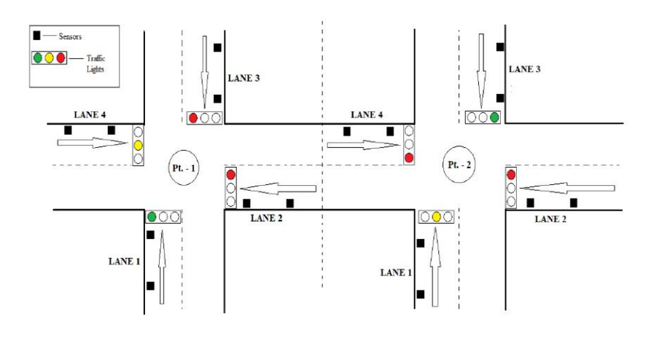

**Program:**

import paho.mqtt.client as mqtt

import json

import random

import time

# MQTT broker information

mqtt_broker = "your_mqtt_broker_address"

mqtt_port = 1883

mqtt_topic = "traffic_data"

# Simulated IoT device information

device_id = "iot_device_1"

location = "Intersection A"

# Create an MQTT client

client = mqtt.Client(device_id)

# Callback when the client successfully connects to the MQTT broker

def on_connect(client, userdata, flags, rc):

if rc == 0:

print(f"Connected to MQTT broker at {mqtt_broker}")

else:

print(f"Failed to connect to MQTT broker with code {rc}")

# Set the on_connect callback

client.on_connect = on_connect

# Connect to the MQTT broker

client.connect(mqtt_broker, mqtt_port)

# Function to generate simulated traffic data

def generate_traffic_data():

timestamp = int(time.time())

vehicle_count = random.randint(0, 50)

average_speed = round(random.uniform(10, 60), 2)

status = "normal" if random.random() < 0.9 else "congested"

traffic_data = {

"device_id": device_id,

"location": location,

"timestamp": timestamp,

"vehicle_count": vehicle_count,

"average_speed": average_speed,

"status": status,

}

return json.dumps(traffic_data)

try:

# Loop to continuously send traffic data

while True:

traffic_data = generate_traffic_data()

# Publish traffic data to the MQTT topic

client.publish(mqtt_topic, traffic_data)

print(f"Published: {traffic_data}")

time.sleep(5) # Simulate sending data every 5 seconds

except KeyboardInterrupt:

print("Script terminated by the user.")

client.disconnect()

**Implementation Diagram:**

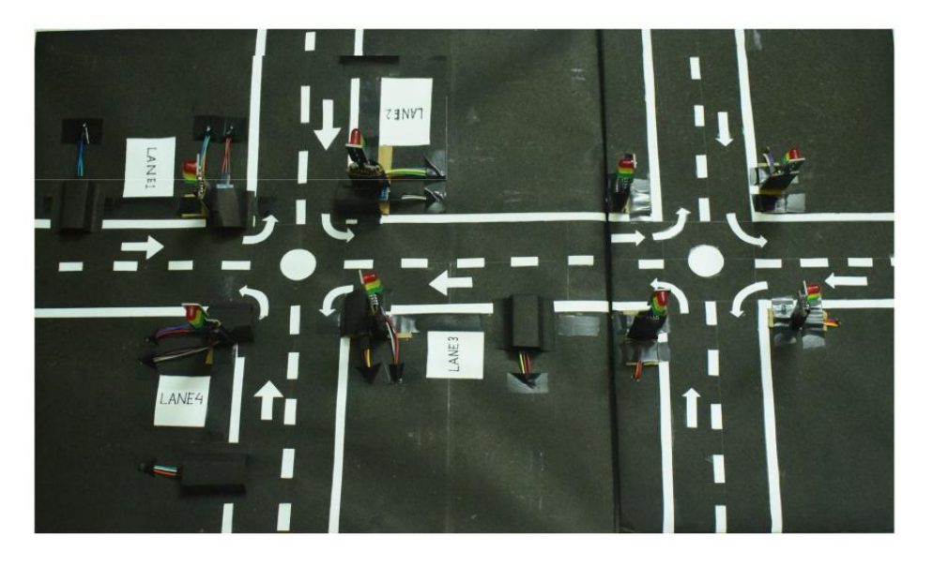**Circuit Diagram:**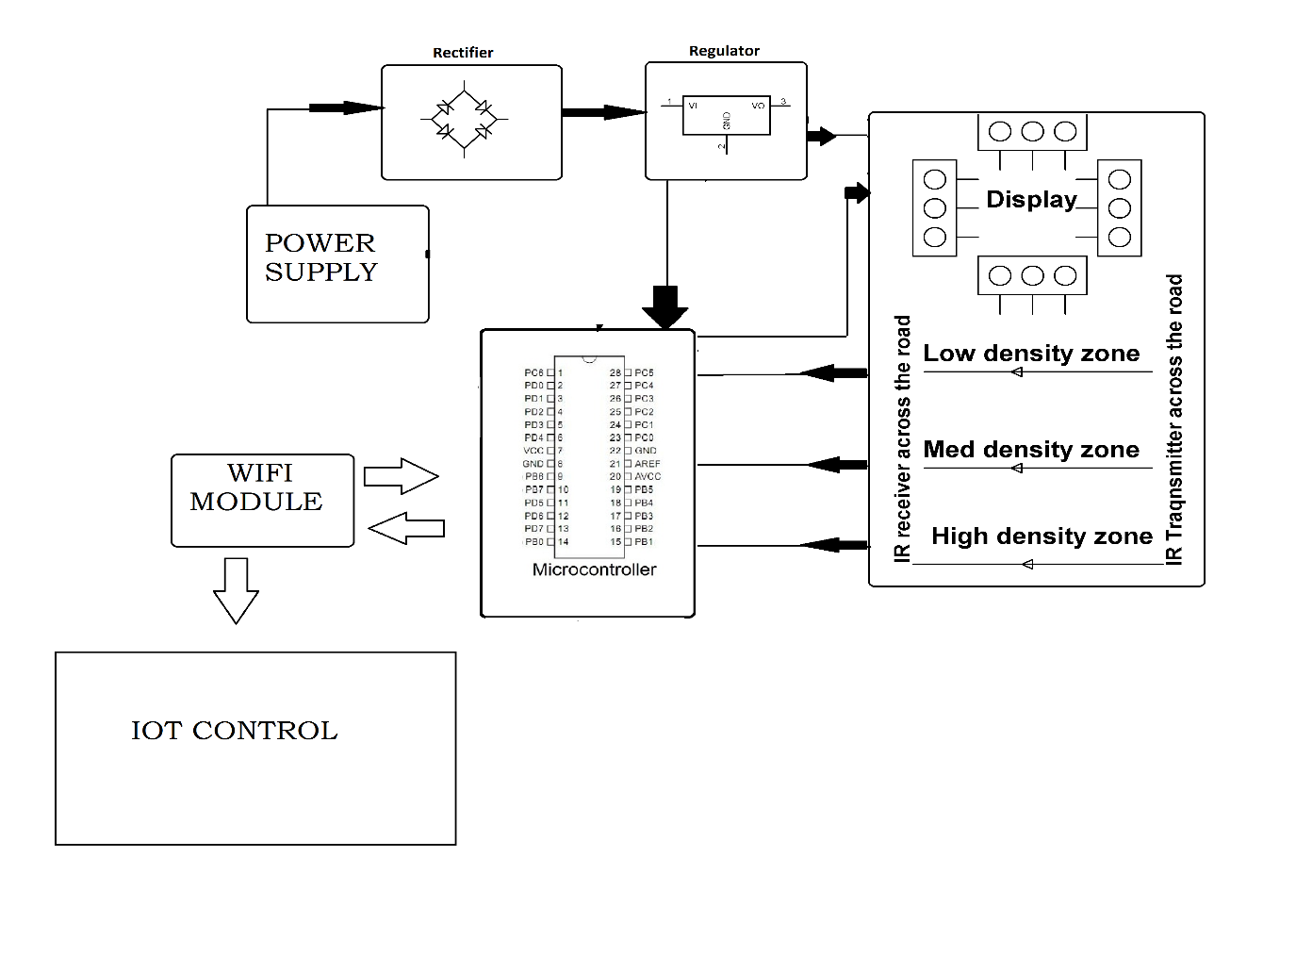

**Web Application:**

**Index.html:**

<!DOCTYPE html>

<html lang=”en”>

<head>

<meta charset=”UTF-8”>

<meta name=”viewport” content=”width=device-width, initial-scale=1.0”>

<title>Traffic Management</title>

<link href=<https://cdn.jsdelivr.net/npm/bootstrap@5.3.2/dist/css/bootstrap.min.css> rel=”stylesheet”>

<script src=<https://cdn.jsdelivr.net/npm/bootstrap@5.3.2/dist/js/bootstrap.bundle.min.js>></script>

<link rel=”stylesheet” href=”./style.css”>

<script src=”./script.js”></script>

</head>

<body>

<div class=”container-fluid text-center bg-danger” style=”min-height:15vh;”>

<h2 class=”text-white py-4 px-5 “ >TRAFFIC MANAGEMENT SYSTEM</h2>

</div>

<div class=”container”>

<h2 class=”text-center mt-5” >Traffic Light Simulation</h2><br><br>

<div class=”row mt-3”>

<div class=”col-md-3”><h4>Lane 1</h4>

<h5>Vehicle Count = <span id=”ph-level”>12</span></h5>

<div id=”traffic-light”>

<input type=”radio” name=”traffic-light-color” id=”color1” value=”color1” />

<input type=”radio” name=”traffic-light-color” id=”color2” value=”color2”/>

<input type=”radio” name=”traffic-light-color” id=”color3” value=”colo3” />

</div>

</div>

<div class=”col-md-3”><h4> Lane 2</h4>

<h5>Vehicle Count =<span id=”conductivity”>42</span></h5>

<div id=”traffic-light”>

<input type=”radio” name=”traffic-light-color” id=”color1” value=”color1” />

<input type=”radio” name=”traffic-light-color” id=”color2” value=”color2”/>

<input type=”radio” name=”traffic-light-color” id=”color3” value=”colo3” />

</div>

</div>

<div class=”col-md-3”><h4>Lane 3</h4>

<h5>Vehicle Count = <span id=”temperature”>18</span></h5>

<div id=”traffic-light”>

<input type=”radio” name=”traffic-light-color” id=”color1” value=”color1” />

<input type=”radio” name=”traffic-light-color” id=”color2” value=”color2”/>

<input type=”radio” name=”traffic-light-color” id=”color3” value=”colo3” />

</div>

</div>

<div class=”col-md-3”><h4>Lane 4</h4>

<h5>Vehicle Count = <span id=”temperature1”>1</span></h5>

<div id=”traffic-light”>

<input type=”radio” name=”traffic-light-color” id=”color1” value=”color1” />

Hi <input type=”radio” name=”traffic-light-color” id=”color2” value=”color2”/>

<input type=”radio” name=”traffic-light-color” id=”color3” value=”colo3” />

</div>

</div>

</div>

</div>

</body>

</html>

**Style.css:**

#traffic-light {

Margin-left: 20px;

Margin-top: 40px;

Background-color:#333;

Width:120px;

Height:320px;

Border-radius:30px;

}

Input {

Appearance: none;

Position: relative;

Left: 50%;

Width:80px;

Height:80px;

Margin-top: 30px;

Margin-left:-40px;

Background-color: grey;

Border-radius: 100%;

Display: block;

&#color1 {

Background-color: darken( #FF0000,15%);

&:hover {

Animation: blink1 1.1s step-end infinite;

}

&:checked {

Background-color: #FF0000;

Box-shadow: 0 0 6em lighten( #FF0000,10%);

}

}

&#color2 {

Background-color: darken(#FFFF00,15%);

&:hover {

Animation: blink2 1s step-end infinite;

}

&:checked {

Background-color: #FFFF00;

Box-shadow: 0 0 6em lighten(#FFFF00,10%);

}

}

&#color3 {

Background-color: darken(#00FF00,15%);

&:hover {

Animation: blink3 1s step-end infinite;

}

&:checked {

Background-color:#00FF00;

Box-shadow: 0 0 6em lighten(#00FF00,10%);

}

}

}

@keyframes blink1 {

0% {

Background-color:#FF0000;

Box-shadow: 0 0 6em lighten(#FF0000,10%);

}

50% {

Background-color: darken(#FF0000,15%);

Box-shadow: 0 0 0em transparent;

}

}

@keyframes blink2 {

0% {

Background-color: #FFFF00;

Box-shadow: 0 0 6em lighten(#FFFF00,10%);

}

50% {

Background-color: darken(#FFFF00,15%);

Box-shadow: 0 0 0em transparent;

}

}

@keyframes blink3 {

0% {

Background-color: #00FF00;

Box-shadow: 0 0 6em lighten(#00FF00,10%);

}

50% {

Background-color: darken(#00FF00,15%);

Box-shadow: 0 0 0em transparent;

}

}

**Script.js:**

Function updateData() {

// Simulated data (replace with actual data retrieval logic)

Const phValue = (Math.random() * 14).toFixed(2);

Const conductivityValue = (Math.random() * 50).toFixed(2);

Const temperatureValue = (Math.random() * 30).toFixed(2);

Const temperature1Value = (Math.random() * 30).toFixed(2);

// Update the HTML elements with the new data

Document.getElementById(“ph-level”).textContent = phValue;

Document.getElementById(“conductivity”).textContent = conductivityValue;

Document.getElementById(“temperature1”).textContent = temperature1Value;

Document.getElementById(“temperature”).textContent = temperature1Value;

}

// Poll for updates every 5 seconds (adjust as needed)

setInterval(updateData, 11000);

**Output:**

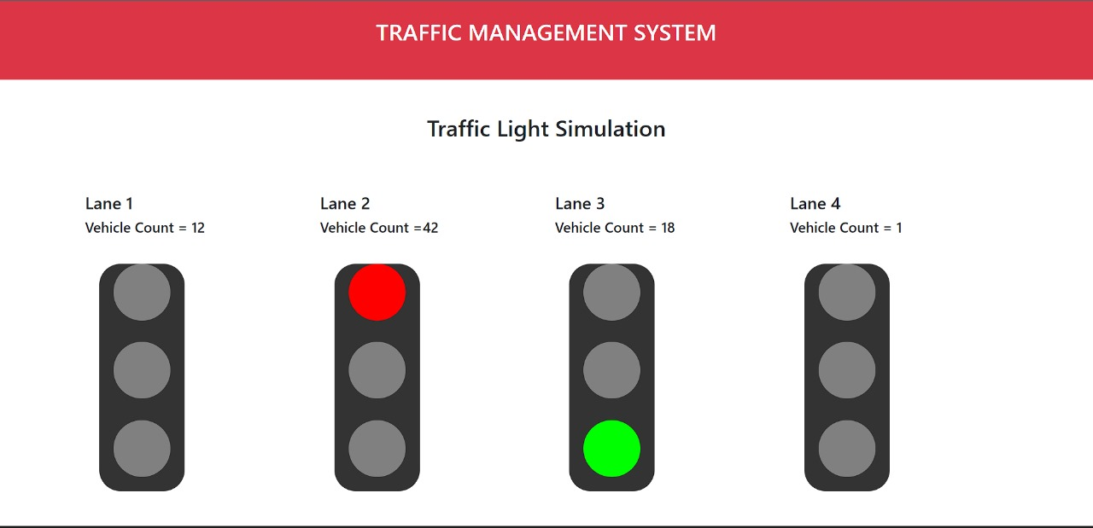

**Mobile Application:**

