# INTRODUCTION

Web-based BLOOD WAY Blood Donation Management System is **a management system**

**website that enables individuals who want to donate blood to help the needy**. It also enables hospitals to record and store the data for people who want to communicate with them, and it also provides a centralized blood bank database.  Blood donation is a vital part of worldwide healthcare. **It relates to blood transfusion as a life-sustaining and life-saving procedure as well as a form of therapeutic phlebotomy as a primary medical intervention**. Over one hundred million units of blood are donated each year throughout the world.

# OBJECTIVES

1. To estimate the cost-effectiveness of alternative minimum donation intervals between whole-blood donations.
2. To investigate the frequency at which donors are willing to donate whole blood according to alternative hypothetical changes to the blood donation service.
3. To estimate the cost-effectiveness of alternative strategies for maintaining the supply of whole blood to the NHS.
4. The main objective of the development of this application is to overcome the problems that exist in the current system.
5. The main objective of developing the system is gather all donors under a single roof, and encourage to donate blood.
6. **Blood is essential to help patients survive surgeries, cancer treatment, chronic illnesses, and traumatic injuries**.
7. The blood drive system is being developed with a purpose of replacing all paper work done at during the process of donation.

# FLOW CHART

# PICTURES OF PROJECTS

HOME PAGE

THIS PAGE CONTAINS

1. WHERE WOULD YOU LIKE TO DONATE
2. DONATION PROCESS
3. YOU CAN FIND A DONOR

Work done by MADDI DINESH REDDY

REGISTRATION NUMBER

12111718

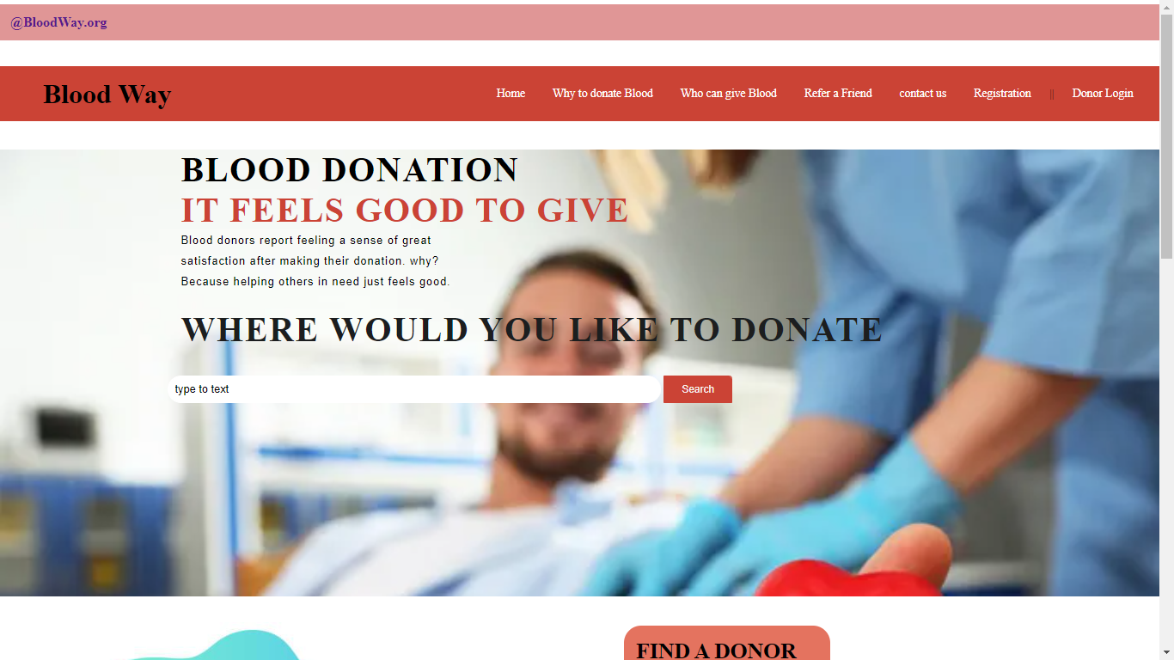

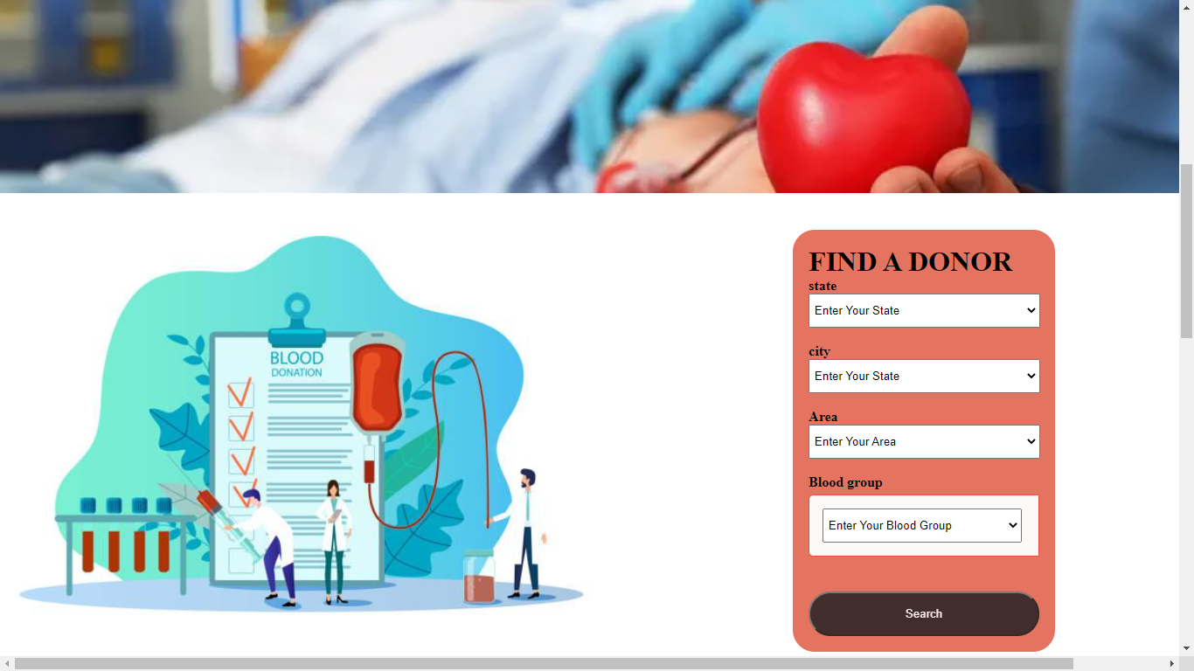

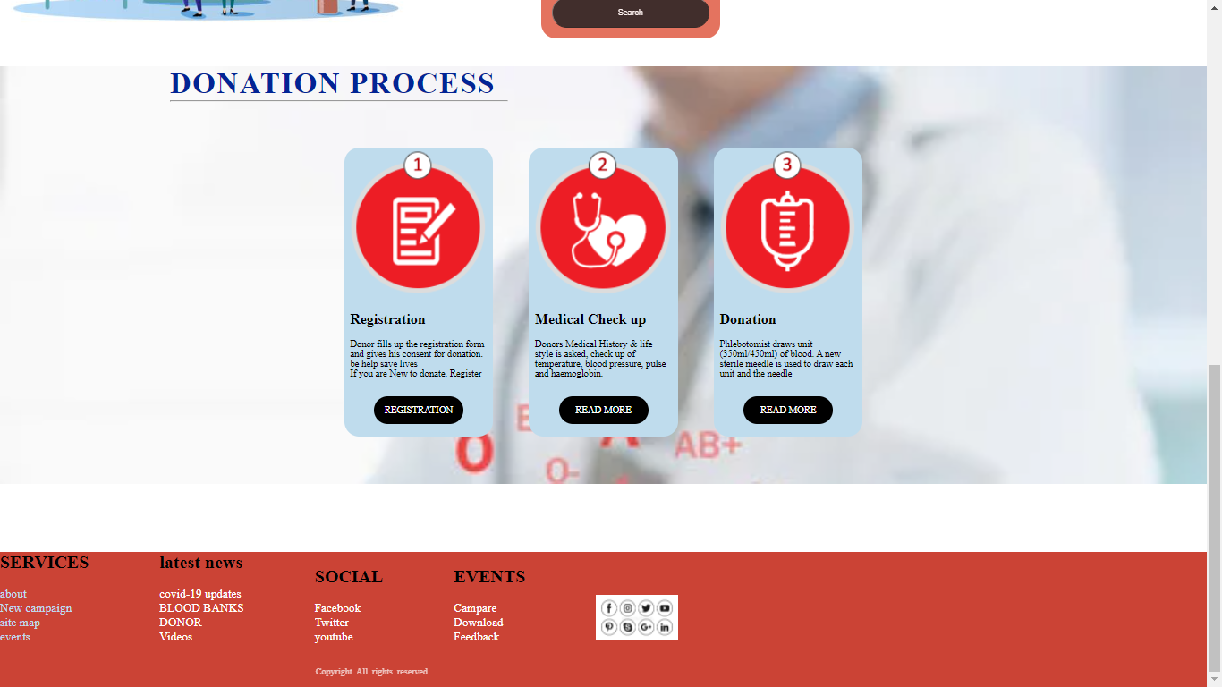

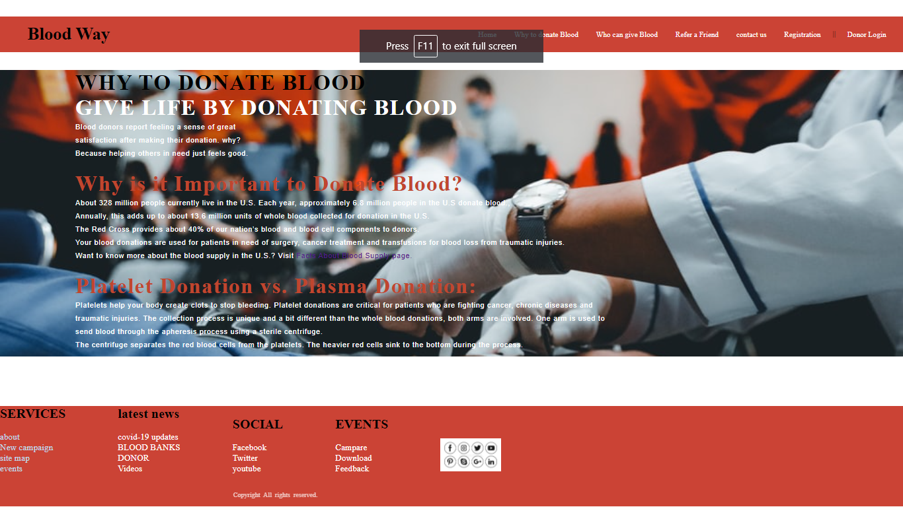

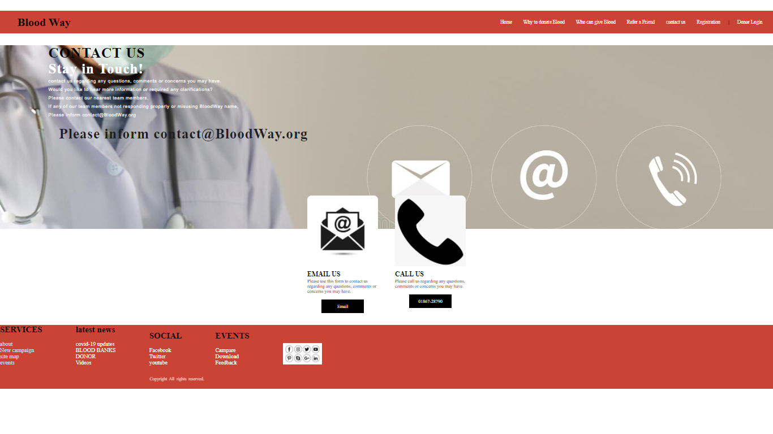

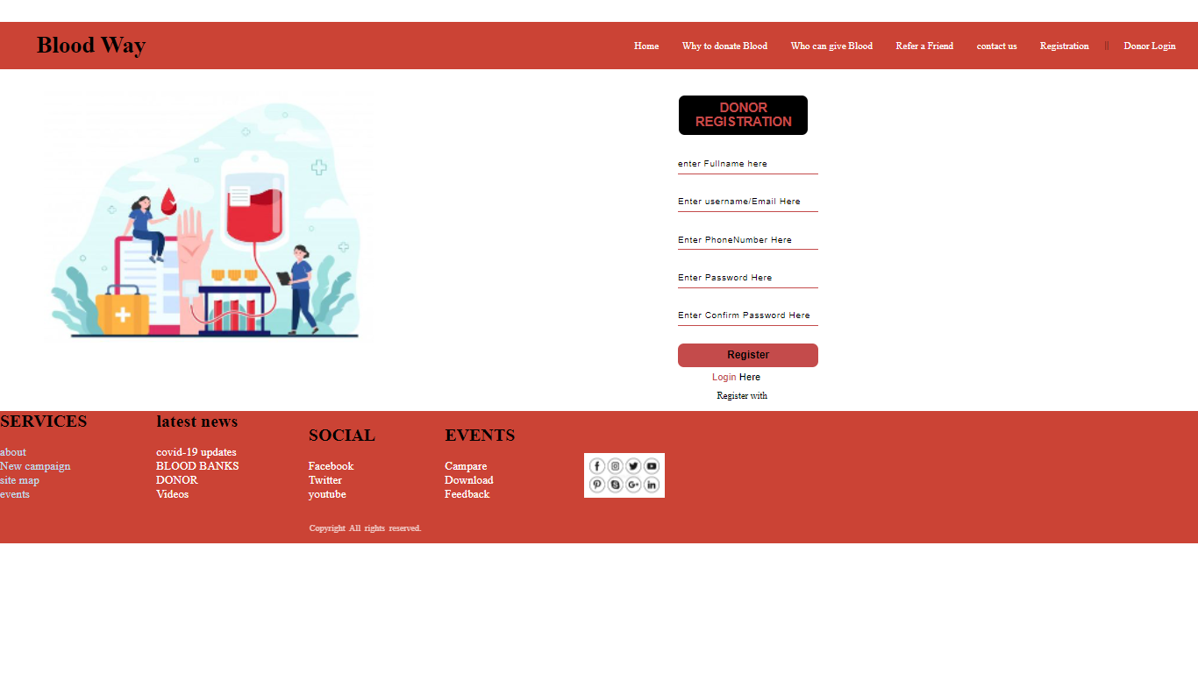

# Conclusion

# In this project I can conclude that way of design and **and Implementation of an Online Blood Bank Management System .**

The system also has a feature that allows registered blood banks to send a notification to registered blood donors on the application requesting for blood donation. My site also helps people who are in need of blood by giving the details of the donors by searching, if at all there are no donors having the same group and with in their own city they will be given the addresses with phone numbers of some contact persons in major cities who represent a club or an organization with free of cost.

# Project done by

MADDI DINESH REDDY

REGISTRATION NUMBER : 12111718

CLASS : K21KP