**Apple Mart Ecommerce Project**

**Project Description:**

In this Project we will get to know about Gadgets like Mobiles, Audio wearable’s, Smart Devices, Accessories and cables and connectors, batteries and chargers and etc….

We can buy any product on online , which makes easier to customer’s and we have 6 months to 1 year warranty too.

We provide every product that belong to Apple in this side.

### Software Requirements:

### 1. Operating System: Windows 8 and above

### 2. Frontend Technology: Html, CSS, Bootstrap, React JS

### 3. Framework: Node JS (<https://nodejs.org/en/download/>)

### 4. Database: MySQL (<https://www.mysql.com/downloads/>)

### 5. IDE: VS Code (<https://code.visualstudio.com/download>)

### Modules should be installed in Node Js:

### 1. C:\Users\USER>npm init -y

### 2. C:\Users\USER>npm install mysql.connector

### 3. C:\Users\USER>npm install Express

### 4. C:\Users\USER>npm install cors

### 5. To check more dependencies goto>package.json.

### Modules should be installed in React Js:

### 1. C:\Users\USER>npm install react-bootstrap

### 2. C:\Users\USER>npm install react-icons

### 3. C:\Users\USER>npm install react-router-dom

### 4. To check more dependencies goto>package.json.

### Run the Project:

### 1. Open Code in Visual studio

### 2. Go to Terminal > New Terminal

### create an app “npx create-react-app my-app” .

### 3. Enter command in terminal: cd my-app

### 4. Enter command in terminal: npm start

### 5. cd my-app  command is used to create node modules and react folders.

* **Npm start:**Runs the app in development mode. Open [http://localhost:3001](http://localhost:3001 )to view it in the browser.
* The page will automatically reload if you make changes to the code. You will see the build errors and lint warnings in the console.

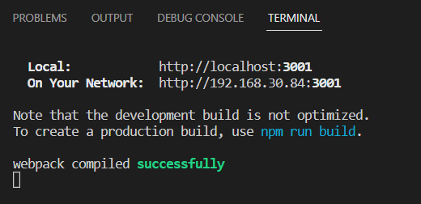

### 6. Open the URL in browser and the web application runs in browser.

### 7. Create Database and Modify user and password as per your database credentials in Server.js File

### 

### 8. Create Tables in database with the help of sql text file

### 9. Update applemart.py with user, password and database name and run file. After Successful run the code, the data will be visible in products table.

### 10. Go to Terminal > New Terminal

### 11. Enter Command in Terminal: cd Backup

### 12. Enter Command in Terminal: npm start

### Note: We need to start both frontend and backend to run application