Jakarta, 20 November 2024
No. Surat | : | 1/SJSA-JKT/SP/XI/2024
Perihal | : | Surat Penawaran Keagenan

Kepada Yth. :
PT Srikandi Indah Sentosa

Test

No. | Description | Cost | Remarks
BIAYA TETAP
1 | Agency Fee | Rp.3.000.000
2 | Biaya Clearance In & Out | Rp.3.000.000
3 | Cek Fisik | Rp.750.000
4 | Izin Sandar | Rp.750.000
5 | Izin Muatan Berbahaya | Rp.750.000
6 | KKP Out | Rp.750.000
7 | Izin Gerak | Rp.500.000
8 | Biaya Rambu | -
9 | Biaya Tambat | -
10 | Biaya Labuh | -
11 | Biaya VTS | -

Transfer Bank BNI Cabang Jakarta
PT. DWI JAYA SAMUDRA
No. Rek : 2233202215

Hormat Kami, | Disetujui,
PT. Dwi Jaya Samudera | PT Srikandi Indah Sentosa
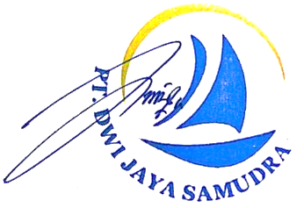
Erdanalis Yovita
Kepala Cabang

