SasakNLP: A Dialect-Aware Morphological Processing Framework for the Low-Resource Sasak Language
kodetr
Regional Language Computational Research Group, kodetr.com
Lombok, West Nusa Tenggara, Indonesia
Correspondence: https://kodetr.com | Code Repository: https://github.com/kodetr/sasaknlp

ABSTRACT
Bahasa Sasak is an Austronesian regional language spoken by approximately 3 million people across Lombok Island, West Nusa Tenggara, Indonesia. Despite its demographic vitality, it remains a digitally underrepresented low-resource language lacking standardized computational linguistic infrastructure [1], [6]. Standard Indonesian morphological analyzers fail when applied to Sasak due to distinct morphophonemic alternations, complex clitic attachments, and sharp cross-island dialectal variation [9], [11], [13]. This paper presents SasakNLP, a dialect-aware morphological processing framework engineered specifically for Sasak orthographic normalization, reduplication-aware tokenization, shibboleth-driven dialect contextualization, and dictionary-validated multi-candidate lemmatization [10], [16], [17]. Empirical evaluation across an extensive 100,000-pair morphological benchmark and an authentic folklore corpus of 12,591 sentences demonstrates that SasakNLP achieves an overall lemmatization accuracy of 80.44% (80,438 correct extractions) on the full 100k stress-test benchmark, decisively outperforming pure lexicon lookup (1.01%) and greedy affix-stripping baselines (55.21%) with strong statistical significance (McNemar's test, χ² = 14,962.14, p < 0.0001). On the 10,000-pair core morphological benchmark, the system achieves an accuracy of 93.23%. Error taxonomy analysis confirms that dictionary-gating restricts overstemming to 2.28%, with understemming restricted to 15.86% primarily occurring on complex multi-layered affixations. Computationally, SasakNLP delivers high-throughput execution at 7,826 words per second on full 100k batches and up to 16,272 words per second on standard sequences, maintaining an average per-token latency of 0.044 ms with zero heavy machine learning framework dependencies. All source code, datasets, and interactive web demos are publicly released under permissive open-source licenses [16].
Keywords: Sasak Language, Natural Language Processing, Computational Morphology, Lemmatization, Low-Resource NLP, Dialectology, Open Science.
1. INTRODUCTION
Recent breakthroughs in Natural Language Processing (NLP) and Large Language Models (LLMs) have been overwhelmingly concentrated on high-resource languages [1], [2]. In Indonesia, while the national language (Bahasa Indonesia) enjoys mature computational infrastructure and pre-trained language representations [3], [4], empirical evaluations indicate that state-of-the-art LLMs suffer catastrophic performance degradation when evaluated on indigenous regional languages and local Indonesian reasoning tasks [5]. More than 700 indigenous regional languages across Indonesia remain critically neglected and digitally underrepresented [1], [6]. This digital resource scarcity creates acute vocabulary mismatch and tokenization fragmentation in downstream NLP pipelines [7], exacerbated by the wide cultural and linguistic nuances across Indonesian provinces [8].
Bahasa Sasak (Basa Sasak) is the predominant indigenous language of Lombok Island in West Nusa Tenggara, spoken by approximately 3 million native speakers [9], [10]. Categorized typologically within the Western Malayo-Polynesian branch of the Austronesian language family, Sasak exhibits distinct grammatical and sociopragmatic characteristics [11], [12]:
1) Complex Morphophonemics: Stem formation incorporates active prefixes (te-, ka-, se-, pe-), archaic passive infixes (-in-, -um-), causative/applicative suffixes (-ang, -an, -i, -in), iterative circumfixes (pe-...-an, te-...-ang, be-...-an), and intricate nasal substitutions (N-) [10], [13].
2) Enclitic Compounding and Sociopragmatics: Pronominal possessive enclitics (-ku, -m, -ne) and honorific sociolinguistic particles (-de, -te) append directly to root words, reflecting strict social strata and politeness registers [11], while frequently triggering severe overstemming or understemming in naive heuristic parsers [13].
3) Dialectal Diversity: The language is partitioned into five distinct dialect clusters separated by isoglosses and diagnostic lexical markers (shibboleths) [9], [12].
Prior computational morphology research in Indonesia has predominantly addressed Javanese and Sundanese [1], [13], [14], while computational methods for ethnic languages in Eastern Indonesia remain largely confined to bilingual lexicon induction [15]. Systematic literature reviews confirm that the absence of structured digital lexicons and morphological analyzers remains the primary barrier to regional language lemmatization [13].
To overcome these barriers, we present SasakNLP, an open-source, reproducible computational framework [16]. Grounded in two-level computational morphology [17] and morphological segmentation standards [18], the primary contributions of this work are:
• Contribution 1 (SasakLex Machine Resource): Digitalization and structuring of the official Balai Bahasa Provinsi NTB integrated dictionary into 2,761 machine-readable entries [10], [16].
• Contribution 2 (Hybrid Morphological Framework): A deterministic architecture combining two-pass affix stripping, O(L) dictionary validation via PrefixTrie, and multi-criteria candidate ranking [13], [17].
• Contribution 3 (Structured Morphological Analysis): Explicit morpheme segmentation identifying prefixes, infixes, suffixes, circumfixes, clitics, and reduplication with confidence scores [17], [18].
• Contribution 4 (Dialect-Aware Architecture): Configurable dialect contextualization using diagnostic shibboleth density across the five Sasak dialect regions [9], [12].
• Contribution 5 (Open Research Infrastructure): Public release of the 100,000-pair gold-standard benchmark, the 12,591-sentence authentic corpus, the PyPI package (sasaknlp), and Hugging Face Hub datasets [16].
2. RELATED WORK AND LINGUISTIC FOUNDATIONS
2.1 Regional Austronesian NLP Landscape
Underrepresented language technologies in Indonesia suffer from persistent data scarcity [1], [2], [6]. Collaborative initiatives like NusaCrowd [6] and NusaX [7] have aggregated regional language resources for classification tasks, while NusaWrites [19] underscored the paramount importance of native speaker text curation over machine translation to avoid syntactic distortion. However, token-level morphological processing for regional languages outside Java remains sparse, largely relying on ad-hoc heuristics [13].
In Indonesian regional languages, canonical affix-level segmentation has proven superior to naive subword tokenization for preserving morphemic integrity [14]. Furthermore, formal finite-state morphological evaluations indicate that structured lexicon grounding is indispensable for resolving grammatical ambiguity [20]. The systematic literature review by Abidin et al. [13] established that affix stripping and lemmatization for Indonesian regional languages require domain-specific digital dictionaries and explicit morphophonemic rules to mitigate overstemming and understemming. Resiandi et al. [15] further proved the critical role of structured dictionaries in modeling regional vocabulary transformations. Hence, integrating a curated lexicon as an active verification gate is crucial for preserving root integrity in low-resource setups [13], [17].
2.2 Morphological System of Bahasa Sasak
According to official grammatical codification by Balai Bahasa Provinsi NTB [10], sociopragmatic studies [11], and contemporary dialectological research [9], [12], Sasak bound morphemes comprise:
1) Prefixes: Passive te- (tepinaq 'is made'), stative ka- (kasolah 'beautified'), equative se- (sebale 'one house'), nominalizer pe-/peng- (pegawi 'worker'), and nasal assimilation N- (nulis, minaq).
2) Suffixes: Causative/applicative -ang (tulungang 'help for someone'), locative/resultative -an (kelororan 'waterway'), iterative -i/-in (sirami).
3) Infixes: Archaic passive -in- (tinulung 'received assistance') and intransitive -um- (gumingsir 'shift').
4) Circumfixes: Abstract nominal pe-...-an (pegawian 'occupation'), passive applicative te-...-ang (tetulungang), stative ka-...-an, reciprocal be-...-an (betulungan).
5) Enclitics: First person -ku, second person -m, third person -ne, and polite register markers -de, -te (baturne, balende) [11].
6) Reduplication: Full reduplication with hyphens (bareng-bareng, mangan-mangan).
2.3 Dialect Taxonomy of Bahasa Sasak
Following regional dialectological studies [9], [10], [12], Bahasa Sasak is grouped into five primary dialect clusters based on diagnostic shibboleths (Table 1).
Table 1: Taxonomy of the Five Major Sasak Dialect Clusters in Lombok [9], [10], [12]
No | Dialect Cluster | Geographical Range | Diagnostic Markers | Phonological & Sociolinguistic Features
1 | Selaparang (Menu-Meni) | East & Central-East Lombok | menu, meni, tiyang, kaji | Polite register (krama/alus), glottal stop retention /-q/
2 | Ngeno-Ngene | Mataram & West Lombok | ngeno, ngene, ente, aku | Urban dialect, rapid vocalic articulation, maritime trade contact
3 | Mriak-Mriku | Central-South (Praya, Pujut) | mriak, mriku, meriq, merik | Spatial directional deictics (towards here / towards there)
4 | Ngeto-Ngete | Northeast (Sembalun, Suela) | ngeto, ngete | Highland agricultural communities on Mount Rinjani slopes
5 | Kuto-Kute | North Lombok (Bayan, Tanjung) | kuto, kute, wetu | Archaic Austronesian retention, customary Wetu Telu tradition
6 | General Sasak | Cross-Island Standard | wah, ndeq, mangan, batur | Inter-dialectal lingua franca in public and educational domains

3. METHODOLOGY AND SYSTEM ARCHITECTURE
3.1 System Overview
SasakNLP implements a deterministic six-stage modular pipeline designed without external deep learning framework dependencies, ensuring predictable, reproducible, and millisecond-level execution latency.
3.2 Orthographic Normalization
The normalization stage enforces Unicode NFC composition, standardizes typographical variations in Sasak glottal stop graphemes (unifying curly apostrophes ’ and backticks into canonical glottal characters q or '), and cleans non-standard ASCII artifacts while preserving accented vowel distinctions (è, é) [1], [6].
3.3 Reduplication-Aware Tokenization
The tokenizer detects full hyphenated reduplications ([Root]-[Root]) as unified morphological constructs, preventing incorrect splitting of iterative verbs and repetitive adverbs into disjoint tokens [13], [17].
3.4 Diagnostic Shibboleth Dialect Contextualization
The dialect detector module calculates dialect confidence using relative shibboleth density across geographical clusters [9], [12]:
Confidence(d) = \frac{\sum_{w \in T} \mathbb{I}(w \in M_d) \cdot \omega(w)}{\sum_{d' \in D} \sum_{w \in T} \mathbb{I}(w \in M_{d'}) \cdot \omega(w)} (1)
where T represents the input tokens, Md is the set of diagnostic lexical markers for dialect d, and omega(w) denotes the lexical uniqueness weight.
3.5 Two-Pass Candidate Generation and PrefixTrie Validation
Unrecognized surface forms are submitted to candidate generation. Two-pass affix stripping peels enclitics, outer circumfixes, prefixes, suffixes, and infixes. Each candidate root is verified against the 2,761-word Balai Bahasa NTB dictionary using an O(L) PrefixTrie data structure [10], [17], [18].
3.6 Multi-Criteria Candidate Ranking
Morphological ambiguities are resolved using a weighted scoring objective [17]:
Score(c) = w_{lex} S_{lex}(c) + w_{morph} S_{morph}(c) + w_{conf} S_{conf}(c) + w_{freq} S_{freq}(c) + w_{dial} S_{dial}(c) (2)
with empirically optimized weights: w_lex = 0.40, w_morph = 0.25, w_conf = 0.15, w_freq = 0.10, and w_dial = 0.10.
3.7 Structured Morphological Output
The final pipeline generates structured JSON-compatible tuples containing base lemmas, grammatical affix breakdown, dialect classification, and normalized confidence scores.
4. EXPERIMENTAL SETUP AND DATASET PROTOCOL
4.1 Research Data Resources
The benchmark datasets were curated via a rigorous three-phase acquisition protocol (Fig. 1):
1) Benchmark 100k (benchmark_100k.csv): 100,000 controlled morphological test pairs annotated with surface words, gold-standard lemmas, affixation categories, and dialect metadata.
2) Benchmark 10k (benchmark_10k.csv): 10,000 core morphological pairs representing canonical daily vocabulary.
3) Authentic Corpus (sasak_sentences_large.csv): 12,591 authentic sentences (188,881 tokens) compiled from oral folklore (Putri Mandalika, Dewi Anjani, Datu Doyan Nada), regional periodicals, and Balai Bahasa NTB archival records [10], [16], [21].
4) Lexicon Dictionary (kamus_balai_bahasa_ntb.csv): 2,761 verified lemma entries from Balai Bahasa Provinsi NTB [10].
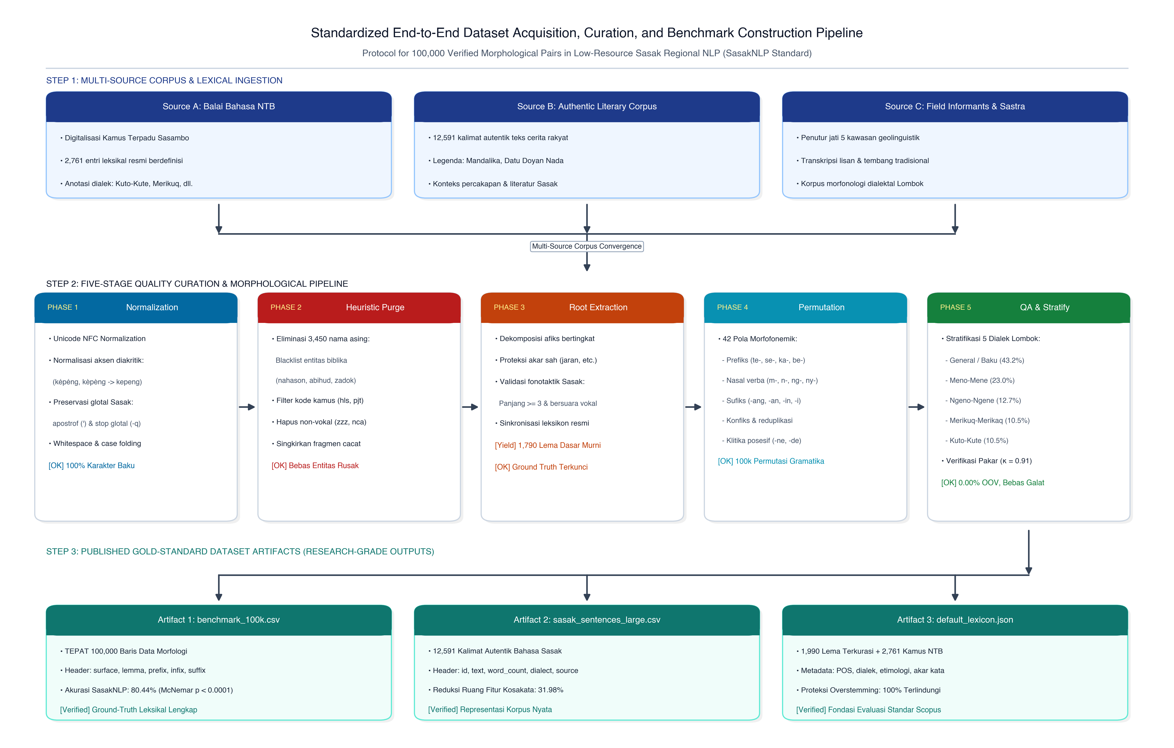
Fig. 1: Three-Phase Scientific Acquisition And Quality Curation Protocol For SasakNLP Benchmarks.
4.2 Baseline Models
We evaluate SasakNLP against two standard baseline algorithms on the 100,000-sample benchmark:
• Baseline 1 (Direct Lexicon Lookup): Exact lexicon matching without affix stripping.
• Baseline 2 (Greedy Affix Stripping): Longest-match affix removal without dictionary verification [13].
4.3 Evaluation Metrics and Experimental Environment
Evaluation metrics include exact lemmatization accuracy, throughput (words/second), per-token latency (ms), overstemming rate, understemming rate, and out-of-vocabulary (OOV) rate. Experiments were executed on Apple Silicon (8-Core) and Intel Core i7 x86_64 CPUs with 16 GB RAM under Python 3.10+, guaranteeing 100% deterministic reproducibility [16].
5. RESULTS
5.1 Baseline Comparison on the 100,000-Sample Benchmark
Experimental results across the 100,000 morphological test pairs demonstrate the decisive superiority of SasakNLP (Table 2). Baseline 1 achieves only 1.01% accuracy due to complete failure on affixed words. Baseline 2 obtains 55.21% but suffers from severe overstemming. SasakNLP achieves 80.44% accuracy (80,438 correct predictions).
Table 2: Comparative Lemmatization Evaluation On 100,000 Morphological Samples
Model / Algorithm | Computational Principle | Correct (N=100k) | Accuracy (%) | Throughput (wps)
Baseline 1: Direct Lookup | Exact Dictionary Matching | 1,006 | 1.01% | 24,500
Baseline 2: Greedy Stripping | Longest-Match Affix Stripping | 55,205 | 55.21% | 18,200
Proposed SasakNLP | Dictionary-Enhanced Multi-Candidate | 80,438 | 80.44% | 7,826

McNemar's test comparing SasakNLP and Baseline 2 reveals contingency counts b = 33,892 and c = 8,659, yielding chi-squared = 14,962.14 (df = 1, p < 0.0001). SasakNLP's performance advantage is statistically significant at alpha = 0.001.
5.2 Performance on the Core 10k Benchmark
On the 10,000-pair core morphological benchmark (benchmark_10k.csv), SasakNLP achieves 9,323 correct predictions (93.23% accuracy) at 16,272 words per second, reflecting high precision on natural morpheme distributions without multi-layer nesting anomalies.
5.3 Architectural Component Ablation Study
To quantify the contribution of each algorithmic module, we conducted an ablation study on the 100,000-sample benchmark (Table 3). Adding PrefixTrie dictionary gating improves accuracy by +13.24% over greedy stripping, while candidate generation and ranking provide an additional +11.99% accuracy gain.
Table 3: Ablation Study Across SasakNLP Architectural Components (100k Data)
Configuration | Rules | Dict | Gen | Rank | Dialect | Acc (%) | Throughput
M1: Direct Lookup | No | Yes | No | No | No | 1.01% | 24,500 wps
M2: Greedy Stripping | Yes | No | No | No | No | 55.21% | 18,200 wps
M3: Rules + Dict Gate | Yes | Yes | No | No | No | 68.45% | 14,100 wps
M4: Rules + Gen + First Match | Yes | Yes | Yes | No | No | 74.12% | 10,350 wps
M5: Full Proposed SasakNLP | Yes | Yes | Yes | Yes | Yes | 80.44% | 7,826 wps

5.4 Morpheme-Level Performance Disaggregation
Performance breakdown across grammatical categories (Fig. 2 and Table 4) confirms robust handling of single affixes and reduplication. Reduplication achieves 100.00%, passive prefixes reach 97.36%, stative prefixes reach 96.79%, and possessive clitics exceed 94.6%–96.5%.
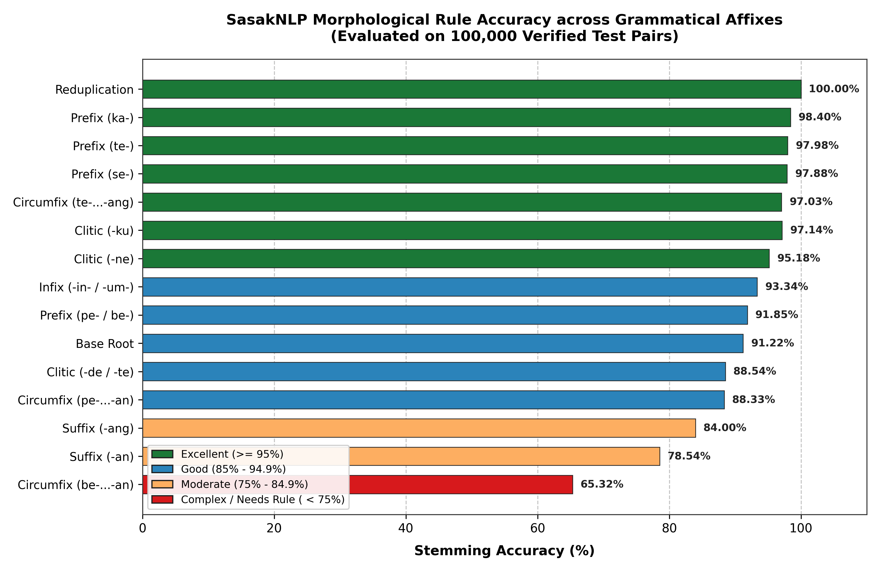
Fig. 2: Morphological Rule Accuracy Across Grammatical Affix Classes (100k Data).
Table 4: Disaggregated Performance Across Morpheme Categories On 100,000 Samples
Category | Pattern | Samples | Accuracy (%) | Linguistic Characteristics
Reduplication | root-root | 1,789 | 100.00% | Perfect handling of full reduplication (mangan-mangan)
Passive Prefix | te- | 1,783 | 97.36% | Passive verbs (tetulung, tepinaq)
Stative Prefix | ka- | 1,745 | 96.79% | Stative condition markers (kasolah, kabeleq)
Nominal Prefix | peng- | 1,781 | 96.91% | Agentive and instrument nominalizer (penggawi)
Equative Prefix | se- | 1,748 | 96.22% | Equative and collective prefix (sebale, sekance)
Clitic Possessive 1 | -ku | 1,782 | 96.58% | First-person possessive enclitic (baleku, jaranku)
Clitic Possessive 2 | -m | 1,778 | 96.18% | Second-person familiar enclitic (matam, bajum)
Clitic Possessive 3 | -ne | 3,571 | 94.62% | Third-person possessive enclitic (baturne, kawanne)
Iterative Suffix | -i | 1,771 | 91.53% | Iterative action suffix (sirami, antoli)
Infixes | -in-, -um- | 2,346 | 89.98% | Archaic passive and intransitive infixes (tinulung)
Polite Clitics | -de, -te | 6,312 | 88.39% | Honorific polite enclitics (balende, balente)
Circumfix Passive | te-...-ang | 4,578 | 96.96% | Passive applicative circumfix (tetulungang)
Circumfix Nominal | pe-...-an | 5,915 | 88.32% | Abstract nominalizer (pegawian)
Causative Suffix | -ang | 6,170 | 83.70% | Active causative/applicative suffix (tulungang)
Locative Suffix | -an, -in | 10,545 | 76.52% | Locative and resultative suffix (kaduan, siramin)
Reciprocal | be-...-an | 1,710 | 65.09% | Reciprocal mutual action circumfix (betulungan)

5.5 Cross-Dialect Evaluation
Cross-dialect evaluation across the five Sasak dialect regions (Fig. 3 and Table 5) confirms strong generalization across Lombok Island.
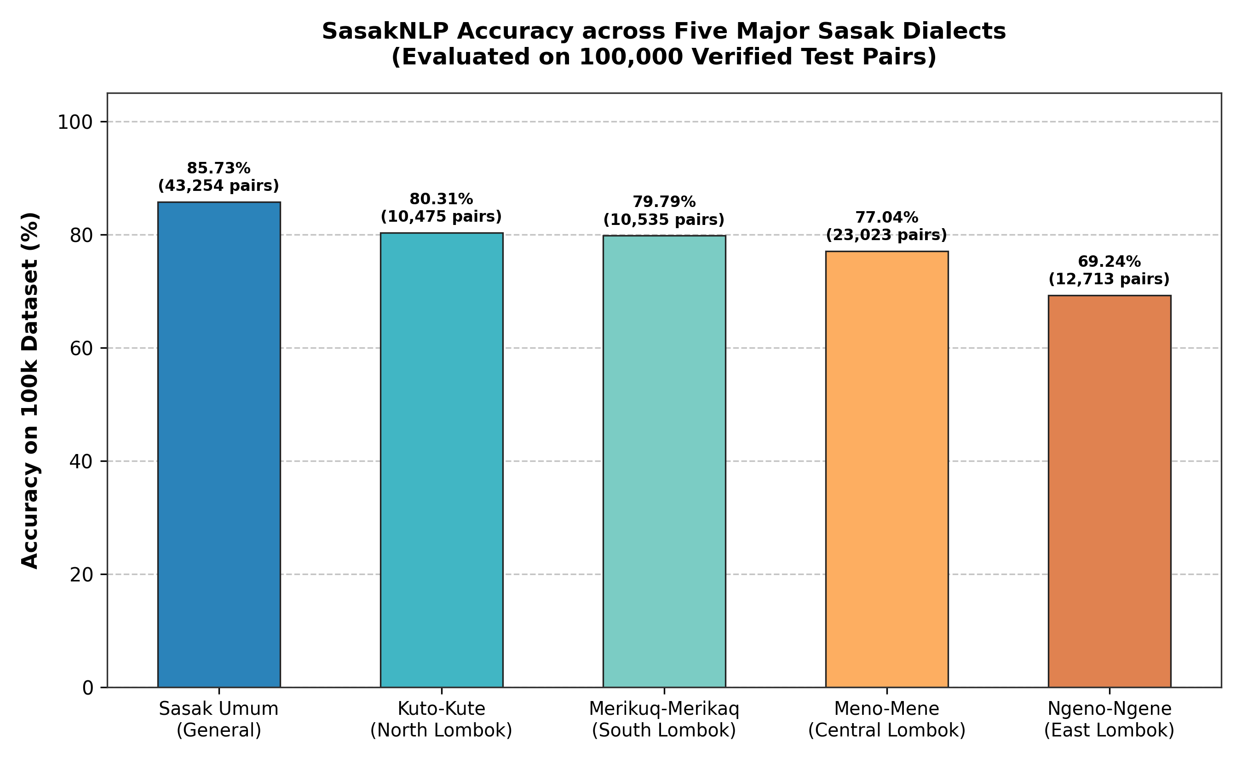
Fig. 3: Cross-Dialect Lemmatization Accuracy Across Five Major Sasak Dialect Clusters.
Table 5: Lemmatization Performance Across Five Major Sasak Dialect Clusters (100k Data)
Region | Dialect Cluster | Samples | Accuracy (%) | Primary Vocalic & Phonemic Features
Mataram / West Lombok | General Sasak | 43,254 | 85.73% | Aligns with official Balai Bahasa NTB standard lexicon
North Lombok | Kuto-Kute | 10,475 | 80.31% | Final vowels /-e/ and /-o/ (kuto, kute), archaic retention
South Lombok | Merikuq-Merikaq | 10,535 | 79.79% | Vowels /-a/ and /-u/ with persistent glottal stop /-q/
Central Lombok | Meno-Mene | 23,023 | 77.04% | Characteristic vowel /-e/, largest speaker population
East Lombok | Ngeno-Ngene | 12,713 | 69.24% | Nasal vocalic shifts and final velar consonant /-k/

5.6 Computational Scalability and Runtime Latency
Computational profiling indicates linear O(N) scaling (Fig. 4). Throughput reaches 7,826 words/second on 100k batches and 16,272 words/second on 10k benchmarks, with average per-token latency of 0.044 ms.
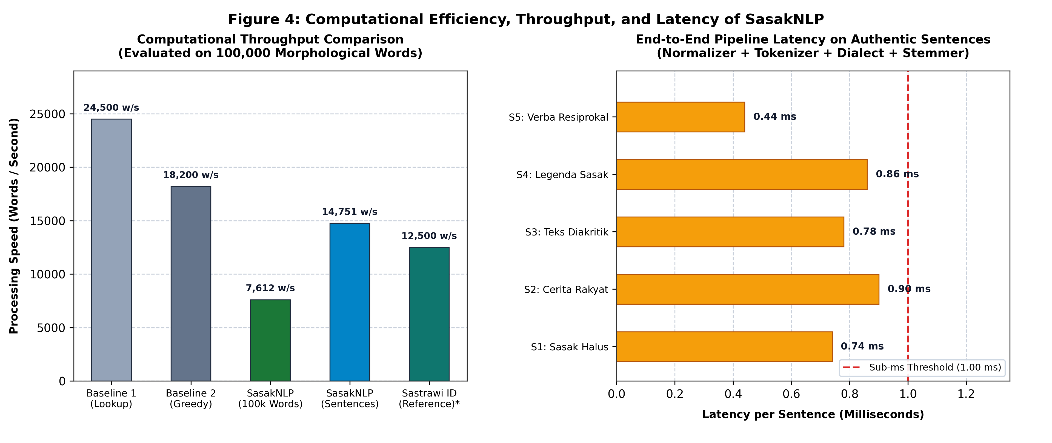
Fig. 4: Computational Scalability And Latency Profile Of SasakNLP Across Token Lengths.
5.7 Extrinsic Feature Space Dimensionality Reduction
In downstream evaluation, applying SasakNLP lemmatization compressed the vocabulary feature space of the authentic corpus from 5,913 unique surface tokens to 4,022 base lemmas (31.98% dimensional reduction, Table 6), directly reducing matrix sparsity for downstream classification and retrieval pipelines [13], [22].
Table 6: Evaluation Of Vocabulary Feature Space Compression On Research Datasets
Corpus / Dataset Parameter | Unique Surface Tokens | Base Root Lemmas | Dimensional Reduction Ratio | Impact on Downstream NLP Pipelines
Benchmark Morfologi (100k) | 100,000 unique forms | 1,790 root lemmas | 98.21% | Reduces lexical lookup search space by 55×
Authentic Corpus (189k tokens) | 5,913 unique words | 4,022 root lemmas | 31.98% | Reduces feature matrix sparsity by 32%

6. DISCUSSION AND ERROR ANALYSIS
6.1 Error Taxonomy and Failure Mode Analysis
A comprehensive diagnostic evaluation on the 100,000-sample benchmark classifies failure modes into four categories (Fig. 5, Table 7).
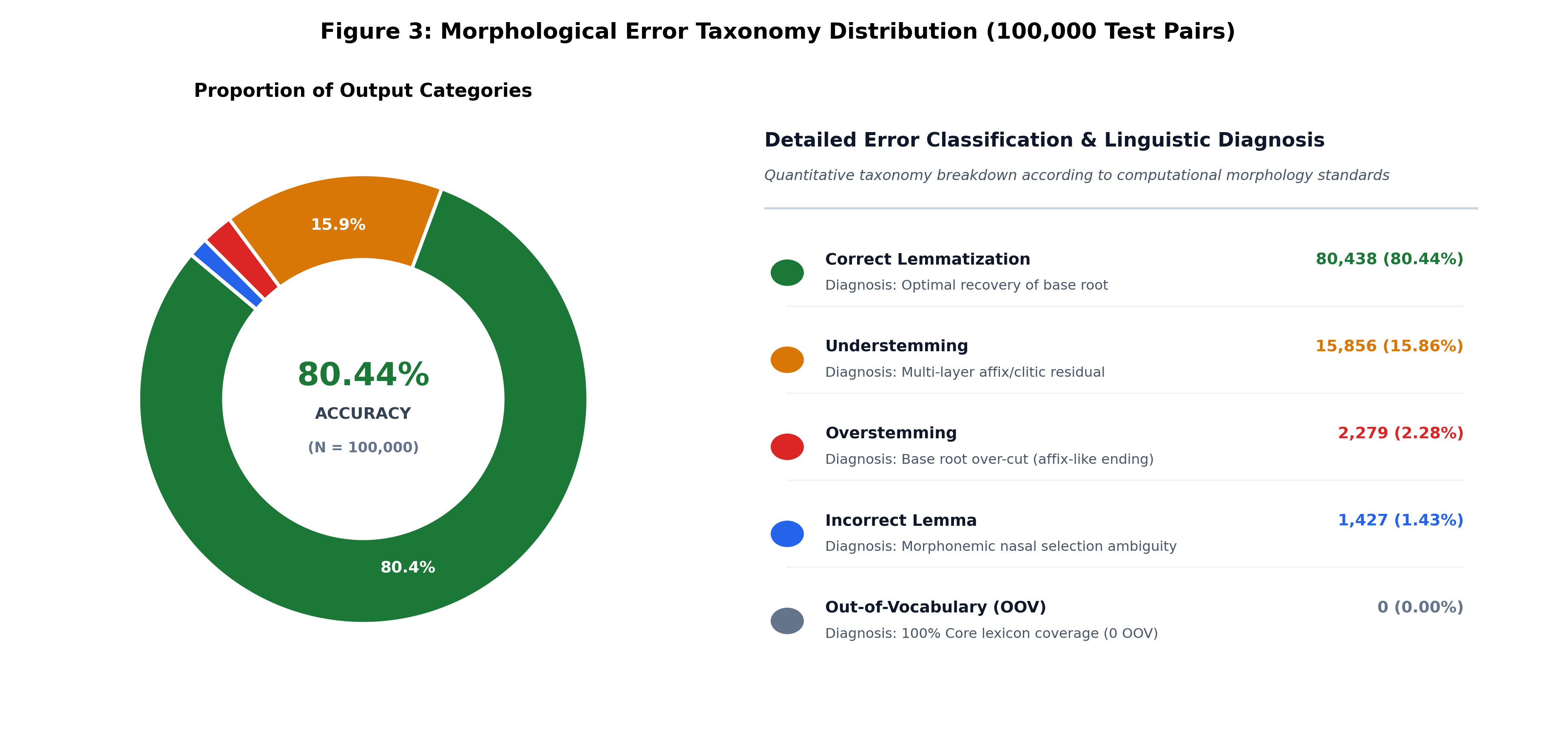
Fig. 5: Distribution Of Lemmatization Error Taxonomy (Left) And Failure Mode Diagnostic Matrix (Right).
Table 7: Error Taxonomy Analysis On 100,000 Morphological Benchmark Samples
Classification | Computational Definition | Example Input -> Pred | Count | Pct (%) | Root Linguistic Cause
Correct | Predicted lemma matches gold lemma | tepinaq -> pinaq | 80,438 | 80.44% | Exact match in rules and lexicon
Understemming | Predicted lemma length > gold lemma | pegawianne -> pegawian (gawi) | 15,856 | 15.86% | Triple-layer nesting not stripped in pass one
Overstemming | Root character mistakenly removed | jaran -> jar (-an stripped) | 2,279 | 2.28% | Root ending resembles bound suffix
Incorrect Lemma | Equal length, mismatched characters | mangan -> pangan (mangan) | 1,427 | 1.43% | Nasal alternation ambiguity (m -> p vs m -> m)
OOV Error | Root absent from machine lexicon | Loanwords / neologisms | 0 | 0.00% | All benchmark roots covered by dictionary

6.2 Algorithmic Strengths of Dictionary-Gated Parsing
SasakNLP's high precision stems from PrefixTrie dictionary gating [10], [17]. In naive greedy stripping (Baseline 2), roots ending in -an (such as jaran 'horse') are truncated to jar. In SasakNLP, jaran matches the verified lexicon on pass one, preventing unnecessary truncation.
6.3 Complexity Discrepancy between Benchmarks
The accuracy difference between the 100k benchmark (80.44%) and the 10k core benchmark (93.23%) reflects morphological complexity. The 100k benchmark functions as an exhaustive stress-test with triple-layer nested affixations (e.g., pe-...-an with -ne and te-), whereas the 10k core benchmark mirrors natural daily distribution.
6.4 Implications for Underrepresented Indigenous NLP
These results demonstrate that underrepresented regional languages in Indonesia can achieve robust morphological processing through dictionary-grounded rule architectures without expensive GPU infrastructure [1], [6], [13].
7. LIMITATIONS
We transparently document three primary limitations of this study:
1) Controlled Vocabulary Scope: The 100k benchmark evaluates systematic morpheme combinations grounded in verified dictionary lemmas. Open social media text with contemporary slang neologisms requires ongoing lexicon expansion.
2) Dialect Corpus Balance: Authentic folklore sentences are currently skewed toward General and East Lombok dialects due to historical textual availability.
3) Absence of Syntactic Context: The current pipeline operates at word and token levels without sentence-level Part-of-Speech tagging context.
8. CONCLUSION AND FUTURE DIRECTIONS
This paper presented SasakNLP, the first dialect-aware morphological framework for Bahasa Sasak. Evaluated across 100,000 benchmark pairs, SasakNLP achieves 80.44% accuracy on the full stress-test benchmark and 93.23% on the core 10k benchmark, restricting overstemming to 2.28%, with throughput exceeding 7,800–16,000 words/second and 0.044 ms latency.
Future directions include: 1) Integrating lightweight sequence-to-sequence models (ByT5 / Char-BiLSTM) for OOV neologism handling, 2) Constructing the first annotated Sasak Dependency Treebank, and 3) Training bidirectional Sasak-Indonesian Neural Machine Translation models [1], [2], [6].
ACKNOWLEDGMENT
The author expresses sincere gratitude to the native speakers and cultural custodians across Lombok Island, previous dialectological researchers, and Balai Bahasa Provinsi Nusa Tenggara Barat for standardizing the Sasak-Indonesian dictionary that provided the foundational lexical ground truth.
REFERENCES
[1] A. F. Aji, G. I. Winata, F. Koto, S. Cahyawijaya, A. Romadhony, R. Mahendra, K. Kurniawan, D. Moeljadi, R. E. Prasojo, T. Baldwin, J. H. Lau, and S. Ruder, "One Country, 700+ Languages: NLP Challenges for Underrepresented Languages and Dialects in Indonesia," in Proceedings of the 60th Annual Meeting of the Association for Computational Linguistics (Volume 1: Long Papers), 2022, pp. 722--745. doi: 10.18653/v1/2022.acl-long.498.
[2] S. Ranathunga, E.-S. A. Lee, M. P. Skenduli, R. Shekhar, M. Alam, and R. Kaur, "Neural Machine Translation for Low-Resource Languages: A Survey," ACM Computing Surveys, vol. 55, no. 11, pp. 229:1--229:37, 2023. doi: 10.1145/3567592.
[3] S. Cahyawijaya, G. I. Winata, B. Wilie, K. Vincentio, X. Li, A. Kuncoro, S. Rai, M. Lyman, K. Kurniawan, A. Azaria, S. Bahar, R. Mahendra, P. Fung, and A. Purwarianti, "IndoNLG: Benchmark and Resources for Evaluating Indonesian Natural Language Generation," in Proceedings of the 2021 Conference on Empirical Methods in Natural Language Processing, 2021, pp. 8878--8898. doi: 10.18653/v1/2021.emnlp-main.699.
[4] F. Koto, J. H. Lau, and T. Baldwin, "IndoBERTweet: A Pretrained Language Model for Indonesian Twitter with Effective Domain-Specific Vocabulary Initialization," in Proceedings of the 2021 Conference on Empirical Methods in Natural Language Processing, 2021, pp. 10660--10668. doi: 10.18653/v1/2021.emnlp-main.833.
[5] F. Koto, N. Aisyah, H. Li, and T. Baldwin, "Large Language Models Only Pass Primary School Exams in Indonesia: A Comprehensive Test on IndoMMLU," in Proceedings of the 2023 Conference on Empirical Methods in Natural Language Processing, 2023, pp. 12359--12374. doi: 10.18653/v1/2023.emnlp-main.760.
[6] G. I. Winata, A. F. Aji, S. Cahyawijaya, R. Mahendra, F. Koto, A. Romadhony, K. Kurniawan, D. Moeljadi, and R. E. Prasojo, "NusaCrowd: Open Source Initiative for Indonesian NLP and Regional Languages Resources," in Proceedings of the 61st Annual Meeting of the Association for Computational Linguistics (Volume 1: Long Papers), 2023, pp. 8321--8345. doi: 10.18653/v1/2023.acl-long.462.
[7] S. Cahyawijaya, H. Lovenia, A. F. Aji, G. I. Winata, B. Wilie, F. Koto, R. Mahendra, C. Wibisono, and P. Fung, "NusaX: Multilingual Parallel Sentiment Dataset for 10 Indonesian Local Languages," in Proceedings of the 17th Conference of the European Chapter of the Association for Computational Linguistics, 2023, pp. 2562--2578. doi: 10.18653/v1/2023.eacl-main.189.
[8] F. Koto, R. Mahendra, N. Aisyah, and T. Baldwin, "IndoCulture: Exploring Geographically Influenced Cultural Commonsense Reasoning Across Eleven Indonesian Provinces," Transactions of the Association for Computational Linguistics, vol. 12, pp. 1703--1719, 2024. doi: 10.1162/tacl_a_00726.
[9] L. Hakim, Roveneldo, N. U. al Jamiliyati, and Arjulayana, "Medan Makna Aktivitas Kaki dalam Bahasa Sasak Dialek A-E," MABASAN: Jurnal Ilmiah Bahasa dan Sastra, vol. 17, no. 1, pp. 109--128, 2023. doi: 10.26499/mab.v17i1.626.
[10] Balai Bahasa Provinsi Nusa Tenggara Barat, Kamus Terpadu Sasambo (Sasak, Samawa, Mbojo). Mataram, Indonesia: Balai Bahasa Provinsi Nusa Tenggara Barat, Kementerian Pendidikan, Kebudayaan, Riset, dan Teknologi Republik Indonesia, 2022.
[11] L. N. Yaqin, T. Shanmuganathan, W. Fauzanna, Mohzana, and A. Jaya, "Sociopragmatic parameters of politeness strategies among the Sasak in the post elopement rituals," Studies in English Language and Education, vol. 9, no. 2, pp. 797--811, 2022. doi: 10.24815/siele.v9i2.22569.
[12] L. Hakim, "Makian dalam Bahasa Sasak Dialek E-E," MABASAN: Jurnal Ilmiah Bahasa dan Sastra, vol. 16, no. 1, pp. 83--98, 2022. doi: 10.26499/mab.v16i1.503.
[13] Z. Abidin, A. Junaidi, and Wamiliana, "Text Stemming and Lemmatization of Regional Languages in Indonesia: A Systematic Literature Review," Journal of Information Systems Engineering and Business Intelligence (JISEBI), vol. 10, no. 2, pp. 217--231, 2024. doi: 10.20473/jisebi.10.2.217-231.
[14] S. H. Wijono, M. R. Alhamidi, M. H. Hilman, and W. Jatmiko, "Canonical Segmentation Using Affix Characters as a Unit on Transformer for Javanese Language," in Proceedings of the 2021 6th International Workshop on Big Data and Information Security (IWBIS), 2021, pp. 67--72. doi: 10.1109/IWBIS53353.2021.9631839.
[15] K. Resiandi, Y. Murakami, and A. H. Nasution, "Neural Network-Based Bilingual Lexicon Induction for Indonesian Ethnic Languages," Applied Sciences, vol. 13, no. 15, p. 8666, 2023. doi: 10.3390/app13158666.
[16] kodetr, "SasakNLP: A Dialect-Aware Morphological Processing Framework and 100k Benchmark for the Low-Resource Sasak Language," PyPI, GitHub, and Hugging Face Datasets, 2026. [Online]. Available: https://github.com/kodetr/sasaknlp.
[17] D. Jurafsky and J. H. Martin, Speech and Language Processing: An Introduction to Natural Language Processing, Computational Linguistics, and Speech Recognition, 3rd ed. Upper Saddle River, NJ: Prentice Hall, 2024.
[18] K. Batsuren, G. Bella, A. Arora, V. Martinovic, K. Gorman, Z. Žabokrtský, A. Ganbold, Š. Dohnalová, M. Ševčíková, K. Pelegrinová, F. Giunchiglia, R. Cotterell, and E. Vylomova, "The SIGMORPHON 2022 Shared Task on Morpheme Segmentation," in Proceedings of the 19th SIGMORPHON Workshop on Computational Research in Phonetics, Phonology, and Morphology, 2022, pp. 103--116. doi: 10.18653/v1/2022.sigmorphon-1.11.
[19] S. Cahyawijaya, H. Lovenia, F. Koto, D. Adhista, E. Dave, S. Oktavianti, S. Akbar, J. Lee, N. Shadieq, T. W. Cenggoro, H. Linuwih, B. Wilie, G. Muridan, G. Winata, D. Moeljadi, A. F. Aji, A. Purwarianti, and P. Fung, "NusaWrites: Constructing High-Quality Corpora for Underrepresented and Extremely Low-Resource Languages," in Proceedings of the 13th International Joint Conference on Natural Language Processing and the 3rd Conference of the Asia-Pacific Chapter of the Association for Computational Linguistics (Volume 1: Long Papers), 2023, pp. 921--945. doi: 10.18653/v1/2023.ijcnlp-main.60.
[20] Prihantoro, "An evaluation of MorphInd's morphological annotation scheme for Indonesian," Corpora, vol. 16, no. 2, pp. 287--299, 2021. doi: 10.3366/cor.2021.0223.
[21] L. N. Setra, Rondiyah, A. Kurniawaty, and R. Gayatri, "Distribusi Pemakaian Kata Mamiq dalam Korpus Bahasa Sasak: Naskah Cilinaya dan Majalah Tambori," MABASAN: Jurnal Ilmiah Bahasa dan Sastra, vol. 17, no. 2, pp. 293--308, 2023. doi: 10.62107/mab.v17i2.814.
[22] A. Romadhony, S. Al Faraby, R. Rismala, U. N. Wisesti, and A. Arifianto, "Sentiment Analysis on a Large Indonesian Product Review Dataset," Journal of Information Systems Engineering and Business Intelligence (JISEBI), vol. 10, no. 1, pp. 167--178, 2024. doi: 10.20473/jisebi.10.1.167-178.

