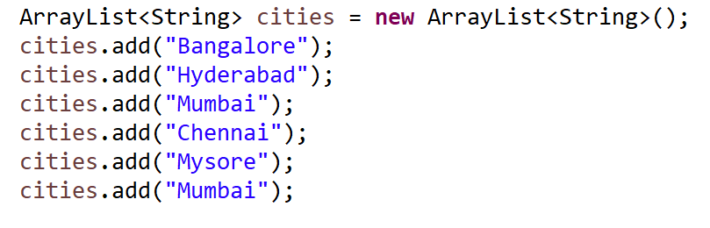

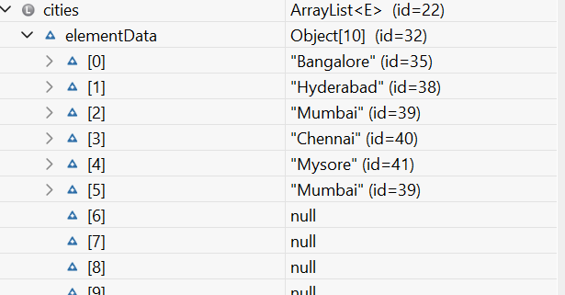
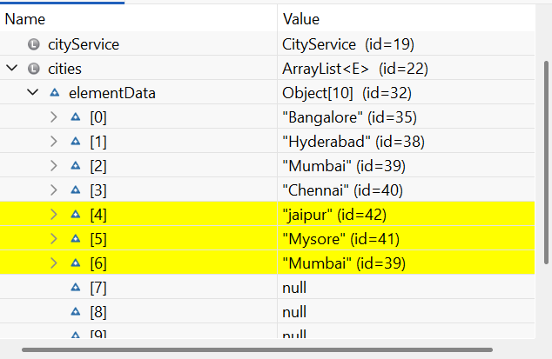

cities.add(4, jaipur)

Time complexity

- Array list is best suitable for random access by index O(1)
- Array list is not suitable for adding/removing elements O(n) due to shifting of an elements.
2000 elements add(5, “some element”) X 100k

Homework :
- Explore the arraylist’s methods
- Understand the time complexity
- Develop some programs and process the arraylist.
- Decide when to use array list and when not to use?

