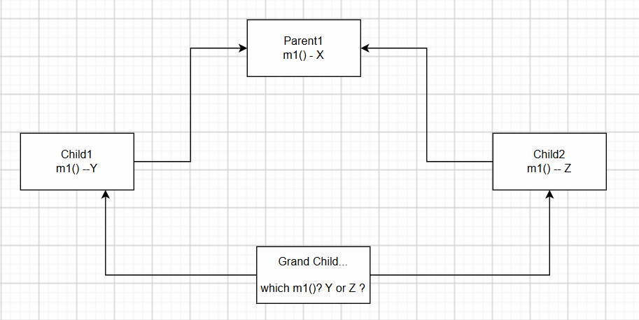

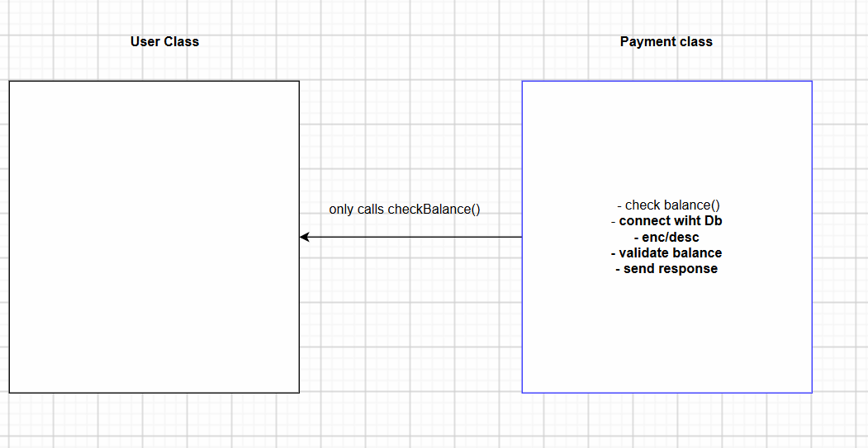

Reusable
Maintainable
Secure
Modular
Note : Multiple Inheritance X and GC
UPI, CC, Wallet + (Phone Pay)
Encapsulation Hiding the data(private fields + public getter setter (Control))
Inheritance Reusing the parent class(other classes) functionalities
Polymorphism
PhopnePay Payment processing – F1
GPay Payment processing – F2
Upi Payment processing – F3
After a year, Credit card payment need to be processed New requirement

5 cr customers

Abstraction Hide the logic(Implementation)
MetaSpace

Stack
Heap

Payment p = new Payment();

