Types of an Interfaces

- Normal Interface 100% contact
- Marker Interface Tag Interface / Empty interface
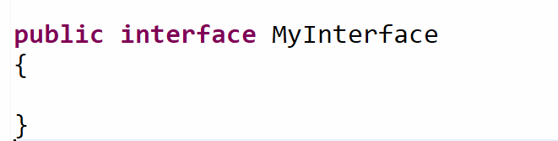

Marker interface is giving an ability(Permission) to perform some activity(Cloning, Serialization etc.)

Cloneable Marker interface
Serializable Serialization to be allowed or not.

PAN Card Need owner’s permission to copy the pan card.

Instanceof obj is type of an Interface or not

- Functional Interface
- Nested Interface

If(obj instacneOf Clonable)
{
}

