Serialization Object Transfer over the network / Save to file system / Save to DB
De- Serialization Converting the byte stream to Object
SerDe

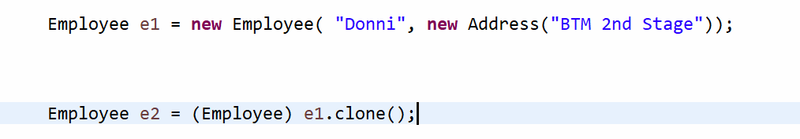

Types
- Shallow Just close the reference and no nested cloning.
- Deep Nested

