- LinkedList is not index based
- Follow Node structure(prev address – Data – next address)
- It is not using continuous memory location.
RAM


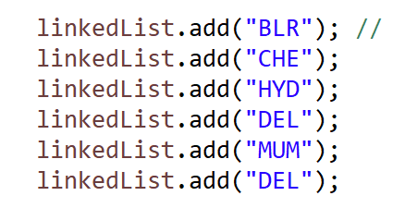

Time Complexity
- Reading an element linkedList.get(5)
- O(N)
- Adding an element
- O(1) + O(N) O(N)



Array List LinkedList
Adding elements in the list O(1) + O(N) to reach at the index
Random Read / Access by index O(N)
- Random Read / Access by index O(1)

Adding or removing elements O(N)

