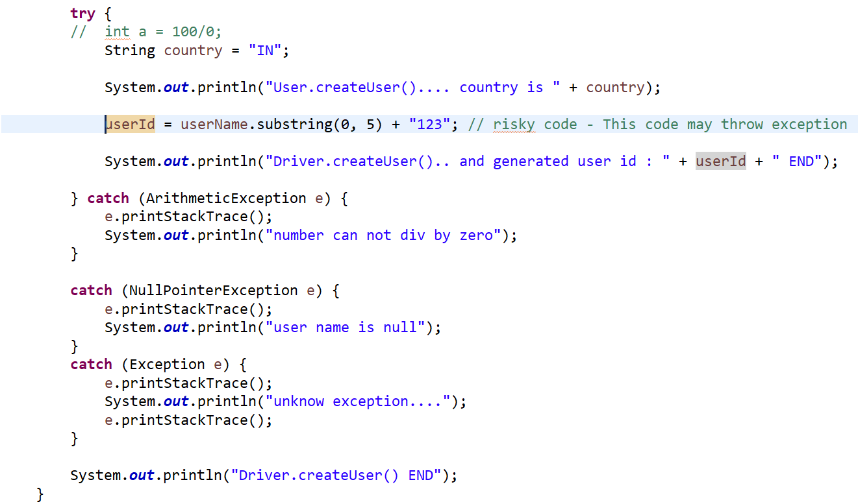

Write a method which return an int from try and finally. What will be the values returned when we call the method.

