SCP – String constant Pool

Heap

- String literals String s = “Hello”; SCP(before creating object in scp it check if object is already exists or not, if exists then it will not create and start referring same object)
- Using new keyword

Employee e = new Employee();

String s1 = new String(“Hello”);

- One object created in scp “Hello”
- Object created in heap and newly created object(heap) will be referred by s1

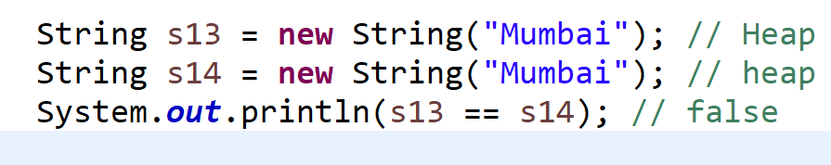

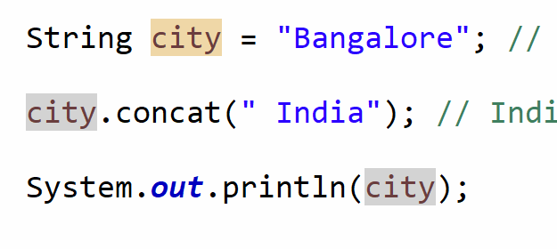

How do we compare the object reference ==

.equals() ?

