List (Ordered and Allow Duplicates)
- Array List
- LinkedList
Set (Uniqueness and Unordered?)
- HashSet Uniqueness and Unordered
- HashSet[Uniqueness] + LinkedList [Order] = LinkedHashSet Uniqueness but Ordered?
HashSet
+

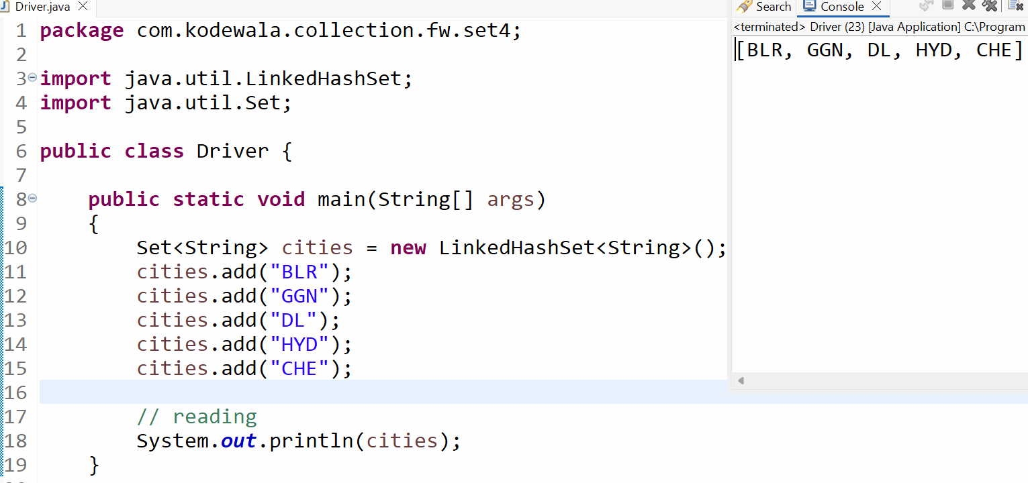
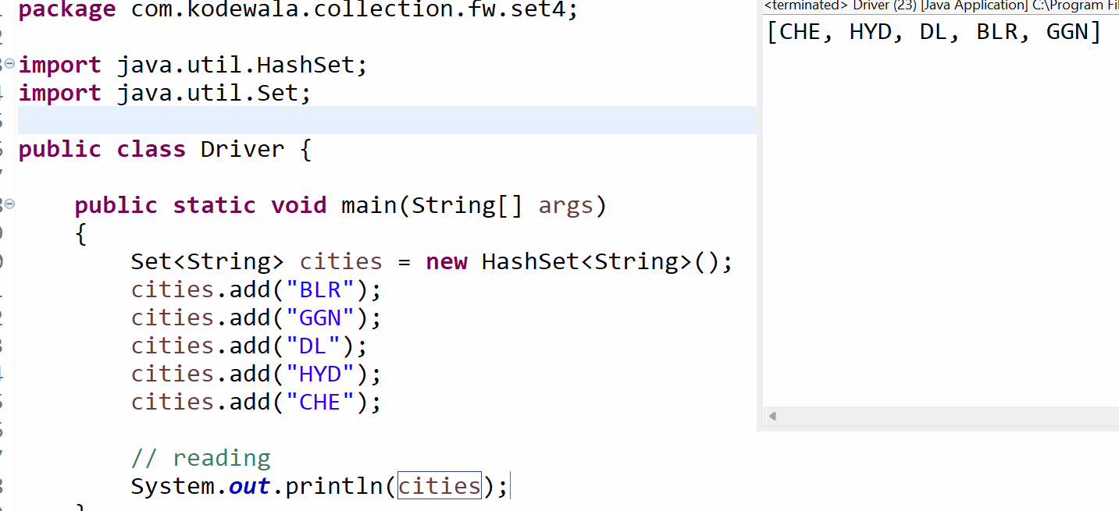

What if I want unique elements and in sorted order ?
TreeSet (Uniqueness and sorted)

Equals() Both are same or not(boolean)
Compare() large and small( int -ve , 0 , +ve)

24, 24 , 56 , 12 12 , 24, 56,

