Inheritance We will reuse the code which developed by someone.

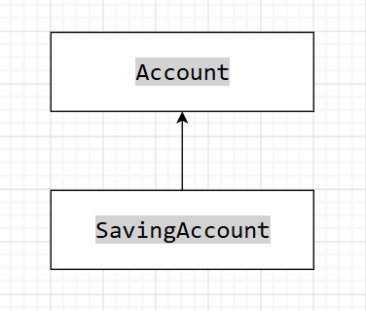 Single Inheritance

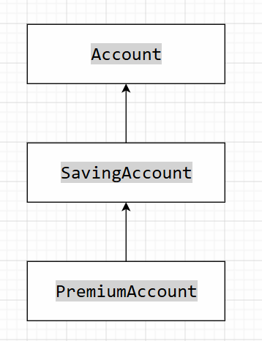Multi- Level
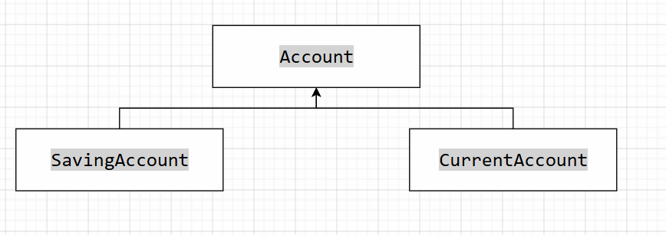
Hierarchical

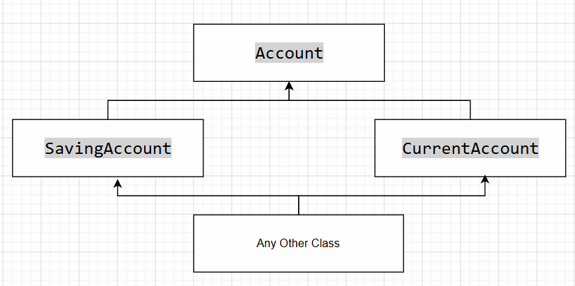
Multiple inheritance

Dentist IS A type of Doctor

