Exception

- Performance
- Usability(Easy to Use)
- Error / Message
- Internal server error
- There is high load on the server and you may try after 1-2 hrs.
- Email id already exists
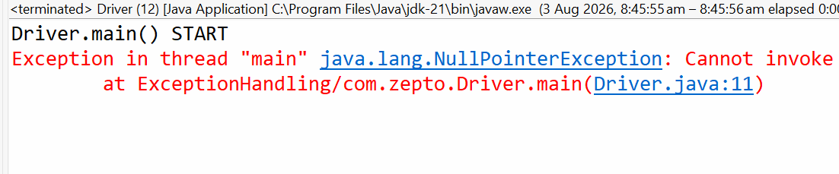
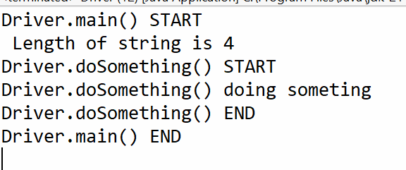

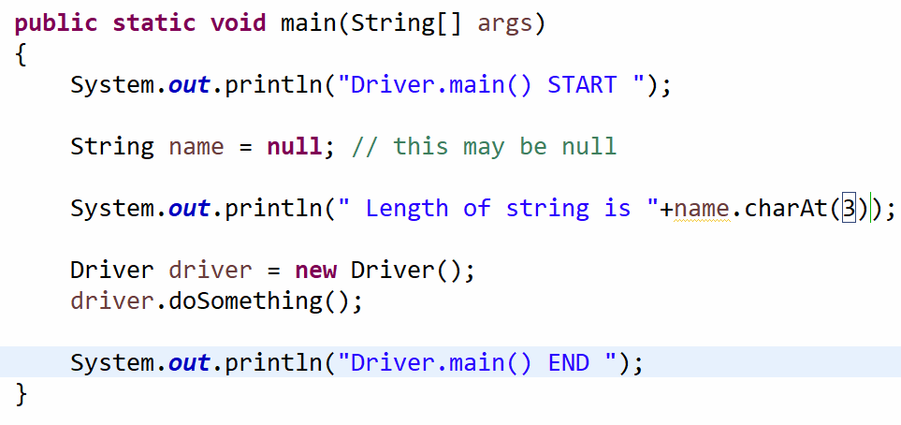

- Null Pointer Exception
- Array Index out of bound exception

try
{
// Risky code Code which may throw exception
}
catch()
{
// Exception Handling
}
cont….

Write a program and explore the followings
- Null Pointer
- Array Index Out of Bound
- Arithmetic Exception

