HashSet set = new HashSet(); default cap : 16

TC Add an elements O(1)
Core : Identify the bucket ?
“BLR”.hashCode() 32456546
Then it will apply bitwise AND Operation
Number & 15 0 to 15 only
32456546 & 15 8th Bangalore stored at the index 8th.
Before adding an element, it will check, is there existing elements or not.
- If not then LinkedList will be created with one node and element will be added at 8th index
- If it find an existing elements,
- Scenario 1 element may be duplicate , it will call “New element”.equals(“Existing Element”) and if it return true then It will not add an elment.(Duplicate)
- Scenario 2 : hash collision it will call “New element”.equals(“Existing Element”) and if it return false then it is hash collision and it create new node and add to existing linked list.

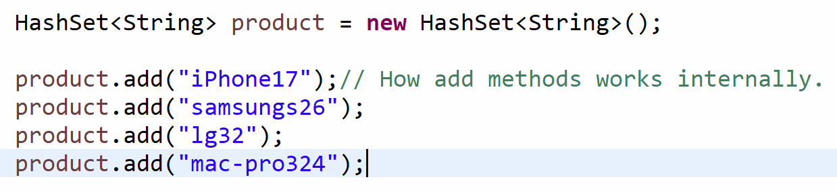

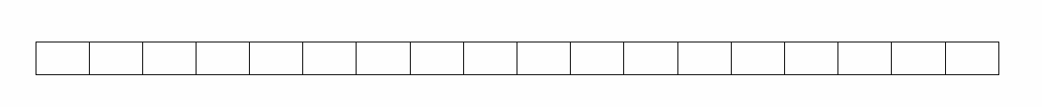

Ka

- Calculate the hashcode “iPhone17”.hashCode() -619339925
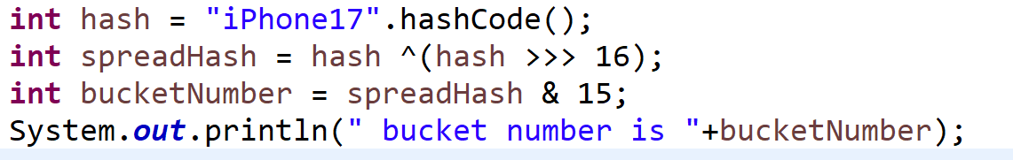

- We will get the bucket number and in the case of iPhone17, as per above logic, we got bucket number 14th.
- “mac-pro324”.equals(“iPhone17”) false

product.contains(“iPhone17”);
Best : Read O(1) assuming no collision
Worst : O(N) where n is the number of collision at the particular index.

How does contains method works in hash set?
What is the return type of add method True / False
Default Cap : 10 50%
HashSet Cap : 16 , Load Factor .75 OR 75% TH: 12
Rehashing process

BLR 54321 & 15 8th
54321 & 31 17th

