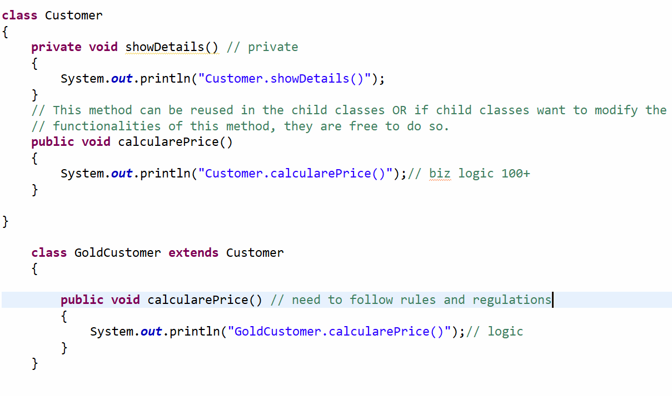

Rules for Method Overriding
- Method name should be same
- Method params should be same(order, type, number)
- Method return type should be same.(Except covariant )
- Access modifiers should be same or widen. Reducing scope is not allowed.
- Default to default
- Default to Protected
- Default to public
- Protected to Public
- Protected to Default Not Allowed, You are reducing the scope
- Exception X

5-7 Mins

