MVC Framework
User Http Request(data + action) Web.xml(Dispatcher Servlet{ Front controller }) Handler Mapping Controller
Method(GET/POST) | Action | Controller | Method | ….
GET | viewFrom | LoginController | viewLoginPage()
GET | logout | LoginController | logout()

GET Read from the backend (Login, Checking PNR Status, know your order status)
POST Create new Resource / Record (Register, ticket booking, Place order)
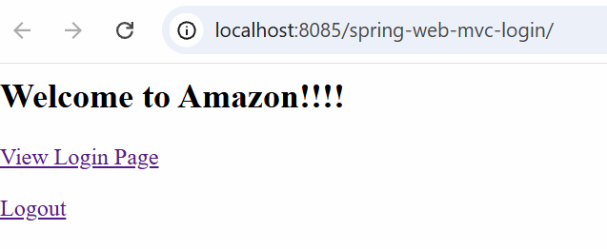
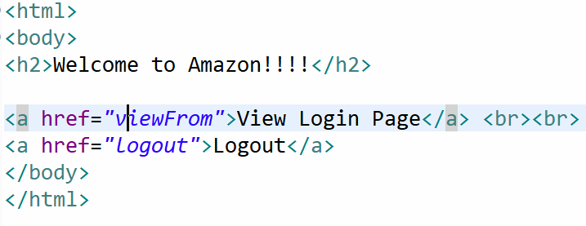

Controller (No Biz Logic)
- Receive Http request
- Send Https response

Data and action Handler Mapping Controller and Method Service Repository DB PNR Status Service Controller View Resolver "login-form" prefix + "login-form" + suffix Full path of the page page displayed to the user as a response.
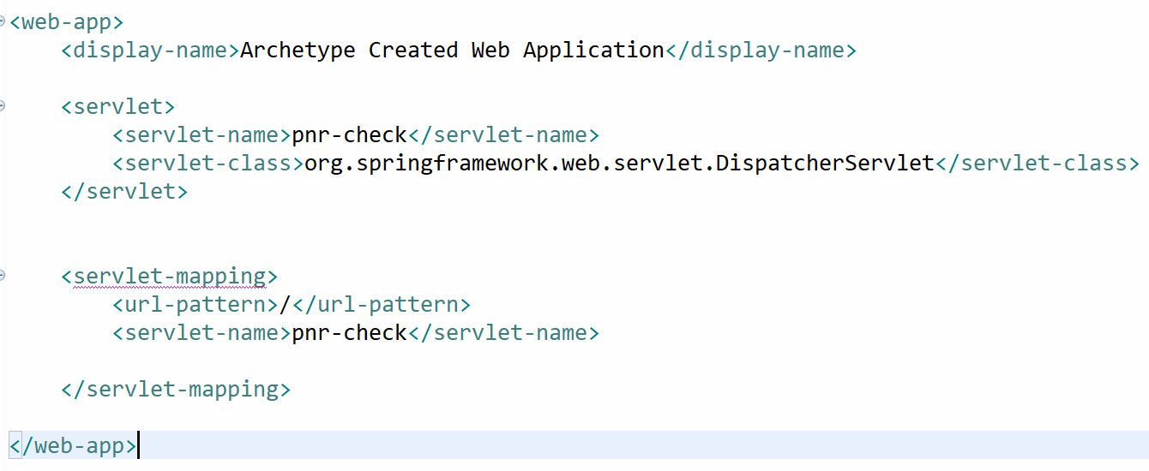

Ways to send data from Client to Server
- Request Param key=value form
- Path Variables
- Model Attributes
- Request body

