Screen shot1 of repo on VS Code for submission

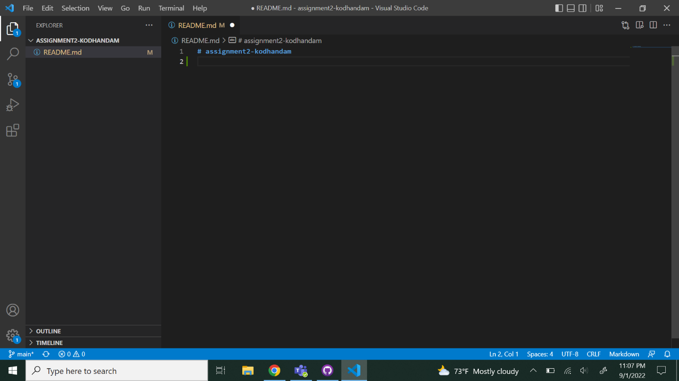

Screen shot2 on VS Code of edited README

