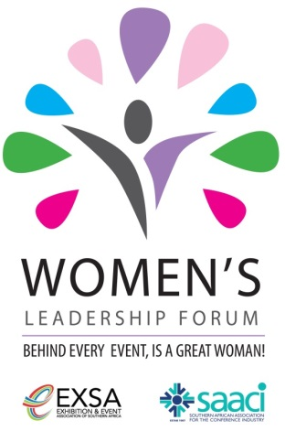**WOMEN’S LEADERSHIP FORUM**

**BEHIND EVERY GREAT EVENT THERE’S A GREAT WOMAN!**

**20 NOVEMBER 2013**

**SANDTON HOLIDAY INN**

**PROGRAMME**

08h00-09h00 Registration

09h00-09h20 Welcome/Opening

Our MC for the Day - Mark Bayly

09h20-10h10 Women in the Economy –what a difference we make!

Daniel Silke, renowned Economist

10h10-11h00 Be the CEO of **Your** Brand :

Kate Moodley, Author and Entrepreneur

11h00-11h30 REFRESHMENT BREAK

11h30-12h30 Your Image – body language, dress to impress!

Wendy Hind, Chata Romano Consultant

12h30-12h45 Q & A

12h45-14h00 NETWORKING LUNCH

14h00-14h45 Breaking Through the Glass Ceiling

Prof Shirley Zinn, HR Consultant

14h45-15h30 Future proofing your financial planning - are you ready?

15h30-15h45 REFRESHMENT BREAK

15h45-16h30 Let's Get High - putting things into perspective. Don't sweat the small stuff! Sarah Bauling, Sales and Marketing Expert

16h30-17h00 Closure, followed by Cocktail Party to celebrate the first WLF with

entertainment and fun!