

***EcoMobility: A Transport Solution For Visible Policing In SA***

P

olice visibility in South Africa has reached its peak for concern especially with police killings reaching the highest it’s ever reached in 12 years. Criminal activities in local communities within South Africa have immensely increased due to common criminal role players such as unemployment, drug and substance abuse.

Local South African citizens now live in fear within their communities as they no longer feel safe in their homes due to these criminal activities. It can be argued that the matter at hand is a result caused by the lack of police response towards criminal activities when reported by local residents. The Minister of the South African Police Services (SAPS) has commenced by implementing a visible policing strategy for 2015 however, an effective solution is needed to ensure that police visibility is increased in South Africa. Safety is one of the major concerns in the hearts of all South Africans, hence SAPS aims to increase visible policing in all South African communities.

RBJ Green Mobility has just the perfect solution to ensure that an effective strategy is implemented to enhance the activity and visibility of police on the streets of South Africa. We propose a transport solution that will utilise eco-mobility vehicles, making it more convenient and mobile to increase police visibility. Our fleet of eco-mobile vehicles will assist SAPS to effectively implement its ongoing visible policing strategy. These vehicles are easy to use and are convenient for SAPS police officers to utilise them while on duty. Our eco-mobility vehicles can serve as a substitute for police vehicles and its usage will decrease pollution hence it is considered to be environmentally friendly.

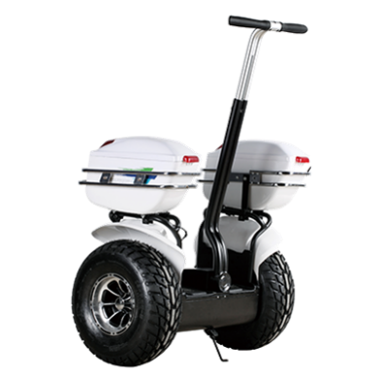The Eco-mobile vehicles will ease the implementation of the visible policing strategy that is currently being implemented by SAPS. These eco-mobile vehicles will allow SAPS to allocate more police vehicles to a larger capacity of police officers within each province/ municipality. This also means that more officers will be frequently visible on the streets, ensuring that safety for all South Africans is guaranteed.

Most police departments rely on a combination of vehicle, foot, and bicycle patrol to effectively monitor and prevent crime. While patrol cars are the core of any law enforcement department, foot and bicycle patrolling plays an important part in building positive relationships with residents and businesses within the community.

With the advent of electric patrol vehicles, flexible mobility and quick response times can be achieved simultaneously. Police mobility vehicles allow access to areas where patrol cars cannot go, providing enhanced police presence and protection. In addition, officers on foot patrol and those in mobile vehicles can be perceived as more approachable by the public than officers in patrol cars.

The eco-mobile vehicle is a fantastic community policing tool and it is also an effective police vehicle. It transitions seamlessly from high traffic (slow speed) pedestrian environments to a high speed vehicle that’s capable of quick response times and even pursuits.

For more information about RBJ Marketing Solutions and RBJ Green Mobility,

Visit: [www.rbjmarketing.com](http://www.rbjmarketing.com) www.rbjgreenmobility.com