RBJ MARKETING SOLUTIONS- ON THE MOVE!

RBJ Marketing Solutions CEO- Jeff Madibeng, “We are proud to announce that we will be managing the PR and Marketing aspect for the upcoming Gauteng SANSUI Summer Cup which will be held on the 28th November 2015 at the Turffontein Racecourse in Johannesburg.”

The Gauteng SANSUI Summer Cup is an annual horse racing event and this year it promises to go bigger and better. The theme for the Gauteng SANSUI Summer Cup 2015 is “More Jozi” and can be translated as “Nothing is big unless it`s Jozi big”. The event is known to be captivating and because of its popularity over the years, guests never seem to get enough of it. The high profile event hosts the likes of popular socialites, celebrities and fashion icons from all around South Africa.

“RBJ Marketing Solutions has managed many high profile events since its establishment in 2003, we started off with small events which hosted up to 100 people but today we are proud to say that we have successfully hosted major events with over 10 000 people. Our hard work is evident through the passion that we show our clients and we will and have always prided ourselves by stating that any event whether big or small should be treated as a high profile event to ensure quality and satisfaction for all our clients. The Gauteng SANSUI Summer will be no different because our passion for marketing and event management is ever constant.” – Jeff Madibeng

With just 46 days left before this year`s Gauteng SANSUI Summer Cup, RBJ Marketing Solutions is 100% positive that the event will be bigger than expected!

For more information about ticket sales visit: [www.rbjmarketing.com](http://www.rbjmarketing.com)

Email: [marketing@rbjmarketing.com](mailto:marketing@rbjmarketing.com)

Telephone: 010 591 2867

[](http://www.rbjmarketing.co.za/upcoming-events/bookings)[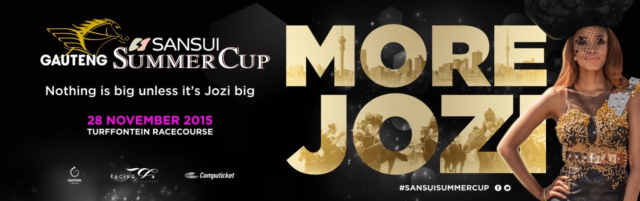](http://www.rbjmarketing.co.za/upcoming-events)