Joan Ramagoshi Madibeng visits SOS Children’s Village Mamelodi

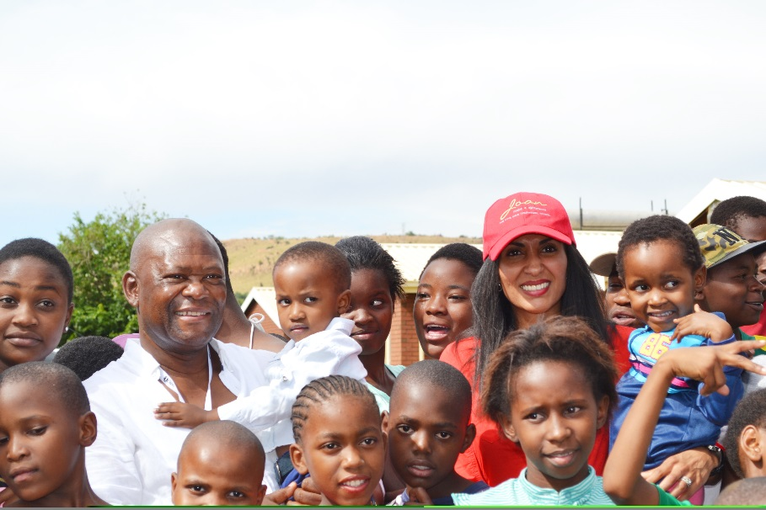

Former Miss South Africa Joan Ramagoshi Madibeng continues to give hope and support to shelters in and around Mamelodi. Last weekend the former Beauty Queen and Businesswoman spent her afternoon with children from the SOS Children’s Village in Mamelodi generously giving her time to help the organization raise funds and bring awareness the work that SOS Mamelodi fulfils in the community. In a bid to transform and continue with her philanthropic endeavours Madibeng invited some of her partners such as the Gauteng SANSUI Summer Cup patrons and celebrity friends including Muvhango actor John Morapama to take some time out of their busy schedule, to come read, play and generate a lot of laughs with children from the Village.

The Mamelodi SOS Children’s Village has been in operation for the past 28 years. The Children’s Village provides a safe home for underprivileged children and child headed homes. Many of the children receive full support from staff and from the community as they journey towards adulthood and their chosen careers.

Joan Ramagoshi Madibeng who is one of Gauteng SANSUI Summer Cup celebrity dash participants said: “Mamelodi is my home and the children of SOS Children`s Village are my family and I love them as I love my own children. Being a title holder doesn’t end with gowns and tiara’s but it’s our responsibility 365 days to make sure that we change the face of our communities by ensuring access to basic services and education,” expressed Madibeng.

Children from the Village enjoyed a delightful afternoon with entertainment and a meal. Joan and her guests read and played soccer with the children, whilst children from the centre recited songs extending their heartfelt gratitude to Mrs Madibeng and guests. Through her partnership with Gauteng SANSUI Summer Cup, Mrs Madibeng donated party packs and gifts to all the children.

Thanking Joan for extending an invite, Muvhango actor John Morapama commented: “Community involvement is closer to my heart and when Mrs Madibeng called I immediately availed myself because I believe in bringing the best out of young people”, said Morapama.

The SOS Children’s Village Mamelodi sojourn was fully supported by Gauteng SANSUI Summer Cup 2015.

**Follow Joan Ramagoshi Madibeng**:

On Facebook at Joan Ramagoshi

On Twitter at @JMadibeng

On Instagram at Joan Ramagoshi

ABOUT JOAN RAMAGOSHI MADIBENG

Joan Ramagoshi Madibeng is a former Miss South Africa and businesswoman. She has been at the helm of Communications in Soccer, having worked for one of South Africa’s celebrated soccer club Mamelodi Sundowns FC as head of Marketing. Madibeng is a co-founder of RBJ Marketing, Director of Terra De Africa, Philanthropist, Brand consultant, Motivational speaker and most of all a wife and mother to two beautiful children.

**About SOS Children's Villages**

SOS Children‘s Villages is an independent, non-governmental, social development organisation that provides family-based care to children in 133 countries and territories and that advocates the concerns, rights and needs of children, especially of those without parental care. For more information visit [www.sos.org.za](http://www.sos.org.za/)

For any further information, media queries and interview requests, please contact

Eugene Mametse on 083 539 3882 or eugene@7colors.co.za

Issued by: Seven Colors Communications